Angular’s @Input() decorator is letting a parent component pass data into a child component.
- In weather2.ts, I defined a property using @input():
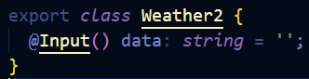
This tells Angular that this value will come from outside the component.
- In the parent component (App), I included the child component using its selector:
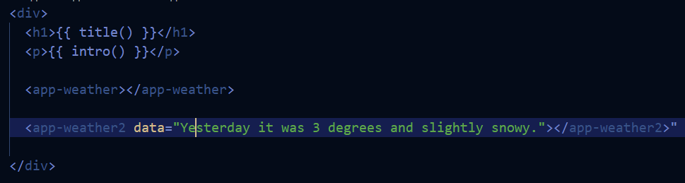
Here, “Yesterday it was 3 degrees and slightly snowy.” is passed directly to the data property.
- Inside weather2.html, I displayed it using Angular interpolation:
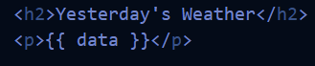

*My file names do not include ‘component’. I followed the installation instructions provided by Angular and it seems that naming conventions have changed slightly since the course was written.

