QMBE 1320 Final Project Stage 1 – by Chelsea Rodriguez

For this project, I selected a dataset containing descriptions of adoptable dogs from various shelters and data containing different places where dogs have been exported/imported from along with other data such as their environment compatibility, and their health conditions, the data also provides insights into the breeds, physical characteristics of the dogs included in the data. The primary goal is to understand trends that may influence a dog’s likelihood of adoption, such as breed popularity, location, and descriptive keywords in their profiles. Analyzing this dataset can help shelters optimize their efforts to increase adoption rates. The reason why I chose this dataset is because as someone who has adopted dogs, I want to do deeper research since dog adoption plays a critical role in providing a second chance to millions of dogs across the country, I want to find out what variables make a difference and how big of a difference it is that they make.

2. Write 2-3 Problem Statements
a. Problem statement 1: I want to analyze which dog breeds are most likely to be adopted based on their descriptions and characteristics; I want to analyze the relationship between breed types and adoption rates. Specifically, which breeds or characteristics (ex: age, size, fixed status) are most likely to lead to quicker adoptions?

b. Problem Statement 2: I aim to explore whether location or shelter-specific attributes (ex: state, city) influence the time it takes for dogs to be adopted.

c. Problem Statement 3: I want to identify key descriptive keywords or traits that resonate with adopters and lead to quicker adoptions such as environmental factors (ex: whether a dog is compatible with children or other pets) affect the likelihood of adoption.

What is your plan to analyze these problem statements? How will this analysis help the consumer or business? (1 paragraph)
The plan involves using descriptive and inferential statistics to understand trends, followed by predictive modeling to determine factors that influence adoption likelihood. This analysis can assist by prioritizing specific dogs for promotional efforts and finding ways to make sure every dog gets a chance of a second chance. It benefits both the consumer (in this case the adopter) by improving accessibility to adoptable dogs and the business (shelter) by increasing adoption rates.

3. How did you clean your data? (1-2 paragraphs)
In the Dog Descriptions dataset, I removed columns that I did not think were important to the research such as URLs, photos, and location information that did not feel necessary, focusing only on relevant attributes like breed, age, and size. Missing values in key fields (ex: color and description) were filled with "Unknown" or N/A" while columns with excessive missing data, or more information deemed unnecessary such as “declawed status” and “tags” was eliminated from the dataset. I cleaned the text in the description column by removing special characters and standardizing the format.
For the Dog Moves dataset, I replaced missing numerical values in the exported, imported and total columns with zeros to ensure accurate calculations. The dataset required minimal cleaning as it was already well-structured.
In the Dog Travel dataset, I dropped columns with excessive missing values (manual, remove and still_there) as I did not see these fit for this, I then ensured the remaining columns were complete. This left a dataset with relevant attributes such as location and descriptions and helped clear it and make it more legible and easier to understand. Finally, to adjust my data completely and create my Summary Stats table I decided to combine both of my most important data sets together to create the following chart down below:

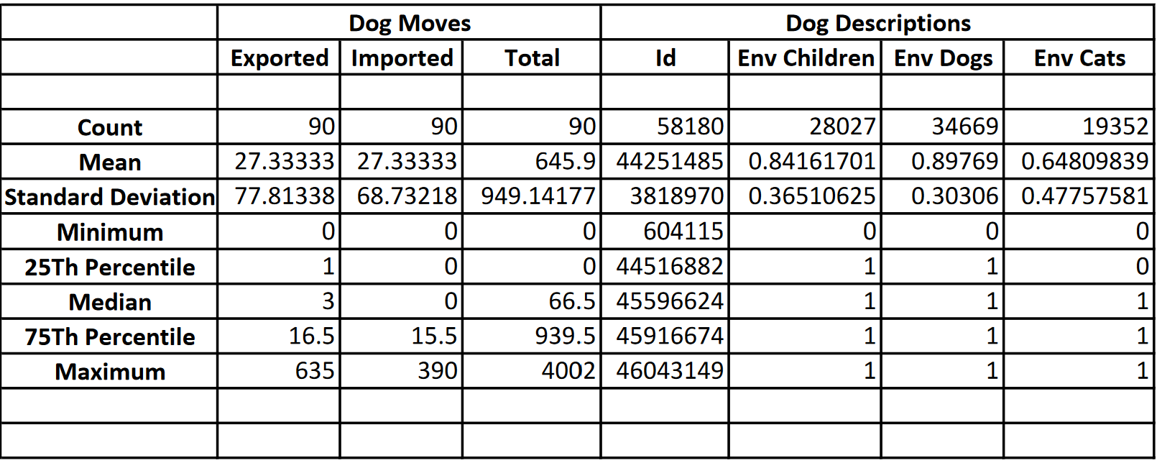

Have you thought about creating new variables or combining data sets? What variables can you create that you might use for your analysis? How would you create them? (1 paragraph)

Creating new variables or combining datasets can help provide deeper insights. For example, I could create a "Relocation Ratio" by combining the exported and imported data from the Dog Moves dataset. This would highlight states that are net exporters or importers of dogs. Additionally, combining the Dog Descriptions dataset with the Dog Travel dataset using a common key like id could reveal how breed, age, or size influences relocation trends. Another useful variable could be "Adoption Likelihood", calculated from the Dog Descriptions dataset by analyzing the proportion of dogs with the status "adoptable" compared to those already adopted in a specific breed or region. These variables could uncover patterns in adoption preferences, relocation efficiency, and regional shelter needs, providing actionable insights for animal welfare organizations. I could combine these data sets by adjusting the different columns and putting them in excel to create the new columns.

5. Visualize Data: (Several graphs or tables depending on your “important variables)

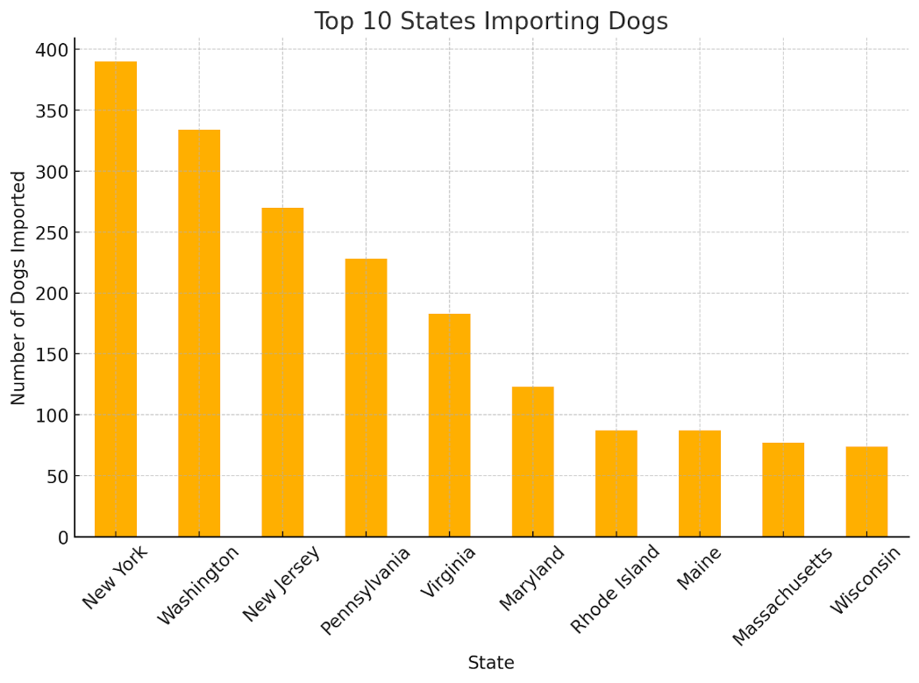

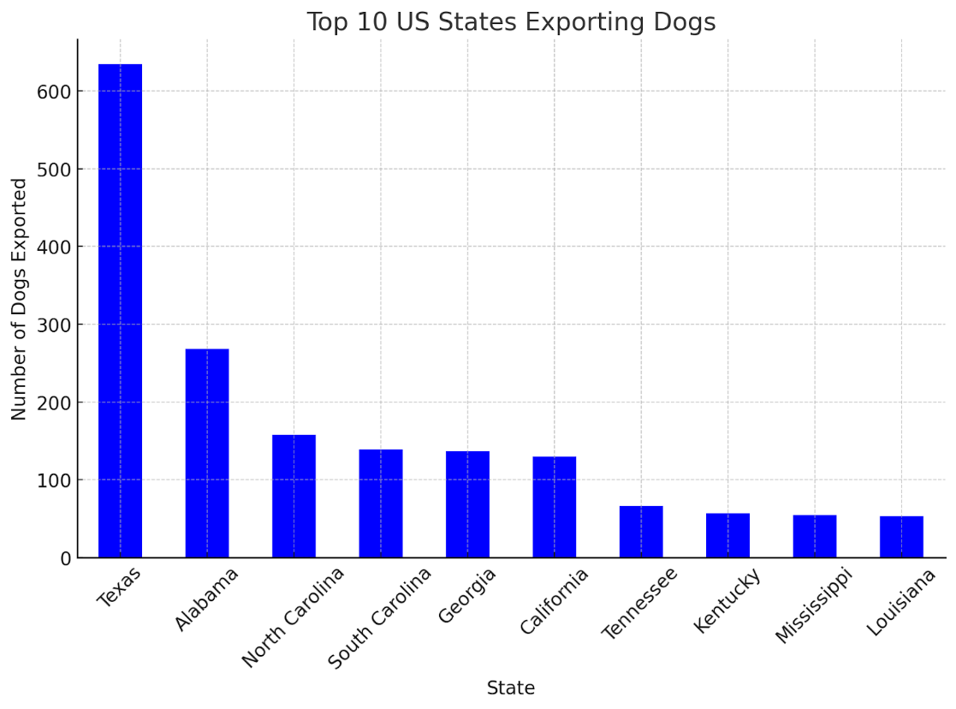

What insights or observations can you make from your data? Do you notice patterns or trends?

The data reveals significant trends in dog relocation and adoption patterns across the United States. Southern states like Texas, Alabama, and North Carolina are the primary exporters of dogs due to high shelter populations and lower local adoption rates. On the other hand, Northern states, including New York and Massachusetts, are top importers, having higher adoption demand and fewer stray animals. This "Southern-to-Northern pipeline" highlights the critical role of relocation programs in balancing shelter overcrowding and ensuring more dogs find homes. Younger dogs, mixed breeds, and those that are spayed or neutered have higher adoption rates, while senior dogs and less popular breeds, such as Pit Bulls, tend to wait longer for adoption.
Another key insight is the importance of environmental compatibility in adoption. Dogs compatible with children or other pets are more likely to be adopted, particularly in family-oriented areas. However, incomplete data on these traits suggests shelters could improve documentation to better match dogs with potential adopters. These trends emphasize the need for targeted campaigns, such as promoting senior dog adoptions, enhancing spay/neuter programs in high-export states, and expanding interstate relocation efforts. Together, these measures can save more lives and address the geographic disparities in shelter populations.

