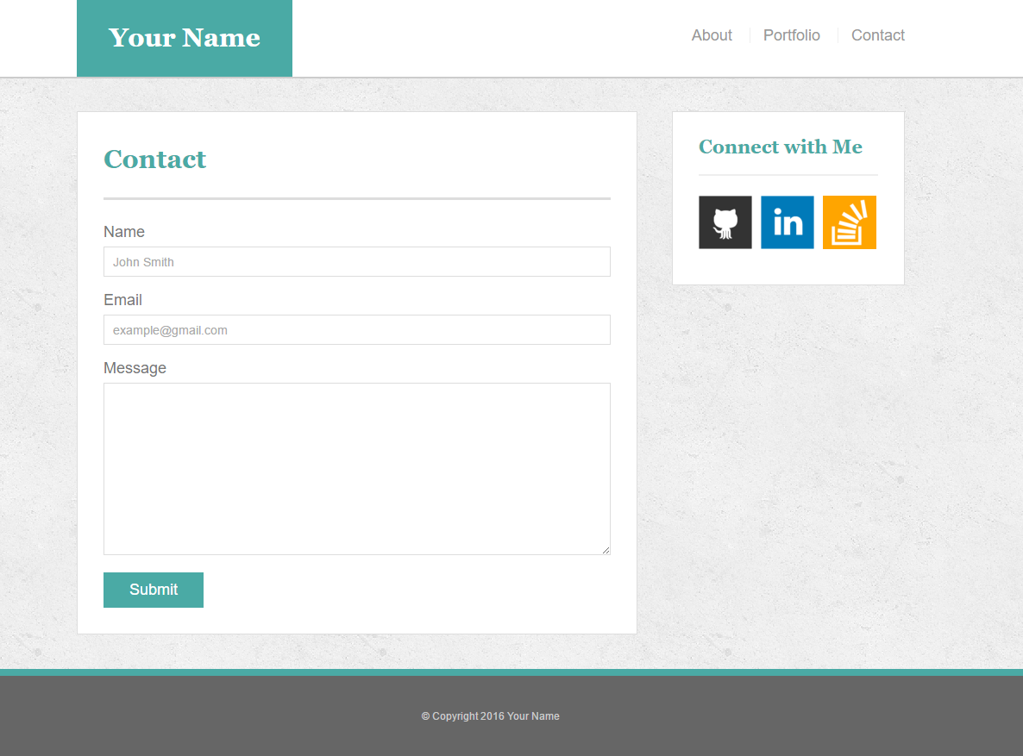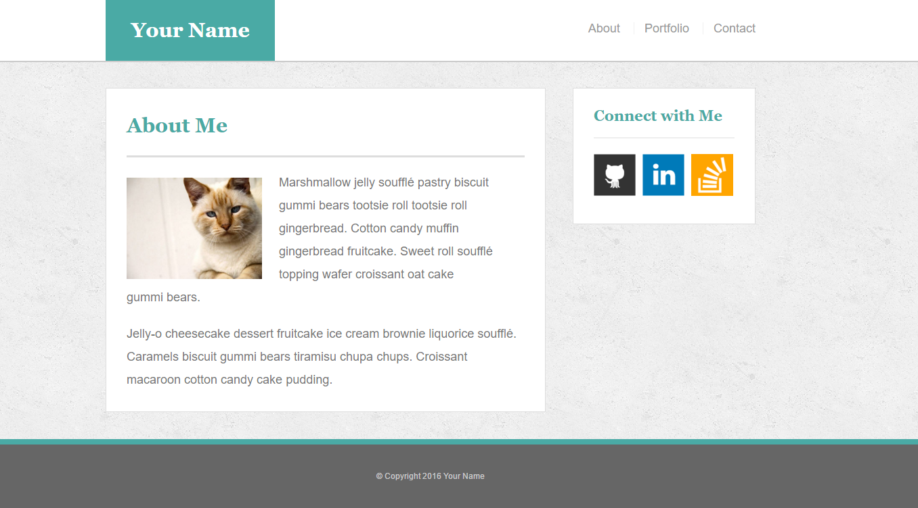

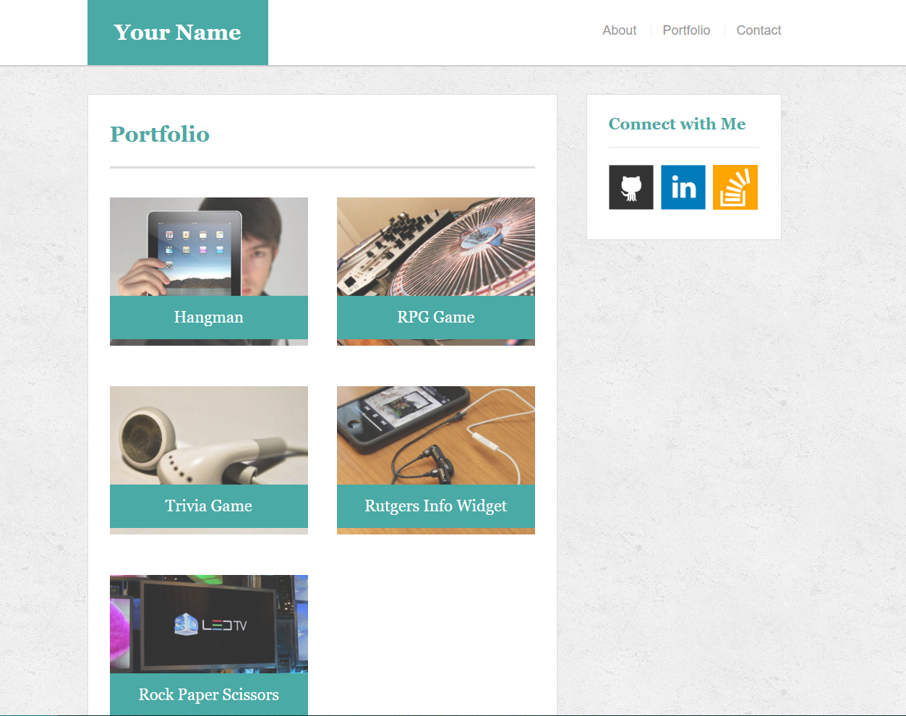

* **IMPORTANT** Your site's layout must match the designs in these screenshots. You'll find the specs for these designs below.

1. When you create a website, it's standard practice to code your HTML files before writing any CSS and to write up one HTML file before moving onto the next. Write your HTML semantically, too:

* If something is a heading, you use a heading tag.
* If something is a list, you use an unordered or ordered list tag.
* So on and so forth.

1. The content for the index.html should be unique to **you**.

* Write a paragraph or two about yourself. Make it fun, show your personality!
* The main logo where it says "Your Name" should say your name. This may make the logo section smaller or wider depending on how long your name is—that is fine and expected.
* Add, commit, and push your code to GitHub often, especially when you complete a page.

1. After all of your HTML is written, you can begin styling your pages using the style.css file you created.

* Be sure to [validate your html](https://validator.w3.org/#validate_by_input).
* Consult the specs below these instructions for advice on styling your CSS files.

1. Push your changes to Github.

**Additional Specifcations**

1. Colors *Pro-tip: Use the*[*Eye Dropper*](https://chrome.google.com/webstore/detail/eye-dropper/hmdcmlfkchdmnmnmheododdhjedfccka)*Chrome extension to find the colors used on web pages.*
   * Teal color (used for headings and backgrounds): #4aaaa5
   * Regular font color (used for paragraphs and all text besides the headings): #777777
   * Main header background color: #ffffff
   * Main header border color: #cccccc
   * Footer background color: #666666
   * Main content background color: #ffffff
   * Main content border color: #dddddd
2. Fonts:
   * For heading fonts use font-family: 'Georgia', Times, Times New Roman, serif;.
   * For all other fonts use 'Arial', 'Helvetica Neue', Helvetica, sans-serif;.
3. Profile Image Found on index.html:
   * Use a picture of yourself.
   * If you don't have a picture, you can grab a placeholder image from [LoremPixel](http://lorempixel.com/" \t "_blank). Save the images to your images folder.
4. Portfolio Images:
   * Placeholder images can be found at [LoremPixel](http://lorempixel.com/" \t "_blank).
   * Save the images to your images folder.
5. Social Link Images (Github, LinkedIn, StackOverflow, etc.):
   * These images can be found on [IconFinder](https://www.iconfinder.com/" \t "_blank).
   * Save the images to your images folder.
   * Ensure that these icons are live links to your GitHub, LinkedIn, and Stack Overflow profiles.
6. Background Images:
   * The background pattern used was found on [Subtle Patterns](https://subtlepatterns.com/). You can browse through that site and find whichever pattern you like.
7. Dimensions:
   * The entire content area is 960px wide.
   * The main section content is 650px wide.
   * The sidebar is 270px wide.
   * Pro-tip: Use the [Page Ruler](https://chrome.google.com/webstore/detail/page-ruler/jlpkojjdgbllmedoapgfodplfhcbnbpn/related?hl=en) extension to measure the size of elements.