Q2: Hysteresis and Management

Colin Dassow and Chelsey Nieman

7/17/2020

# Abstract

# Introduction

Recreational angling has a major impact on the ecology of freshwater ecosystems and is likely to structure community dynamics through selective harvest of certain individuals and species from the system (**???**). In recognition of the impact anglers have on freshwater fish communities, ecosystem-based management, adaptive management, and safe operating spaces have all been invoked in an effort to better manage freshwater resources. In order to successfully manage fish populations, management must account for the intricate dyanmics of multiple species that are targeted in recretaional fishing (**???**). A central theme of these strategies is a holistic view of the ecosystems we manage and a rejection of single species management strategies applied broadly in favor of flexibility that allows managers to consider the full context of the systems they work in and tailor their actions appropriately (**???**).

Regime shifts are likely to have drastic impacts on aquatic systems and the recreational fisheries that rely on these systems. Increasingly, efforts have been made to incorporate ecosystem states and regime shifts into fisheries management (**???**). Current work to incorporate ecosystem-based management has focused on ecosystem change, such as climate change, and management strategies to maintain stable states of a system in light of ecosystem change (Liu et al. 2015). Management of ecologically driven regime shifts tend to focus on identifying the underlying cause of change, and, in many cases, adapting to those changes **citation** or mitigating the effects of those changes through increased systemic resilience **citation**. While increased resilience has been shown to decrease the likelihood of rapid shifts in the stable state of a system (**???**), many of these regime shifts are initiated by drivers that are not ecologically-driven. One such driver, harvest driven regime shifts, are of particular interest in fisheries systems (Steele 1996; Rothschild and Shannon 2004).

Harvest driven regime shifts in fisheries have been studied in commercial and marine fisheries when ecosystem-based management has been implemented (Oken and Essington 2016; Essington et al. 2015). The recognition of the role interspecific interaction between species, and the hysteretic behavior that follows, has helped foster the adoption of ecosystem-based management (Walters and Kitchell 2001; Blackwood, Hastings, and Mumby 2012). Crowder et al. (2008) has explored the simultaneous impacts of multiple fished species on marine systems. This type of ecosystem-based management plays an import role in maintaining a desired stable state, often in the form of a specific fish community structure. This stands in contrast to more traditional management decisions which take a linear view of the system (e.g. fish population is over exploited so managers reduce mortality or stock in response). Instances where these simple solutions have had no effect, or even a negative effect, are abundant and demonstrate a need to consider alternative stable states and the hysteretic behavior that is often present in the complex aquatic communities we study (Pine et al. 2009).

One of the commonly hypothesized reasons for these counterintuitive responses to management actions was formalized as ‘cultivation-depensation’ effects by Walters and Kitchell (2001). They describe how intraguild predation can lead to alternative, self-reinforcing, states that can be transitioned between through the intensity of harvest on the adults of the top predator species which is an intraguild predator with the forage fish species. Cultivation-depensation mechanisms have been empirically demonstrated in marine fisheries resulting in alternative stable states, thereby reducing the ability for recovery of some exploited species (**???**). In freshwater systems however, there has been limited focus on the effects of harvesting multiple interacting species and the consequences it has for maintaining a desire stable state in the system. The hysteretic behaviors of many freshwater communities have, to date, focused on ‘trophic triangle’ models where a single harvested species is an intraguild predator with second species that is not part of the fishery, while in reality most freshwater systems are home to multiple harvested fish species which often interact with each other (Walters and Kitchell 2001; Biggs, Carpenter, and Brock 2009).

We expand on a model presented in Biggs, Carpenter, and Brock (2009) and present here a two species, stage structured, fisheries model. In keeping with the tenets of ecosystem-based management our model moves away from a single harvested species management scenario and towards a more realistic system where multiple harvested sportfish species compete with each other. The outcome of this competition both affects and is affected by the effects of humans on the ecosystem through fishing activities (*I’m not sure if we want to limit this to just fishing or also thing about shoreline development, climate change as human effects too*). Adults and juveniles of both species compete with each other and are simultaneously harvested, but to different degrees. We parameterize this model to represent the largemouth bass (*Micropterus salmoides*) (*or should this be all centrarchids?*) and walleye (*Sander vitreus*) competitive interaction in north temperate lakes. This model is unique in that it looks at hysteresis and management in (1) a freshwater system, and (2) a multispecies system where both species are sport fish targeted by anglers. The goals of our modeling exercises are to (1) understand the role hysteresis plays in both the type and magnitude of management responses necessary to maintain a system in a desired configuration, and (2) to investigate the role management responses can play in reverting to an alternative configuration. We accomplish this by modeling species-specific responses to regulations and stocking in a system where hysteresis is present or absent. We perform those model experiments in systems where the manager’s goal is to either maintain a desired stable state or push the system to a desired stable state from an undesired one.

# Methods

## Base model

We used a stage structured, fishery model from Biggs, Carpenter, and Brock (2009). Their original model contained trophic triangle dynamics between a harvested sport fish with juvenile and adult stages, and a single stage planktivore fish that was not part of the fishery. The model also contains basic foraging arena dynamics where juvenile sportfish and planktivores move between the foraging arena and refuge. In this model adult sportfish can prey upon their own juveniles and planktivores when they are in the foraging arena. Planktivores can prey on juvenile sportfish in both the refuge and the foraging arena. Harvest rate and the amount of refuge available to fish are both externally controlled.

We modified this model by replacing the single stage planktivore with a second two-stage sport fish species. Adults of both species can predate on their own juveniles and juveniles of the opposite species when juveniles are present in the foraging arena. Juveniles of both species compete with each other for resources as well. Here too, harvest rate and the amount of refuge available to fish are both externally controlled. Our model is set up as a series of differential equations where adults are removed through catch and subsequent harvest ($−qE_{1}A_{1}$) and natural mortality ($s_{1}−1$). New adults are produced by juveniles maturing at a constant rate($s_{1}J_{1}$). As an example we provide the equations for species 1 adults ($A_{1}$) and juveniles ($J_{1}$). The equations for species 2 are identical with reversed subscripts.

$$\frac{dA_{1}}{dt}=−qE_{1}A_{1}+(s_{1}−1)A_{1}+s_{1}J_{1}$$

$$\frac{dJ_{1}}{dt}=−c_{J_{1},A_{1}}J_{1}A_{1}−c_{J_{1},J_{2}}J_{1}J_{2}−\frac{c_{J_{1},A_{2}}v_{1}J_{1}A_{2}}{h_{1}+v_{1}+c_{J_{1},A_{2}}}+f_{1}A_{1}+ϵ_{1}$$

The model displays hysteretic behavior typical of systems were competing species have limited more strongly by each other than by themselves. This manifests itself in what is typically called a ‘priority effect’ where the initial abundance is all the determines which species dominates. Here, the more abundant species is able to cultivate conditions for itself through predation on and competition with juveniles of the opposite species. The equilibrium abundances of the two competing species will depend on both the strength of harvest on each species and the strength of their effects on each other. When the species limit themselves more than they limit each other there is only one stable equilibrium point and hysteresis is gone from the system.

## Simulations

Simulations were run using the ‘deSolve’ package in R (**???**; **???**). We varied management measures of stocking and harvest rate within the system in order to understand the impact of management on the maintenance of alternate stable states. Stocking as included in our version of the Biggs, Carpenter, and Brock (2009, 2009) model through the term $+ϵ$. Stocking takes the form of a yearly addition of a number juveniles to the system. Harvest rate control in our model is done through setting harvest rate to a given level (*Note to us: this results in a proportion of the population removed each time step, at smaller pop size fewer fish are removed and vis versa*). This can be set as a constant level across time or can be allowed to vary between years. Similarly, stocking of juveniles by managers can be held constant through time or allowed to vary through time. A third management option which we do not address here is through improvements in refuge ($h$) availability leading to increased juvenile survival. Simulation were run in order to look at the magnitude of management intervention necessary to maintain or alter the state of a system.

Paramater Values

|  |  |
| --- | --- |
|  | Value |
| s1 | 0.100 |
| cJ1A1 | 0.002 |
| cJ1A2 | 0.500 |
| cJ1J2 | 0.003 |
| v1 | 1.000 |
| f1 | 2.000 |
| s2 | 0.100 |
| cJ2A2 | 0.002 |
| cJ2A1 | 0.500 |
| cJ2J1 | 0.003 |
| v2 | 1.000 |
| f2 | 2.000 |

# Results

### Base Model Behavior

This model shows the presence of alternative stable states (Figure 1) occuring with dominance of species 1 and species 2 based on initial conditions. When initial abundance of species 1 is high and species 2 is low, low harvest will maintain high abundance of species 1 and low abundance of species 2 (when harvest of species 2 remains constant). At high harvest of species 1, eventually the model results in functional extinction of species 1, while maintaining a moderate abundance of species 2. However, when we alternate these (species 2 is initially dominant), we find that even low levels of harvest of species 1 result in functional extinction of species 1, and maintentance of species 2 (again with harvest of species 2 remaining constant).

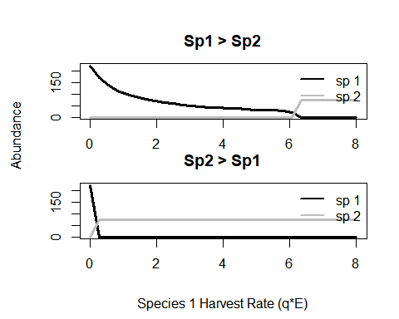

Figure 1. Model run to equilibrium over a range of harvest parameters, no stocking. Top panel shows equilibrium abundances for the range of harvests when species 1 is initially dominant. Bottom panel shows equilibrium abundances for the range of harvests when species 2 is initially dominant.

### Impact of stocking on system dynamics

At low levels of stocking of Species 1, increased harvest resulted in dominance of Species 2. However, when stocking was increased, dominance of Species 1 also increased (Figure 2). In model simulations in which Species 1 initially dominated in the system, low levels of stocking were all that were necessary to maintain the stable state of Species 1 dominance. Here, we found hysteresis resulted in increased likelihood that Species 2 would dominate the system at low levels of stocking. In systems in which Species 2 initially dominated, we found that low levels of stocking were not enough to result in an alternative stable state in which Species 1 dominates. In these systems, we found that the presence of hysteresis resulted in higher levels of stocking necessary in order to result in that shift in stable state. These results indicate that in order to manipulate the stable state of a system, it may be necessary to increase the magnitude of the stocking intervention.

### Impact of Managment on system dyanmics

* optimal strategy and magnitude
* influence of hysteresis

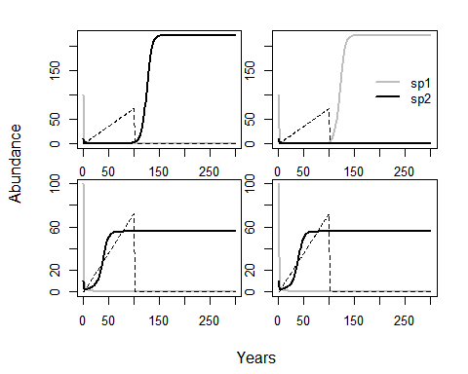

Figure 3. Top row of figures show effect of management response in a system where hysteresis is considered. Bottom row shows effect of management without hysteresis. The left column is for a scenario where the goal is to flip the state from sp1 to sp2 dominating at equilibrium. The right column is for a scenario where the goal is to maintain the system in a state where sp1 dominates at equilibrium.

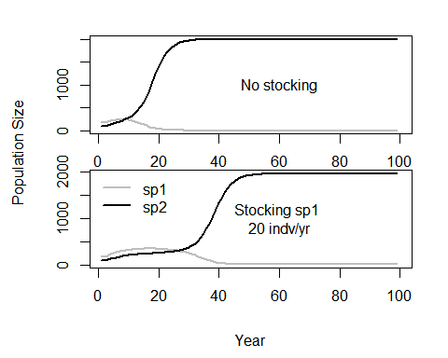

Figure 4. Top panel shows a switch in dominant species in a scenario with no stocking. Bottom panel shows the effect of stocking at delaying the transition. For both model runs, no harvest just slow declines in refuge. Both species experience a decline in refuge availability but for sp1 the decline is more significant while sp2 experiences less of a decline.

### Optimal Strategies/management and stocking

When we model the combination of stocking and harvest control on the system, we find evidence that taking into account the hysteretic behavior of these systems dramatically alters what management actions are necessary to either keep a system in a desired state (Fig 2. a & c) or flip a system into a desirable state (Fig 2. b & d).

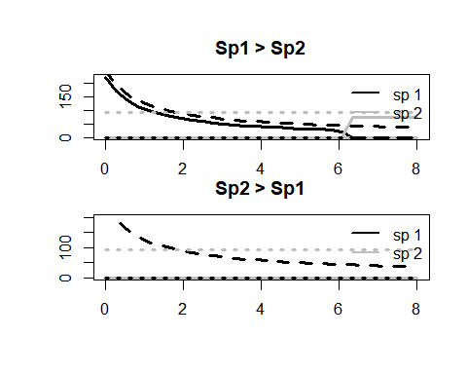

Figure X. System dynamics over a range of management interventions, including both stocking and harvest. Solid lines indicate no stocking, long dashes indicate stocking of species 1, short dashes indicate stocking of species 2.

# Discussion

Here, we found evidence that the hysteretic behavior that characterizes the transition between states plays an important role in determining what level of management action is necessary to acheive a manager’s goals. Our models which include and exclude hysteresis generally show that when we assme those dynamics are absent from the system we will underestimate the magnitude of action necessary to either maintain or flip a system. These results highlight the importance of understanding the ecological interactions of fishes in a multispecies fishery. Further, our results indicate the importance of ecosystem-based multi-species management in systems where multiple species are targeted by recreational anglers.

Impact of hysteresis in our model  
How timing of management and stocking are important factors to consider.  
extrapolate to freshwater fish dynamics  
* How our model is/is not a good representation of freshwater systems + Right now the parameter values, abundances, harvest and stocking rates, etc. are pretty abstract. We can still do more to ground this. + The effect of refuge on model dynamics isn’t as strong as the effect of stocking or harvesting, maybe we should’ve expected this? * What is missing from our model.  
+ Fishing effort is controlled externally, it’s not responsive to changes in catch rate. It’s maybe not important to add in just to note that the model is set up this way (in q3 we change this and allow effort to respond to abundance within the model)

Optimal Management Strategies  
* What did we learn from comparing stocking and controlling harvest?  
* Management implications - do we use models like this to identify ‘Early Warning Signs’ of potential regime shift? (**???**).

How can this be used by managers  
* Strategies for maintaining a desired stable state

Future work  
* Ground truth this model with empirical data  
* Think about how angler dynamics can impact fisheries outcomes  
*I’m just adding these to show that the need to understand these is there (and to put a plug for our other two papers)*  
Conclusions

# References

# Supplemental

# Figure graveyard

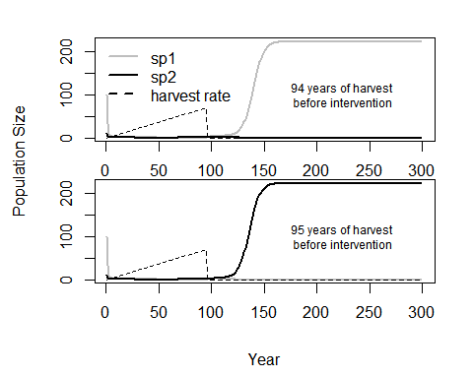

Figure 2. Temporal influence of management interventions. Intervention to stop harvest one year too late can allow for regime shift to undesired state

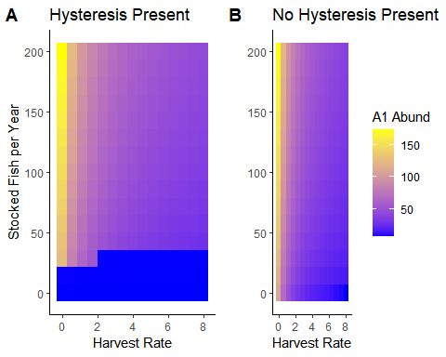

Figure 3. Effect of stocking at different harvest rates. (a) with hysteresis, (b) without hysteresis

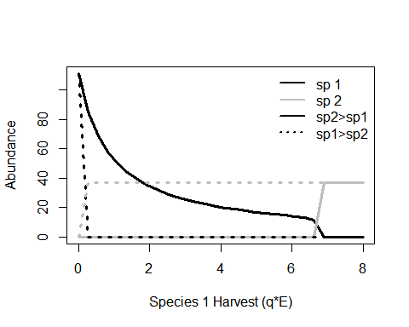

Figure 1. Basic model behavior. When species are equal in all interactions, alternate stable states can be produced by through harvest. The stable state will depend on the combination of harvest rate and the species with the higher initial abundance.

Biggs, Reinette, Stephen R. Carpenter, and William A. Brock. 2009. “Turning Back from the Brink: Detecting an Impending Regime Shift in Time to Avert It.” *Proceedings of the National Academy of Sciences* 106 (3): 826–31. <https://doi.org/10.1073/pnas.0811729106>.

Blackwood, Julie C., Alan Hastings, and Peter J. Mumby. 2012. “The Effect of Fishing on Hysteresis in Caribbean Coral Reefs.” *Theoretical Ecology* 5 (1): 105–14. <https://doi.org/10.1007/s12080-010-0102-0>.

Crowder, Larry B., Elliott L. Hazen, Naomi Avissar, Rhema Bjorkland, Catherine Latanich, and Matthew B. Ogburn. 2008. “The Impacts of Fisheries on Marine Ecosystems and the Transition to Ecosystem-Based Management.” *Annual Review of Ecology, Evolution, and Systematics* 39 (1): 259–78. <https://doi.org/10.1146/annurev.ecolsys.39.110707.173406>.

Essington, Timothy E, Marissa L Baskett, James N Sanchirico, and Carl Walters. 2015. “A Novel Model of Predator-Prey Interactions Reveals the Sensitivity of Forage Fish: Piscivore Fishery Trade-Off to Ecological Conditions.” *ICES Journal of Marine Science* 72 (5): 1349–58. <https://doi.org/doi:10.1093/icesjms/fsu242>.

Liu, Junguo, Giri Kattel, Hans Peter H. Arp, and Hong Yang. 2015. “Towards Threshold-Based Management of Freshwater Ecosystems in the Context of Climate Change.” *Ecological Modelling*, Ecological management for human-dominated urban and regional ecosystems, 318 (December): 265–74. <https://doi.org/10.1016/j.ecolmodel.2014.09.010>.

Oken, Kiva L, and Timothy E Essington. 2016. “Evaluating the Effect of a Selective Piscivore Fishery on Rockfish Recovery Within Marine Protected Areas.” *ICES Journal of Marine Science* 73 (9): 2267–77. [https://doi.org/doi:10.1093/icesjms/fsw074 Original](https://doi.org/doi:10.1093/icesjms/fsw074%20Original).

Pine, William E., Steven J. D. Martell, Carl J. Walters, and James F. Kitchell. 2009. “Counterintuitive Responses of Fish Populations to Management Actions.” *Fisheries* 34 (4): 165–80. <https://doi.org/10.1577/1548-8446-34.4.165>.

Rothschild, B. J., and L. J. Shannon. 2004. “Regime Shifts and Fishery Management.” *Progress in Oceanography*, Regime shifts in the ocean. Reconciling observations and theory, 60 (2): 397–402. <https://doi.org/10.1016/j.pocean.2004.02.010>.

Steele, John H. 1996. “Regime Shifts in Fisheries Management.” *Fisheries Research* 25 (1): 19–23. <https://doi.org/10.1016/0165-7836(95)00440-8>.

Walters, Carl, and James F Kitchell. 2001. “Cultivation/Depensation Effects on Juvenile Survival and Recruitment: Implications for the Theory of Fishing.” *Canadian Journal of Fisheries and Aquatic Sciences* 58 (1): 39–50. <https://doi.org/10.1139/f00-160>.