**Supplementary Information**

Table S1. Descriptions of model experiments and key parameter values. Unless noted all other parameter values are as listed in Table 1 of the manuscript.

|  |  |  |
| --- | --- | --- |
| **Model Experiment** | **Description** | **Parameters Changed** |
| Leveraging Interactions Experiment | How to outcomes differ across a range of species 1 harvest and stocking levels either with or without harvest of species 2. | $k_{1}$ range 0 to 4000 $qE_{1}$ 0 to 8 $qE_{2}$ 0 or 2 respectively |
| Alternative Approaches Experiment | Managers may achieve the same outcome through managing the focal species only or both interacting species. We compare outcomes across a range of species 1 stocking and species 2 harvest combinations at 3 different levels of species 1 harvest. | $k_{1}$ range 0 to 4000 $qE_{2}$ 0 to 8 $qE_{1}$ 0 or 2 respectively |
| Safe Operating Space Experiment | Given a slow moving change that is outside managerial control, can we use the tools at our disposal to keep the system in the safe operating space where the desired stable state is maintained. | Panel A: fecundity declines to 1% of its initial value over 100 years  Panel B: Fecundity declines as above, $qE_{2}$ = 2  Panel C: Fecundity declines as above, $k_{1}$**=** 15  Panel D: Fecundity declines as above, $k_{1}$**=** 15, and $qE_{2}$ = 2 |

Increases in harvest can drive regime shifts.

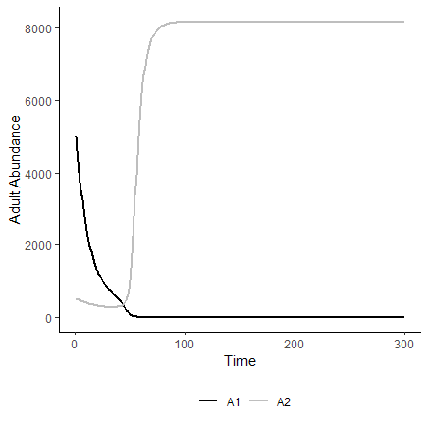

Figure S1. Increases in harvest over time can drive a regime shift in our system.

Model dynamics for scenarios where the manager’s goal is to flip the system from species 2 to species 1 are similar to the maintain scenarios presented in the main text (Fig 2 and S3). The magnitude of management action necessary to achieve the desired outcome (species 1 dominance) is larger in the flip scenario in order to overcome the initial dominance of species 2.

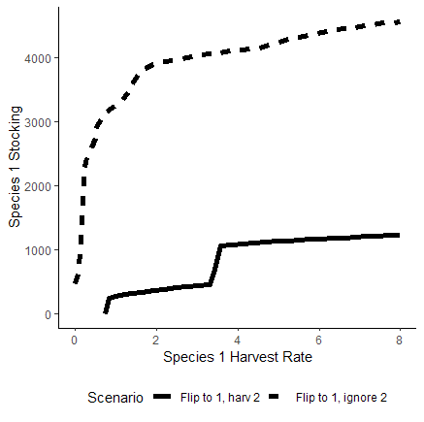

Figure S2. Isoclines here separate different outcomes for two management approaches. Species 1 dominates in areas above the line. Areas below the isoclines represent outcomes where species 2 dominates. In this model experiment, species 2 is initially dominant and the management goal is to flip the system towards species 1. Solid line separates outcomes when the manager considers species interactions, while the dashed line separates outcomes where the manager only manages species 1.

Tradeoffs in managing species 1 or its competitor allow similar outcomes to be achieved through different actions. The magnitude of action necessary to flip the system towards species 1 increases as harvest of species 1 increases.

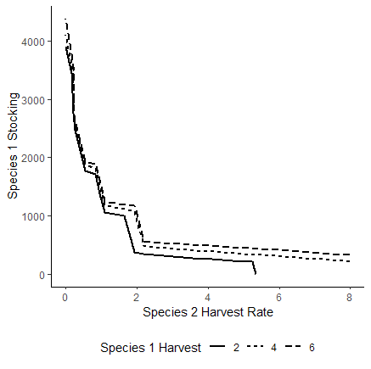

Figure S3. Stocking of species 1 and harvest of species 2 can, on their own, result in flipping to the desired stable state of a system (species 1 dominance). Tradeoff between stocking and competitor harvest are presented for various levels of harvest on species 1 (solid and dashed lines). Areas above/to the right of the lines represent positive outcomes (species 1 dominance), areas below/to the left represent maintenance of species 2 dominance. The negative relationship between stocking species 1 and harvesting species 2 allows managers to achieve similar outcomes through implementation of either strategy or a combination of both.

Sensitivity Analysis

Here we systematically vary juvenile survival $s$, adult natural mortality $m$, cannibalism $c_{j_{1},a_{1}}$, predation by adult $c_{j_{1},a_{2}}$, juvenile competition $c_{j_{1},j_{2}}$, and fecundity (Beverton - Holt parameters $a$ and $b$) to see how the effect the occurence of stabe states. We varied only values for species 1 and did not vary any of these parms in combination with each other, only in isolation. Parameter values were varied between 1% and 200% of their typical value and simulations were run with either species as the initially dominant species.

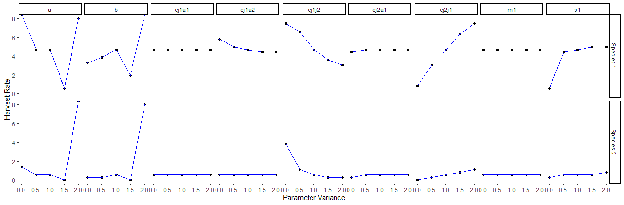

Figure 4. Sensitivity of alternative stable state tipping points to variation in model parameters. The harvest level where the system transitioned to an alternate stable state is plotted against variation in parameter value that ranged from 1% to 200% of the original value. This was conducted for situations when species 1 was initially dominant (top row) and when species 2 (bottom row) was initially dominant.