**Supplementary Information**

Table S1. Descriptions of model experiments and key parameter values. Unless noted all other parameter values are as listed in Table 1 of the manuscript.

|  |  |  |
| --- | --- | --- |
| **Model Experiment** | **Description** | **Parameters Changed** |
| Leveraging Interactions Experiment | How to outcomes differ across a range of species 1 harvest and stocking levels either with or without harvest of species 2. | $k_{1}$ range 0 to 4000 $qE_{1}$ 0 to 8 $qE_{2}$ 0 or 2 respectively |
| Alternative Approaches Experiment | Managers may achieve the same outcome through managing the focal species only or both interacting species. We compare outcomes across a range of species 1 stocking and species 2 harvest combinations at 3 different levels of species 1 harvest. | $k_{1}$ range 0 to 4000 $qE_{2}$ 0 to 8 $qE_{1}$ 0 or 2 respectively |
| Safe Operating Space Experiment | Given a slow moving change that is outside managerial control, can we use the tools at our disposal to keep the system in the safe operating space where the desired stable state is maintained. | Panel A: fecundity declines to 1% of its initial value over 100 years  Panel B: Fecundity declines as above, $qE_{2}$ = 2  Panel C: Fecundity declines as above, $k_{1}$**=** 15  Panel D: Fecundity declines as above, $k_{1}$**=** 15, and $qE_{2}$ = 2 |

Increases in harvest can drive regime shifts.

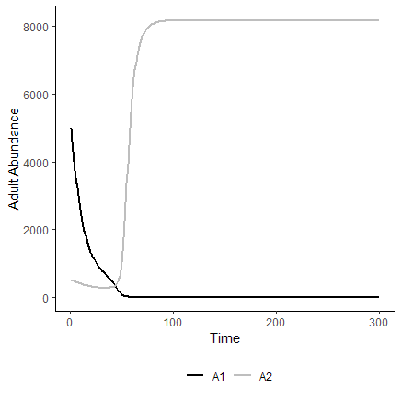

Figure S1. Increases in harvest over time can drive a regime shift in our system.

Model dynamics for scenarios where the manager’s goal is to flip the system from species 2 to species 1 are similar to the maintain scenarios presented in the main text (Fig 2 and S3). The magnitude of management action necessary to achieve the desired outcome (species 1 dominance) is larger in the flip scenario in order to overcome the initial dominance of species 2.

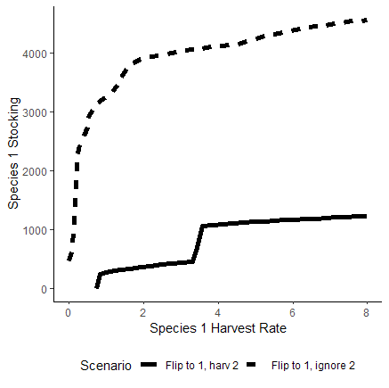

Figure S3. Isoclines here separate different outcomes for two management approaches. Species 1 dominates in areas above the line. Areas below the isoclines represent outcomes where species 2 dominates. In this model experiment, species 2 is initially dominant and the management goal is to flip the system towards species 1. Solid line separates outcomes when the manager considers species interactions, while the dashed line separates outcomes where the manager only manages species 1.

Tradeoffs in managing species 1 or its competitor allow similar outcomes to be achieved through different actions. The magnitude of action necessary to flip the system towards species 1 increases as harvest of species 1 increases.

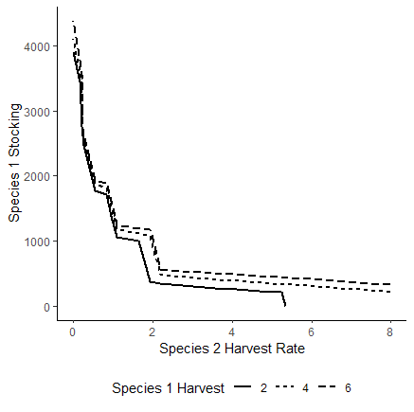

Figure S4. Stocking of species 1 and harvest of species 2 can, on their own, result in flipping to the desired stable state of a system (species 1 dominance). Tradeoff between stocking and competitor harvest are presented for various levels of harvest on species 1 (solid and dashed lines). Areas above/to the right of the lines represent positive outcomes (species 1 dominance), areas below/to the left represent maintenance of species 2 dominance. The negative relationship between stocking species 1 and harvesting species 2 allows managers to achieve similar outcomes through implementation of either strategy or a combination of both.

Sensitivity Analysis

Here we systematically vary juvenile survival $s$, adult natural mortality $m$, cannibalism $c_{j_{1},a_{1}}$, predation by adult $c_{j_{1},a_{2}}$, juvenile competition $c_{j_{1},j_{2}}$, and fecundity (Ricker parameters $a$ and $b$) to see how the effect the occurence of stabe states. We varied only values for species 1 and did not vary any of these parms in combination with each other, only in isolation.

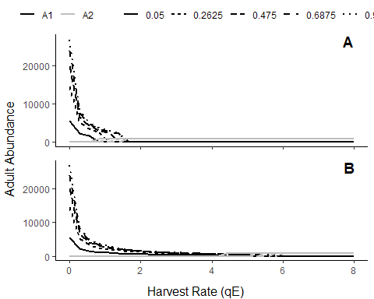

Figure S5. Juvenile Survival rate. Alternate stable states persist for different values, except the lowest value and only when species 2 is initially dominant (0.05). The range of harvest values over which alternate states occur increases as juvenile survival increases. Panel A - species 2 initially dominant; Panel B - species 1 initially dominant.

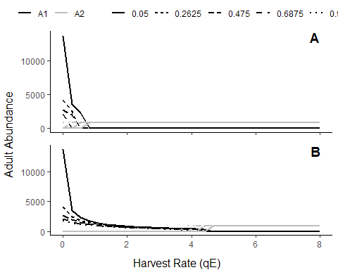

Figure S. Adult natural mortality rate. Alternate stable states persist for all values. The range of harvest values over which alternate states occur decreases as adult natural mortality decreases. In other words, as fewer adults die annually more harvest can occur on species 1 while still allowing it to dominate (panel A). Panel A - species 2 initially dominant; Panel B - species 1 initially dominant.

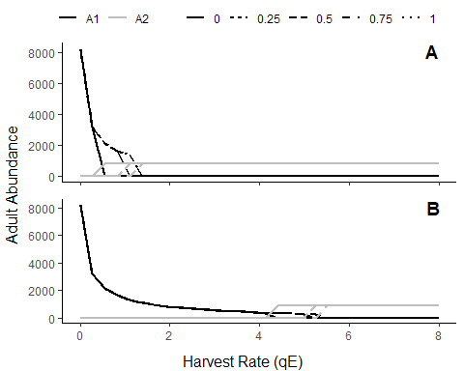

Figure S. Species 1 adult predation on species 2 juveniles. Alternate stable states persist for all values except when species 2 is dominant and Adults of species 1 have no effect on species 2 juveniles (0). As the effects of species 1 adults on species 2 juveniles increases the range of harvest values over which alternate stable states occur shifts right (i.e. more harvest can be tolerated before the system flips). Panel A - species 2 initially dominant; Panel B - species 1 initially dominant.

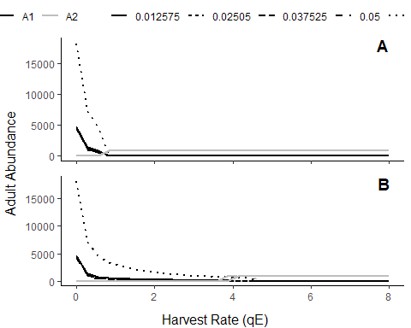

Figure S8. Species 1 cannibalism rate. Alternate stable states persist for all values. When little cannibalism occurs (0.0001) more harvest can be tolerated, and vice versa when more cannibalism occurs. Most cannibalism rates result in roughly the same flipping points. Panel A - species 2 initially dominant; Panel B - species 1 initially dominant.

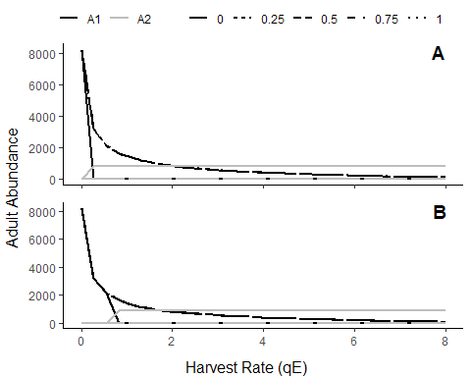

Figure S9. Effect of J1 on J2. Alternate stable states do not persist for all values. This parameter has a large effect on whether or not alternate states exist and when the flipping point is crossed. Panel A - species 2 initially dominant; Panel B - species 1 initially dominant.

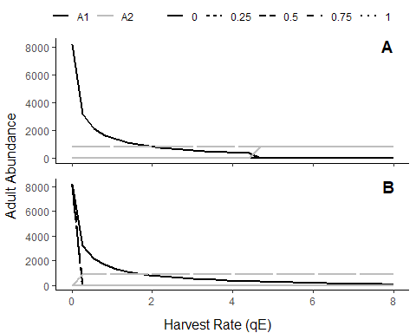

Figure S. Effect of J2 on J1. Alternate stable states do not persist for all values. This parameter has a large effect on if alternate states exist and when the flipping point is crossed. Panel A - species 2 initially dominant; Panel B - species 1 initially dominant.

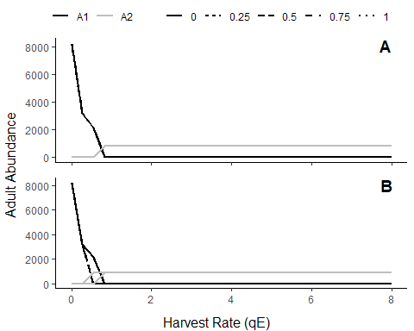

Figure S. Effect of A2 predation on J1. Alternate stable states persist across all values. As the effect of A2 on J1 decreases more harvest of species 1 can be tolerated before the system flips. Panel A - species 2 initially dominant; Panel B - species 1 initially dominant.

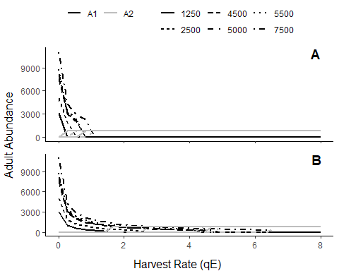

Figure S. Effect varying Beverton-Holt parameter ‘a’ - max number of recruit produced. Alternate stable states persist across all values except the very lowest ‘a’ value (1250) and only when species 2 is initially dominant (panel A). Parameter ‘a’ has a larger effect on when flipping happens in panel B; where species 1 is initially dominant. Panel A - species 2 initially dominant; Panel B - species 1 initially dominant.

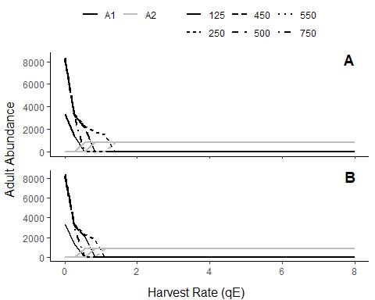

Figure S. Effect varying Beverton-Holt parameter ‘b’- stock size to produce .5 of A. Alternate stable states persist across all values. Seems to be a large effect of this parameter in either scenario (panel A or B). No general trend here because of the nonlinear effect of Beverton-Holt parameter ‘b’ on recruitment for a given abundance. Panel A - species 2 initially dominant; Panel B - species 1 initially dominant.