New Look Q2

Colin Dassow and Chelsey Neiman

10/15/2020

## What’s New

Chelsey and I have reworked the intro and updated the figures. We’ve been rotating between you, Stuart, and Greg on feedback. We’re still focused on higher level things, paragraph order, baby-werewolf-silver bullet. Looking to hear what you think about the intro and figures.

A couple things we’re still working on that aren’t reflected in here: * We’re working to ground model parmameters in reality a bit more so things like a harvest rate of .8 or stocking 100 fish mean something tangible + We’re working on quantifying the cost of stocking using data from Greg + Making stocking in our model mimic WDNR stocking strategies * I want to talk some about the tradeoff between angler satisfaction and cost to maintain a fishery. Fishing for either species produces some satisfaction, maybe there’s an argument to made that the lower satisfaction returned from a bass fishery is still alright because it doesn’t cost as much to maintain and does still provide some value. This might be a good plug for q3, the paper Chelsey is leading which will go deeper into species preference, and angler hetergeneity ideas. * I talked with Greg 2 weeks ago and we discussed recruitment in our model. Currently it’s a linear process and I’m second guessing that now and wondering if we should have a non-linear function like B-H that allows for an upper limit on recruitment and recruitment compensation when adult abundance is low. I’m going to give that a try in the model and see where it goes. + I have this on the list of models to talk about at FishScapes meeting next week if we get to it.

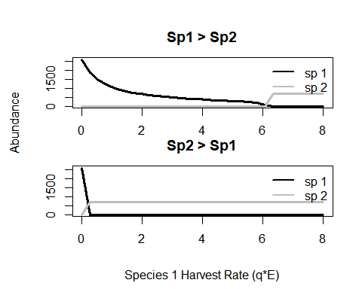

Figure 1. Model run to equilibrium over a range of harvest parameters for species 1, species 2 harvest is held constant at 1.8. No stocking. Top panel shows equilibrium abundances for the range of harvests when species 1 is initially dominant. Bottom panel shows equilibrium abundances for the range of harvests when species 2 is initially dominant.

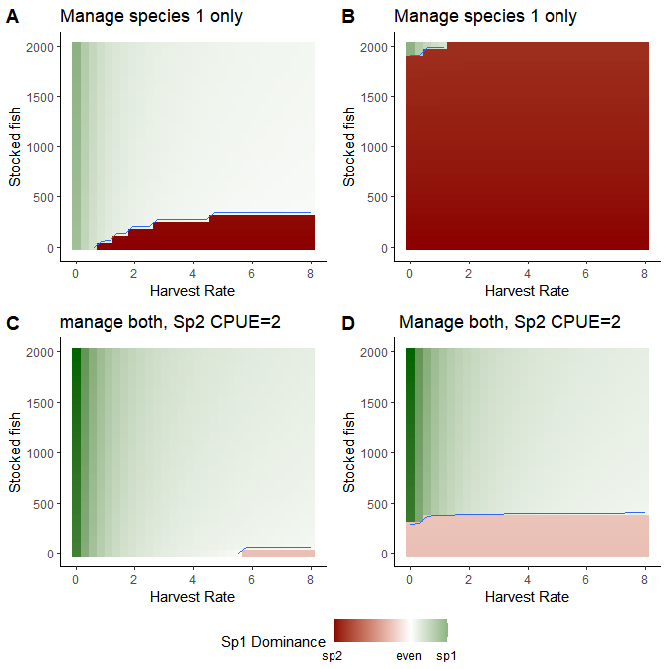

Figure 2. Effect of ‘multispecies’ thinking on either maintaining sp1 dominance (A&C) or flipping to a state where sp 1 dominates (B&D). This is described for systems where a manager managers only the focoal species (A&B) or both species (B&D). Green = sp1 >sp2, red = sp2 > sp1. Blue line marks boundary where sp1 > sp2 by at least 100 individuals. This is shown as an exmaple of what a manager may care about, not just that sp1 is a little more abundant than sp2 but that the diffferent meets some minimum requirement.

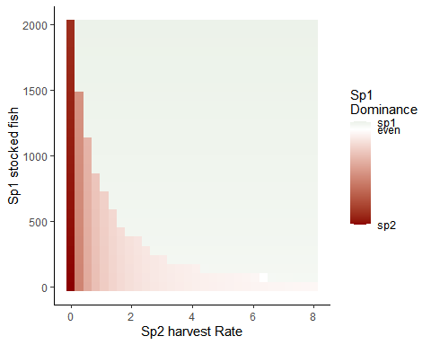

Figure 3. Differences between species 1 and 2 at equillibrium. Here managers can stock species 1 (y axis) or increase harvest on it’s predator (species 2, x axis). I was trying to show that adding harvest of sp2 in makes it much easier to reach management goals. I held sp1 harvest constant at 4. If you look at panel B from the previous figure you see that with no amount of stocking at a harvest of 4 should we be able to flip a system from sp2 to sp1 dominant. Here we see that if you add some harvest of sp2 in addition to stocking then you can stock less or stock just as much but tip the scales farther towards sp1. Not sure if this is the best way to vizualize this but it’s a start.

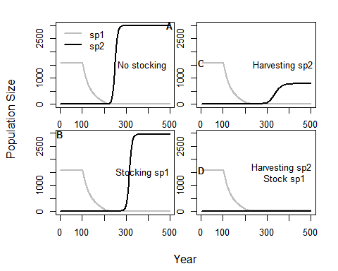

Figure 4. Delaying a transitions. Slow moving variable ’h’represents changing habitat availability which will inevitably flip system from sp1 dominated to sp2 (panel A). The flip in system state can be delayed through either stocking of the desired species (panel B), harvest of it’s competitior (panel C), or both (panel D).