Colin Dassow, Chelsey Nieman, Chris Solomon, Greg Sass, and Stuart Jones

11/5/2020

# Introduction

Interactions between species are often overlooked in natural resource management for simplification. However, as human influences on ecosystems continue to grow, so does the need to move from single species management to ecosystem-based management. Ecosystem-based management takes a holistic approach to managing natural resources that includes the interactions of humans within social-ecological systems. Ecosystem-based management can be difficult to implement due to the complex nature of social-ecological systems, where ecosystem services and states of interest are integrated within larger systems ranging across governance boundaries from local to international. Although ecosystem-based management implementation may be difficult, it is nevertheless warranted. Aquatic social-ecological systems, including fisheries, provide excellent examples to explore the difficulties of implementing ecosystem-based management. Counterintuitive responses by fish populations to management have shown that in many cases a linear, single-species focused view of these systems can lead managers to make decisions that, in hindsight, are ineffective or even detrimental to these systems (Walters et al. 2000; Hansen et al. 2015; Sass and Shaw 2020). In some situations, the stable state of a system may shift to an undesirable state as a result of these management actions, or an undesirable state may be reinforced despite well intentioned action by managers (Carpenter 2003; Carpenter et al. 2017).

In order to successfully manage freshwater fisheries, management action must be targeted and specific, which can be difficult in fisheries with complex ecosystem dynamics that do not always respond to management in a linear fashion. Pine et al. (2009) used several case studies to explore why predictions for ecosystem responses to management actions were not met in simple and complex systems. A central theme of these incorrect predictions was a failure to consider interactions between multiple species and life stages (Walters et al. 2000). In aquatic communities, species may be in competition and coupled with human influences, which can directly affect multiple species simultaneously. For example, human-induced climate change can result in altered ice cover regimes, thereby altering species interactions between Arctic char (*Salvelinus alpinus*) and brown trout (*Salmo trutta*), likely resulting in decreased Arctic char biomass and systems dominated by brown trout (Helland et al., 2011). Ultimately, through direct and indirect effects cascading interactions through the community, human disturbance in these systems is likely to affect all community members in various ways from direct harvesting of these species to changing environmental conditions leading to loss of habitat and food resources (Carpenter et al. 2017; Sass et al. 2017).

These complex intra- and inter-specific interactions in aquatic systems can result in positive feedback loops that allow a stable state to reinforce itself such that efforts by managers to change the stable state may have no or unintended effects. Walters and Kitchell (2001) described how positive feedback loops can create two stable states in a food web consisting of a top predator and a forage species through cultivation-depensation effects. Under low exploitation, the top predator species is abundant and able to cultivate conditions to increase survival of its juveniles by preying on the predators of its juveniles, namely the forage species. Alternatively, the forage species may dominate when exploitation of the top predator is high (as is the case in many fisheries), allowing the forage species to cultivate conditions for itself through predation on juveniles of the top predator. When top predator abundance declines enough, recruitment of new juveniles may be compromised through density-independent elevated mortality rates (in contrast to the commonly assumed density-dependent compensatory recruitment and elevated survivorship) (Liermann and Hilborn 1997; 2001; Carpenter 2003; Hilborn et al. 2014; Sass et al. ?). The positive feedback loops that enable cultivation-depensation effects demonstrate one mechanism by which aquatic systems may display non-linear dynamics. If the forage species has established itself as the dominant species, simply increasing the survival of adult predators (even through fishery closure) may have no effect or possibly a negative effect if the associated increase in juvenile production further increases foraging opportunities for the forage species and leads to further increases in their biomass with the increased prey availability. These dynamics allow the point at which the stable state changes to vary depending on which state the system is in. This potentially hysteretic behavior can make rehabilitating ecosystems particularly difficult, costly, and sometimes irreversible. For example, rehabilitating a collapsed fishery may not be accomplished simply through a reduction in fishing mortality past the point that caused the initial collapse (Walters and Kitchell 2001). Instead, drastic reductions in fishing mortality, coupled with stocking, and possibly habitat improvements may all be necessary to push the system out of its current stable state and back to the desired state if possible at all.

The non-linearity that can arise when dealing with inter-specific interactions, as demonstrated by cultivation-depensation theory, can lead to counterintuitive outcomes and pose a problem for managers who are often limited in the options available to them (Carpenter et al. 2017). Some variables, such as a changing climate, are outside of the direct control on managers (Carpenter et al. 2017), resulting in a limited number of ways that managers are able to influence the system. Considering this, Carpenter et al. (2017) laid out a conceptual framework where mangers aim to keep systems in a ‘safe operating space’ (SOS) using what they can control to compensate for forces outside their control, while still achieving positive outcomes. In the case of recreational fisheries, the ‘levers’ available to managers are often based on linear, single species views of system dynamics (i.e. a reduction in harvest of species ‘X’ will result in a proportional increase in their population size). When the levers available to mangers, and the lens through which they view the system, do not consider the complex intra- and inter-specific interactions, regime shifts can occur that are likely to have major implications for the ecology of the system and human users (Xu et al. 2014). For example, catch and release angling is often promoted to help rehabilitate populations experiencing unsustainable harvesting, to increase population size structure, and to improve trophy potential. However, unintended consequences of catch and release angling can result in density dependent effects on growth (decreased length and body condition) restructuring populations, often in opposition to angler and manager desires. Indeed, this effect has been documented in largemouth bass (*Micropterus salmoides*) and muskellunge (*Esox masquinongy*) (Gilbert and Sass 2016, Miranda et al. 2017, Sass and Shaw 2020, Hansen et al. 2015, Rypel et al. 2016). The recognition of the role of intra- and inter-specific and trophic interactions among species, and the hysteretic ecosystem-state behavior that may lead to unintended consequences, has helped foster the adoption of more ecosystem-based management strategies (Blackwood, Hastings, and Mumby 2012).

In fisheries, it is common to focus applied research on a single focal species, even when this species is embedded in a larger community where harvest of multiple species takes place (Hansen et al. 2015). The tradeoffs between competing management goals for several co-occurring species are often not considered; however, some notable exceptions do exist (Essington et al. 2015, Oken et al. 2016, others?). Essington et al. (2015) used competing objectives for a predator fishery (Atlantic cod, *Gadus morhua*) and a forage species fishery (Atlantic herring, *Clupea harengus*) to show how the ecological interactions between the two and the market price of each species combined to determine the appropriate level of mortality for each species given specific management goals (maximizing combined profit of both species at equilibrium). In contrast to commercial fisheries where users aim to maximize profit, recreational fishery users vary along multiple axes of species preference, catch rate, fish size, location, valuation, utility, avidity, and harvest opportunity. Users place differing levels of importance on each of these aspects of the fishing experience, leading to divergent, and in some cases, competing, desires by fishery users and ultimately complex management problems. Given the limited ways in which managers can influence recreational fisheries (i.e., fishing regulations, stocking, habitat alteration, valuation), understanding and leveraging ecological interactions allows managers to make the most of the limited tools at their disposal to keep systems within a safe operating space and to meet the diverse goals of users in the system (Carpenter et al. 2017).

Here, we use an example of a recreational fishery with two harvested species to explore how limited management levers and a linear, single species system view can lead to counterintuitive responses by fish populations to management intervention. We then show that the adoption of a non-linear approach that considers community interactions can improve outcomes and help maintain a system in the desired stable state or safe operating space. In keeping with the idea that species do not occur in isolation and should not be managed that way, we chose a simple fishery model that allows for the dynamics of multiple harvested species to occur. We use our model to explore how embracing the complexity of the system and leveraging ecological interactions can improve outcomes within a hypothetical recreational fishery. While here we evaluate the complexity in a two-species system, these concepts are important to assess at multiple levels of biological complexity. Our hypothesis that inter-specific interactions play an important role in determining the appropriate management action leads us to predict that consideration of non-linear dynamics arising from inter-specific interaction leads to more positive and predictable outcomes for managers. Outcomes that are of specific interest here include economic benefits, high angler satisfaction, and a stable state in which the desired species dominates.

# Methods

## Model

We modified a stage-structured food web model (Carpenter and Brock 2005, Carpenter et al. 2008, Biggs et al. 2009). The original model contained trophic triangle dynamics between a harvested sport fish with juvenile and adult stages, and a single-stage planktivorous fish not subjected to harvest. We modified this model to two stage-structured fish populations that are simultaneously harvested. The model contains basic foraging arena dynamics where juvenile sportfish move between the foraging arena and refuge. In our model, adult sportfish can prey upon their own juveniles and juveniles of the competing sportfish species when they are in the foraging arena. The population dynamics for the two species are identical. Unless noted, all parameters are constant through time.

### Adult Dynamics

Eq. 1

Eq. 2

Adults are produced through the maturation of juveniles at a constant rate or . Adults undergo natural mortality, and , and are harvested at rate and . Harvest rate can be either constant or time-dependent in our model.

### Juvenile Dynamics

Eq. 3

Eq. 4

Juveniles are produced through density-dependent recruitment based on Ricker stock-recruitment relationships. Additionally, stocking of juveniles can be imposed through and . Juveniles are removed from the population by one of three ways. The strength of each mortality source is represented by the parameter which can be thought of in general terms as the ‘effect’ of one species/life stage on another. Juvenile mortality occurs through cannibalism (read this as ‘the effect of on ’), which is dependent on refuge dynamics. Second, juveniles undergo mortality through predation by adults of the opposite species . These dynamics are dependent on refuge and are controlled by two rates, the rate at which juveniles leave refuge and enter the foraging arena, and the rate at which they leave the forage arena and enter refuge. Changes in the amount of refuge available to fish are simulated through changes in the parameter, which determines how many juveniles are in the foraging arena. The last juvenile mortality source is through direct competition with juveniles of the opposite species either through competition for resources or direct predation. This competition occurs independent of refuge dynamics such that all juveniles compete in all areas. We assumed that juveniles of both species occupy the same refuge and same foraging arena. The three processes described above are currently the only way juveniles leave the juvenile life stage. All juveniles not claimed by the 3 sources of mortality above then mature to adults. These fish then survive at some proportion to join the adult population ().

Table 1. Parameter definitions used

|  |  |
| --- | --- |
| Term | Definitions |
| s1 | Juvenile survival sp1 |
| m1 | adult natural mortality |
| cJ1A1 | cannibalism |
| cJ1A2 | predation by sp2 |
| cJ1J2 | Juvenile competition |
| v1 | rate sp1 juveniles enter FA |
| h1 | rate sp1 juveniles leave FA |
| S1 | stocking species 1 |
| qE1 | harvest rate sp1 |
| s2 | Juvenile survival sp2 |
| m2 | adult natural mortality |
| cJ2A2 | cannibalism |
| cJ2A1 | predation by sp1 |
| cJ2J1 | Juvenile competition |
| v2 | rate sp2 juveniles enter FA |
| h2 | rate sp2 juveniles leave FA |
| S2 | stocking species 2 |
| qE2 | harvest rate sp2 |

## Simulations

Different modeling runs used slightly different parameterizations for harvest, stocking, and habitat availability . Species interaction parameters, mortality, survival, and fecundity are all held constant across simulations. In our modeling runs, species 1 is considered a strongly harvest-oriented species. Species 2 represents a less harvest-oriented species. Model simulations were performed in R using RStudio and the deSolve package (Soetaert et al. 2010, R Core Team 2020, RStudio Team 2020).

# Results

The model demonstrated alternative stable states by running the model to equilibrium across a range of harvest rates for species 1, while holding species 2 harvest rate constant (Fig. 1). Across the range of harvest rates, the model outcomes differed depending on the initial system state. For example, a harvest rate of 4 on species 1 resulted in scenarios where species 1 dominates over species 2 or vice versa. 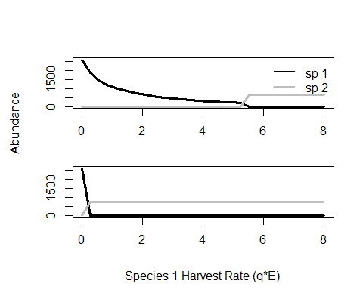

Figure 1. Model exhibits alternative stable states. The model is run to equilibrium over a range of harvest rates for species 1, species 2 harvest is held constant at 2. Top panel shows equilibrium abundances for the range of harvests when species 1 is initially dominant.

Managing both species simultaneously produced drastically different outcomes for the hypothetical fisheries manager in the model. First, scenarios where only species 1 was managed under regimes where the harvest-oriented species (species 1) was already established (Fig.2a) or where species 2 was established and the goal was to flip the system to a species 1 dominated state were explored (Fig. 2b). When species 1 began as the dominant species, stocking and harvest reductions could be used separately or in combination to maintain this dominance. As harvest increases, stocking would be required to maintain the stable state. Higher harvest resulted in greater stocking need. When trying to flip the stable state from species 2 dominating to species 1, some level of stocking would always be necessary regardless of the harvest pressure. Higher levels of stocking were necessary across all harvest rates in order to flip the system to favor species 1. When management of species 1 and species 2 co-occurs, the options for managers expanded from stocking and harvest regulations for species 1 to stocking and harvest regulations for both species, doubling the number of options available to achieve desired outcomes. Figure 2 c & d considered a scenario where the manager regulated harvest on both species and stocks species 1 in order to allow species 1 to dominate over species 2. When species 1 is established as the dominant species and a small amount of fishing mortality is applied on species 2, the system is able to maintain species 1 dominance under all but the most intense harvest pressure scenarios on species 1 with no stocking necessary. A small amount of stocking was able to overcome extreme harvest effects and allow for species 1 to dominate across any harvest rate (Fig. 2c). When species 2 dominates and the goal is to flip the system in favor of species 1, relatively little stocking was necessary across any species 1 harvest rate to flip the system (Fig. 2d) because of the addition of a small amount of harvest on species 2.

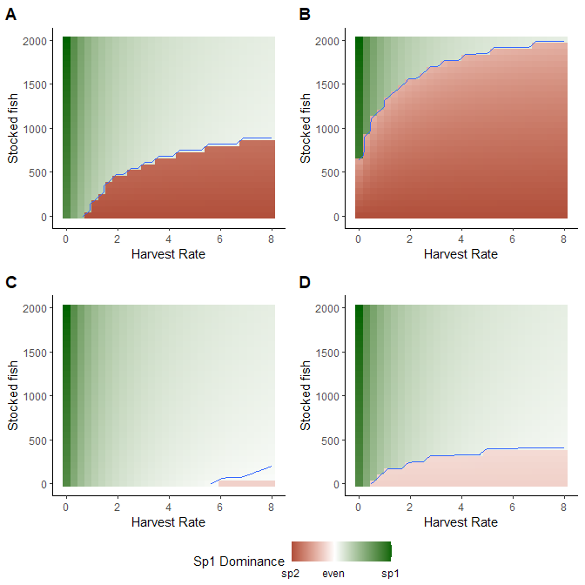

Figure 2. Effect of managing species 1 only (A & B) or both species simultaneously (C & D). Color represent instances where the equilibrium abundances of species 1 was greater than species 2 (green) or vice versa (red). Panels A and C are for a scenario where species 1 is already dominant and needs to be maintained. Panels B and D represent scenarios where species 2 dominates and the goal is to flip the system in favor of species 1.

When the goal of management action is to ‘flip’ a system, or to alter which species dominates, managers must consider the interactive effects of stocking species 1 and harvest of species 2 (Figure 3). Given a constant level of harvest for species 1, stocking of species 1 and harvest of species 2 are negatively correlated. Similar outcomes can be achieved through high stocking of species 1 with no harvest of species 2, high harvest of species 2 with minimal stocking, or some intermediate combination of the two (Fig. 3).

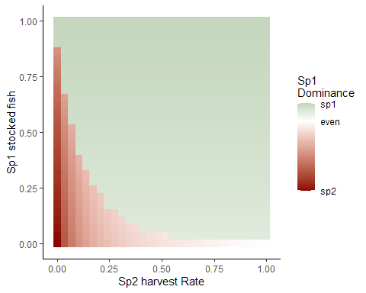

Figure 3. Here managers can stock species 1 (y axis) or increase harvest on it’s predator (species 2, x axis). The negative relationship between stocking species 1 and harvesting species 2 allows managers to achieve similar outcomes through implementation of either strategy or a combination of both.

A scenario was explored where slow moving changes in habitat availability can drive an eventual flip in system state from species 1 to species 2. Management action can delay an inevitable transition through either stocking species 1 (Fig. 4b) or harvesting species 2 (Fig. 4c). In combination, managing both species may be able to prevent a regime shift altogether (Fig. 4d). Management action here was limited to what might be feasible given time and budget constraints for most managers.

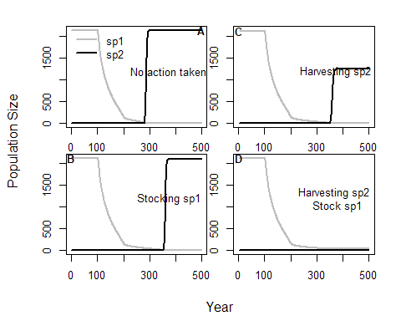

Figure 4. Delaying transitions. Slow moving variable ’h’represents changing habitat availability which will inevitably flip system from sp1 dominated to sp2 (panel A). The flip in system state can be delayed through either stocking of the desired species (panel B), harvest of it’s competitior (panel C), or perhaps prevented altogether by stocking and harvesting (panel D).

# Discussion

1. We use a simple, but more realistic, model of a multi-species recreational fishery to describe how ecological interactions between species and human influences can combine to create stable states in recreational fisheries. Managers are limited in the tools at their disposal to effect change in system dynamics but can leverage ecological interactions between species to achieve their goals.
2. Discuss how ecological interactions, specifically cultivation effects, can lead to counter intuitive responses.
   1. Non-linearity of systems
   2. Implications of these counter-intuitive effects.
3. Understanding ecological interactions can allow us manage both species in ways that account for this and can create positive outcomes.
   1. Thinking about how we can stock less if we harvest a competitor (figures 2 &3)
   2. The most effective tool at delaying inevitable stable state flips may be managing
   3. This work highlights how species interactions can result in ineffective management action. In particular, in the case of stocking, we show that this doesn’t always work the way we want it to because of these competitive interactions.
4. This flows into talking about costs associated with achieving the same outcomes through different management actions
5. Zoom out a bit to think about ecosystem stable states in general and the negative consequences of regime shifts.
   1. While our model focuses on a relatively simple two species model, ultimately the theory presented here on non-linear management action should be applied in more complex systems.
   2. Understanding interactions between species can help us to creatively manage these systems to prevent/delay regime shifts or perhaps just mitigate their effects.
   3. While species interactions are important for management focus, understanding of angler preferences and desires are also important drivers in these systems.