Colin Dassow, Chelsey Nieman, Chris Solomon, Greg Sass, and Stuart Jones

11/5/2020

# Introduction

Interactions between species are often not considered in natural resource management in order to simplify complex management problems (Walters and Martell 2004). This simplification may lead managers to make decisions that in hindsight, were ineffective or even detrimental (Walters et al. 2000; Hansen et al. 2015; Sass and Shaw 2020). However, as human influences on ecosystems continue to grow, so will the need to avoid undesirable outcomes. Ecosystem-based management uses a holistic approach to manage natural resources that includes accounting for inter-specific interactions and human decision making. Further, these complex social-ecological systems are integrated within larger systems ranging across governance boundaries from local to international. Although implementing ecosystem-based management may be difficult, it is nevertheless warranted as humans seek to maintain desired stable states to provide ecosystem services. Aquatic social-ecological systems, including fisheries, provide excellent examples to explore the potential benefits of implementing ecosystem-based management. Counterintuitive responses by fish populations to management have shown that in many cases a linear, single-species focused view of these systems can lead to actions that result in undesirable stable states (Hutchings 2000).

Consideration of the interactions between species can help managers avoid unexpected, and often undesirable, outcomes (Pine et al. 2009). Instead, managers can leverage these interactions to creatively influence system dynamics and meet their goals. In aquatic communities, species may be simultaneously in competition with each other and interacting with human users of the system. For example, human-induced climate change can result in altered ice cover regimes, thereby altering species interactions between Arctic char (*Salvelinus alpinus*) and brown trout (*Salmo trutta*), likely resulting in decreased Arctic char biomass and systems dominated by brown trout (Helland et al., 2011). Overfishing has interacted with climate change and inter-specific interactions to cause dramatic shifts in dominant species in coastal ecosystems around the world and in north-temperate lakes (Jackson et al. 2001; Hansen et al. 2017; Embke et al. 2019). These unexpected outcomes are akin in that they all failed to consider interactions between multiple species and life stages (Walters et al. 2000).

Complex intra- and inter-specific interactions in aquatic systems can result in positive feedback loops that allow a stable state to reinforce itself such that efforts by managers to change the stable state may have no or unintended effects. Walters and Kitchell (2001) described how positive feedback loops can create two alternative stable states in a food web consisting of a top predator and a forage species through cultivation-depensation effects. Under low exploitation, the top predator is abundant and able to cultivate conditions to increase survival of its juveniles by preying on the predators of its juveniles, namely the forage species. Alternatively, the forage species may dominate when exploitation of the top predator is high (as is the case in many fisheries), allowing the forage species to cultivate conditions for itself through predation on juveniles of the top predator. When top predator abundance declines below a critical threshold (depensation), recruitment of new juveniles may be compromised through elevated mortality rates (in contrast to the commonly assumed density-dependent compensatory recruitment and elevated survivorship above the critical threshold) (Liermann and Hilborn 1997; 2001; Carpenter 2003; Hilborn et al. 2014; Sass et al. 2021). If the forage species dominates, simply increasing the abundance and survival of adult predators (even through fishery closure) may have no effect, or possibly a negative effect if the associated increase in juvenile production further increases foraging opportunities for the forage species, leading to further increases in their biomass with the increased prey availability. Regime shifts driven by overfishing are one example of the persistence of these new stable states where fish populations are unable to recover even when the fishery is closed for decades (Hutchings 2000).

In fisheries, it is common to focus applied research and management on a single focal species, even though this species is embedded in a larger community where harvest of multiple species takes place (Hansen et al. 2015). The tradeoffs between competing management goals for several co-occurring exploited species are often not considered; however, some notable exceptions do exist (e.g., Essington et al. 2015, Oken et al. 2016). Essington et al. (2015) used competing objectives for a predator fishery (Atlantic cod, *Gadus morhua*) and a forage species fishery (Atlantic herring, *Clupea harengus*) and showed how ecological interactions between the two and the market price of each species could be combined to determine the appropriate level of mortality for each species given specific management goals (maximizing combined profit of both species at equilibrium). In contrast to commercial fisheries where users aim to maximize profit, recreational fishery users vary along multiple axes of species preference, catch rate, fish size, location, valuation, utility, avidity, and harvest opportunity (e.g., Johnston et al., 2010; Beardmore et al., 2015; Arlinghaus et al., 2017). Users place differing levels of importance on each of these aspects of the fishing experience, leading to divergent, and in some cases, competing desires by fishery users and ultimately complex management problems. Given the limited ways in which managers can influence recreational fisheries (i.e., fishing regulations, stocking, habitat alteration, valuation), understanding and leveraging ecological interactions may allow managers to make the most of the limited tools at their disposal to keep systems within a safe operating space and to meet the diverse goals of users in the system (Carpenter et al. 2017).

Here, we use an example of a recreational fishery with two managed species to explore how managers can leverage ecological interactions between species to achieve their goals. Outcomes that are of specific interest arise from stable states where the desired species dominates, resulting in higher economic benefits and user satisfaction. Our model, like all models, makes necessary simplifying assumptions to balance tractability with realism. We use a relatively simple fishery model that allows for the interaction and harvest of two species, which is an improvement over many of the single species models used to date. We use this two species model to explore how ecological interactions can be leveraged, in combination with human intervention, to maintain desired stable states that otherwise could not be maintained using single species approaches. Our hypothesis that inter-specific interactions play an important role in determining the appropriate management action leads us to predict that consideration of these interactions and the resulting non-linear dynamics can lead to more positive and predictable outcomes.

# Methods

## Model

We used a modified version of a stage-structured food web model that has previously been used to explore alternative stable states in lake ecosystems (Carpenter and Brock 2005, Carpenter et al. 2008, Biggs et al. 2009). The original model contained trophic triangle dynamics between a harvested sport fish with juvenile and adult stages, and a single-stage planktivorous fish not subjected to harvest. We modified this model to include two stage-structured fish populations that are simultaneously harvested. The model contains basic foraging arena dynamics where juvenile sportfish move between the foraging arena and refuge. In our model, adult sportfish can prey upon their own juveniles and juveniles of the competing sportfish species when they are in the foraging arena. The population dynamics for the two species are identical. Unless noted, all parameters are constant through time.

### Adult Dynamics

Eq. 1

Eq. 2

Adults are produced through the maturation of juveniles at a constant rate or . Adults undergo natural mortality, and , and are harvested at rate and . Harvest rate can be either constant or time-dependent in our model.

### Juvenile Dynamics

Eq. 3

Eq. 4

Juveniles are produced through density-dependent recruitment based on Ricker stock-recruitment relationships. Additionally, stocking of juveniles can be imposed through and . Juveniles are removed from the population by one of three ways. The strength of each mortality source is represented by the parameter which can be thought of in general terms as the ‘effect’ of one species/life stage on another. Juvenile mortality occurs through cannibalism (read this as ‘the effect of on ’), which is dependent on refuge dynamics. Second, juveniles undergo mortality through predation by adults of the opposite species . These dynamics are dependent on refuge and are controlled by two rates, the rate at which juveniles leave refuge and enter the foraging arena, and the rate at which they leave the forage arena and enter refuge. Changes in the amount of refuge available to fish are simulated through changes in the parameter, which determines how many juveniles are in the foraging arena. The last juvenile mortality source is through direct competition with juveniles of the opposite species either through competition for resources or direct predation. This competition occurs independent of refuge dynamics such that all juveniles compete in all areas. We assumed that juveniles of both species occupy the same refuge and same foraging arena. The three processes described above are currently the only way juveniles leave the juvenile life stage. All juveniles not claimed by the three sources of mortality above then mature to adults. These fish then survive at some proportion to join the adult population ().

Table 1. Parameter definitions used

|  |  |
| --- | --- |
| Term | Definitions |
| s1 | Juvenile survival sp1 |
| m1 | adult natural mortality |
| cJ1A1 | cannibalism |
| cJ1A2 | predation by sp2 |
| cJ1J2 | Juvenile competition |
| v1 | rate sp1 juveniles enter FA |
| h1 | rate sp1 juveniles leave FA |
| S1 | stocking species 1 |
| qE1 | harvest rate sp1 |
| s2 | Juvenile survival sp2 |
| m2 | adult natural mortality |
| cJ2A2 | cannibalism |
| cJ2A1 | predation by sp1 |
| cJ2J1 | Juvenile competition |
| v2 | rate sp2 juveniles enter FA |
| h2 | rate sp2 juveniles leave FA |
| S2 | stocking species 2 |
| qE2 | harvest rate sp2 |

## Model Experiments

In our modeling experiments, species 1 is considered a strongly harvest-oriented species. Species 2 represents a less harvest-oriented species. Species 1 is more valued than species 2 by anglers. Because of this, the management goal is to promote dominance of species 1 over species 2. We focused on four different model experiments that reflect scenarios that are likely commonly encountered by fisheries managers. First, we sought to understand how the fishery in this model functioned over a range of harvest levels (both species 1 and 2). The aim of this simulation was to understand species dynamics and the stable states that are present in our simulated fishery system. Second, we sought to compare the influence of active management of only one species (species 1) *versus* both species (species 1 and 2), and the resultant influence on species dynamics, with a particular interest on managing the system for dominance of species 1. Our third model experiment focused on the interactive effects of management on both species in the system. Here, we sought to understand the influence of different management levers for different species, and the resultant outcomes in terms of dominant species. Finally, we explored the influences of slow changes in habitat availability and the resultant influences on stable states. Within this model experiment, we sought to understand how management action can prevent changes in stable states caused by changes in habitat availability. Different modeling runs used slightly different parameterizations for harvest, stocking, and habitat availability (Appendix/Supplement). Species interaction parameters, mortality, survival, and fecundity were held constant across simulations (Appendix/Supplement). Model simulations were performed in R using RStudio and the deSolve package (Soetaert et al. 2010, R Core Team 2020, RStudio Team 2020).

# Results

The model demonstrated alternative stable states (Fig. 1). Across the range of harvest rates, the model outcomes when run to equilibrium differed depending on the initial system state. For example, a harvest rate of < 5fish per unit effort on species 1 resulted in scenarios where species 1 dominates over species 2 or vice versa depending on initial system state. 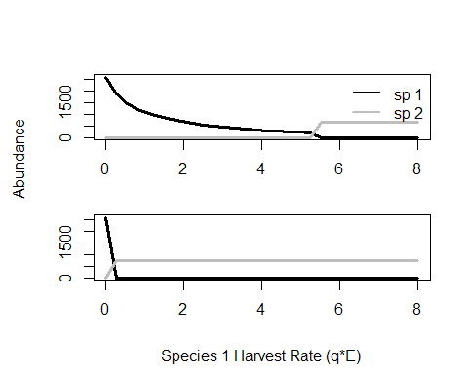

Figure 1. Model exhibits alternative stable states. The model is run to equilibrium over a range of harvest rates for species 1, species 2 harvest is held constant at 2. Top panel shows equilibrium abundances for the range of harvests when species 1 is initially dominant. Bottom panel represents outcomes when species 2 is initially dominant.

Managing both species simultaneously produced drastically different outcomes for the hypothetical fisheries manager in the model. First, when only species 1 was managed under regimes where the harvest-oriented species (species 1) was already established and the management goal is maintain its dominance (Fig.2). When species 1 began as the dominant species, stocking and harvest reductions could be used separately or in combination to maintain this dominance. As harvest increased, stocking would be required to maintain the stable state. Higher harvest resulted in greater stocking need. When management of species 1 and species 2 co-occurs, the options for managers expanded from stocking and harvest regulations for species 1 to stocking and harvest regulations for both species, doubling the number of options available to achieve desired outcomes. Figure 2 considered a scenario where the manager regulated harvest on both species and stocks species 1 in order to allow species 1 to dominate over species 2. When species 1 is established as the dominant species and a small amount of fishing mortality is applied on species 2, the system is able to maintain species 1 dominance under all but the most intense harvest pressure scenarios on species 1 with no stocking necessary. A small amount of stocking was able to overcome extreme harvest effects and allow for species 1 to dominate across any harvest rate (Fig. 2). These analyses were also conducted in a model scenario where the undesirable species (species 2) was initially dominant and the management goal was to flip the system to favor species 1. The dynamics in that scenario mirror those presented here, but because of the initial dominance of species 2, the magnitude of management action (stocking or harvest) needed to flip to system towards species 1 is higher in order to overcome the initial dominance of species 2.

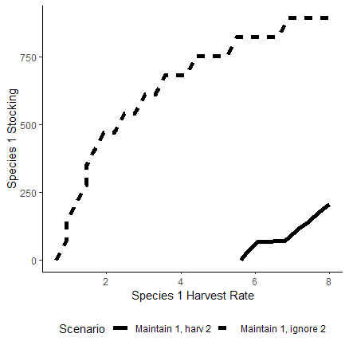

Figure 2. Species 1 dominance isocline where areas above line represent species 1 stocking and harvest combinations that allow species 1 to dominate. Areas below the isoclines represent scenarios where species 2 dominates. Species 1 is initially dominant and the management goal is to maintain this dominance.

Considering species interactions allow managers to combine direct management action (i.e. stocking) with indirect action (i.e. managing a competitor). Managers can use these strategies by themselves or in combination to achieve the same outcome (Figure 3). The trade-off between stocking and harvest of competitor is consistent across different levels of harvest on the desired species; only the magnitude of management action necessary changes.

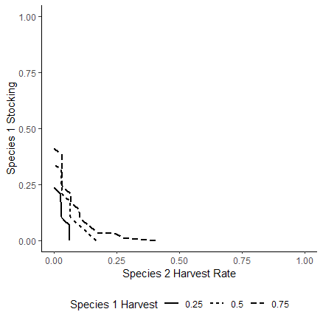

Figure 3. Here managers can stock species 1 (y axis) or increase harvest on its predator (species 2, x axis). Tradeoff between stocking and competitor harvest are presented for various levels of harvest on species 1 (solid and dashed lines). Areas above the lines represent positive outcomes, areas below represent negative outcomes. The negative relationship between stocking species 1 and harvesting species 2 allows managers to achieve similar outcomes through implementation of either strategy or a combination of both.

A scenario was explored where slow moving changes in habitat availability can drive an eventual flip in system state from species 1 to species 2. Management action can delay an inevitable transition through either stocking species 1 (Fig. 4b) or harvesting species 2 (Fig. 4c). In combination, managing both species may be able to prevent a regime shift altogether (Fig. 4d). Management action here was limited to what might be feasible given time and budget constraints for most managers.

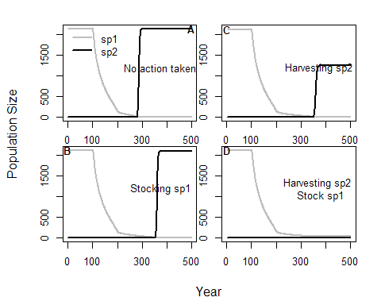

Figure 4. Delaying transitions. Slow moving variable ’h’ represents changing habitat availability which will inevitably flip system from sp1 dominated to sp2 (panel A). The flip in system state can be delayed through either stocking of the desired species (panel B), harvest of its competitor (panel C), or perhaps prevented altogether by stocking and harvesting (panel D).

# Discussion

Sudden, unexpected regime shifts represent a growing threat to aquatic systems as human influences on these systems grow and erode system resilience. Our relatively simple model of a multi-species recreational fishery demonstrates how understanding the ecological interactions between species can allow a manager to creatively manage a system to reach desired outcomes where a single species management approach is infeasible or unable to reach those outcomes. Here, we have illustrated how species interactions can result in non-linearity in a fisheries system, which can ultimately result in transition between alternative stable states. We further demonstrate how management interventions can be used to maintain stable states of a system through careful consideration of human influences and species interactions within the system. Although species interactions have long been known to exert influence on a system, here we show how direct management can use those interactions in order to influence fishery outcomes.

Managers are limited by political, monetary, mechanical, and technological constraints when confronting complex management problems. Most commonly, fishery managers turn to one of four different tools for preventing or mitigating the negative influences of humans on the system; (1) Stocking, (2) harvest regulation (e.g., length and bag limits), (3) habitat modification, and (4) fishery closure (either temporary or permanent). Although each of these management interventions has a history of success in certain circumstances, management response to disturbance in a system is not always straightforward. Often, these actions produce no response or a counterintuitive response when we don’t think about interactions between species (fig. 2). For example,

* + 1. 2 examples – ineffective stocking and failure to recover in a closed fishery
       1. Highlight non-linearity
       2. Could replicate those examples using our model if we wanted
    2. One example of the incorporation of non-linearity in a fishery system is within the safe operating space literature. Here, the focus is on managing dynamic fisheries within a safe operating space rather than single species harvest (Carpenter SOS paper).

1. Although the limited set of options available to managers are often ineffective or even detrimental when implemented without consideration of species interactions, these interactions can be leveraged to create more avenues for positive outcomes.
   1. Tradeoffs between directly managing a species or indirectly managing through its competitor (fig. 3)
   2. Example – stocking is often ineffective; can we achieve better outcomes at lower cost through managing a predator/competitor? (fig. 2 or 3)
      1. Cost of management intervention are often a limiting factor that can drive management decisions. Here, however, we illustrate how ecological interactions might be a reason why stocking might not be the most effective management action. Our model shows that lower cost options, such as harvest controls of the target species or through management of a competitor species can often be more effective than stocking in producing favorable outcomes. There are other drivers that influence the effectiveness of stocking in a system (e.g., habitat loss, climate change), highlighting the importance of considering factors beyond harvest in management decision making.
2. Human influences on ecosystems will continue to increase, and understanding species interactions can help us creatively manage these systems given the constraints on what managers can feasibly do. Future work incorporating the cultivation effects of species-interactions can provide empirical evidence supporting the importance of considering ecological interactions in the managing complex systems.
   * 1. Bass-walleye example? Call out to q1 paper on cultivation effects in centrarchids?
   1. While here our model focuses on a relatively simple two-species model, ultimately the ideas presented here should be applied in more complex systems.
   2. Management goals, ultimately, are focused on maintaining a system in an ‘desired’ stable state, however, what is considered ‘ideal’ is generally based on human desires. An understanding of how ecological interactions (specifically through cultivation-depensation mechanisms) will respond to changing harvest pressure can reveal how managers can respond to changing demands from angler stakeholders in their system.

Integration of ecological dynamics into adaptive management of freshwater fisheries can increase managers’ ability to maintain systems in a desired stable state, reducing the likelihood of unexpected or undesirable outcomes, while using standard interventions and reducing overall costs. For example, our fairly robust kon ecological interactions and should While our understanding of ecological interactions between species remains incomplete, we do understand some food webs and species fairly well. The wide breadth of knowledge we do have can play an integral role in building resilient fisheries. By taking a more ecosystem-oriented view of management, we can improve outcomes and identify areas for further exploration when our actions produce unexpected outcomes.

Old text & outline….

1. We use a simple, but more realistic, model of a multi-species recreational fishery to describe how ecological interactions between species and human influences can combine to create stable states in recreational fisheries. Managers are limited in the tools at their disposal to effect change in system dynamics but can leverage ecological interactions between species to achieve their goals.
2. Discuss how ecological interactions, specifically cultivation effects, can lead to counter intuitive responses.
   1. Non-linearity of systems
   2. Implications of these counter-intuitive effects.
3. Understanding ecological interactions can allow us manage both species in ways that account for this and can create positive outcomes.
   1. Thinking about how we can stock less if we harvest a competitor (figures 2 &3)
   2. The most effective tool at delaying inevitable stable state flips may be managing
   3. This work highlights how species interactions can result in ineffective management action. In particular, in the case of stocking, we show that this doesn’t always work the way we want it to because of these competitive interactions.
4. This flows into talking about costs associated with achieving the same outcomes through different management actions
5. Zoom out a bit to think about ecosystem stable states in general and the negative consequences of regime shifts.
   1. While our model focuses on a relatively simple two species model, ultimately the theory presented here on non-linear management action should be applied in more complex systems.
   2. Understanding interactions between species can help us to creatively manage these systems to prevent/delay regime shifts or perhaps just mitigate their effects.
   3. While species interactions are important for management focus, understanding of angler preferences and desires are also important drivers in these systems.