Sensitivity Analysis Doc

Colin Dassow, Chelsey Neiman, Chris Solomon, Greg Sass, and Stuart Jones

12/31/2020

# Sensitivity Analysis

Here I systematically vary juvenile survival $s$, adult natural mortality $m$, cannibalism $c_{j_{1},a_{1}}$, predation by adult $c_{j_{1},a_{2}}$, juvenile competition $c_{j_{1},j_{2}}$, and fecundity (Ricker parameters $a$ and $b$) to see how the effect the occurence of stabe states. I did this by only varying values for species 1 and I didn’t now vary any of these parms in combination with each other, only in isolation.

Below are figures to describe the results

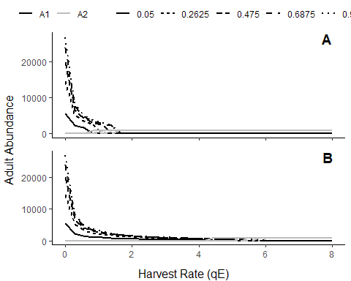

Juvenile Survival rate. Alternate stable states persist for different values, except the lowest value and only when species 2 is initally dominant (0.05). The range of harvest values over which alternate states occur increases as juvenile survival increases. Panel A - species 2 initially dominant; Panel B - species 1 initially dominant.

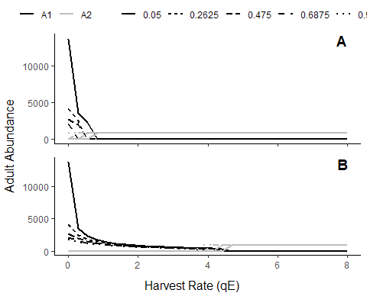

Adult natural mortality rate. Alternate stable states persist for all values. The range of harvest values over which alternate states occur decreases as adult natural mortality decreases. In other words, as fewer adults die annually more harvest can happen on species 1 while still allowing it to dominate (panel A). Panel A - species 2 initially dominant; Panel B - species 1 initially dominant.

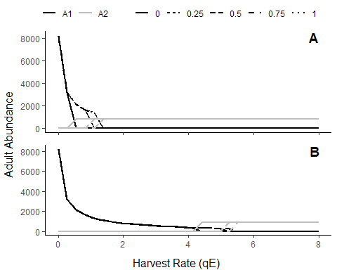

Species 1 adults predationon species 2 juveniles. Alternate stable states persist for all values except when species 2 is dominant and Adults of species 1 have no effect on species 2 juveniles (0). As the effects of species 1 adults on species 2 juveniles increases the range of harvest values over which alternate stable states occur shifts right (i.e. more harvest can be tolerated before the system flips). Panel A - species 2 initially dominant; Panel B - species 1 initially dominant.

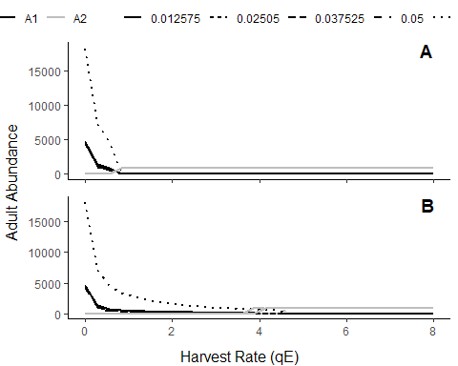

Species 1 cannibalism rate. Alternate stable states persist for all values. When little cannibalism occurs (0.0001) more harvest can be tolerated, and vice versa when more cannibalism occurs. Most cannibalism rates result in roughly the same flipping points. Panel A - species 2 initially dominant; Panel B - species 1 initially dominant.

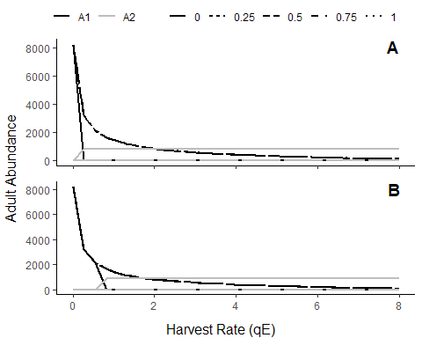

Effect of J1 on J2. Alternate stable states do NOT persist for all values. This parameter has a large effect on if alternate states exist and when the flipping point is crossed. Panel A - species 2 initially dominant; Panel B - species 1 initially dominant.

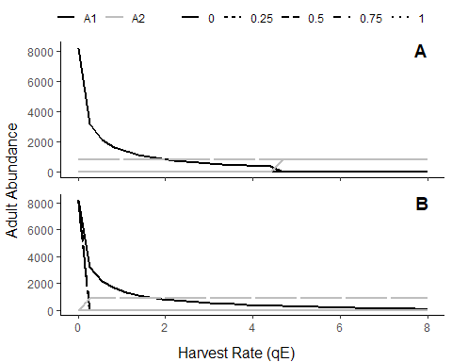

Effect of J2 on J1. Alternate stable states do NOT persist for all values. This parameter has a large effect on if alternate states exist and when the flipping point is crossed. Panel A - species 2 initially dominant; Panel B - species 1 initially dominant.

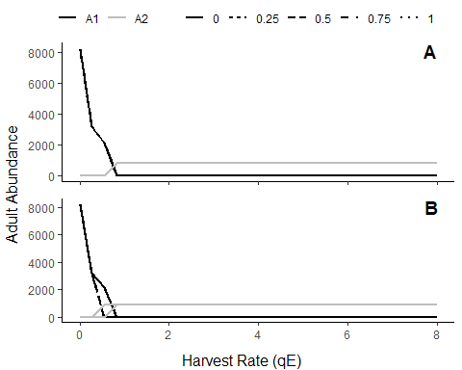

Effect of A2 predation on J1. Alternate stable states persist across all values. As the effect of A2 on J1 decreases more harvest of species 1 can be tolerated before the system flips. Larger effect on the upper end of the stable state where the system starts dominated by species 1 and flips to spcies 2 at high harvest (panel B). Panel A - species 2 initially dominant; Panel B - species 1 initially dominant.

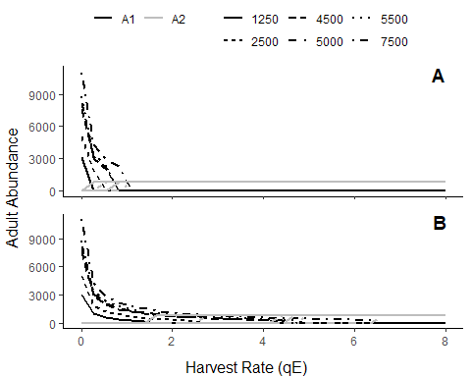

Effect varying ricker A parm - max number of recruit produced. Alternate stable states persist across all values except the very lowest a value (1250) and only when species 2 is initially dominant (panel A). Parameter A has a larger effect on when flipping happens in panel B; where species 1 is initially dominant. Panel A - species 2 initially dominant; Panel B - species 1 initially dominant.

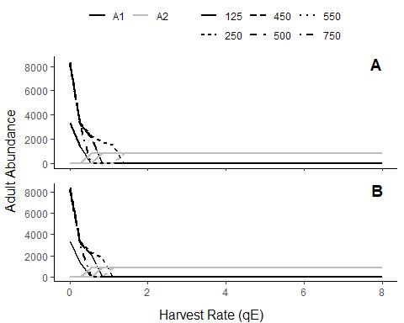

Effect varying ricker B parm - stock size to produce .5 of A. Alternate stable states persist across all values. Seems to be a large effect of this parameter in either scenario (panel A or B). No general trend here because of the nonlinear effect of ricker parm b on recruitment for a given abundeance. Panel A - species 2 initially dominant; Panel B - species 1 initially dominant.