**Windows Installation Instructions:**

1. Make a working directory that you will use during the class (for example, *FloPy-short-course*). Please do not use spaces in the directory name.
2. Copy the installation and testing scripts (*install_packages.py* and *test_install.py*) to your working directory.
3. Copy the Anaconda Prompt to your working directory
   1. 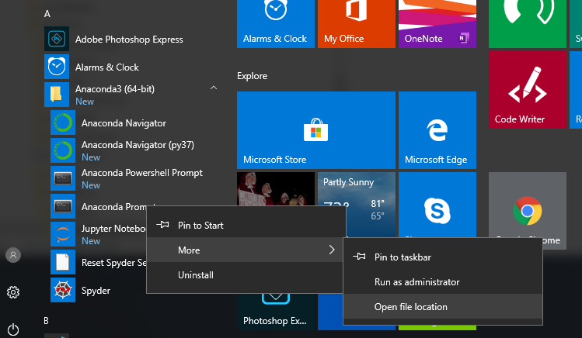Under Anaconda3, right click on the *Anaconda Prompt* and then select *More*→*Open file location*
   2. 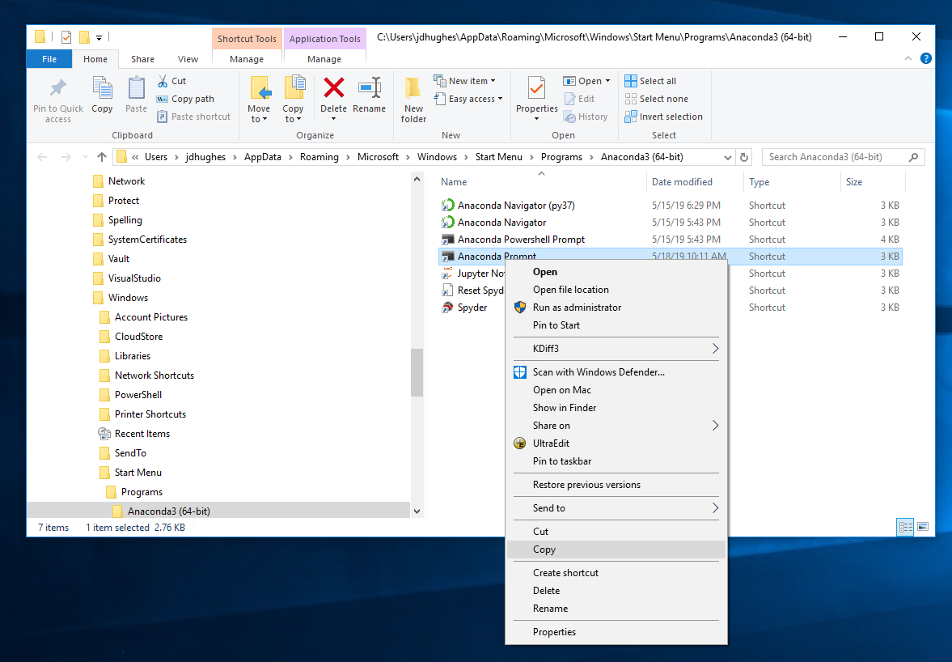Copy the *Anaconda Prompt* by right clicking on *Anaconda Prompt* selecting *Copy*. Next paste the *Anaconda Prompt* in your working directory.
   3. 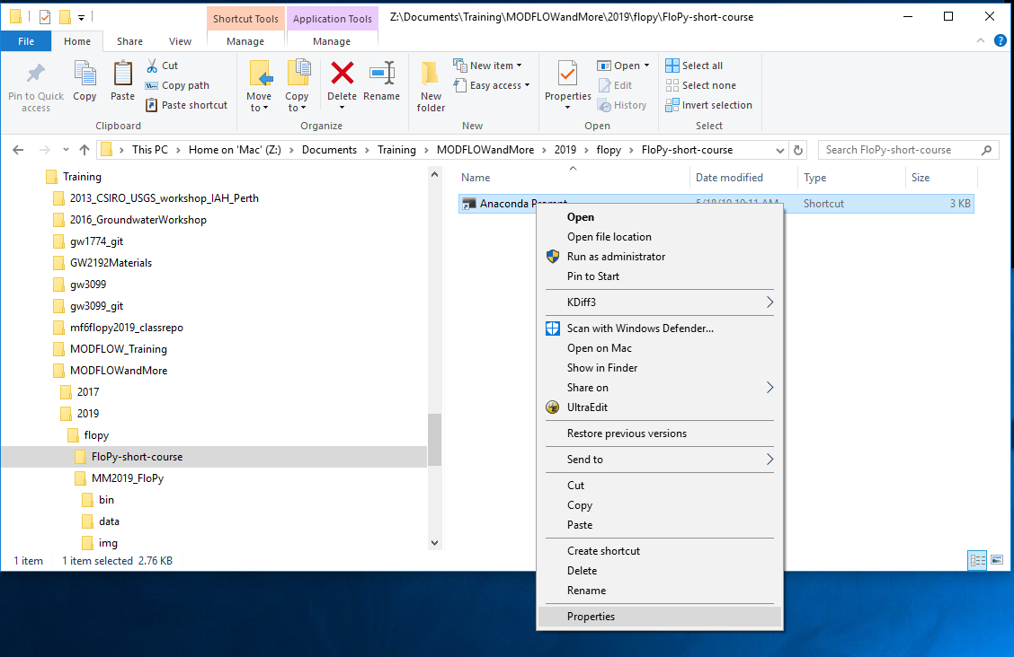Right click on the *Anaconda Prompt* in your working directory and select *Properties*.
   4. 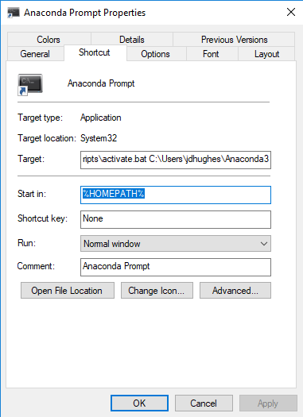Delete *%HOMEPATH%* in the *Start In:* text box and select *OK*.
   5. Double click on *Anaconda Prompt* in your working directory.
4. If you created a python environment in an existing Anaconda distribution run the following command in the command windows that opens:  
     
    *activate <your environment name>*  
     
   where *<your environment name>* is the name you gave your environment when you created it. Otherwise skip this step.
5. Run the following command in the command window that opens:  
     
    *python install_packages.py*
6. Report any errors that your encounter while the script is running. A successful test will look something like this.  
     
   Running tests of installed python packages in root installation...  
    using python installed in "C:\Users\jdhughes\Anaconda3\python.exe"  
   C:\Users\jdhughes\Anaconda3\python.exe -m nose -v test_install.py  
   test_install.test_anaconda ... ok  
   test_install.test_modules('numpy',) ... ok  
   test_install.test_modules('matplotlib',) ... ok  
   test_install.test_modules('shutil',) ... ok  
   test_install.test_modules('subprocess',) ... ok  
   test_install.test_modules('pandas',) ... ok  
   test_install.test_modules('platform',) ... ok  
   test_install.test_modules('shapefile',) ... ok  
   test_install.test_modules('flopy',) ... ok  
   test_install.test_modules('pymake',) ... ok  
   test_install.test_modules('pyemu',) ... ok  
   test_install.test_matplotlib ... ok  
   test_install.test_cleanup ... ok  
     
   ----------------------------------------------------------------------  
   Ran 12 tests in 10.844s  
     
   OK