**Hotel Data Analysis**

Overview:

Our "Hotel Data Analysis" project focuses on understanding user behavior and industry trends within the hotel sector, with a specific emphasis on our establishment. Through rigorous data analysis, we aim to uncover insights into user preferences, revenue streams, and engagement patterns. This analysis will provide actionable intelligence to inform strategic decisions and enhance operational efficiency.

Technologies Used:

* MySQL Workbench: MySQL was used to store and manage the structured data, making it accessible for analysis and reporting.
* Power BI: Power BI was used to generate interactive reports and dashboards, enabling stakeholders to explore the project’s findings.

Project Highlights:

* Data Preparation: Describe any significant data preprocessing steps, such as data cleaning, transformation, or feature engineering.
* SQL Queries: Highlight key SQL queries or operations performed on the database.
* Visualization: Mention the main visualizations created using Power BI, and how they contribute to the project’s objectives.
* Insights: Summarize the key insights or findings derived from the analysis.

Folder Structure:

* DataBase : This folder contains the data of different years and Tables.
* Power Bi Dashboard: This folder contains the ‘POWER BI Dashboard’ for visualizations.
* SQL Work : This folder contains the ‘SQL WORK’ .

SQL WORKS (Some of SQL Queries) –

* TO JOIN ALL THE TABLES

create table hotels as (

(select * from eighteen)

union

(select * from ninteen)

union

(select * from twenty));

**Note:** Here I assigned the name of all tables as their number of the year. Like 2018 as ‘eighteen’ and 2019 as ‘ninteen’.

* TO GET REVENUE(TOTAL NIGHT STAYS*ADR) AS PER YEARS AND HOTELS.

select

arrival_date_year, hotel,

round(sum((stays_in_week_nights+stays_in_weekend_nights)*adr),2) as revenue

from hotels

group by arrival_date_year,hotel;

For reference-

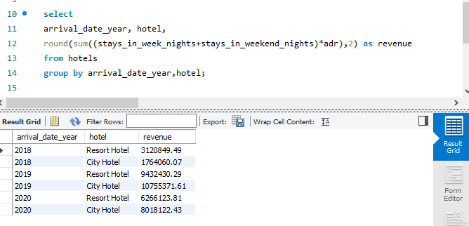

* TO JOIN LEFTOUT TABLES ON THE BASIS OF SIMILAR COLUMN

select * from hotels

left join project.market_segment

on hotels.market_segment=market_segment.market_segment

left join project.meal_cost

on meal_cost.meal=hotels.meal;

POWER BI DASHBOARD

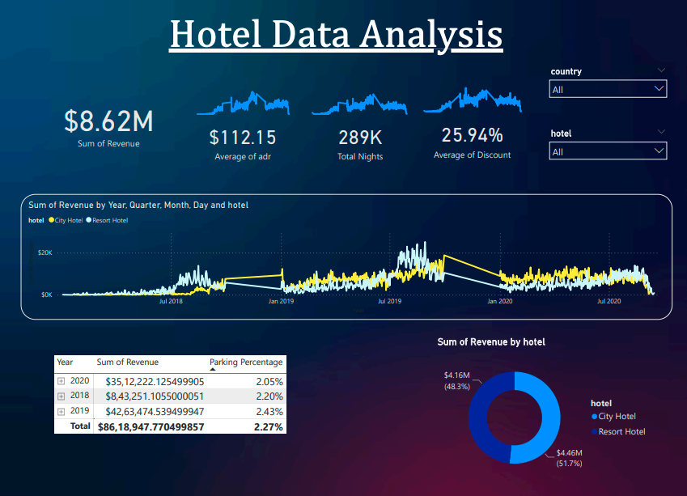

It’s a Dynamic Dashboard

I used Number Cards to represent Sum of Revenue, Average of ADR(Average Daily Rate), Total nights and Average of Discount.

I have taken use of different Line charts to represent the graphical presentation of Number Cards.

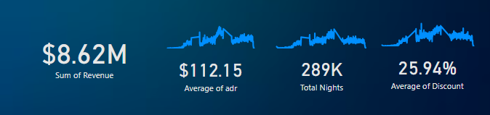

This is a Line Chart to analyse the Revenue throughout the years.

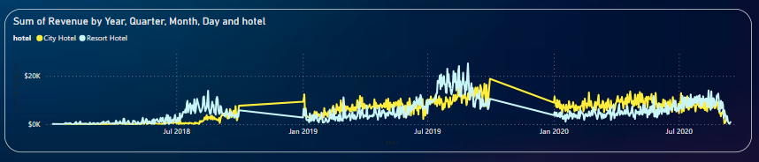

I analysed ‘REVENUE WITH PARKING PERCENTAGE’ and ‘REVENUE BY HOTELS’ with the help of ‘MATRIX TABLE’ and ‘DONUT CHART’.

