COS 214 Practical 4
u24612082
U24577988
U25657764

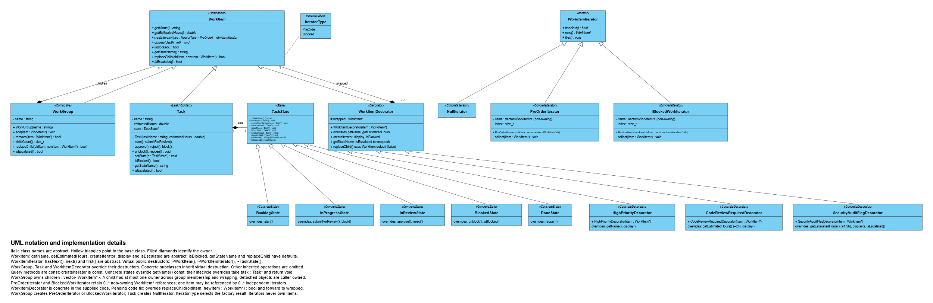
Task 1

\TaskForge is a software delivery work-management system. It organises development work into nested Epics, Features, Stories and Tasks. It solves the problem of tracking, traversing and updating hierarchical work while tasks move through lifecycle states and receive additional responsibilities such as priority marking, code review and security auditing.

Task 3
Traversal-Modification Policy

The Decision
TaskForge iterators use a snapshot policy. When WorkGroup::createIterator() is called (or BlockedWorkIterator is constructed directly), the iterator eagerly walks the hierarchy once at construction time and stores every relevant item in an internal list. From that point on, the iterator is completely decoupled from the live WorkGroup structure: it has no reference back to the original containers, only the flat list of WorkItem* pointers it already collected.

What This Means in Practice
If the hierarchy is structurally changed after an iterator has been created, for example a Task is moved from one WorkGroup to another via remove() and add(), any iterator that already exists continues to reflect the structure exactly as it was at the moment it was constructed. It will not see the item's new location, but it still holds the pointer to the same object, wherever that object now lives, so the move is safe to observe through a stale iterator. A brand-new iterator created after the change will walk the current structure and reflect the change immediately.
Newly added items are, by the same logic, deliberately invisible to iterators that were snapshotted before the addition occurred. This is intended behaviour, not an oversight: a sweep already in progress operates over the population that existed when it began, and a fresh iterator created afterward will include the new item.

The Deletion Case: Boundary of the Policy
The snapshot policy guarantees safety when an item is moved between groups, because the object itself continues to exist and only its owning container changes. It does not, by itself, protect against an item being removed and destroyed outright while a snapshot iterator still holds a pointer to it: dereferencing that pointer afterward would be a dangling pointer access.
TaskForge avoids this case structurally: in every scenario in the running system, an item is only ever permanently deleted after any iterator that could hold a reference to it has already completed its traversal (for example, during the escalation sweep, items are read and flagged but never deleted mid-sweep; deletions, where they occur, happen as a separate, later step once all active iterators have gone out of scope). This is a deliberate ordering constraint on how the system is used, not an automatic guarantee enforced by the iterator itself, and it is documented here as the boundary of the snapshot policy's safety guarantee.

Why We Chose This Policy
The alternative, a live iterator that re-reads the underlying containers on every next() call, introduces real risks in a Composite structure with owning raw pointers: if an item is removed and deleted while an iterator is mid-traversal, a live iterator risks dereferencing a dangling pointer, which is undefined behaviour and a serious source of Valgrind-detectable memory errors. The snapshot approach sidesteps this for the move case entirely, because the snapshot is taken once and never re-reads the group's internal vector, so it can never be invalidated by a structural change that happens afterward. This trades a small amount of freshness (an in-progress traversal will not reflect a concurrent move, and will not include concurrent additions) for guaranteed safety against dangling references arising from moves, a defensible and deliberate choice for a system where ownership and destruction are managed manually rather than via smart pointers.

Consequence for Decoration
This policy is also why the escalation workflow (runEscalationWorkflow) takes its own snapshot before modifying anything. It collects all direct children into a local std::vector<WorkItem*> first, then safely calls remove() and add() on the WorkGroup afterward, without ever iterating over a container it is simultaneously mutating.

Demonstrated in Code and Diagrams
main.cpp's menu option 5 explicitly shows this: after moving task3 between Features, a fresh WorkItemIterator created afterward immediately reflects the new structure, while the design guarantees any iterator created before that point continues to reflect the pre-move structure. This decision point is visualised directly in Activity Diagram 2 ("Active iterator inspecting hierarchy during mutation?"), which shows the fork between an in-flight iterator continuing on its pre-mutation snapshot and a direct structural update proceeding independently.

Task 4
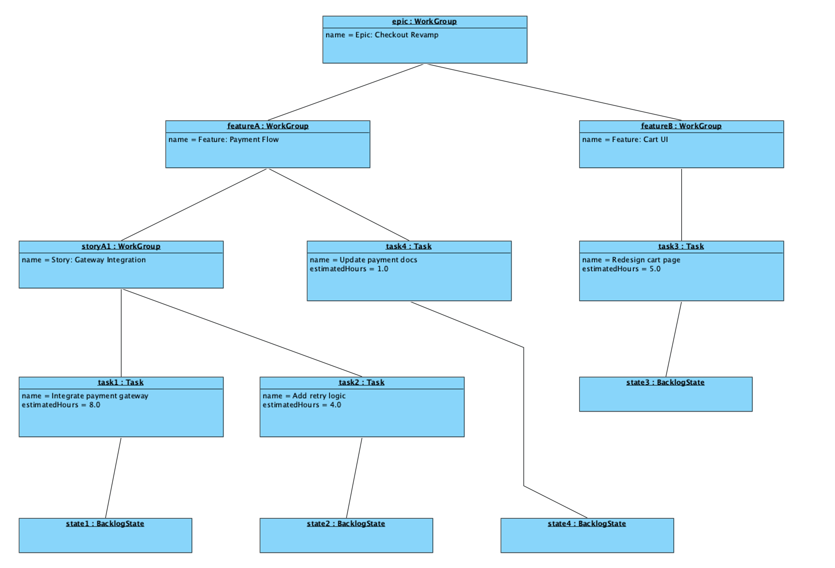

Task 4 - UML Activity Diagram Portfolio
The three Activity Diagrams below explain the most important workflows in TaskForge: escalating blocked work during a hierarchy sweep, moving a task between groups while an iterator is active, and taking a task through its review lifecycle. Each diagram is traceable to the corresponding behaviour in the final C++ implementation.

Diagram 1 - Escalation Workflow
This diagram traces a full escalation sweep over the hierarchy. A BlockedWorkIterator is created over the hierarchy and driven by repeated hasNext() and next() calls. Each item is checked against the guard isBlocked() and not isEscalated(), so an already-escalated item is left untouched on repeated sweeps. Items that satisfy the guard have their decorator installed via replaceChild(item, decorated) and have the escalation event logged, with decoration and logging carried out one after the other rather than in parallel, before the loop moves to the next item. Once the traversal is exhausted, the workflow prints or reports every item that was escalated during the sweep.
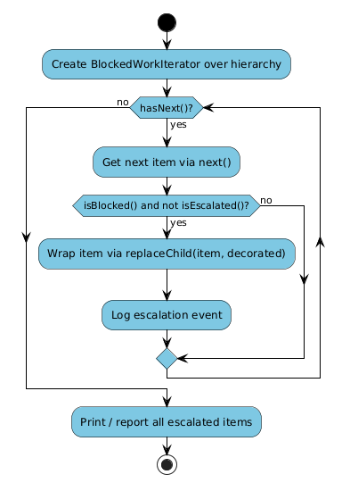

Diagram 2 - Mutation Workflow
This diagram makes the traversal-modification policy visible as part of a larger workflow. A developer requests that task4 be moved from Feature A to Feature B, and the system first creates an iterator over the hierarchy and partially advances it, so that some next() calls have already been consumed before the structure changes. The move itself is carried out as WorkGroup::remove(task4) from Feature A followed by WorkGroup::add(task4) to Feature B. A guard then asks whether an active iterator is inspecting the hierarchy during the mutation: if one is in flight, it resumes safely on its own pre-mutation snapshot; if there is no active iterator, no visibility conflict occurs. Both branches merge before a new iterator is created to traverse the hierarchy in its updated form, giving the developer confirmation that the move succeeded while leaving any in-progress traversal undisturbed, exactly as described in the team’s snapshot traversal policy.
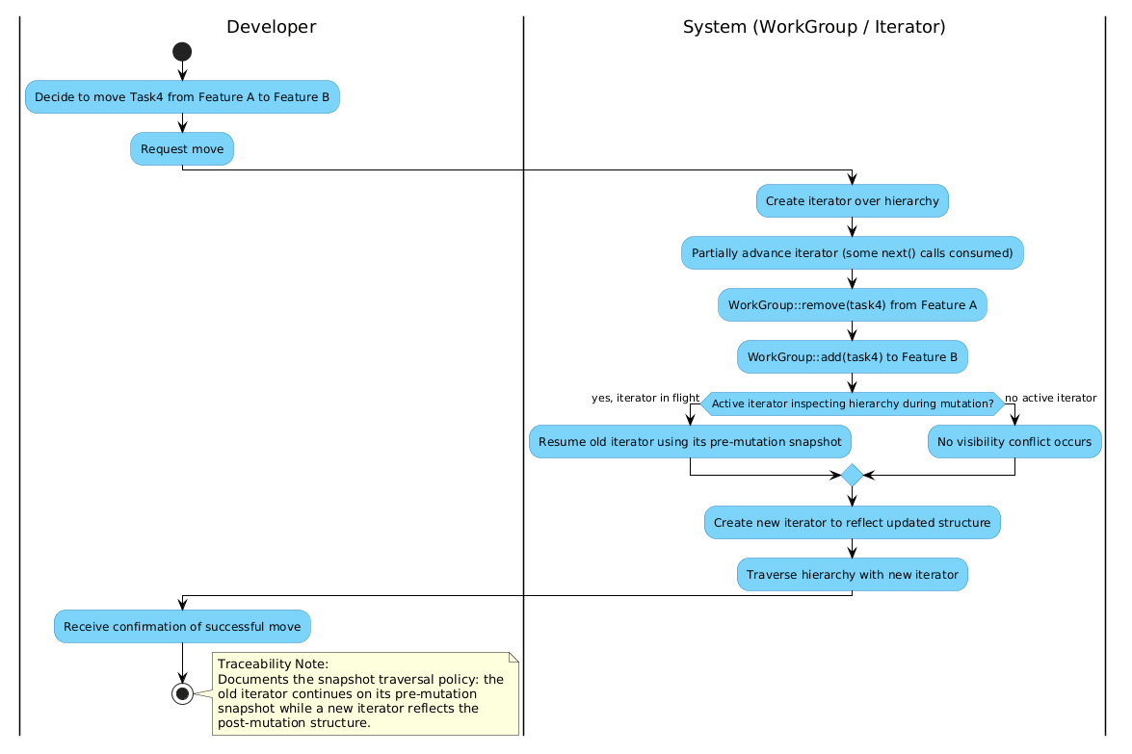

Diagram 3 - Review Workflow
This diagram follows a single Task through its actual lifecycle. start() moves the task from Backlog to InProgress, and submitForReview() moves it on to InReview, where a reviewer inspects the task and decides to reject or approve it. A reject sends the task back to InProgress via reject(), while an approve calls approve() to transition the task to Done. Before that transition completes, a guard checks whether the task was blocked before approval; if so, it is wrapped via replaceChild(task, new SecurityAuditFlagDecorator(task)), adding a runtime responsibility without altering the task’s own class. Both branches of that guard merge into a called sub-activity, Run Full Board Traversal, which performs a composite traversal of the whole board before the final state is recorded, showing a reusable, independently invokable workflow rather than an inline traversal hidden inside this one diagram.
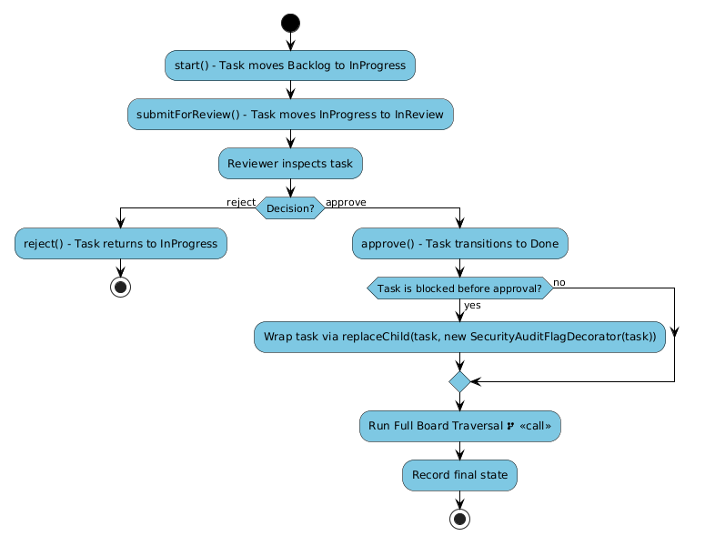

State Diagram - Task Lifecycle
This diagram shows the complete lifecycle of a Task, matching the State pattern implementation. A filled initial node transitions into Backlog, and start() moves it to InProgress. From there, submitForReview() sends the task to InReview, where reject() returns it to InProgress and approve() moves it on to Done. Independently of the review path, InProgress can transition to Blocked via block(), and unblock() returns it to InProgress, each transition running in a single direction only. Finally, a completed task is not permanently fixed: reopen() allows a Done task to move back to InProgress if further work is required. Invalid actions, such as approving a task that is still in Backlog, are rejected by the state objects rather than silently ignored, consistent with the non-negotiable rule that invalid transitions must be handled sensibly.
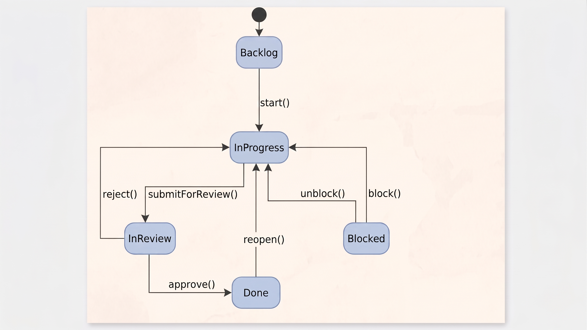

Task 5
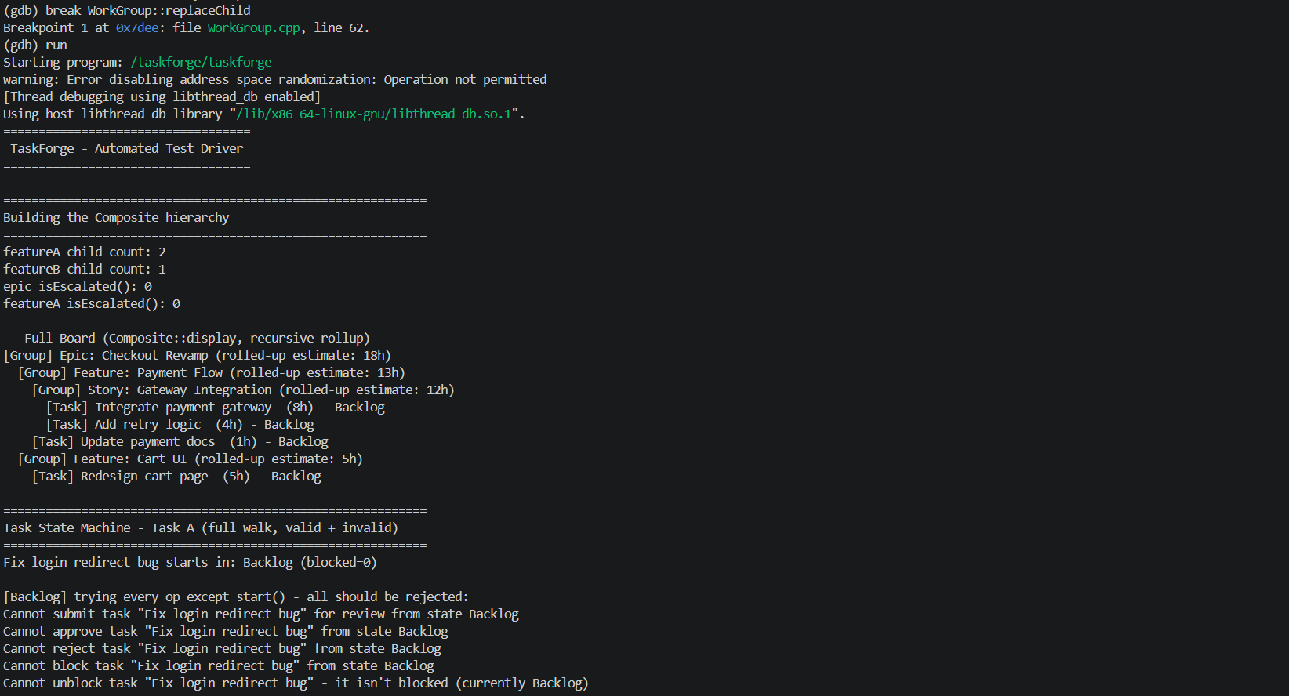
Evidence of using GDB
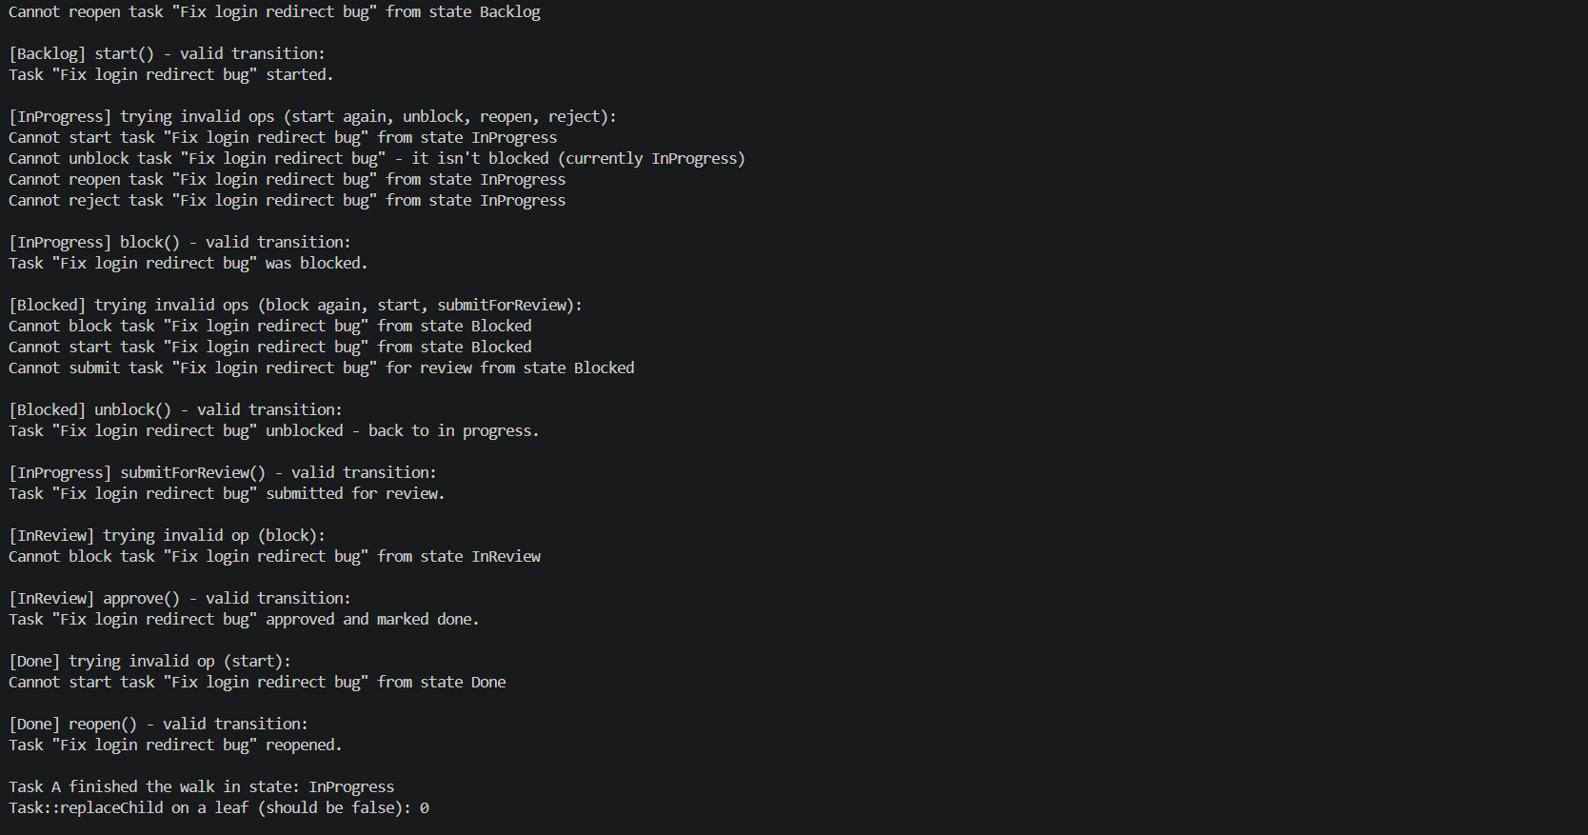

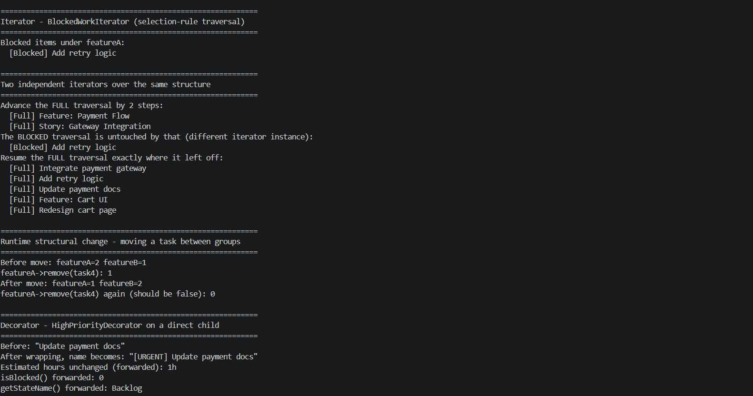
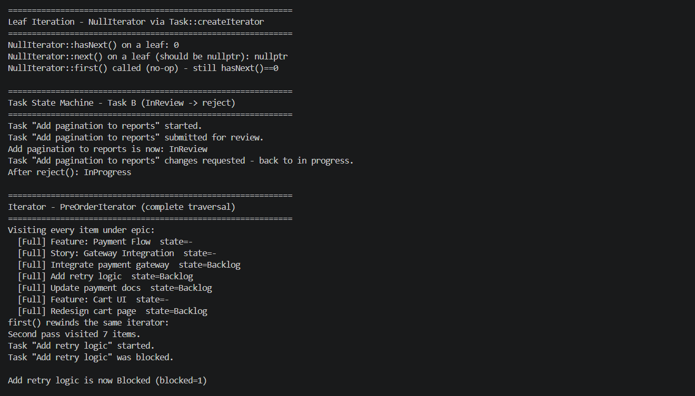

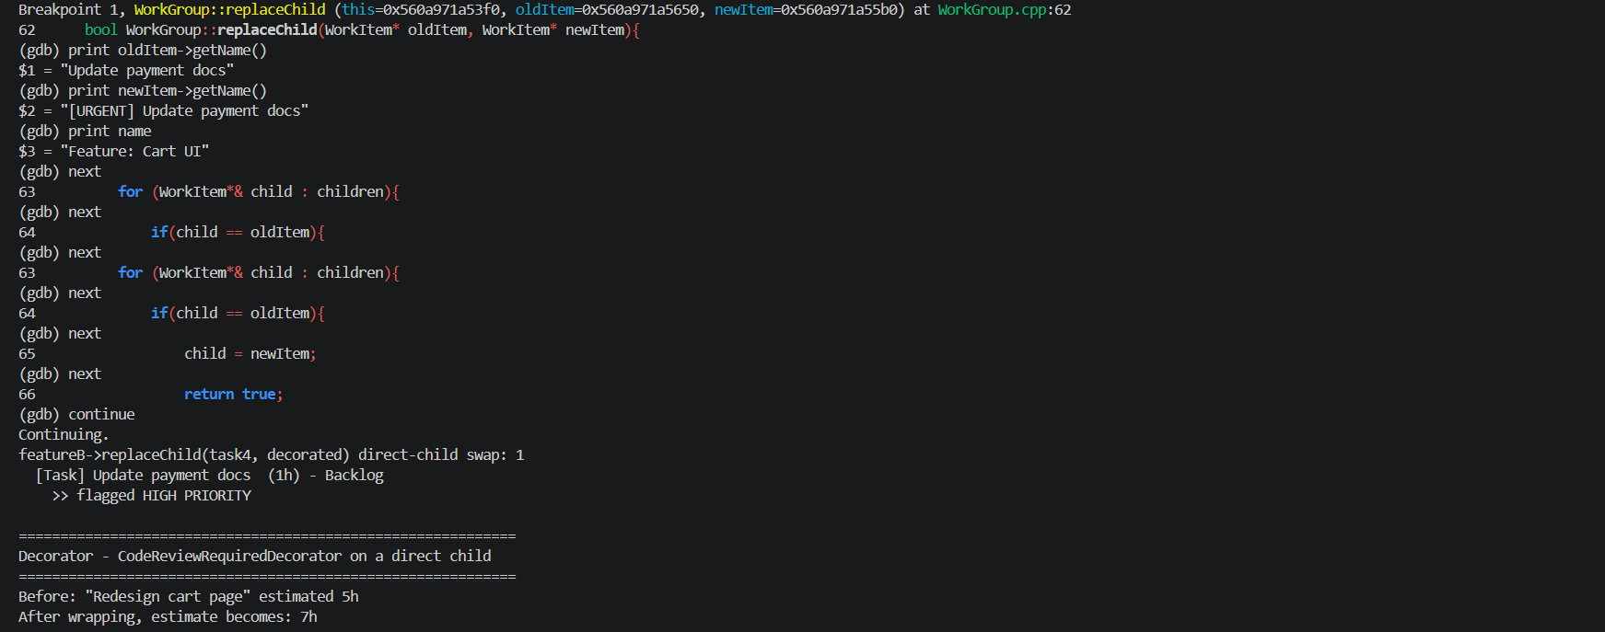

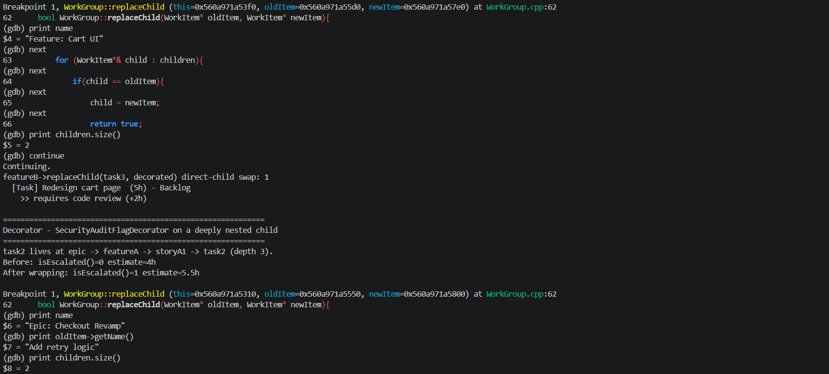

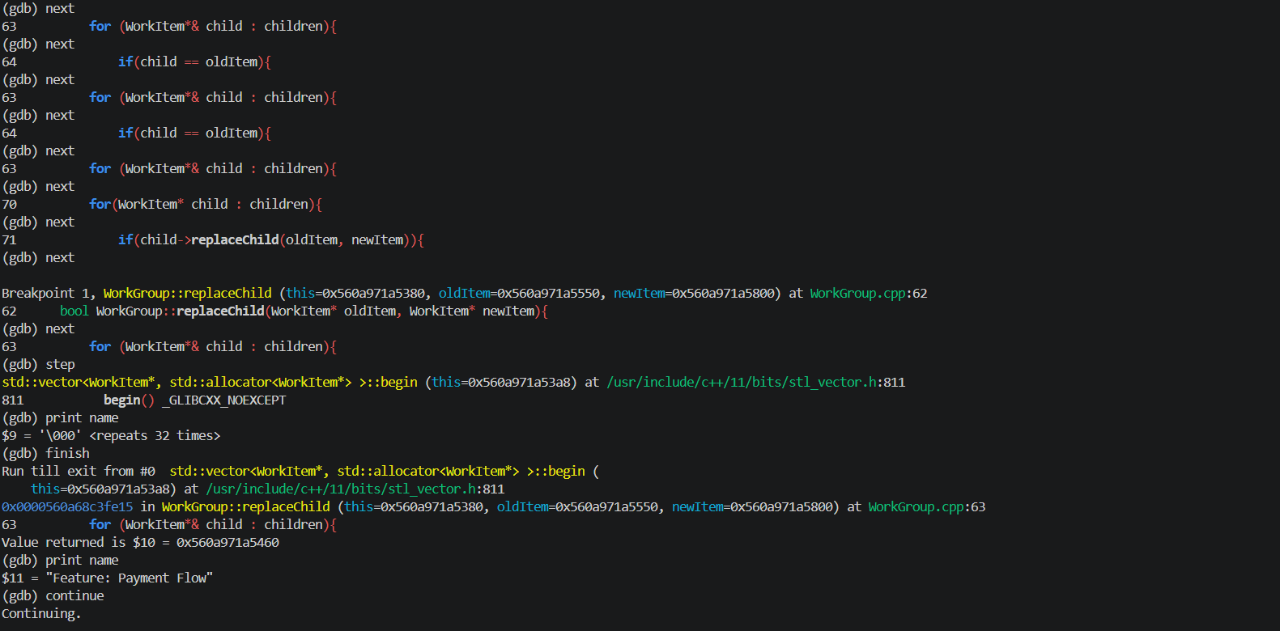

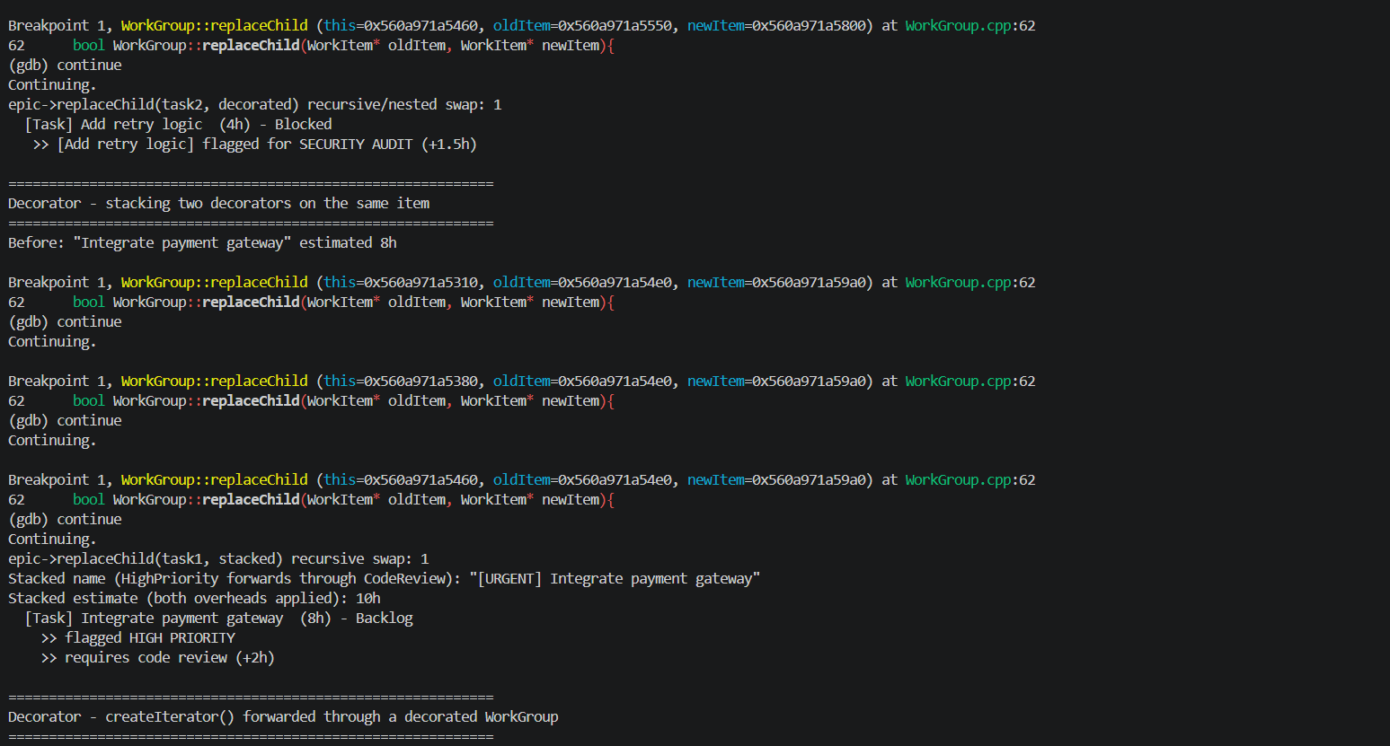
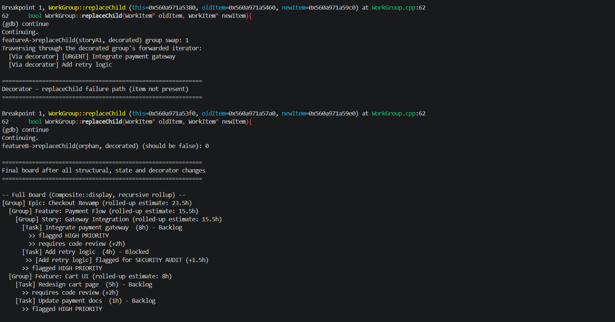
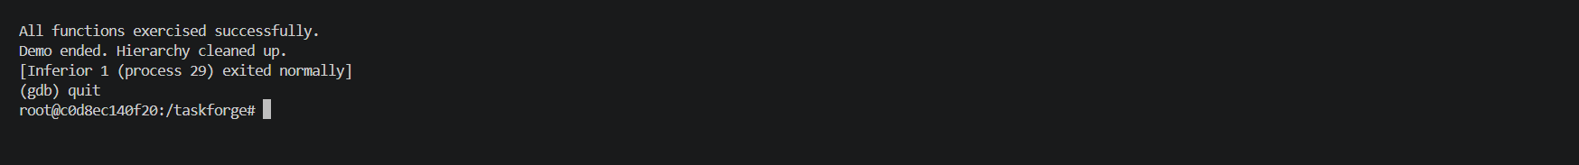
Description of what took place
GDB Investigation: WorkGroup::replaceChild
What we tested: We set a breakpoint on WorkGroup::replaceChild(WorkItem*, WorkItem*) and ran the program under GDB to observe the function's behaviour across both of its cases: replacing a direct child, and replacing a deeply nested item that requires recursing down through the composite structure.
Direct child replacement. The breakpoint first triggered inside featureB's call, where task4 (wrapped by HighPriorityDecorator) was being swapped in. We inspected the arguments directly. print oldItem->getName() returned "Update payment docs" and print newItem->getName() returned "[URGENT] Update payment docs", confirming GDB was giving us live access to the actual polymorphic objects, not just raw pointers. print name returned "Feature: Cart UI", confirming which group instance we were inside. Stepping line by line with next showed the function's first loop (for (WorkItem*& child : children)) comparing each child against oldItem, finding a match on the very first iteration, executing child = newItem, and returning true. The same path was confirmed again on a second breakpoint hit when task3 was replaced in the same group.
Recursive replacement. The more interesting case was replacing task2, which lives three levels below the root (epic contains featureA contains storyA1 contains task2). At this breakpoint, print name returned "Epic: Checkout Revamp" and print children.size() returned 2, confirming we were at the root with only its two direct children (featureA, featureB). Stepping through showed the first loop completing all iterations without finding a match, since task2 is not a direct child of epic. The function then entered its second loop, which recurses into each child via child->replaceChild(oldItem, newItem). Using step (rather than next) on that line followed the call into the next level of recursion, and a repeated print name confirmed we had landed inside featureA's own invocation of replaceChild. This demonstrated that the recursive search correctly descends the hierarchy one WorkGroup at a time until the target is found, without the client (main.cpp) ever needing to know the structure's depth or shape.
A recovery worth noting. At one point, using step on the range based for loop's opening line inadvertently followed the compiler generated call into std::vector<WorkItem*>::begin() inside the C++ standard library (stl_vector.h), rather than into our own recursive call. This was visible immediately: GDB showed no corresponding source file for our own code, and print name returned garbage ('\000' <repeats 32 times>) since name isn't in scope inside std::vector::begin(). We used finish to run out of that frame and return cleanly to WorkGroup::replaceChild, confirmed via a subsequent print name returning "Feature: Payment Flow", showing the recursion had in fact proceeded correctly one level further by that point. This is expected GDB behaviour: step follows any function call, including implicit ones generated by range based for loops, and finish is the correct way to step back out of library code you don't intend to debug.
Conclusion. The session confirmed that WorkGroup::replaceChild behaves correctly in both the direct child and multi level recursive cases, that the traversal never exposes the underlying children container to client code (as required by the non negotiable rules), and that ownership is transferred cleanly at the point of replacement, consistent with the zero leak result later confirmed by Valgrind.

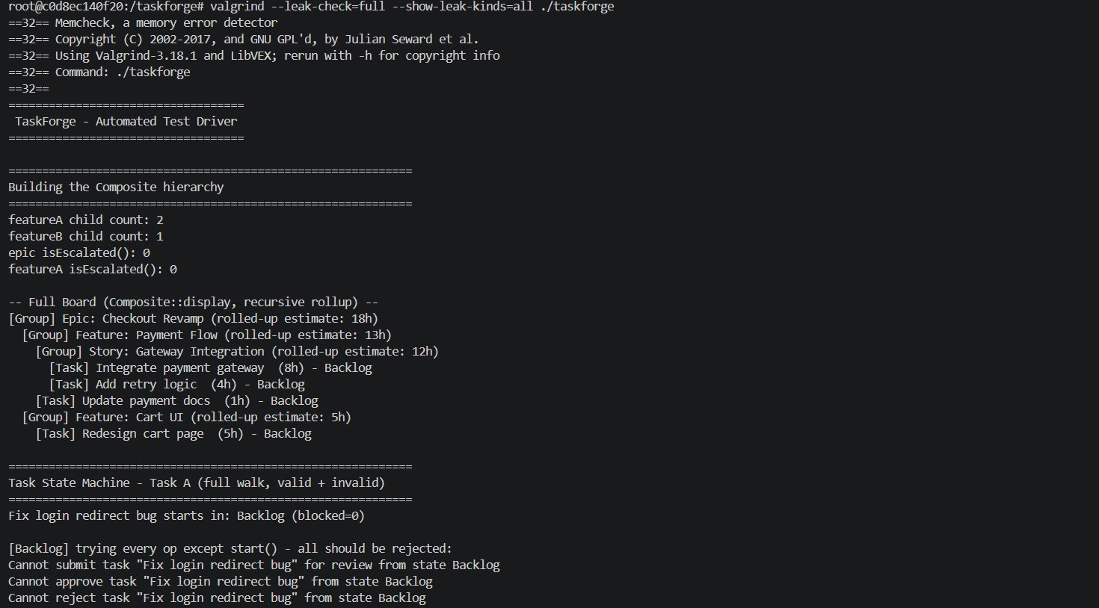
Evidence of using Valgrind
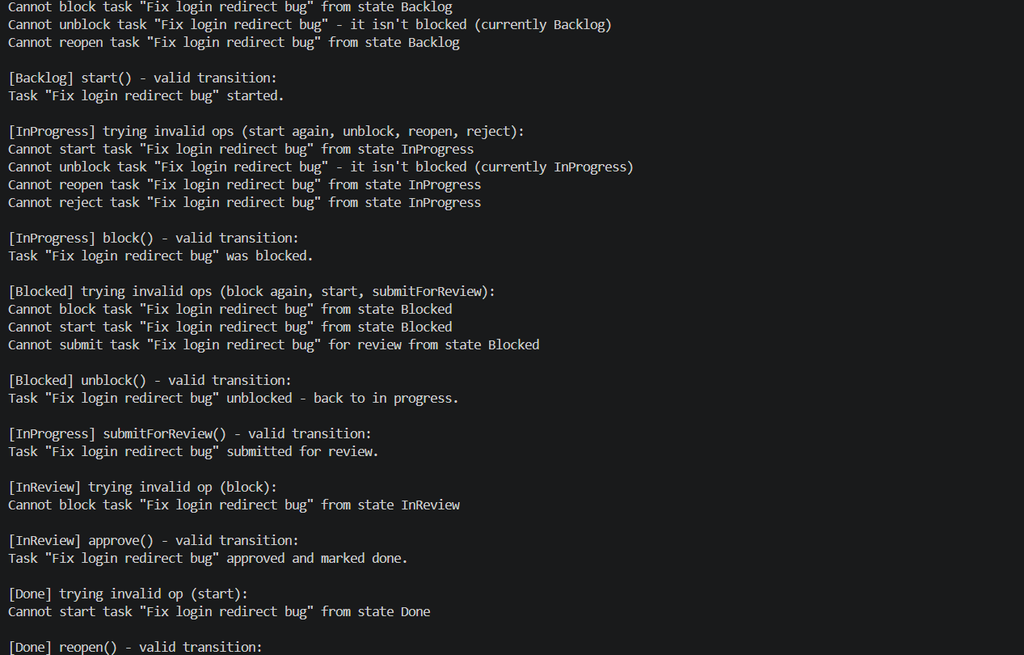

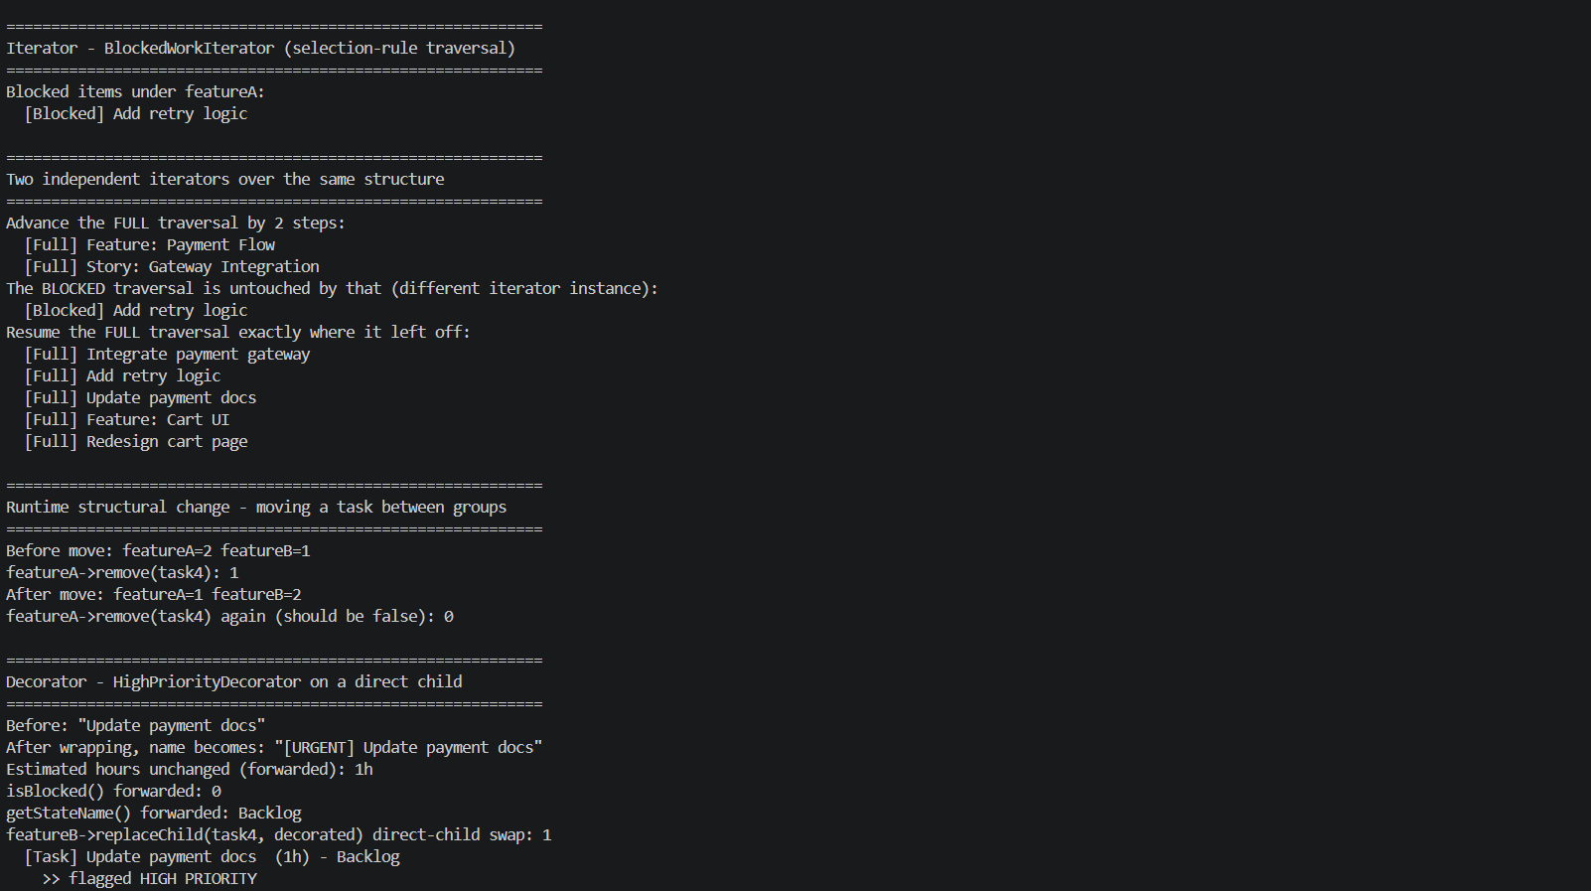
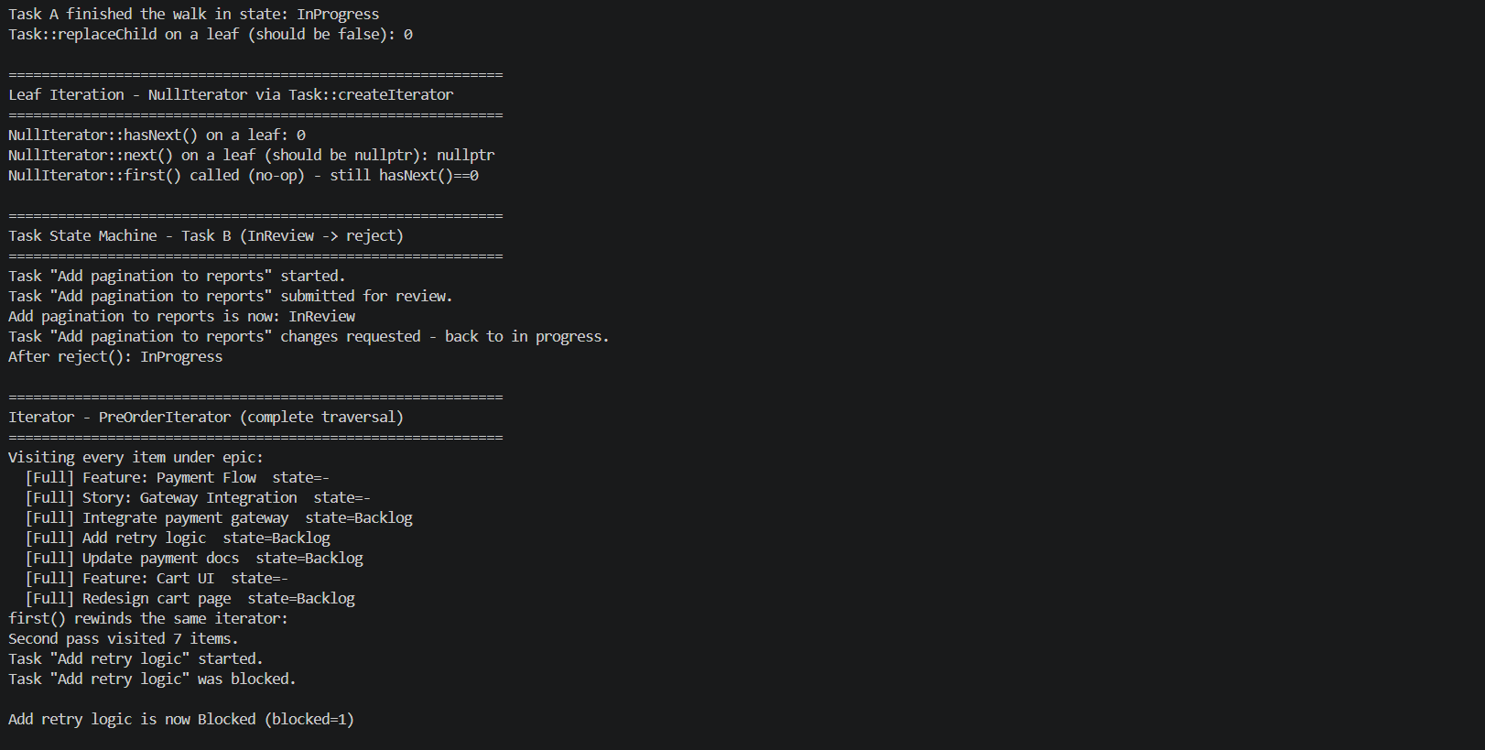

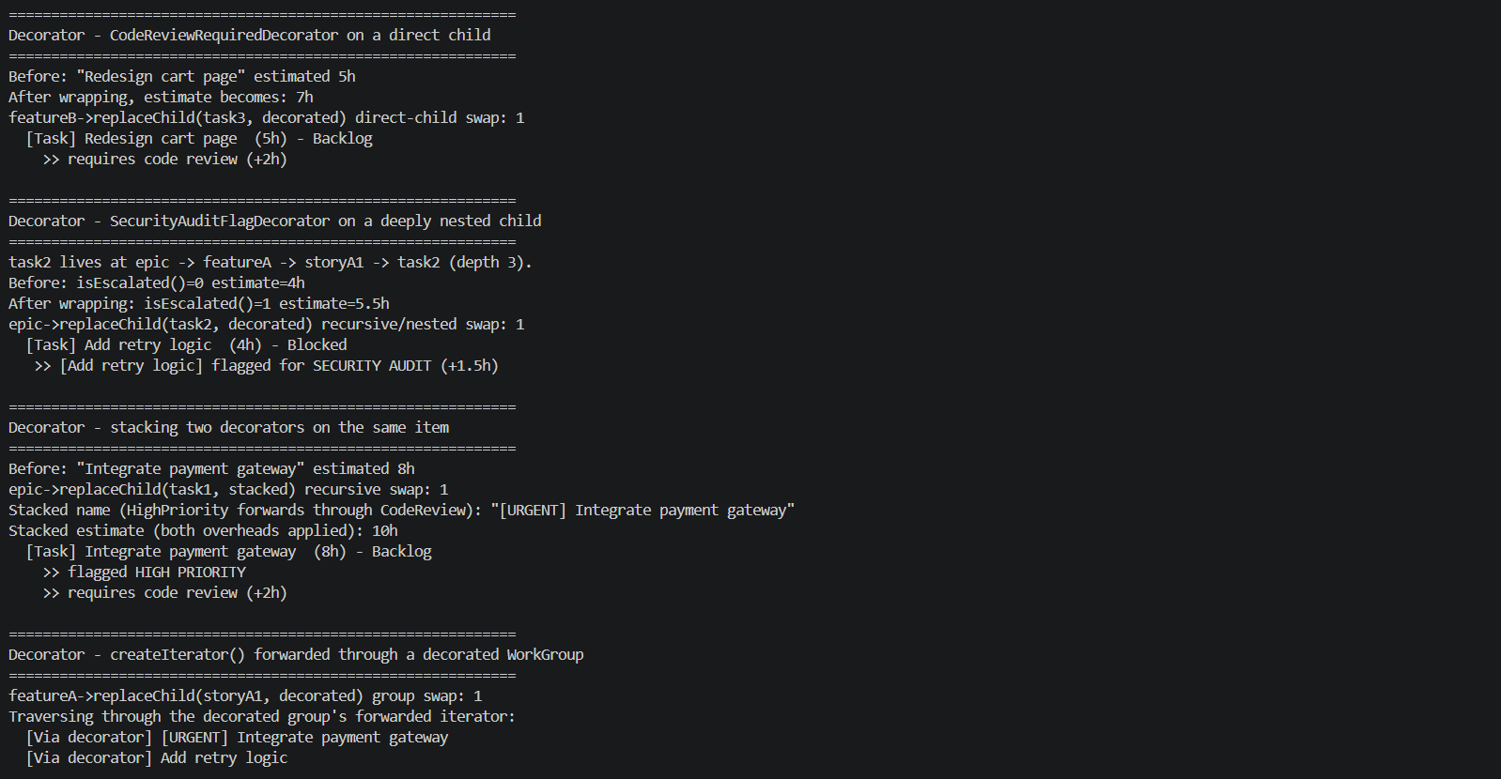
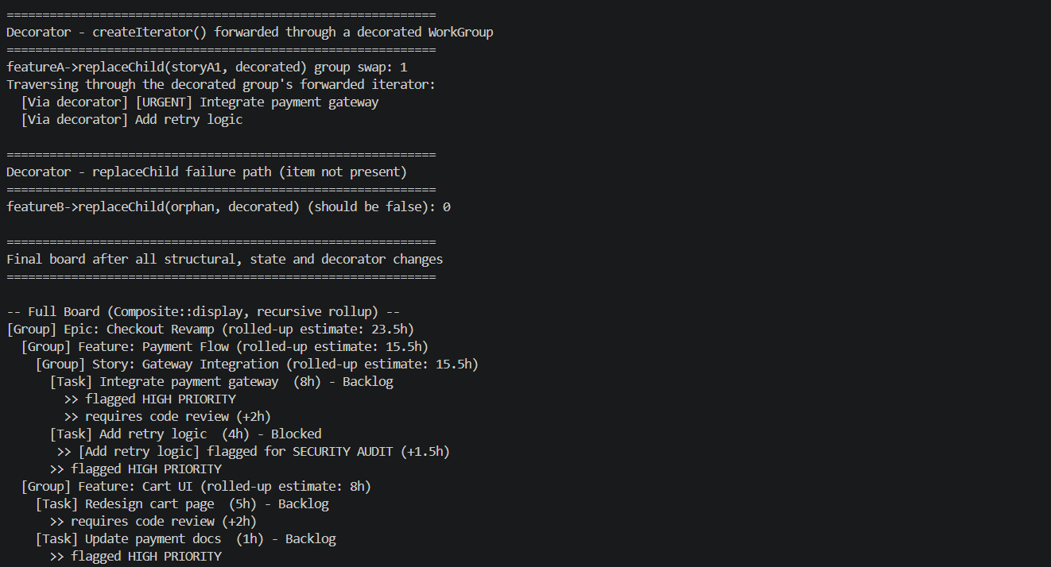

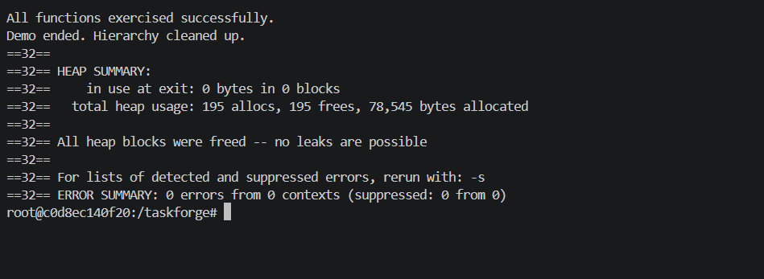
Short Description of the Valgrind Output
Valgrind Investigation
We ran the final build under Valgrind's memory checker with full leak detection:
valgrind --leak-check=full --show-leak-kinds=all ./taskforge
The program ran to completion normally, executing the full demo (composite hierarchy construction, state transitions, both iterator types, structural changes, and all three decorators including a stacked pair) before Valgrind printed its summary. The heap summary reported 195 allocations and 195 frees, with 0 bytes in use at exit, and Valgrind confirmed "All heap blocks were freed, no leaks are possible." The error summary reported 0 errors from 0 contexts.
This confirms that every object allocated during the run, whether owned directly by a WorkGroup, transferred to a decorator via replaceChild, or created as a standalone Task for the state machine tests, was correctly freed exactly once, with no memory leaks, no double frees, and no invalid memory accesses anywhere in the program.

