CHELTENHAM ASSSOCIATION MEETING MINUTES
Date: July 21, 2011
Time: 7:00 P.M.
Location: St. Francis Church
Board Members in Attendance:
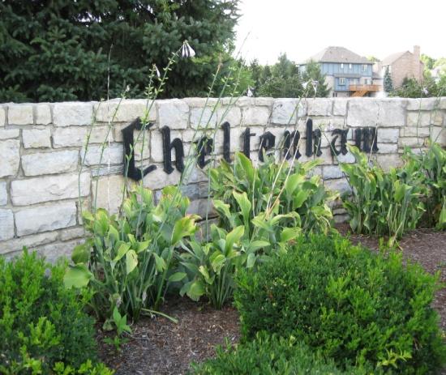
Leda Potente—President
Jene Curell—V. President; Architectural Committee
Cathy Frank—Treasurer
Konnie Marshall—substitute Secretary

Association Members in Attendance:
Cal Frank Ken Ellzey
Phil Kern Mark Peters
Walter Baab Paul and Faye Jendrian
Corinne Smith Roland and Judy Carroll
Dave Bilbery Karen Posey
Scott Graham

President: Leda Potente
Leda called the meeting to order at 7:10, giving time for late arrivals.
Leda gave notice that she is relinquishing her position as president due to her moving to California. All have expressed she will be missed and thanked her for her outstanding performance as president of the Cheltenham Association. Prior to this emergency meeting, volunteers for this position have not been forth coming. Leda advocates working as a team, using team effort of two or possibly three members for the position. The office of president entails: calling the city offices, calling neighbors, calling the police dept., dealing with problems, cleaning up the neighborhood, working with the board members, and conducting a forty-five minute meeting once a month. She relies on neighbors to contact the board regarding problems, such as: loose dogs, post lights unlit, cars on the streets, mailboxes needing repair, and neighborhood theft. An interim president and secretary will fill the open positions until the second Thursday in November where as the election of new board members will take place for the coming year Dec. 2011 through Dec. 2012.
Cal Frank has volunteered as interim President. Walter Baab made the motion to nominate Cal and Karen Posey second the motion.
Motion passed by membership.
Walter has volunteered to work with Cal.
Corinne Smith has volunteered to take the position of secretary. Konnie Marshall made the motion to nominate Corinne as secretary and Karen Posey second the motion.
Motion passed by membership.
Ken Ellzey volunteered his wife to help the board and possibly fill a needed position working with another member.

Welcome Committee:
Sharon Armstrong has been welcoming new neighbors by presenting a basket of gifts and coupons along with presenting the Cheltenham Covenants. Karen Posey is willing to work with Sharon using her marketing expertise to pinpoint methods to entice new blood to become more involved with the neighborhood. Karen advocates using proactive communication. Corinne Smith suggested using personal contact with the residents by assigning members to streets to make contacts. Corinne has volunteered to work with Karen and Sharon to promote methods to entice new members to become invested in the community.

Voiced Concern:
Walter Baab has requested the police department to be contacted for stepped-up patrol of the neighborhood. Concern stemming from the amount of construction in the neighborhood involves many vehicles and construction workers that are present throughout the day. As a precautionary measure, he also requests patrols during the night.

Treasurer: Cathy Frank
Unplanned expenses for 2011 $4700
- Lamp Post Shades X 6 $1470
- Fence Repair $800
- Lawyer $1000
- Website $400
- Huffman Tree Service $800
- Additional Postage $70
- Arborist $150
Total $6,160

Projected bills for Seven months of 2011-2012:
- Lake Doctor X 3 months $1110
- DP&L 7 months $1200
- Water for Sept. & Dec. $2500
- Lawn Service $14500
- Postage & Envelopes $100
Total $19,410
Balance Left $14,388.33
Projected additional expense:
Several mite infected trees need to be removed which will total $4100. It was suggested to purchase new trees at the fall sale at Siebenthaler Nursery to replace those removed. Cal Frank, Walter Baab and Pete Potente have previously removed several infected trees. Infected conifers are a continual problem with several homeowners in the area. A variety of possibilities from arborists have been shared among neighbors.

Other Concerns:
Phil Kern shared with the membership that Hollywood Video had a potential buyer but appears to have pulled out of negotiations. Concern with the empty business.

Cheltenham members continue to have concern with trash left at the bus stop on Wilmington and Briggs.

Members express concern with loose dogs and property not maintained.

A definitive date has not been set for the widening of Alex-Bell.

The board extends to the community an invitation to share information. Check the Cheltenham website for community news and shared resources.

Meeting Adjourned: 7:50 P.M.

