Git is the most commonly used version control system. It’s a widely used open-source software tracking application used to track projects across different teams and revision levels. And this guide will show you how to install Git on Windows.
To install Git, first you will need to download the latest Git for Windows Installer.
· To download, visit https://git-scm.com/downloads and click on the Download button.
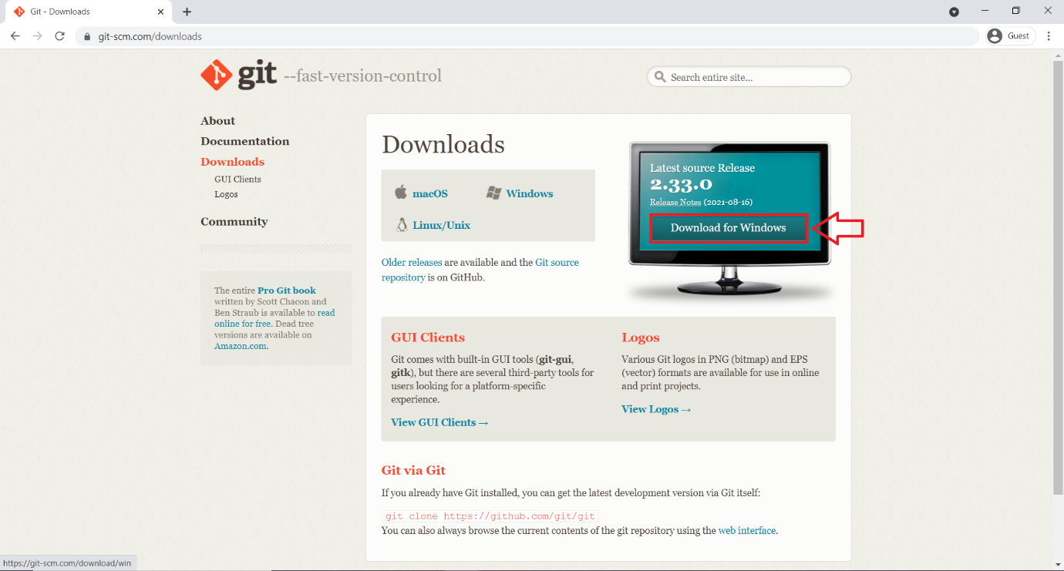
· Browse to the download location and open the Git installer.
· Allow the app to make changes to your device by clicking Yes on the User Account Control dialog that opens.

The installation of Git is very simple, just click on few Next, Next buttons as shown in below screenshots.
· Read the GNU General Public License and then click on Next.
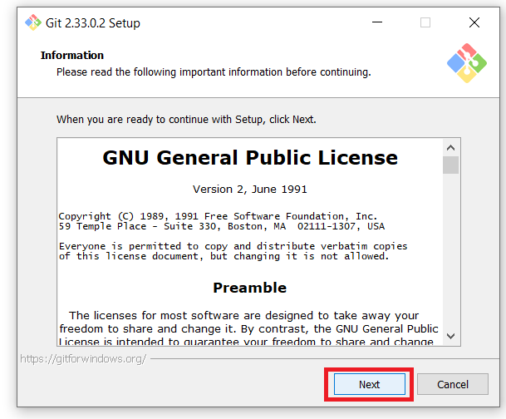
· Then it will ask you to setup the Git installation location. You can keep it to the default location. And click on Next.
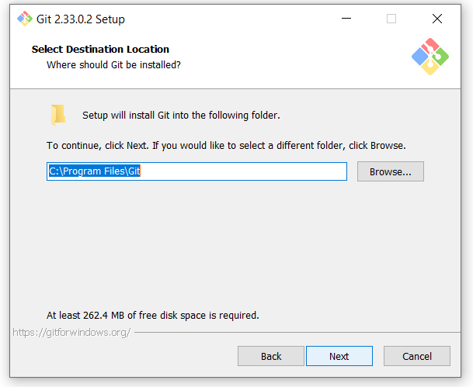
· In Select Components dialog select from the available components to install. (Better keep them as default) and click on Next.
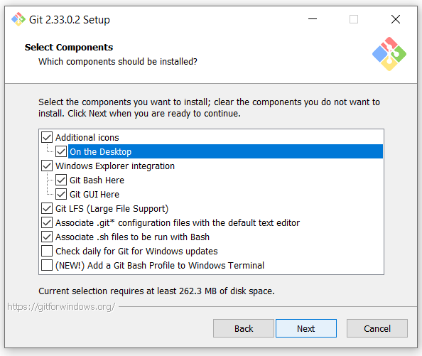
· Then the start menu folder setup will come. Click on Next.
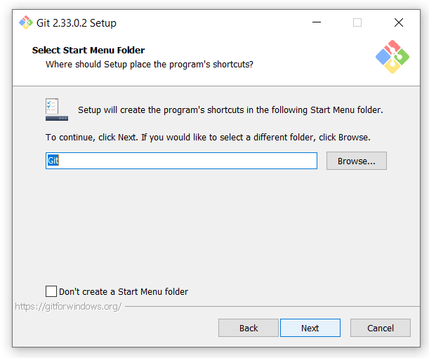
· Next, select from the text editors list you want to use with Git and click Next.
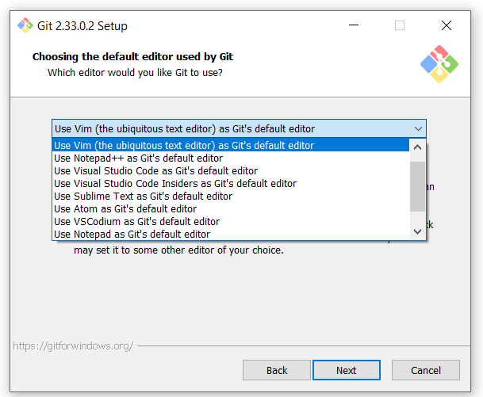
· The next dialog will ask you what should be the initial branch after you run the ‘git init’ command. The default is master; however, you can override it as well. After selecting, proceed.
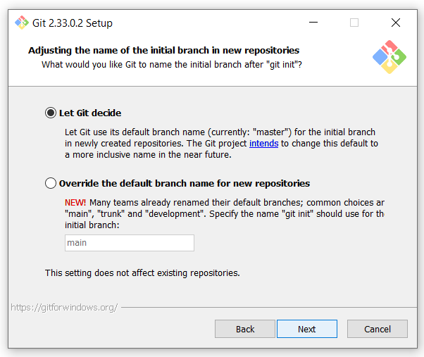
· In adjust your PATH environment dialog, you can change the PATH environment. The PATH is the default set of directories included when you run a command from command line. Better keep the recommended option and click Next.
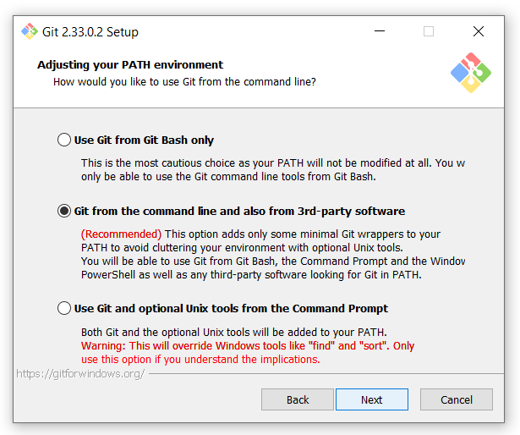
· Which SSL/TLS library would you like Git to use for HTTPS connections? Select the first OpenSSL library.
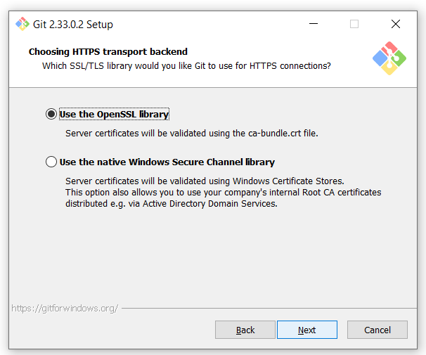
· Line ending conversions? Keep the default select Windows-style option.
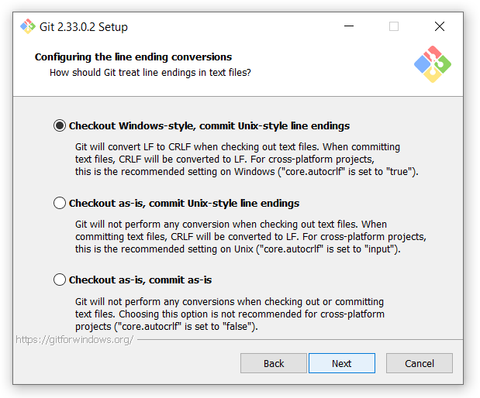
· Which terminal emulator do you want to use with your Git Bash? Check on the MinTTY (the default terminal of MSYS2).
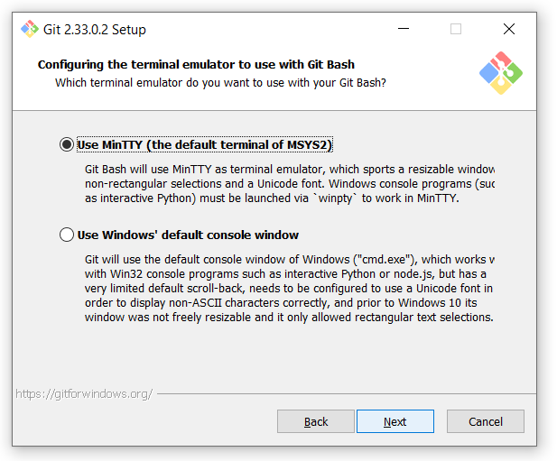
· In the next window it would ask you ‘What should git pull do by default?’ Keep the default selected (fast-forward or merge) option.
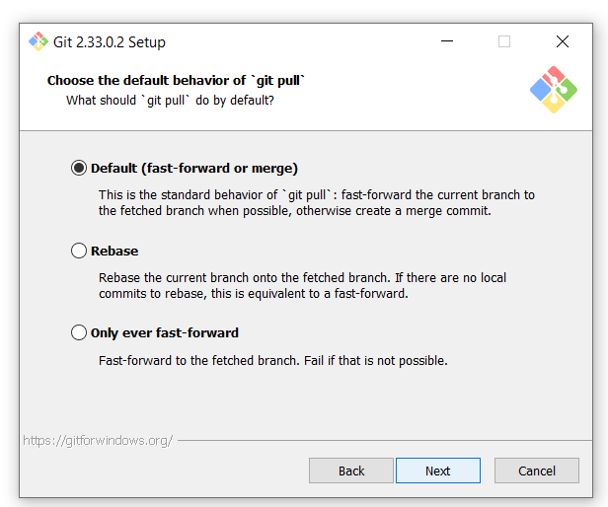
· Choose a credential helper. Select the Git Credential Manager Core.
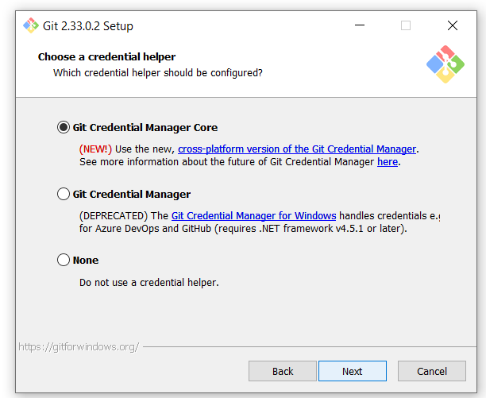
· Additional options, keep the first ‘Enable file system caching’ option checked.
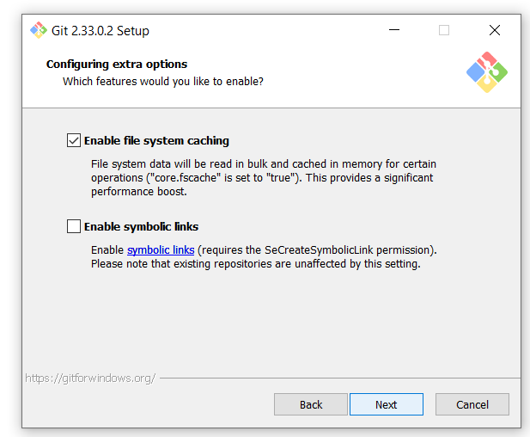
· Experimental options: you can skip them and final click on Install.
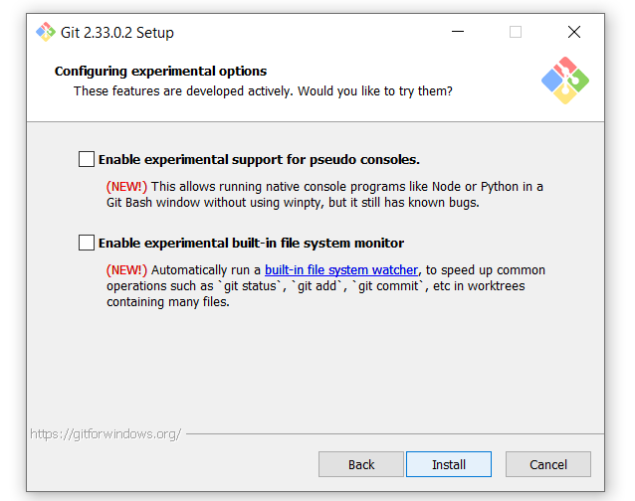
· Once the installation is complete click on the Finish button.
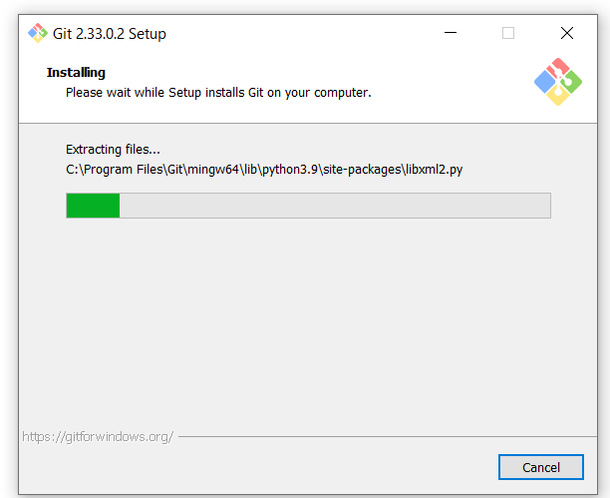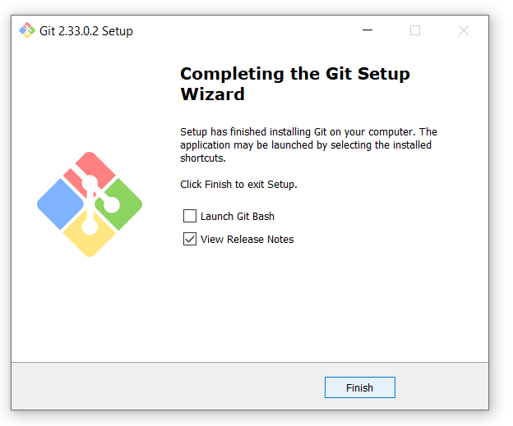

From the Desktop or Start menu, launch the Git Bash application.
To check the installation, type the command ‘git --version’ to check version of it. It should output the installed Git version on your system.
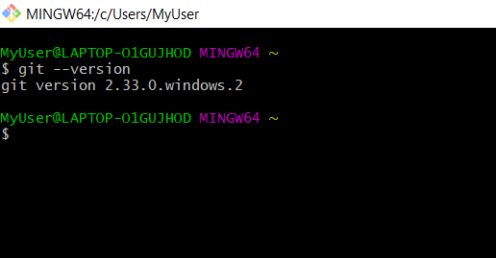
Congratulations! Git is installed on your Windows System.

