batplot: An interactive command-line plotting tool for battery and materials characterization data

Tian Dai, Alexey Y. Koposov
Department of Chemistry, University of Oslo

Abstract
The daily practice of battery materials research involves a diverse set of techniques from structural characterization to electrochemical cycling, with each producing data in distinct formats that have historically required separate, ad hoc scripting for visualization. batplot is an open-source Python command-line tool that unifies these workflows under a single interface, reducing figure preparation to a single terminal command for publication-quality plots. It reads directly from instrument raw output files, supporting common 1D plots for e.g. X-ray diffraction and many more; electrochemistry plots in various formats; and 2D contour plots for the operando/in situ characterization community. Customized interactive menus of each category enable real-time, code-free customization of all visual properties. By accelerating the figure-styling workflow, batplot allows researchers to redirect effort from repetitive visualization process toward scientific interpretation.

Keywords
Data visualization; Battery characterization; X-ray diffraction; Electrochemistry; Command-line interface; Python

Metadata

This ancillary data table is required for the sub-version of the codebase. Please replace the italicized text in the right column with the correct information about your current code and leave the left column untouched.

Nr | Code metadata description | Metadata
C1 | Current code version | V1.8.21
C2 | Permanent link to code/repository used for this code version | https://github.com/chem-plot/batplot
C3 | Permanent link to reproducible capsule | Not available
C4 | Legal code license | MIT Llicense
C5 | Code versioning system used | git
C6 | Software code languages, tools and services used | Python
C7 | Compilation requirements, operating environments and dependencies | Python 3.9 and above; numpy; matplotlib; Windows, macOS and Linux.
C8 | If available, link to developer documentation/manual | https://github.com/chem-plot/batplot/blob/main/USER_MANUAL.md/
C9 | Support email for questions | tianda@uio.no

Motivation and significance
The development of battery materials research generates data across three main categories, each with its own file structure and processing demands for visuallization. The first is basic characterization, including techniques such as X-ray diffraction (XRD), pair distribution function (PDF), spectroscopy, and thermal gravimetric analysis (TGA), etc., which produce data in a common two-column format of intensity versus a physical variable. The second is electrochemical characterization from battery cycling platforms, such as galvanostatic cycling (GC), cyclic voltammetry (CV), differential capacity analysis (dQ/dV), capacity-per-cycle tracking (CPC), galvanostatic intermittent titration (GITT), and impedance spectroscopy, each of which requires dedicated processing to extract the correct columns from raw data files, and separate cycles from the raw instrument output. The third, and increasingly central class is operando / in situ characterization, in which one or multimodal configuration dataset are collected simultaneously with electrochemical cycling. Where assembling a sequence of structural scans into a two-dimensional contour map and aligning it with the concurrent electrochemical cycling profile requires multiple data processing steps that must typically be completed while beamtime remains available. A 2023 perspective review identified the development of “protocols for automated or at least semi-automated data analysis to quickly process the huge amount of data resulting from operando experiments” as one of the central bottlenecks in synchrotron-based battery research.¹ Together, these three classes make up the major pipeline of a modern battery materials study,^{2, 3} yet each produces in its own data structure and requires different, monotonous handling before a figure can be produced.
The growing demand for rapid, accessible visualization across these heterogeneous data types motivates the development of an integrated, code-free platform capable of handling the full range of data encountered in a modern battery materials study. Researchers have typically relied on general-purpose scripting environments such as matplotlib⁴ or Origin⁵, which require repetitive pre-processing metadata and styling. Battery cycling libraries such as Cellpy⁶ and BEEP⁷ provide well-engineered programmatic pipelines for electrochemical data analysis but with less emphasize on publication-aimed visualization. Another key additional barrier across all these tools is that they require substantive programming knowledge, which hinders researchers whose primary expertise lies in materials characterization or electrochemistry. The result is that researchers often count on multiple scripts for plotting each type of data from raw files and customizing the plots is time-consuming.
batplot was herein developed within a battery materials research group to address this gap directly. It reads various raw instrument output files and produces interactive, styled figures for publication use without any user-side scripting, reducing the time from raw file to inspectable figure to a single terminal command. Style export and batch processing enable quick processing without per-file scripting. A researcher who has never written a Python script can use batplot productively from day one. The scientific scope spans the full characterization pipeline of modern battery research: basic characterizations such as XRD, which can be visualized in Q-space or 2θ with automatic wavelength conversion and overlaid Bragg reflection tick marks from CIF files and many other 1D plots; electrochemical data from common battery testing platforms (Biologic, Neware, Landt) are read and plotted without format conversion; and operando/contour mode assembles sequential structural scans with a simultaneous electrochemical panel, a visualization type that previously required per-experiment scripting.

Software description

Software architecture:
As illustrated in Figure 1, batplot is structured as a modular Python package. A command-line interface accepts raw data files, processing flags, and optional style configuration files, and routes execution to one of four mode handlers: an XY mode for one-dimensional diffraction, scattering, and spectroscopy data and many more; a set of electrochemistry modes covering GC, CV, dQ/dV, and cpc; and an operando/contour mode for assembling sequential structural scans into two-dimensional contour maps correlated with an optional side panel. Each mode handler invokes format-specific data readers and constructs a matplotlib figure according to the detected or user-specified axis conventions. Customized interactive editing systems for various types of data, activated by appending the --i flag to any command, operates concurrently with the open figure window and exposes a text-driven menu for modifying visual properties in real time without rerunning the command. A style management subsystem serializes the current figure configuration to portable .bps and .bpsg files. A batch subsystem applies these configuration files uniformly across all matching files in a directory, generating consistently formatted outputs in a single command. A session subsystem serializes the complete figure state, including data, axis parameters, and visual configuration, to a .pkl file for restoration in a subsequent work session.
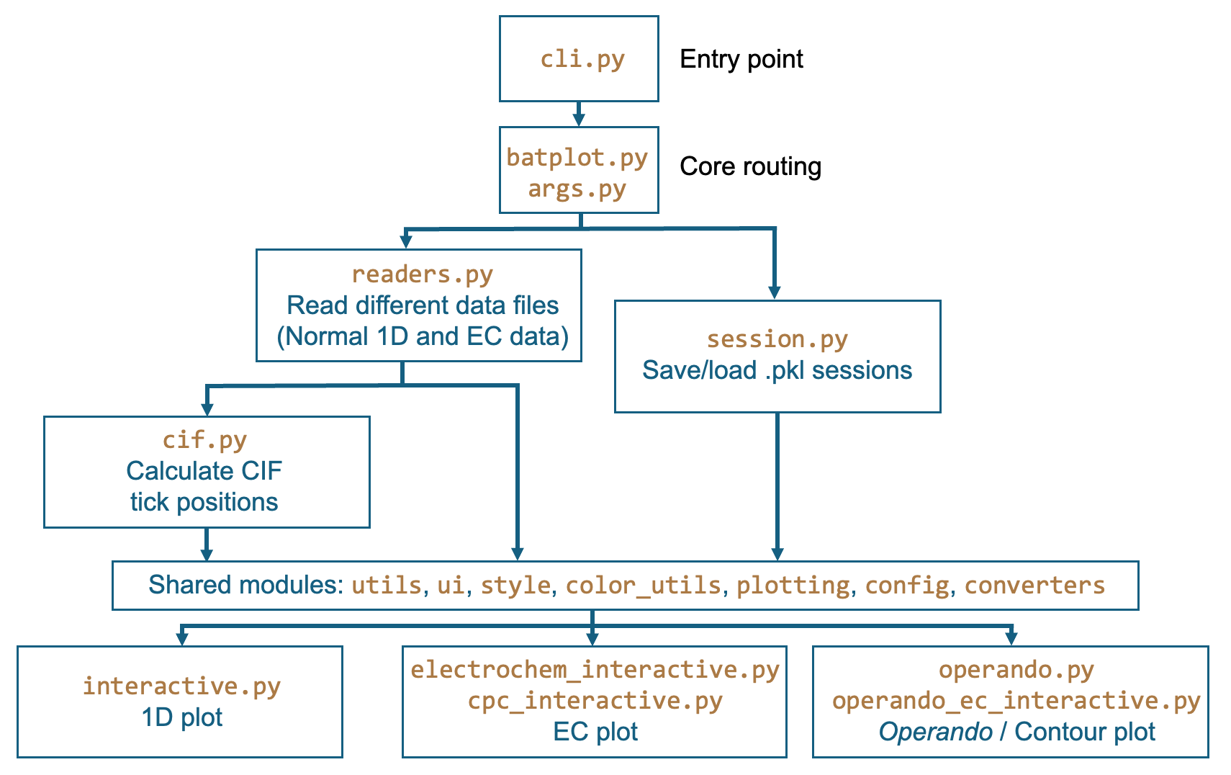Figure 1: batplot code structure
The software is implemented as a pure-Python package with a deliberately minimal dependency requirement. This design choice ensures batplot functions in any standard scientific Python environment. The full packaged user manual can be read directly in the terminal by running batplot -m. The package is distributed via PyPI and supports Python 3.9 to 3.13 on Windows, macOS, and Linux.

Software functionalities:
Figure 2 summarizes the primary functional categories of batplot, each corresponding to a distinct instrument class encountered in battery materials research. The general syntax for batplot is:
batplot path/files --flag1 --flag2 --flag3
where path indicates where batplot should be effective on, and flags are the commands that used to indicate what to do to the path/data files. The most important functionality in batplot is the customized interactive menu by using --i/--interactive flag. Customized interactive menus according to different data types will appear in terminal that are designed according to most common need for plotting battery material characterization and electrochemistry data.
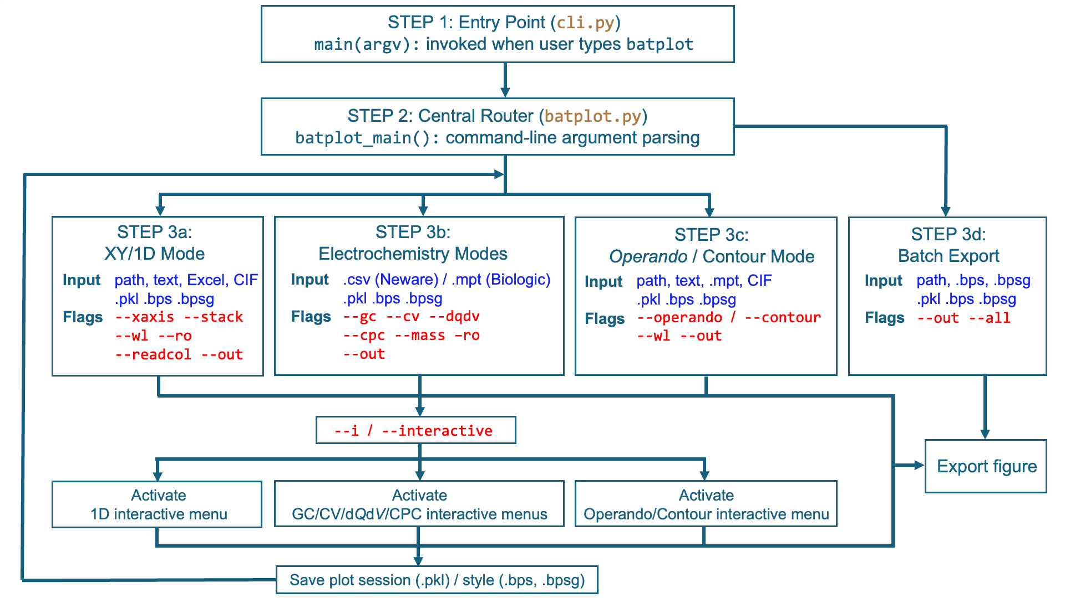
Figure 2: batplot workflow
XY/1D mode accepts all text format files. By default, batplot automatically skips the header lines and uses the first two columns to plot as x and y, alternatively, users can use --readcol m n flag to assign different columns to plot. Wavelength handling for XRD data is a particular strength in this mode. The global --wl λ flag converts all 2θ data to Q-space at once, while per-file colon syntax (e.g. file.xye:0.25995) assigns individual wavelengths when files come from different instruments. A dual-wavelength syntax (file.xye:λ1:λ2) reprojects data from one 2θ frame to another, allowing direct overlay of synchrotron and laboratory XRD patterns on the same axis without any pre-processing. In addition, crystallographic information files (.cif) can be appended to any command to overlay Bragg reflection tick marks with phase labels, and the same CIF files work in both 1D and operando modes with the same wavelength logic.
A built-in data export function (--convert λ1 λ2 or --convert λ q) writes wavelength-converted or Q-space data files to a converted subfolder for use with downstream analysis tools.
Electrochemistry mode supports four analysis types: GC (--gc), CV (--cv), differential capacity analysis (--dqdv), and CPC (--cpc). In all modes, Biologic (.mpt) and Neware (.csv/.xlsx) files are directly read. Multi-files are supported in all types of visualization.
Operando mode (--operando or --contour) is the most distinctive feature of batplot. When pointed at a folder containing sequential XRD or XAS patterns (and all other 1D type of data files), it automatically assembles the patterns into a 2D contour map and, when the .mpt file is detected under the same path, generates the GC curve as a synchronized side panel. This dual-panel figure, correlating evolution with electrochemical state, is the primary visualization type in operando research and previously required dedicated, per-experiment scripting to produce. CIF files can be included in the command to overlay crystallographic phase labels on the contour panel, using the same wavelength conversion logic as in 1D mode.
Interactive menu (--i) is where batplot most distinguishes itself from both scriptable libraries and static plotting tools. Activated by adding --i to any command, it presents a structured menu in the terminal with options for styling/geometry adjustments and options for saving and simple data analysis. Every change is applied live.
Session save and reload: pressing s saves the complete figure state (all data, styling, axis settings, and geometry) to a.pkl file. Reloading this file at a later date (even after restarting the computer) restores the exact interactive session, allowing ongoing refinement of a figure over multiple work sessions without reprocessing any data.
Style and geometry persistence: pressing p exports the current visual configuration as a .bps (style) or .bpsg (style + axis geometry) file, which can be applied to an entire directory with batplot --all style.bpsg --gc, generating a publication-consistent figure set from a single command.
A practical highlight is the allfiles keyword: typing batplot allfiles in any directory instantly overlays all supported data files on one figure, sorted in natural order. Specific extensions can be targeted with allxyfiles, allnorfiles, and so on.

Illustrative examples
The following examples illustrate representative workflows. All commands shown produce a figure window.
Example 1: Simple plot of XRD data
batplot TD_S0062_64.xy --xaxis 2theta
batplot TD_S0062_64.xy Li2FeSeO.cif –-wl 1.54
Navigate to a folder containing the XRD data file (any text format in addition to Bruker .brml and .raw), or use the absolute path to the file at any path. batplot uses x axis to determine the data type, and thus –xaxis flag is needed in most 1D plots. For XRD, one can plot the x axis under either q or 2theta space and the corresponding data type is
Example 1: Stacking plot of XRD data collected from different sources with CIF tick labels.
batplot allfiles --stack --i
Run inside a folder containing any mix of XRD, PDF, or XAS files. batplot reads every supported file, sorts them in natural order (scan2 before scan10), overlays or stacks them on a single figure, and opens the interactive menu. This is the typical first command after returning from a beamline experiment with a folder of raw scans.
Example 2: Synchrotron XRD with wavelength conversion and crystallographic reference.
batplot R02.dat:0.25995 R03.dat:0.25995 Li2Se.cif FeSe.cif --stack --i
Two diffraction patterns from ESRF BM31 (λ = 0.25995 Å) are automatically converted to Q-space. Bragg reflection markers for two phases are overlaid from CIF files. The crosshair cursor (n) can then be used to read exact 2θ, Q, and d-spacing values for any feature of interest directly from the figure.
Example 3: Multi-instrument comparison.
batplot synchrotron.xye:0.25995 lab.xy:1.5406 Li2Se.cif --stack --i
A synchrotron pattern and a laboratory Cu Kα pattern are both reprojected onto the same Q axis via per-file wavelength syntax and stacked for comparison. No pre-processing of either file is required.
Example 4: Galvanostatic cycling with multi-sample overlay.
batplot sample_A.csv sample_B.csv sample_C.csv --gc --i
Charge/discharge profiles from three Neware .csv files are overlaid on one figure. In the interactive menu, each file can be assigned an independent color (c), cycles can be toggled visible or hidden, and the complete styled session is saved (s) for resumption later.
Example 5: Operando XRD and electrochemistry correlation.
batplot /path/to/operando/ Li2Se.cif FeSe.cif --operando --wl 0.709 --i
Sequential XRD scans in the folder are assembled into a 2D contour map. The Biologic .mpt file in the same folder is automatically detected and rendered as a synchronized voltage-time side panel. CIF phase markers are overlaid on the contour. The interactive menu provides dedicated controls for contour colormap, intensity range (cl), and the electrochemical panel’s axis type and range. This figure type is central to mechanistic battery studies and here requires no scripting.
Example 6: Publication batch export.
batplot --all publication.bpsg --gc
Every electrochemical file in the current directory is exported as a separate, identically formatted SVG. The .bpsg style+geometry file was created interactively in the previous step by pressing p → psg. This workflow (design one figure interactively, export all figures consistently) eliminates the per-file formatting effort that commonly introduces visual inconsistency across a paper’s figure set.

- Impact
The primary impact of batplot is on the speed of data visualization with customized interactive modes. A persistent challenge in this field is that raw instrument files from different platforms arrive in incompatible formats, and the repeated effort of reading, converting, and styling these files consumes time that would otherwise go toward their scientific analysis. By providing direct file readers for the most common instrument formats and a unified interactive interface, batplot reduces this overhead to a few terminal commands without any need of coding experience.
The most direct impact of batplot is on the speed of the data inspection step in battery characterization workflows. A researcher at a synchrotron beamline who previously spent several minutes writing a matplotlib script to inspect each incoming XRD pattern can now do so in under ten seconds. This compression of the visualization loop changes what decisions are possible during a finite beam session. Noticing that a new phase reflection has appeared, or that peak broadening is accelerating, is actionable when beam time remains; it becomes a retrospective observation when discovered the following week.
A single-panel structural contour plot correlated with an electrochemical trace is the standard figure type for reporting operando XRD results, yet no openly available, non-scripting tool existed to generate it directly from raw instrument files. batplot fills this gap: a researcher who has collected an operando dataset at ESRF, MAX IV, or Diamond Light Source can render the key correlation figure while still at the facility, without writing code.
The style persistence and batch export system directly benefits publication quality. The “create once, apply to all” workflow (design one figure interactively, save its configuration, run batplot --all style.bpsg) ensures every figure in a study shares identical typography, line weights, tick sizes, and color assignments, without any scripting.
The session save and reload feature changes the economics of figure preparation. Pressing s saves the entire project (data, layout, colors, and axis parameters) to a file that can be reopened days or weeks later for immediate resumption, without reprocessing any data. This is particularly valuable for complex figures that evolve through iterative feedback from collaborators.
Overall, batplot is designed from the earlier moment of quick visualization to the last step – publication ready editing and styling.
batplot is distributed via PyPI (pip install batplot). The current release is v1.8.21 (February 2026). The source code is hosted on GitHub (https://github.com/chem-plot/batplot). The tool is in active use across multiple battery research groups.

Conclusions
batplot provides a unified, zero-configuration command-line interface for the visualization of XRD, PDF, XAS, and electrochemical data, covering the full characterization toolkit of modern battery materials research. Its defining characteristics are speed of access (raw instrument files to a styled figure in seconds) and a deep interactive customization system that requires no programming. The operando mode, which correlates structural contour maps with electrochemical measurements from raw instrument files in a single command, directly addresses a visualization gap identified in the literature as a barrier to the field. The style persistence and batch export system ensures consistent, publication-quality figure sets without per-figure scripting. batplot is openly available via PyPI and GitHub under the MIT License.

Acknowledgements

References
(1) Black, A. P.; Sorrentino, A.; Fauth, F.; Yousef, I.; Simonelli, L.; Frontera, C.; Ponrouch, A.; Tonti, D.; Palacín, M. R. Synchrotron radiation based operando characterization of battery materials. Chemical science 2023, 14 (7), 1641-1665.
(2) Bak, S.-M.; Shadike, Z.; Lin, R.; Yu, X.; Yang, X.-Q. In situ/operando synchrotron-based X-ray techniques for lithium-ion battery research. NPG Asia Materials 2018, 10 (7), 563-580. DOI: 10.1038/s41427-018-0056-z.
(3) Gu, Q.; Kimpton, J. A.; Brand, H. E. A.; Wang, Z.; Chou, S. Solving Key Challenges in Battery Research Using In Situ Synchrotron and Neutron Techniques. Advanced Energy Materials 2017, 7 (24), 1602831. DOI: https://doi.org/10.1002/aenm.201602831.
(4) Hunter, J. D. Matplotlib: A 2D graphics environment. Computing in science & engineering 2007, 9 (3), 90-95.
(5) Origin(Pro), Version Number (e.g. "Version 2022"). OriginLab Corporation, Northampton, MA, USA.
(6) Wind, J.; Ulvestad, A.; Abdelhamid, M.; Mæhlen, J. P. Cellpy–an open-source library for processing and analysis of battery testing data. Journal of Open Source Software 2024, 9 (97), 6236.
(7) Herring, P.; Gopal, C. B.; Aykol, M.; Montoya, J. H.; Anapolsky, A.; Attia, P. M.; Gent, W.; Hummelshøj, J. S.; Hung, L.; Kwon, H.-K. BEEP: A python library for battery evaluation and early prediction. SoftwareX 2020, 11, 100506.

