LiveSankey - User Manual

**Table of Contents**

**Introduction** **2**

**Home Screen** **2**

Data levels 3

Visualization order 3

Visualization settings 3

“Generate diagram” and “Reset” buttons 3

“Data Selection” button 3

**Diagram Screen** **3**

Filters 4

Drag & Drop over nodes 6

Information about the number of instance of a node or a link 7

Zoom 7

Drag & Drop over the diagram 8

# 

# Introduction

LiveSankey allows users to dynamically generate Sankey Diagrams.

“A sankey diagram is a visualization used to depict a flow from one set of values to another. The things being connected are called nodes and the connections are called links. Sankeys are best used when you want to show a many-to-many mapping between two domains (e.g., universities and majors) or multiple paths through a set of stages (for instance, Google Analytics uses sankeys to show how traffic flows from pages to other pages on your web site).“

The system is based on two screens, the Home Screen and the Diagram Screen. The details of the actions that a user may do in each one are presented next.

# Home Screen

The Home Screen of LiveSankey is where the user can configure and generate the Sankey diagram according to the data loaded during the initialization process.

## 

Figure 1. Home Screen of LiveSankey and its different sections

This screen is composed of five sections as shown in Figure 1 with each section numbered:

## Data levels

This section allows users to select the data that will be shown in the diagram. The data levels offered by LiveSankey will be the different fields from the data model loaded during the initialization process.

Some considerations about this section:

* It is necessary, at least, to select two data levels.
* There is no upper limit. However, the selection of five or more levels could increase the complexity and complicate the comprehension of the diagram.

## Visualization order

This section shows the flow order of the selected data levels that will be applied in the Sankey diagram. By default, this flow order corresponds to the order of the data levels that were selected. A user can change this default order by selecting a data level and using the up-arrow and the down-arrow on the left.

## Visualization settings

This section allows changing the granularity of the diagram by indicating the minimum number of instances with the same value required to show a link. It should be noted that a node will not be shown if it has neither an input link nor an output link. Thus, the higher this value, the lower the granularity of the diagram.

## “Generate diagram” and “Reset” buttons

The “Generate diagram” button allows loading the Diagram Screen that will contain the Sankey diagram with the selected configuration (more details about this screen in next section). If the user changes the Data Levels, the Visualization Order and/or the Visualization Settings once the Sankey diagram has been generated, it is necessary to click on this button again to see the new Sankey diagram with the new configuration.

The “Reset” button allows removing completely the current configuration that would be used to generate the Sankey diagram.

## “Data Selection” button

This button allows users to hide or show the Home Screen.

# Diagram Screen

The Diagram Screen of LiveSankey is where the Sankey diagram is shown after its generation. As an example, Figure 2 shows the Sankey diagram generated using the configuration shown in Figure 1.

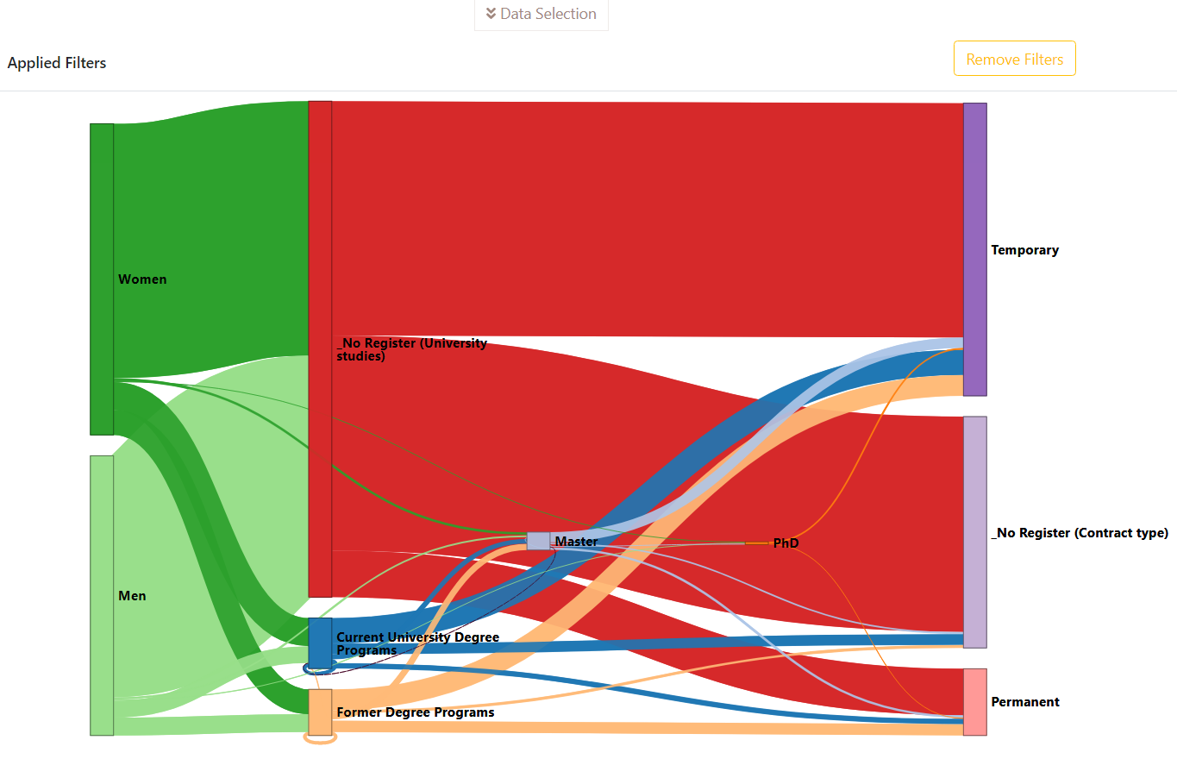

Figure 2. Diagram Screen of the Sankey diagram with the configuration shown in Figure 1

The Diagram Screen provides a set of functionalities that allow to interact and enhance the Sankey diagram. These functionalities are described in the next subsections.

## Filters

This functionality allows users to highlight a node of a data level and the links related to it as well as decrease the intensity of the colours of the rest of the nodes of the same data level (and their links).

To apply this functionality the user should do a double-click on the node.

Some considerations about this functionality:

* There is no limit in the number of filters that can be applied.
* However, if the user select two nodes belonging to the same data level, the result would be that the intensity of the colours of the whole diagram is attenuated.

Figure 3 shows the result of applying the filters “Women” and “Permanent” to the same Sankey diagram displayed in Figure 2. It can be observed how these nodes, and the links related to them, appear highlighted while the rest of the nodes and links appear attenuated. Besides, Figure 3 also shows how the filters that are being currently applied appear on the top left part of the diagram.

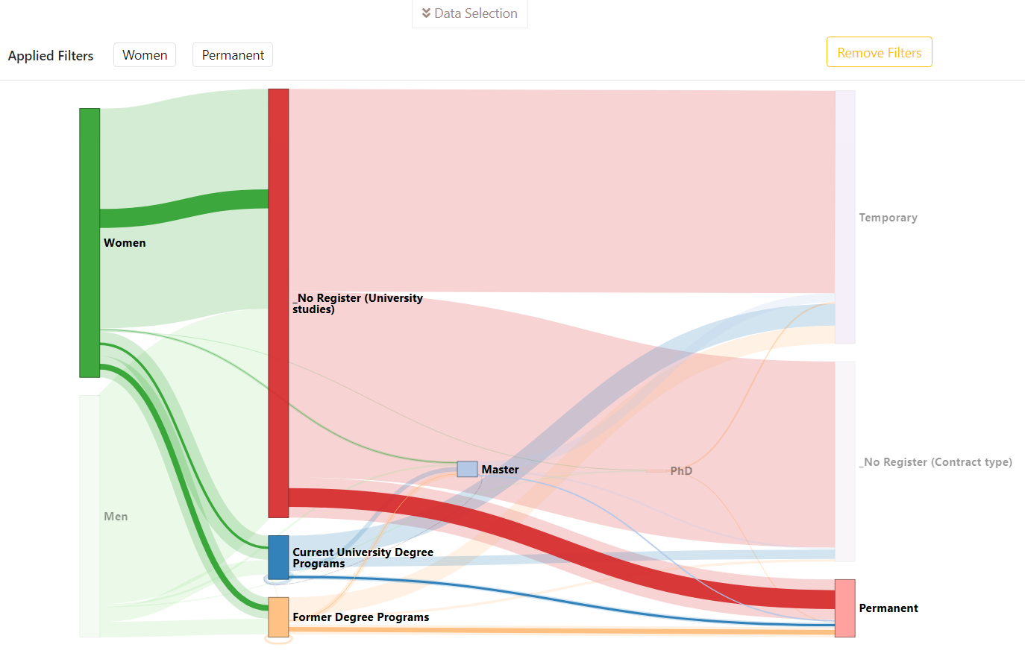

Figure 3. Sankey diagram with “Women” and “Permanent” filters applied

Once one or more filters have been applied, the user has 3 different ways of removing them. First of all, the user could remove all the filters at once by clicking on the “Remove Filters” button located on the top right part of the Diagram.

However, if the user does not want to remove all the applied filters, it is possible to remove the filters one by one either doing a double-click again on the node or simply clicking on the button with the name of the node that appears in the Applied Filters section on the top left part of the diagram.

Figure 4 shows the result of removing only the filter “Permanent” of the Sankey Diagram shown in Figure 3. It can be observed how the node “Women” and all the links related to it appear highlighted while the node “Men” and all the links related to it are attenuated.

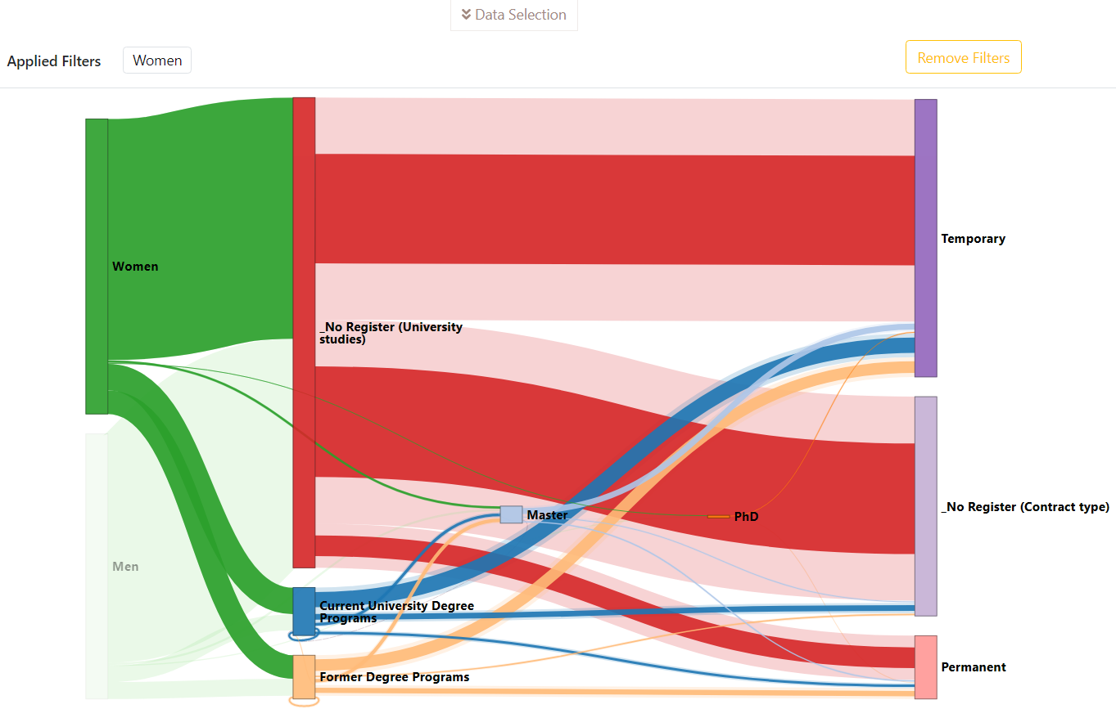

Figure 4. Sankey diagram after removing the filter “Permanent” but with the filter “Women” still applied

## Drag & Drop over nodes

This functionality allows moving vertically the nodes of the diagram with the aim of reorganizing the nodes according to the user’s criteria.

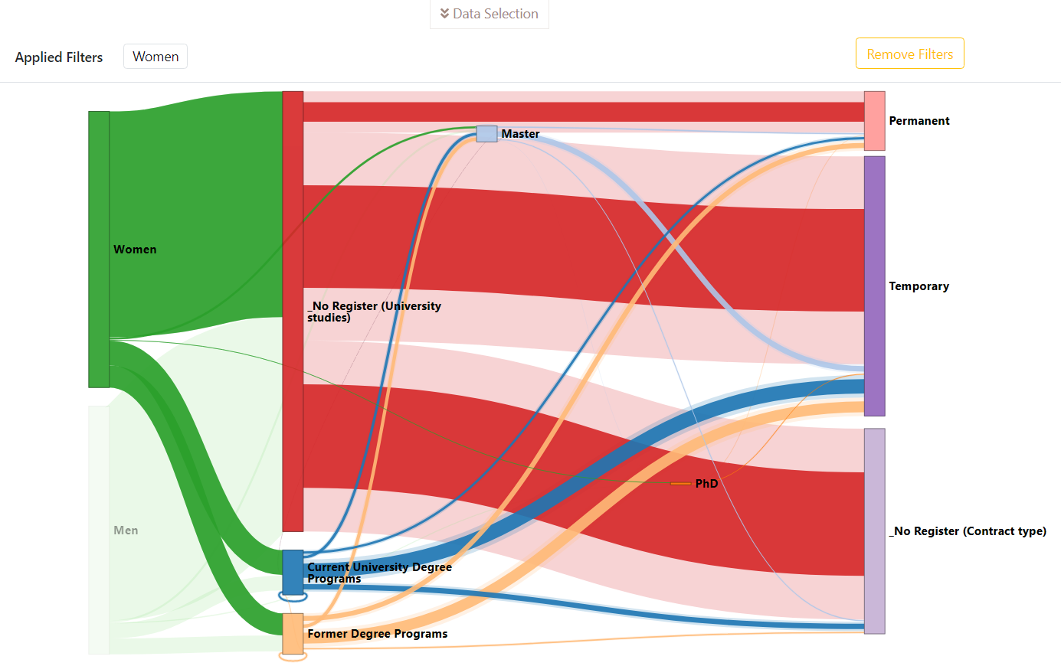

Figure 5. Sankey diagram after moving the nodes “Master” and “Permanent” to the top of the diagram

For instance, Figure 5 shows how the nodes “Master” and “Permanent” of the Sankey diagram shown in Figure 4 have been moved to the top of the diagram to better differentiate them and their links.

To do this, the user should usethe drag and drop method by clicking in the node without releasing the left button of the mouse and drag it until the node is located in the desired location and then released the left button.

## Information about the number of instance of a node or a link

This functionality allows users to see how many instances belong to a node or a link.

To do this, the user only needs to move the cursor over the node or the link and a small pop-up message will appear with this information.

It should be noted that the number of instances shown will be calculated according to the filters applied. Figure 6 shows how the link “Master -> Permanent” is composed of 305 instances but, since the filter “Women” is applied, this number corresponds to the instances with value “Women” in that link.

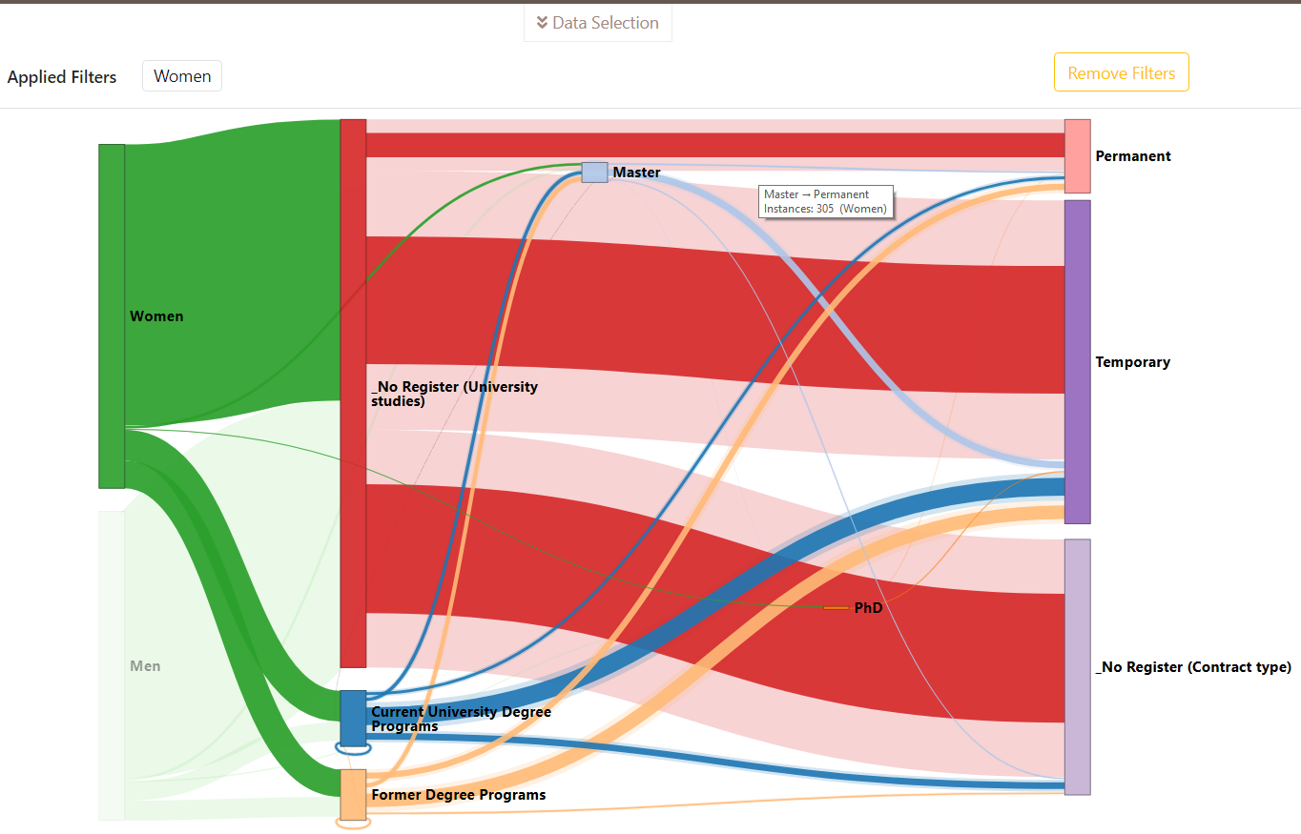

Figure 6. Sankey diagram showing that the link “Master - Permanent” with the filter “Women” is composed of 305 instances

## Zoom

This functionality allows users to zoom in to or out of the Sankey diagram. This functionality is particularly useful when the Sankey diagram is composed of numerous levels with several values belonging to each one.

To use this functionality the user should move the mouse wheel forwards (zoom in) or backwards (zoom out). The zoom in functionality takes the position of the cursor as the origin of this operation. However, the zoom out functionality takes the center of the diagram as the origin of this operation to facilitate that the whole diagram is shown without needing that the user has to do any other action to relocate the diagram.

Figure 7 shows the result of zooming in to the area near to the node “Master” of the Sankey diagram shown in Figure 5.

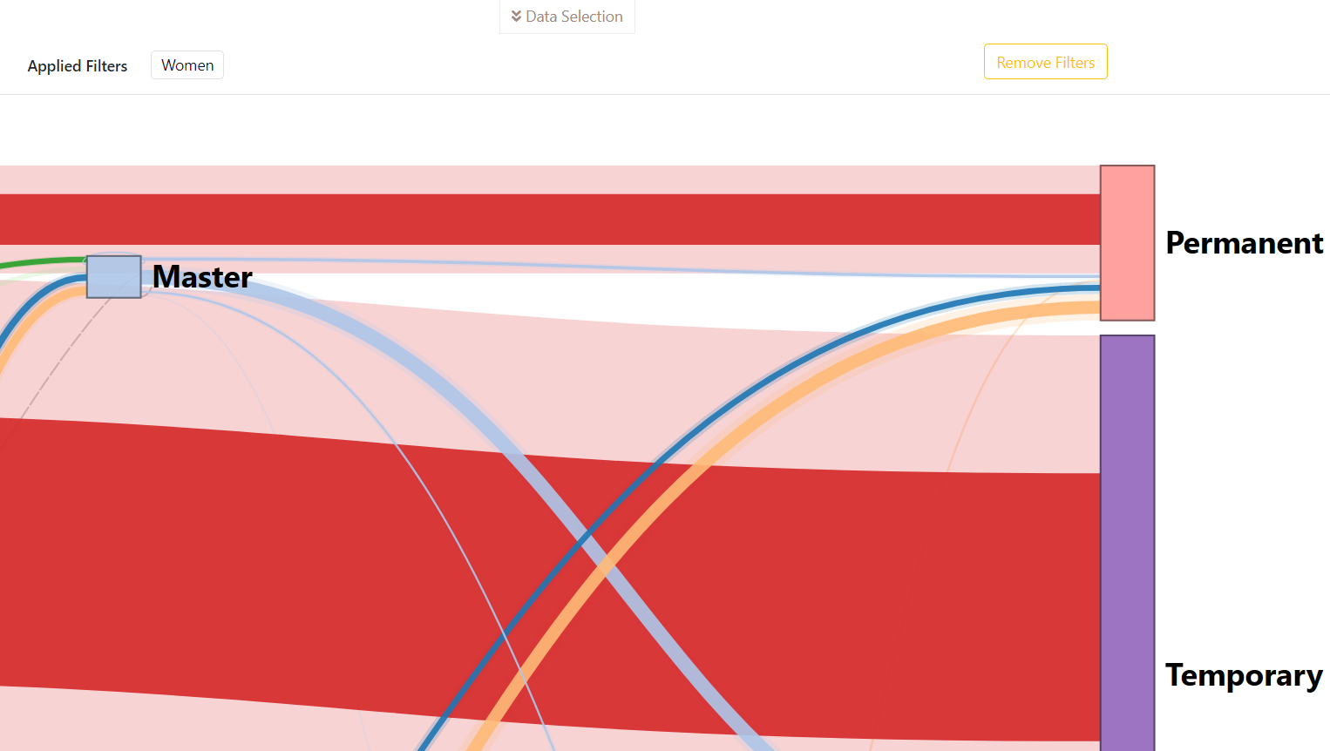

Figure 7. Sankey diagram with the zoom in functionality applied near to the node ”Master”

## Drag & Drop over the diagram

This functionality allows users to move the whole diagram.

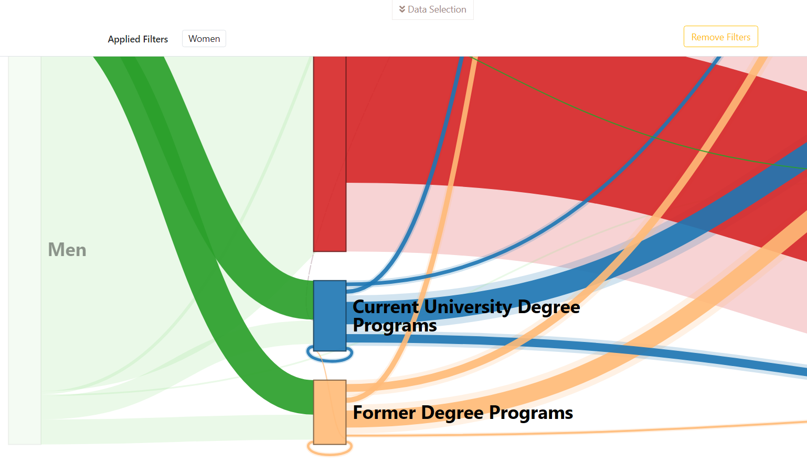

Figure 8. Sankey diagram with the zoom in functionality applied and the diagram moved to see its bottom left part

Thus, it complements the previous one when the zoom in functionality is being applied.

To do this, the user should usethe drag and drop method by clicking in any part of the diagram (except a node) without releasing the left button of the mouse and drag it until the diagram is located in the desired location and then released the left button.

Figure 8 shows the result of moving the diagram with the zoom in functionality applied (shown in Figure 7) to see its bottom left part.