The main objective of this project was to develop a text-based adventure game using elements from HTML, CSS, and JavaScript. During the entirety of the project, we were allocated tasks to work on individually. I took on the role of designing the main page (which I did alongside Adrian), processing page, Game Over page, as well as several rooms in the game (such as: torchroom.html, colourRoom.html, lastRoom.html). I was also the one who came up with the design & aesthetics (CSS) of the game rooms which meant I had to perform final checkups to ensure the layout was consistent.

To elucidate my contributions to the project, I will begin with the main page. For the main page, majority of the coding for the CSS was done by me. I wanted to personalise the game, so I added a session storage key to save the player’s name which will be put into use in different parts of the game.

Apart from the main page, I created a **processing page** to display a countdown timer1 that begins as soon as the webpage loads. Its purpose is to tell the player how long it’ll take until the game begins. The countdown function is designed to redirect the player to the next page right after the timer hits 0.

I also designed another **timer2** to span across all pages within the game. The timer is initially set to 5 minutes & it automatically counts down on load. Session storage has been used to pass down the time remaining along each page. Once the player reaches the last room, an escape button will be displayed on the screen. Pressing it would stop the timer and save the time remaining (to be displayed in the statistics page). The player is automatically redirected to the **Game Over** page once the timer runs out.

The **torch room** represents one of the rooms in the asylum. The player is given a series of options which dictates what their next move will be. Clicking the **‘Walk Around’** button unlocks another set of sub-options which are vital to solve the puzzle. I have created a torch effect3 by utilising the mouseover-mouseleave events & manipulating the image’s opacity. To add on, I have included a **‘Check Lock’** button that will display a text input box. This will then be used to input the code to unlock the door. If it’s incorrect or vice versa, the styling of the input box will change to notify the player.

The colour room mimics the format of the previous room with several significant changes in its features. Like the **‘torch room’**, clicking a certain button displays another set of sub-choices (colour-coded). This time, however, I made a feature where the player must click the coloured buttons4 in a specific order to escape. For this, I used a node list, as well as looping, so that when a button (within the node list) is clicked, it will add the 1st letter of its ‘**value’** to the display box’s (id = ‘pressed’) **‘value’**. The letters would then build up to form the code. Besides that, **‘Stare At Wall’** button which calls a function when clicked. This function displays a ‘text’ box in the middle of the GAME DISPLAY, and gives the user a hint.

Another form of contribution I made was the ‘Game Over’ page. This is where the player will be redirected to if they fail to escape within the time limit. In addition, I also added a **‘RETRY’** button which will redirect the user back to the main page.

**SCREENSHOTS & CODE ANNOTATIONS**

1 Countdown Timer for Processing Page

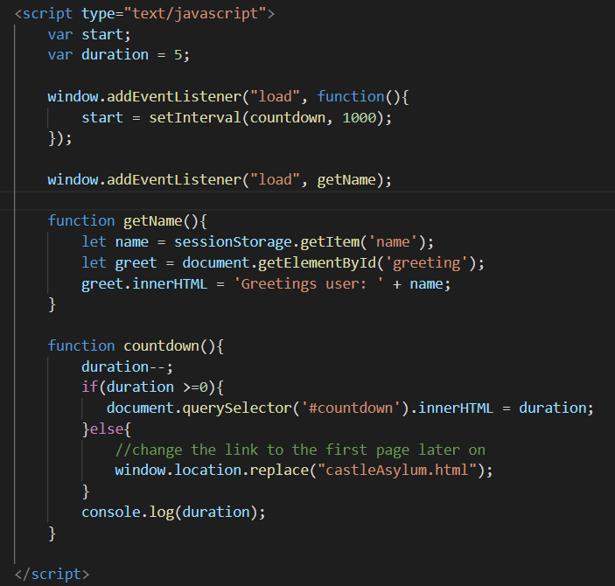

2 Game Timer

^getTimeRem() function to pass the current time from the previous page’s timer

^stops timer after button id: #choice1 is clicked



3 Torch effect

**\*the JavaScript code for the input boxes’ layout won’t be shown here, as it is quite long and extensive**



4 Coloured Button Code

