Csc1030 Group project Personal Report

Matthew Stewart 40332822

**Page 1**

My first page was the arena selection page which allows the user to select either to make their way to the castle or to the asylum using a href on the buttons to redirect the user to the next pageGraphical user interface, website

**Page 2**

this is my outside asylum page which gives the user 2 options to bust into the asylum or turn around and run if the user chooses to turn around a message is displayed using an onclick eventlistener and if the user busts into the asylum text pops up to wish the user good luck using an onclick event listener then the user is directed to room 1 using the nextpage function that I set up I also set a small time delay between switching rooms using my function called setTimeout the pictures below outline the code used Graphical user interface, website

**Page 3**

This is my third page which is the escape room that I made the user is given three choices on what to do each choice pops up with different text for the user to read when chosen this is done using onclick event listeners that display text when the user hits each button. There is a tool hidden in the room that the user must click on to progress To enable the user to interactively click on the tool I used mapping which allows the image to be clickable I then set the coordinates of where I wanted my clickable rectangle to be located. When the user clicks on the crowbar a sub choice button appears using the textPop function that I created then when the user clicks on the textPop function it redirects the user to the next room using an onclick eventlistener with the nextpage function that I set up. All of the images below outline how the code was implementedText

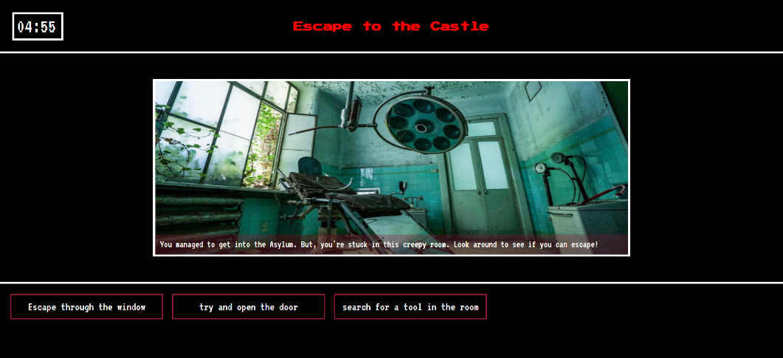

**Stats Page**

Together james and I created the stats page we used session storage that stored all the data of relevant statistics that we needed for the stats page so each time a user entered a room or failed the game It would store the data . we Also used session storage to store the amount of seconds that the user had remaining if they managed to complete the game. We then printed all this data out so the users could see their stats of how they performed. Below are images of how we implemented this code

Together as a group we created this text-based adventure game which is very interactive for users where they must find their way through an asylum solving puzzles along the way to progress. Each member of the group played a key role in the development of the game

I created 3 pages one of them including an escape room and together James and I worked on the stats page together where the user’s performance is displayed at the end of the game if they complete it.