Kinase SARfari Testing Document

1. Go to Kinase SARfari Homepage:

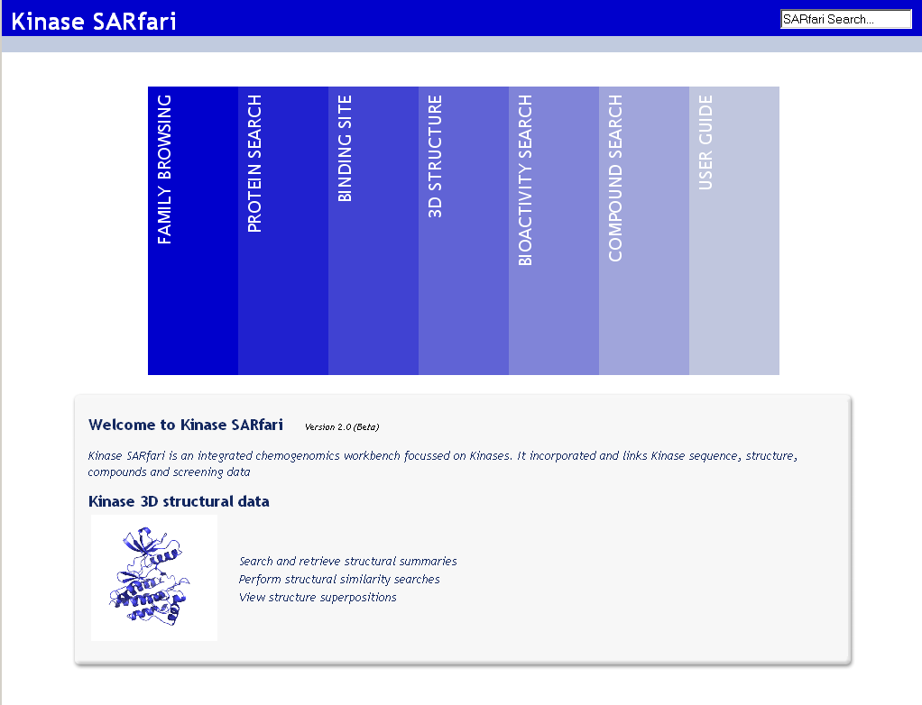

2. Click of Protein Search navigation bar. You should be presented with the following page:

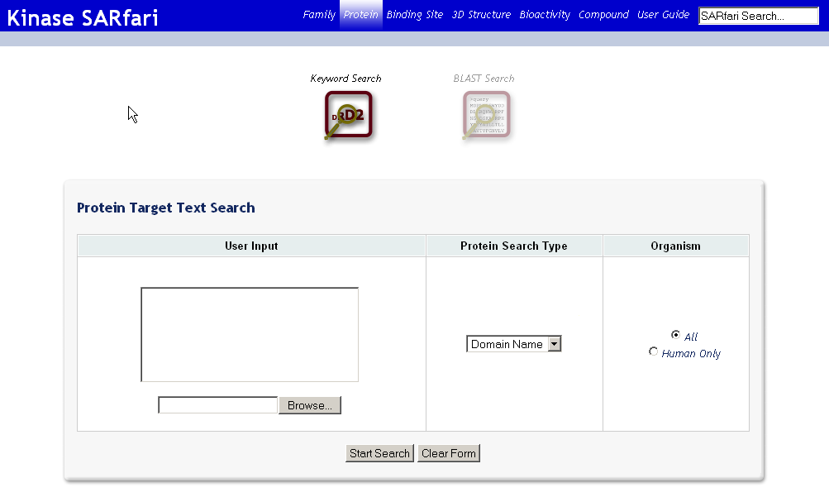

3. In User Input box write ‘cdk’ and select ‘All fields’ from Protein Search Type:

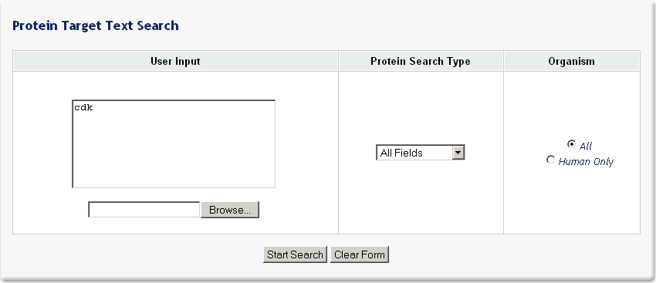

4. After pressing Start Search you should be presented with 43 protein target hits:

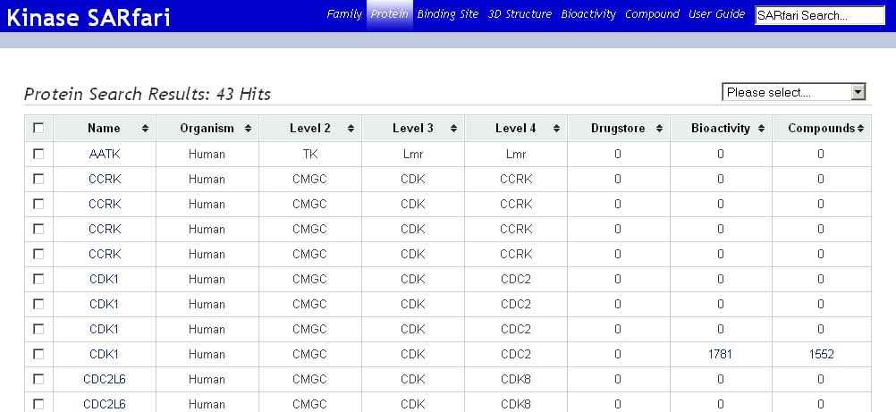

5. Go to Kinase SARfari Homepage and click of Compound Search navigation bar. You should be presented with the following page:

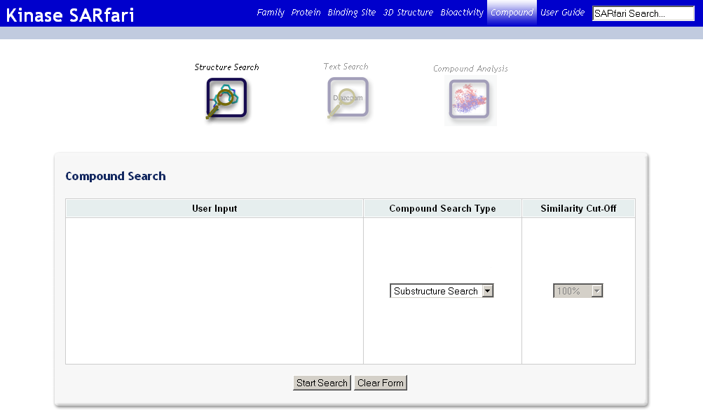
6. In User Input box draw* the compound structure displayed below and select ‘Substructure Search’ from Compound Search Type:

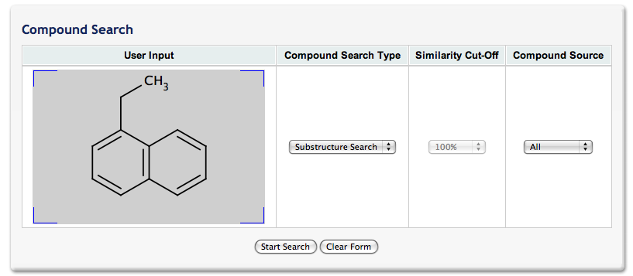

(Double click on User Input to open Marvin Sketcher)

7. After pressing Start Search you should be presented with 45 compound target hits:

