Module 1: Lesson 1 ASSIGNMENT

Read all parts of your assignment carefully, and record your answers in the appropriate places. If you have difficulty with an assignment, review the relevant sections of the lesson and the textbook. Be sure to proofread your answers carefully before submitting your Assignment Booklet.

(15 marks) | Lesson 1 Assignment: Personal Energy Use

- Prepare a spreadsheet that lists both the food and the total energy you consume during one day. Attach your completed spreadsheet to this document for submission to your teacher. See a sample student solution on the next page.

Consider the following headings for your Spreadsheet:

- Time When Food Is Consumed
- Type of Food Consumed
- Serving Size
- Energy Content of Each Type of Food Consumed
- Total Energy Consumed

You can use the internet to research some calorie counter websites to find the energy content of certain foods:

Try this website→ http://caloriecount.about.com/

For the purpose of your spreadsheet, record the energy in joules. If you need to convert a value from calories to joules, you will need to use the conversion equivalent of
1 calorie = 4.19 joules.

Sample Student Answer

Date | 18-Dec-07
Time | Food | Serving Size | Energy Content (J) | Energy Total (J)
7:00 | eggs | 2 | 383 per egg | 766
 | toast (multigrain) | 2 slices | 272 per slice | 544
 | orange juice | 1 glass | 450 | 450
10:30 | banana | 1 | 450 | 450
12:00 | bread (multigrain) | 2 | 272 per slice | 544
 | peanut butter | 30 mL | 775 | 775
 | jam | 15 mL | 205 | 205
 | milk (skim) | 1 glass | 378 | 378
14:30 | chips | 10 | 377 | 377
 | salsa | 30 mL | 30 | 30
16:30 | steak | 1 | 650 | 650
 | potato | 1 | 921 | 921
 | salad | 500 mL | 97 kJ/250 mL | 194
 | red pepper | 1 | 185 | 185
 | milk | 1 glass | 378 | 378
 | cookie | 1 | 372 | 372
 |  |  | Total | 7219

Answers to Try This Question Module 1: Lesson 1-8

Module 1—Thinking Energy

Lesson 1—Personal Energy Use

Try This

An Analysis of the Carbon Cycle

Step 2

Similarities and Differences between Chemical Processes
Chemical Process | Similarities | Differences
Photosynthesis | involve O₂(g), CO₂(g), and  H₂O(g or aq)  can involve a carbohydrate molecule | CO₂(g) and H₂O(g) are reactants.  O₂(g) and carbohydrate (e.g., C₆H₁₂O₆) are products.
Cellular Respiration |  | CO₂(g) and H₂O(g) are products.  O₂(g) and carbohydrate (e.g., C₆H₁₂O₆) are reactants.  Hydrocarbons are not a reactant.
Combustion |  | CO₂(g) and H₂O(g) are products.  O₂(g) and carbohydrate (e.g., C₆H₁₂O₆) are reactants.  Hydrocarbons can be involved in a combustion reaction.

Step 2

Examples of Chemical Reactions
Process | Sample Chemical Equation
Photosynthesis | 6 CO₂(g) + 6 H₂O(g) → C₆H₁₂O₆(aq) + 6 O₂(g)
Cellular Respiration | C₆H₁₂O₆(aq) + 6 O₂(g) → 6 CO₂(g) + 6 H₂O(g)
Combustion | C₆H₁₂O₆(aq) + 6 O₂(g) → 6 CO₂(g) + 6 H₂O(g)  C₃H₈(g) + 5 O₂(g) → 3 C O₂(g) + 4 H₂O(g)

Step 3

Correct Position of Carbon Cycle Diagram

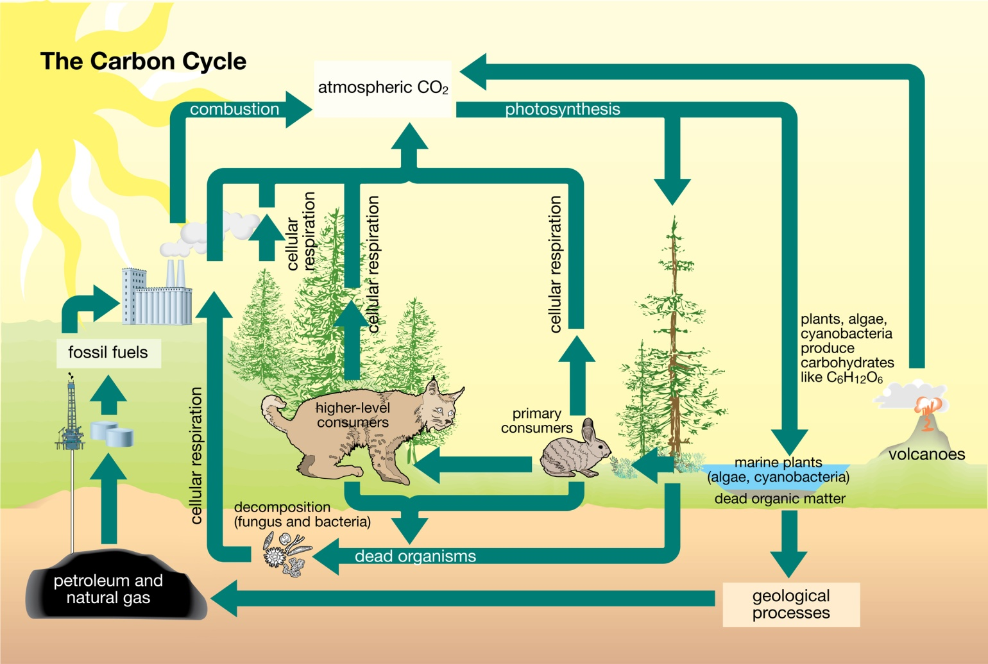

TR 1.

The most important aspect of the carbon cycle is the interrelationship (connectedness) of processes that produce CO₂(g) to those that use CO₂(g) as a reactant. In addition, students may note that the diagram includes fewer processes that use CO₂(g) than those that produce CO₂(g).

TR 2.

Students should be able to recall that CO₂(g) has been identified as a greenhouse gas implicated in global climate change. Processes like the combustion of fossil fuels and deforestation can increase the concentration of CO₂(g) in the atmosphere, adversely effecting Earth’s ecosystems. Designing an ecotour that would not contribute CO₂(g) emissions, or that would balance emissions by promoting practices that remove CO₂(g) from the atmosphere, would minimize adverse impacts on the environment.

Reflect and Connect

RC 1.

Picture | Form of Energy Necessary | Relationship to the Sun
Cross-Country Skis | kinetic energy (from muscles) provided by chemical potential energy from food | All food depends on photosynthesis for its production. The sun is the energy source for photosynthesis.
Automobile Track | chemical potential energy from fuel | Fossil fuels used in automobiles are formed from prehistoric organisms, which were either directly or indirectly dependent on photosynthesis.
Sailboat | kinetic (mechanical) energy (wind) | Uneven heating of Earth’s surface by the sun creates wind.
Airplane | chemical potential energy from fuel | Fossil fuels used in automobiles are formed from prehistoric organisms, which were either directly or indirectly dependent on photosynthesis.

Answers describing how different forms of transportation may be used in an ecotour will vary depending on the activities planned. Justifications for the form of transportation identified may include dependability, ability to access difficult terrain, and environmental concerns such as noise and risk of fuel spillage.

Try This

TR 3.

A carbon offset is a way of reducing one’s carbon footprint by giving money to support projects or programs that reduce greenhouse gas emissions.

TR 4.

Allowing a traveler the opportunity to purchase a carbon offset is consistent with the principles of ecotourism, since the money used to purchase the offset is invested into a project or process that uses CO₂(g) from the atmosphere (e.g., reforestation or maintenance/protection of existing forests).

TR 5.

Answers may vary. Since the traveler elects to pay an additional charge to purchase the offset, one can assume that the traveler has thought about what he or she is purchasing and has determined that it is important. It is also likely that the traveler has or will carefully consider other activities that involve the use of energy, especially fossil fuels.

Try This

Ranking Foods by Their Energy Content

Students are not restricted to collecting information solely about snack foods. The list of foods surveyed should demonstrate breadth of food groups, including snacks, to allow for better comparisons.

Sample Solution

Food | Serving Size | Energy Content per Serving  (kJ) | Energy Content per Gram (kJ/g) | Ranking  (1=highest)
Walnuts | 30 g | 200 Cal x 4.19 kJ/Cal = 838 kJ | 838 kJ/30 g = 28 kJ/g | 1
Fruit and Go | 14 g | 50 Cal x 4.19 kJ/Cal = 210 kJ | 15 | 6 (tie)
Nutrigrain Bar | 37 g | 140 Cal x 4.19 kJ/Cal = 587 kJ | 16 | 5
Fruitsation | 111 g | 50 Cal x 4.19 kJ/Cal = 210 kJ | 1.9 | 8 (tie)
Soup | 250 mL (assume 250 g) | 100 Cal x 4.19 kJ/Cal = 419 kJ | 1.67 | 9
Wheat Thins | 20 g | 90 Cal x 4.19 kJ/Cal = 377 kJ | 19 | 4
Ichiban Noodles | 50 g | 240 Cal x 4.19 kJ/Cal = 1006 kJ | 20 | 3
Pasta | 85 g | 310 Cal x 4.19 kJ/Cal = 1299 kJ | 15 | 6 (tie)
Steak* | 85 g | 240 Cal x 4.19 kJ/Cal = 1006 kJ | 12 | 7
Orange* | 131 g | 60 Cal x 4.19 kJ/Cal = 251 kJ | 1.9 | 8 (tie)
Broccoli* | 155 g | 50 Cal x 4.19 kJ/Cal = 210 kJ | 1.4 | 11
Skim Milk | 250 mL (assume 250 g) | 90 Cal x 4.19 kJ/Cal = 377 kJ | 1.5 | 10
Peanut Butter | 15 g | 90 Cal x 4.19 kJ/Cal = 377 kJ | 25 | 2
*information obtained from http://www.ntwrks.com/~mikev/chart1a.htm

Sample Solutions

TR 1.

The energy content per gram and the ranking are provided in the last two columns of the table above.

TR 2.

Answers will vary. Many reasons may be used to account for differences between perceived and calculated values; for example, portion size and the content of different nutrient components such as fat.

Lesson 3—Specific Heat Capacity

This lesson continues to focus on calorimetry and the review of calculations for energy change using data collected by calorimetry. The analysis of energy transfers, including the algebraic manipulation of algorithms, is covered.

Students will complete two virtual experiments. The first investigation is developed in Self-Check questions 1–4. Students will use the Self-Check responses and animations depicting the manipulation of algorithms to support their initial efforts in reviewing this material. The second investigation involves the analysis of calorimetric data that will be documented in the Lesson 3 Assignment.

Try This

TR 1.

Sample Solution

The first law—that energy can be neither created nor destroyed—is demonstrated in the diagram by the equally sized arrows shown in the system, which indicate that the magnitude of the energy is equal.

The second law—that heat naturally transfers from warmer to cooler objects—is shown by the direction of the arrows. In the case of an exothermic change occurring in the chemical system, energy would radiate to the surrounding water. The reverse occurs during an endothermic change.

TR 2.

The sketch prepared by the student is an opportunity to check for misconceptions regarding an application of the laws of thermodynamics and energy transfers in a system. Lesson 3 and the remaining lessons in Module 1 deal extensively with calorimetry and the analysis of data.

Teachers may wish to initially assess the student’s submission for the proper application of these thermodynamic principles and sufficient detail in explanations offered. The student can incorporate comments provided by the teacher in their work later in this lesson and module. Student incorporation of comments is important evidence of the student’s willingness to consider comments when revising their work.

Sample Sketch

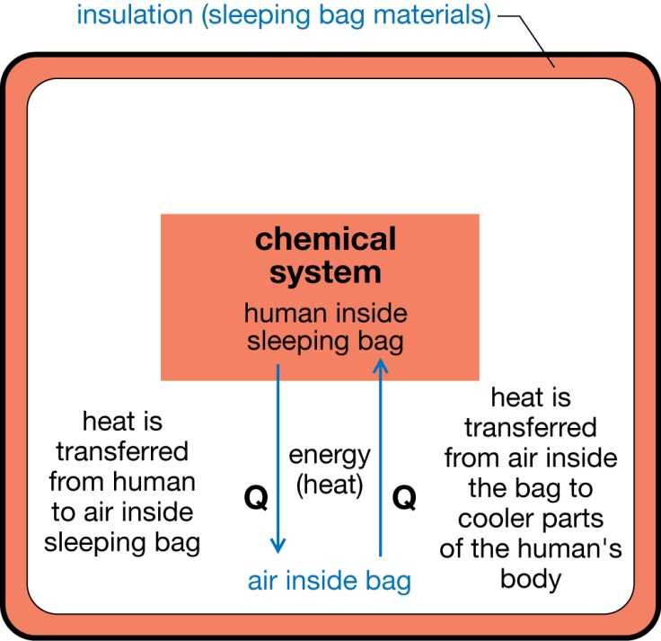

Lesson 4—Enthalpy Changes

Try This

Chemical Potential and Kinetic Energy

TR 1.

Teachers should review cartoons submitted for misconceptions related to chemical potential energy and kinetic energy. More sophisticated examples will identify aspects like boiling and melting points, and different types of chemical bonds that may influence the potential energy within a system.

Weaker responses will not explicitly identify distinctions between the two forms of energy. Teachers might ask students to clarify the distinction by revising their cartoons or to provide a written or verbal description of the meaning and significance of parts of their cartoons.

As a strong knowledge of energy changes and interactions of matter is important in Modules 1 and 2, teachers may wish to assess cartoons and to provide clarifying comments to students where misconceptions exist. To further clarify concepts, teachers may wish to post best examples to the discussion area of their class for review and discussion by all students.

Try This

Energy Measured in a Calorimeter

TR 2.

Sample Solution

A calorimeter is an isolated system, so any energy changes that are detected as a temperature change of the water inside must have occurred due to the energy change of the process being studied in the calorimeter. Since an enthalpy change can be a change in the potential, kinetic, or both potential and kinetic energies of a system, any energy change in the system will influence the temperature of the calorimeter water. As a result, the energy change by the process (system) is equal to the energy change of the water in the calorimeter.

TR 3.

Assumption | Implication
A calorimeter is an isolated system. | Energy transfers only occur between the process being studied and the water in the calorimeter.
The law of conservation of energy is followed. | The energy change of the process equals the energy change of the calorimeter.

Assumptions are listed on page 486 of the textbook.

Reflect and Connect

Energy Change of a Hot Pack

This activity provides an opportunity for student to see how calorimetry can be adapted to study potential energy changes.

RC 1.

Because no other chemical components are placed into the hot pack to cause the reaction, the change is a phase change involving the crystallization of the sodium acetate in the pack’s solution.

RC 2.

A phase change is a change in potential energy involving a rearrangement of the particles from their dissociated state in an aqueous solution to their arrangement in a solid state.

RC 3.

Enthalpy change is the sum of the change in potential and kinetic energies in a system. In the system being studied, the kinetic energy change is 0 since the sodium acetate is undergoing a phase change (crystallization) during the observation.

RC 4.

Δ_{solidifction}H = Q_{calorimeter}

Δ_{solid}H = mcΔt
Δ_{solid}H = 550 g x 4.19 J/(g•ºC) x (30.7ºC – 22.3ºC)
= 19 357.8 J
= 19.4 kJ

RC 5.

The temperature of the water surrounding the hot pack increased when the hot pack was placed in the calorimeter. This means that energy was transferred from the hot pack to its surrounds in an exothermic process.

Lesson 5—Molar Enthalpy

Try This

Molar Enthalpy of Fuel Combustion

TR 1.

Students should indicate that the purpose of determining a molar enthalpy of combustion is to be able to compare the fuels tested in terms of energy released per mole of fuel combusted (similar chemical quantities).

TR 2.

Teachers may wish to focus their comments on whether the experiment described is able to be performed and on whether it would lead to the collection of all necessary data. The formula on the bottom of page 491 of the textbook provides a guide to the measurements that must be completed in the experiment to solve for the value Δ_{c}H_{m}. Safety aspects should also be addressed but may be described generally due to the student’s lack of familiarity with the equipment and fuels identified in the table.

Try This

Reviewing Concepts

Teachers may wish to review the students’ summaries of Lessons 1–5 to ensure they address all topics introduced, that the work is accurate, and that the work demonstrates depth of understanding.

Lesson 6—Communicating Enthalpy Change

Try This

TR 1.

Preparing summaries of the four different methods to express enthalpy changes will improve the student’s ability to identify the differences and similarities between these techniques. Teachers may wish to really focus on this part of the lesson as students are often required to manipulate equations and enthalpy change information into and between these four methods.

Sample Solution

Question | Method to Communicate an Enthalpy Change
Question | Molar enthalpy of reaction for a specific reactant | Enthalpy change for a balanced reaction equation | Inclusion of the energy as a term in a balanced reaction equation | Chemical potential energy diagrams
How is this method done? | Δ_{r}H_{m} | A + B → C + D Δ_{r}H = – XX kJ  substance involved in the experiment | A + B → C + D + XX kJ  from enthalpy of reaction | 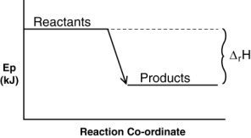
What do I need to remember to do this correctly? | from experimental data: Δ_{r}H / n  or n = coefficient of one species in balanced chemical equation | from experimental data: Δ_{r}H = mcΔt  or Δ_{r}H = n (Δ_{r}H_{m}) where n equals coefficient for one species in the balanced chemical equation or the moles of substance | exothermic reaction = energy on products side; endothermic reaction = energy on reactants side | enthalpy of reaction shows a difference between position of reactants and products; products lower = exothermic

Lesson 7—Hess’ Law

Try This

TR 1.

Reaction 1: AB --> A + B
Reaction 2: A + CD --> AC + D
Reaction 3: B + D → BD
Net Reaction: AB + CD --> AC + BD

TR 2.
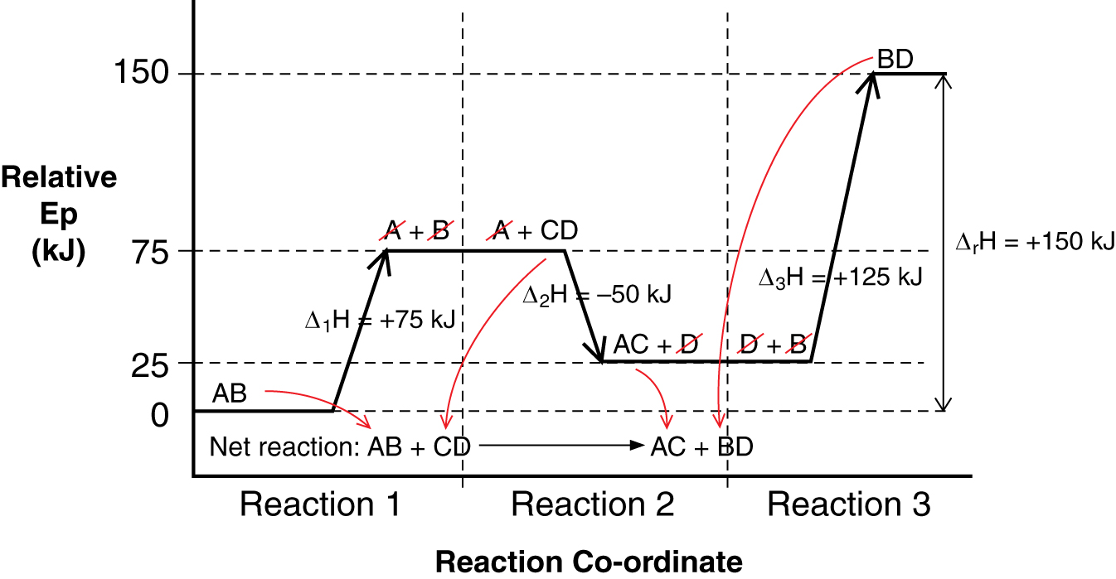

TR 3.

Δ_{r}H = Δ₁H + Δ₂H + Δ₃H
Δ_{r}H = (+75 kJ) + (-50 kJ) + (+125 kJ)
= +150 kJ

TR 4.

Statement | Scientific Principle
- If the chemical reaction is reversed, then the sign of the change in enthalpy is reversed. | A chemical change involves a change in potential energy. The magnitude of the change is determined by the chemical potential energy of the products and the reactants.  Processes are reversible and, if reversed, they change from an exothermic to an endothermic process. Therefore, when a process is reversed the sign on the enthalpy change must be adjusted accordingly.
- If the coefficients of the chemical reaction are altered, then the change in enthalpy is also altered by the same factor. | The magnitude of an enthalpy change is proportional to the chemical quantity of material involved. Coefficients in a balanced chemical equation represent the proportions (at the molar level) of matter involved in a reaction.  These relationships can also be expressed as  Δ_{r}H = Δ_{r}H_{m} (n), where n = moles of substance involved in a reaction.

