Module 2: Lesson 1 ASSIGNMENT

Read all parts of your assignment carefully, and record your answers in the appropriate places. If you have difficulty with an assignment, go back to the textbook and review the appropriate lesson. Be sure to proofread your answers carefully before submitting your Assignment Booklet.

Lesson 1 Lab: Biodiesel

Quantitative Observations

- Record the measurements for

- volume of oil used

Answer: (2 marks)

- volume of biodiesel collected

Answer: (2 marks)

- Calculate the yield of biodiesel as a percentage of the volume of oil used in its production.

Answer: (1 mark)

Qualitative Observations

- Complete the tables below. (9 marks)

Observations of Reactants: | Observations of Biodiesel:
Olive oil Methanol  Colour:  Viscosity:  Clarity: | Colour:  Viscosity:  Clarity:

Type of Fuel in Burner | Colour of Flame | Description of Smoke Produced | Other Observations
Olive Oil
Methanol
Biodiesel

Observations: Testing Biodiesel

- Construct a data table to record and organize the data from the calorimetric test of olive oil, methanol, and biodiesel produced from olive oil.

Answer: (21 marks)

- Calculate the energy of combustion per gram of fuel for each of olive oil, methanol, and biodiesel.

Answer: (6 marks)

- Rank the three materials tested with respect to increasing energy content per gram of substance.

Answer: (1 mark)

- Does the process you undertook to make biodiesel improve the energy content per gram of the oil? Use the data from the experiment to support your answer.

Answer: (2 marks)

- Use the Internet or other resources available to you to provide reasons why biodiesel is produced by a chemical process and vegetable oil is not used directly as a fuel.

Answer: (3 marks)

Answers to Try This Question Module 2: Lesson 1,3

Module 2—Talking Energy

Lesson 1—Alternative Fuels: Biodiesel

Try This

TR 1.

Sample Solution

The following criteria to be considered in choosing an appropriate fuel for a vehicle are ranked in decreasing order of importance:

- energy content of fuel (kJ/g)

- compatibility with engine
- can’t run a diesel engine on regular gasoline

- availability of fuel
- don’t want to be stranded

- environmental impact
- low sulfur gasoline and gasohol cause less pollution than other fuels do
- completeness of combustion
- particulate matter produced

- cost
- regular gasoline, if adequate for the vehicle, is cheaper than premium grade

- ease of ignition
- some fuels may not be volatile enough to readily ignite, especially on cold days

- engine wear
- some fuels are claimed to cause less friction and fewer engine deposits

- fuel consumption in L/100 km
- some fuels or grades give better mileage results than others

- cost of conversion from one fuel to another
- propane or methane might be practical fuels if the cost of converting the vehicle to burn them is not prohibitive

Lesson 2—Energy Diagrams and Activation Energy

Try This

TR 1.

This question can be used to determine if students have a sufficient understanding of different energy levels for different phases of matter and the energy profile for a reaction. Teachers may wish to focus on correct use of terminology to describe phases of matter and the energy changes necessary for a reaction to occur.

Vapourized hydrocarbons have higher potential energy than hydrocarbons in the liquid state. In terms of a potential energy diagram, molecules in the gaseous state are closer to achieving sufficient energy of activation than molecules in the liquid state.

Molecules in the vapour state have higher potential energy than molecules in the liquid state, and, at warmer temperatures, will possess sufficient kinetic energy to collide and result in a chemical reaction converting reactants to products. Due to this higher potential energy, the gap between the energy of the reactants as a vapour and the threshold energy is lower, resulting in a greater probability that combustion will occur.

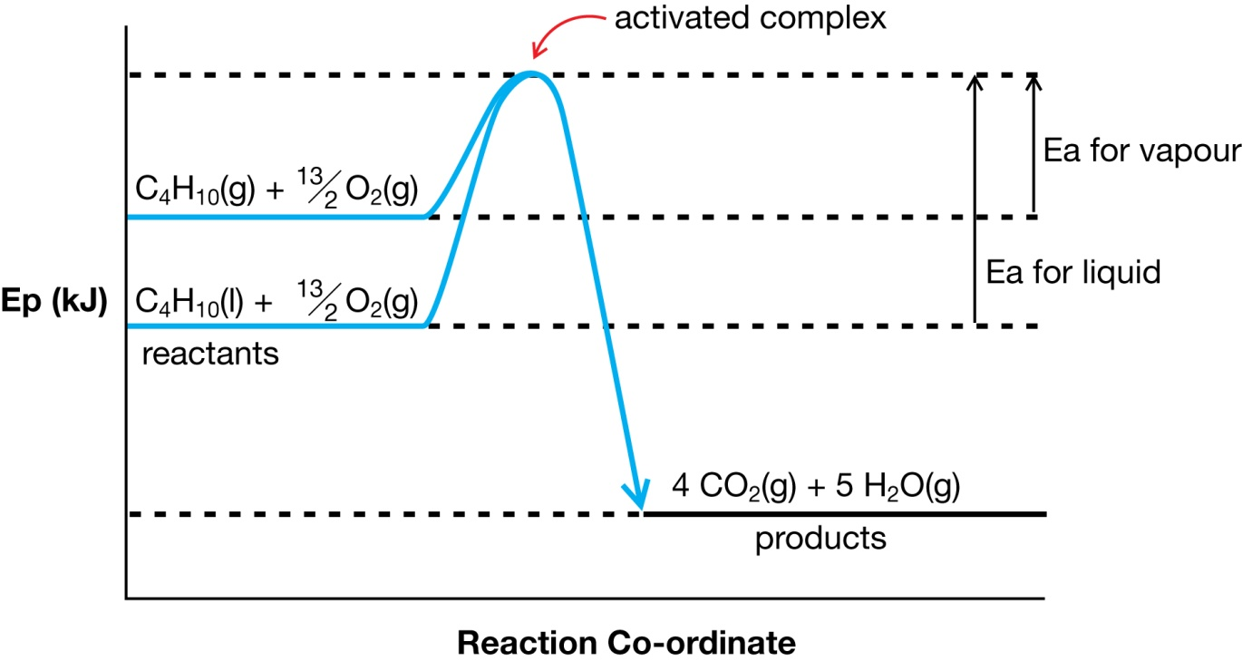

Lesson 3—Catalysts

Try This

TR 1.

Students will find the identification of examples and the descriptions difficult. It is important to review student responses and to provide feedback in order to ensure that students are developing an understanding of concepts. It is also important to help students revise and communicate their scientific and technological knowledge.

Sample Solution

Point | Elaboration
A catalyst is a substance that increases the rate of reaction without being consumed in the overall process. | Since sodium hydroxide is a catalyst in the production of biodiesel, the biodiesel may be corrosive due to the presence of hydroxide ions, which are a strong base.
According to theory, catalysts accelerate a reaction by providing an alternate pathway with a lower activation energy. | The membrane in a fuel cell allows hydrogen and oxygen to react without actually colliding (alternate path), and for this reaction to happen at room temperature without a spark (lower activation energy).
A catalyst does not alter the net enthalpy change of a reaction. Both catalyzed and uncatalyzed versions of the same reaction have the same Δ_{r}H. | The enthalpy change for the reaction in a fuel cell is the same as if it were to happen as a pop test.
Catalysts are widely used in industry, consumer technologies, and biological process. | The metal disk in the commercial hot pack is a catalyst.

