Module 2: Lesson 3 ASSIGNMENT

Read all parts of your assignment carefully, and record your answers in the appropriate places. If you have difficulty with an assignment, go back to the textbook and review the appropriate lesson. Be sure to proofread your answers carefully before submitting your Assignment Booklet.

Lesson 3 Assignment: Catalysts

(15 marks) | 1. | Design an experiment you could carry out to test the hypothesis that changing the catalyst will not affect the production of biodiesel.  Your design must include the following parts:  - statement of problem being investigated  - list of variables for this investigation with each variable identified as manipulated, controlled, or responding  - description (you don’t need to go into great detail) of how the experiment will be conducted  - description of how certain variables will be controlled during the experiment  - identification of how you will determine a “result” in this experiment  - description of the experimental control for this investigation (OMIT)  - description of how data collected from the experiment would be used to answer the research problem posed

Answer:

Unit A: Review

Use the following information to answer this question.
The Uranium-235 isotope is used as a fuel in some nuclear power plants. This isotope is used to enrich natural uranium ore. Prior to the enrichment process, the uranium ore, UO_{2(s),} is converted to UF_{6(s).} This conversion is represented by the following sequential equations:

Equation I UO_{2(s)} + 4HF_{(g)} → UF_{4(s)} + 2H₂O_{(g)}
Equation II UF_{4(s)} + F_{2(g)} → UF_{6(s)}

(4 Marks) | 1. | Use Molar Enthalpies of Formation to calculate the amount of energy involved in producing 2.00 Mg of UF6(s) from natural uranium ore, UO2(s). (4 marks)
  Molar Enthalpies of Formation
  Substance _{f}H_{m} (kJ/mol)
  UO_{2(s)} - 1129.7
  UF_{4(s)} -1914.0
  UF_{6(s)} -2112.9

(1 Mark) | 2. | Evaluate the use of nuclear energy for the generation of electricity. Include a reason for and a reason against the use of nuclear energy. (1 mark)

Use the following information to answer this question.
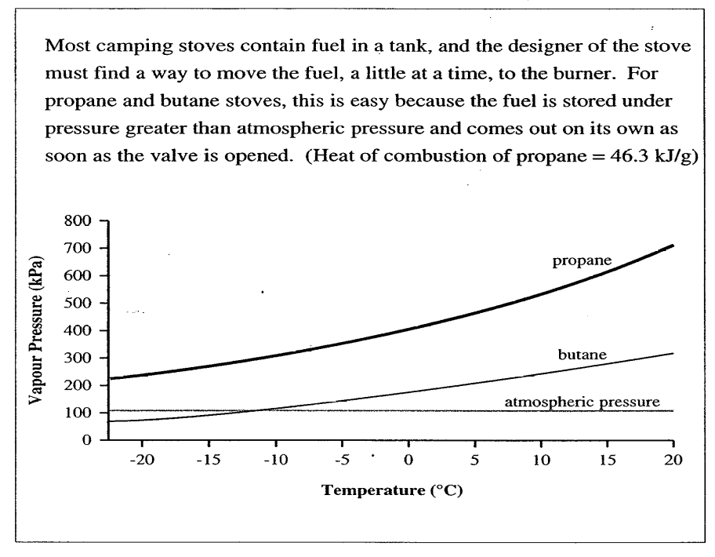
(3 Marks) | 3. | Camp stoves often use compressed butane gas as a fuel. Determine the enthalpy of  combustion of butane in kJ/g. (use H2O(g) as a product.)

(2 Marks) | 4. | Which of the two fuels would you recommend for a winter camping trip? Give two valid reasons to justify your answer. (Consider energy yield and operation in cold weather in your explanation.)

Use the following information to answer the next question.
Hydrogen gas if often considered a good fuel choice because it produces a large quantity of energy per gram and the only product of its combustion is water. Hydrogen gas can be produced by a variety of methods. A simplified representation of three of these methods is shown by the equations below:
Methods for Producing Hydrogen Gas

Method I Hydrogen from hydrocarbons (e.g., propane)
C₃H_{8(g)} + 6H₂O_{(l)} → 3CO_{2(g)} + 10H_{2(g)}

Method II Hydrogen from coal
C_{(s)} + 2H₂O_{(l)} → CO_{2(g)} + 2H_{2(g)}

Method III Hydrogen from the electrolysis of water
2H₂O_{(l)} → 2H_{2(g)} + O_{2(g)}

(5 Mark) | 5. | Compare the three methods for producing hydrogen gas. Identify the best method and include support for your choice.  Your response should include:  - molar enthalpy calculations in kJ/mol of hydrogen gas produced in each method  - a description of the changes in energy that occur in the reaction represented by the method you choose  - another advantage associated with the method you choose

