Module 3: Lesson 4 ASSIGNMENT

Read all parts of your assignment carefully, and record your answers in the appropriate places. If you have difficulty with an assignment, review the relevant sections of the lesson and the textbook. Be sure to proofread your answers carefully before submitting your Assignment Booklet.

Lesson 4 Assignment: Oxidation Numbers and Corrosion Protection

Part 1: Lab—Oxidation States of Manganese

- Use the photographs in the table “Oxidation States of Manganese” in Step 1 of the virtual investigation to identify the final oxidation state of manganese in the solution within each of the jars.

Answer: (5 marks)

- A) Use a half-reaction to describe the chemical change occurring to the manganese ion in Jar 3 (Middle picture only viewed in step 6) as it changes from MnO₄–(aq) to Mn²⁺(aq) in acidic conditions.

Answer: (2 marks)

B) Using the steps on page 567 of your text build a half-reaction to describe the chemical change occurring to the manganese ion in Jar 4 (pictures only viewed in step 8 and 9) as it changes from MnO₄–(aq) to MnO₂(s) assuming acidic conditions.

Answer: (2 marks)

- Identify and explain the oxidation number for the manganese ion in each of the following compounds associated with the virtual investigation:

  - MnSO₄(s) (added to Jar 3)
  - MnO₄^{2–}(the product of the reaction in Jar 2)

Answer: (4 marks)

Balance the following equations using Oxidation Numbers. Remember there are specific steps to follow that you learned about in lesson 4 page 4. (18 marks #1->2 marks, #3-5 four marks each)

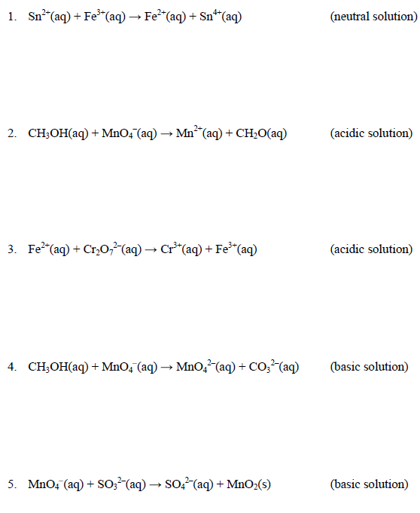

Part 2: Lab—Corrosion of Nails

Data

- Data: Record your observations in the data table below.

Answer: (12 marks; 2 per tube)
Tube | Conditions | Observations
1 | deionized water
2 | HCl(aq)
3 | NaCl(aq)
4 | NaOH(aq)
5 | deaerated water
6 | air (control) | - no change in metal

Analysis

- Use your knowledge of electrochemical reactions to explain the change or lack of change in the iron nail in each of the test tubes prepared.

Answer: (12 marks)

- Evaluate whether the experiment allows for the collection of sufficient data to identify factors that influence the corrosion of iron.

Answer: (2 marks)

- What are the limitations of the experimental design to permit generalizations?

Answer: (2 marks)

Part 3: Questions

- Complete “Section 13.3” question 8.b. on page 595 of the textbook

Answer: (3 marks)

- Use your answer to question 1 to answer questions a through d below.

- Assign oxidation numbers to all atoms/ions in your answer to questions 1.

Answer: (6 marks)

- Identify the atom that is oxidized in this reaction. Describe the change in this atom as a result of the reaction.

Answer: (2 marks)

- Identify the atom that is reduced in this reaction. Describe the change in this atom as a result of the reaction.

Answer: (2 marks)

- Identify the oxidizing and reducing agents in this reaction.

Answer: (2 marks)

Submit your completed Assignment Booklet to your teacher at the end of this lesson.

