Module 3: Lesson 5 ASSIGNMENT

Lesson 5 Assignment: Redox Stoichiometry

Part 1: Lab—Analyzing a Hydrogen Peroxide Solution

 | 1. | - The first step of this lab is to make a STANDARD SOLUTION of known concentration of FeSO₄•(NH₄)₂SO₄•6 H₂O  - We will use this standard solution of FeSO₄•(NH₄)₂SO₄•6 H₂O to determine the concentration of KMnO₄ that we will be using later in the lab as a titrant with H₂O₂.  Calculate the mass of FeSO₄•(NH₄)₂SO₄•6 H₂O(s) required for the experiment from step 1 of Pre-Lab.

Answer: (4 marks)
Calculate the required mass of FeSO₄•(NH₄)₂SO₄•6 H₂O(s) from
Step 1 of Pre-Lab, show your work. = ____________

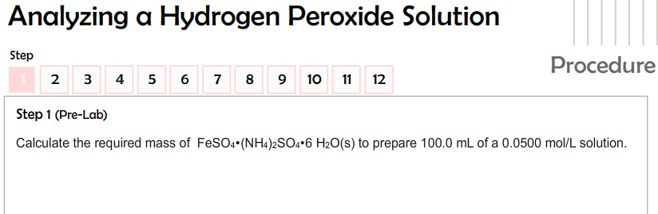

You can check to see if your answer is correct by looking at Step 2 Photo #3.

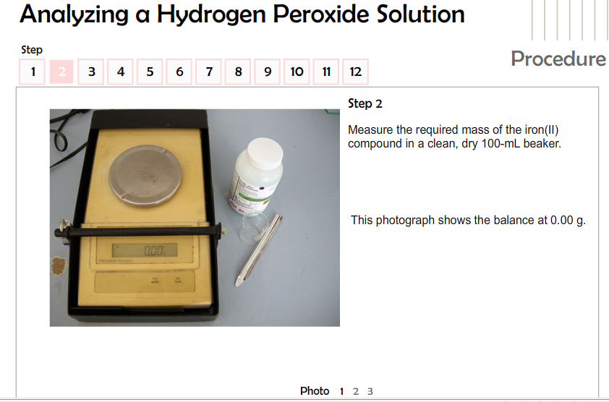

(4 marks) | 2. | Use the data collected in the tables below from Procedure steps 1–7 from the lab to calculate the concentration of the potassium permanganate solution. The readings in the table are from reading the volume levels of the biuret photos in the virtual lab.

Answer:

Titration of Standard Iron(II) Solution
 | Trial
 | 1 | 2 | 3 | 4
Final Burette Reading (mL) | 17.0 | 29.5 | 42.0 | 14.6
Initial Burette Reading (mL) | 4.2 | 17.0 | 29.5 | 2.1
Volume of Titrant (mL) | 12.8 | 12.5 | 12.5 | 12.5
Colour at Endpoint | pink | faint pink | pink | pink

There are three consistent trials: 2, 3, and 4. Use these for your average volume.

The balanced chemical equation is

The concentration of the potassium permanganate solution is __________ mol/L

(4 marks) | 3. | Use the data in the table below collected from Procedure steps 8–11 and your answer from question 2 to calculate the concentration of the diluted hydrogen peroxide solution tested. The readings in the table are from reading the volume levels of the biuret photos in the virtual lab.

Answer:

Titration of Diluted Hydrogen Peroxide Solution
 | Trial
 | 1 | 2 | 3 | 4
Final Burette Reading (mL) | 14.5 | 25.5 | 36.6 | 47.5
Initial Burette Reading (mL) | 3.5 | 14.5 | 25.5 | 36.6
Volume of Titrant (mL) | 11.0 | 11.0 | 11.1 | 10.9
Colour at Endpoint | dark pink | faint pink | faint pink | faint pink

There are three consistent trials: 1, 2, and 3. Use these for your average volume.

The balanced chemical equation is

The concentration of the diluted hydrogen peroxide solution is __________mol/L.

(4 marks) | 4. | Use the information in the Design section on page 603 of the textbook to determine the percentage by volume concentration of the commercial hydrogen peroxide product.

Answer:
Use the answer you got from #3. to calculate the concentration of the undiluted hydrogen peroxide.

_________ mol/L X 40 (the dilution factor) = _________ mol/L

Now interpolate the % concentration of hydrogen peroxide from the graph below using the undiluted concentration you calculated above.

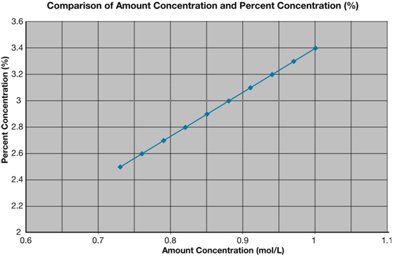

Part 2: Reflect and Connect

(6 marks) | 1. | Calculate the volume of water that can be treated if 50 g of potassium permanganate is added to the system. Assume that the concentration of iron(II) ions in well water is 6.5 ppm.
Answer:
Determine the balanced redox reaction.

Determine the number of moles of MnO₄⁻.

Determine the number of moles of Fe²⁺. Remember to apply the correct mole ratio.

Recall from Chem 20 that → 6.5 ppm = 6.5 mg/kg = 6.5 mg/L
6.5 mg/L=0.0065g/L → Find the number of moles in 0.0065 g of Fe²⁺

Determine concentration of Fe²⁺ in ___________mol/L.

Determine the volume of water. Hint: V=n/C

The volume of water that could be treated is __________ L.

