Module 4: Lesson 2 ASSIGNMENT

Read all parts of your assignment carefully, and record your answers in the appropriate places. If you have difficulty with an assignment, review the relevant sections of the lesson and the textbook. Be sure to proofread your answers carefully before submitting your Assignment Booklet.

Lesson 2 Assignment: Design of Commercial Cells

Part 1: Leaking Alkaline Dry Cell

Use a variety of resources (e.g., textbook, Materials Safety Data Sheets, Internet) to research how a leaking alkaline dry cell should be safely removed from an electronic device and disposed of. Prepare disposal instructions that you could provide to a family member. For each instruction, justify and explain the reasoning for the instruction as it relates to safety and exposure to chemical substances.

Answer: (8 marks)

(54 marks) | Part 2: Lab—Building Voltaic Cells  Pre-Lab  - Complete the following tables to make predictions about the voltaic cells referenced. You will complete the row “Observed Cell Potential” while or after viewing the virtual investigation.

Cell 1 | Zn(s) │Zn²⁺(aq) ║ Cu²⁺(aq) │Cu(s) | Diagram of Operating Cell  - direction of electron movement  - direction of ion movement
Anode
Cathode
Reduction
Half-Reaction
Oxidation
Half-Reaction
Net Cell Reaction
Predicted Standard Cell Potential
Observed Cell Potential
Spontaneous
(Yes or No)

Cell 2 | Zn(s) │Zn²⁺(aq) ║ Fe²⁺(aq) │Fe(s) | Diagram of Operating Cell  - direction of electron movement  - direction of ion movement
Anode
Cathode
Reduction
Half-Reaction
Oxidation
Half-Reaction
Net Cell Reaction
Predicted Standard Cell Potential
Observed Cell Potential
Spontaneous
(Yes or No)

Cell 3 | Fe(s) │Fe²⁺(aq) ║ Cu²⁺(aq) │Cu(s) | Diagram of Operating Cell  - direction of electron movement  - direction of ion movement
Anode
Cathode
Reduction
Half-Reaction
Oxidation
Half-Reaction
Net Cell Reaction
Predicted Standard Cell Potential
Observed Cell Potential
Spontaneous
(Yes or No)

Cell 4 | Mg(s) │Mg²⁺(aq) ║ Zn²⁺(aq) │Zn(s) | Diagram of Operating Cell  - direction of electron movement  - direction of ion movement
Anode
Cathode
Reduction
Half-Reaction
Oxidation
Half-Reaction
Net Cell Reaction
Predicted Standard Cell Potential
Observed Cell Potential
Spontaneous
(Yes or No)

Cell 5 | Mg(s) │Mg²⁺(aq) ║ Fe²⁺(aq) │Fe(s) | Diagram of Operating Cell  - direction of electron movement  - direction of ion movement
Anode
Cathode
Reduction
Half-Reaction
Oxidation
Half-Reaction
Net Cell Reaction
Predicted Standard Cell Potential
Observed Cell Potential
Spontaneous
(Yes or No)

Cell 6 | Mg(s) │Mg²⁺(aq) ║ Cu²⁺(aq) │Cu(s) | Diagram of Operating Cell  - direction of electron movement  - direction of ion movement
Anode
Cathode
Reduction
Half-Reaction
Oxidation
Half-Reaction
Net Cell Reaction
Predicted Standard Cell Potential
Observed Cell Potential
Spontaneous
(Yes or No)

- Be sure that you recorded the observed cell potential for each of the cells constructed in the data tables above.

Analysis

- Compare the predicted standard cell potentials with the observed values. Was there a discrepancy? Provide possible reasons for any differences.

Answer: (1 mark)

- Suggest a reason why very small voltaic cells were constructed for this investigation.

Answer: (1 mark)

- Would you expect a difference in the cell potential if larger cells had been constructed and tested? Suggest an aspect of a cell’s function that may be affected by using a larger cell that contains a greater quantity of chemicals.

Answer: (3 marks)

Part 3: Cell Potential

- A Ni-Cd rechargeable cell has a cell potential of +1.30 V. If the cathode has a potential of +0.49 V, what is the anode’s potential?

Answer: (2 marks)

Answers to Try This Question Module 3: Lesson 2,3,5

Lesson 1–Voltaic Cells and Batteries

Try This

TR 1.

Sample Solution for Household Use for One Year
 | Cell Size
 | Coin Type | AAA | AA | C | 9-volt | Other
Disposable | 5 | 15 | 43 | 6 | 4 | 0
Rechargeable | 0 | 0 | 3 | 0 | 0 | 1
Total | 5 | 15 | 46 | 6 | 4 | 1

TR 2.

Sample Solution for Household Use
 | A | B | C | D | E | F | G
1 | Type of Cell | Coin Type | AAA | AA | C | 9-volt | Other
2 | Disposable | 5 | 15 | 43 | 6 | 4 | 0
3 | Rechargeable | 0 | 0 | 3 | 0 | 0 | 1
4 | Total | 5 | 15 | 46 | 6 | 4 | 1
5 | Cell Mass (g) | 3.1 | 11.2 | 23.9 | 70 | 46.6 | N/a
6 | Mass of Each Cell Type (g) | 15.5  (B4*B5) | 168.0  (C4*C5) | 1099.4  (D4*D5) | 420.0  (E4*E5) | 186.4  (F4*F5)
7 | Total Mass (Kg) | 1.89  SUM(B6:F6)/1000

Student responses may extend the spreadsheet to perform calculations for class or community commercial electric cell use. For class cell use, the calculation will involve summing the masses of each cell type and calculating a total mass.

For community commercial electric cell use, the calculation will require defining average cell use. Students may address this in a variety of ways. The student might assume that the household total is the average, or the student might calculate a mean average using the class data. Teachers should check that students used the number of households, versus the total population, in their calculations.

For example, at the time these resources were developed, Edmonton’s population was 730 372 (metro 1 081 275). The number of households was in excess of 300 000. Therefore,

Total mass for Edmonton = (1.89 kg/household)(300 000 households)
= 567 tonnes of chemical waste from commercial electric cells

TR 3.

Options are landfill and disposal at a specialized waste handling facility, such as an Eco Station. Students may indicate that some landfills ask that this type of waste be separated from other materials and that spent cells may receive special disposal at a later date.

Lesson 3—Electrolytic Cells

The purpose of this lesson is to introduce electrolytic cells. Throughout this lesson students are asked to compare and contrast commercial electric and electrolytic cells. Teachers should ensure that some assessment is targeted toward ensuring that students properly understand that these types of electrochemical cells employ the principles learned in Module 3 and in Lessons 1 and 2 of Module 4.

Students are presented with different examples of electrolytic cells including rechargeable batteries. In the latter example, students may find it difficult to recognize a battery as a closed system with respect to matter and to recognize that half-reactions can be reversible. Remind students of previous work in this unit (e.g., constructing tables of half-reactions) and of situations in which students experienced the reversibility of reactions from how they were initially written.

Try This

Electrolysis of Potassium Iodide

TR 1.

strongest oxidizing agent: H₂O(l)
strongest reducing agent: I–(aq)

TR 2.

2 H₂O(l) + 2 e– → H₂(g) + 2 OH–(aq)
2 I–(aq) → I₂(s) + 2 e–

TR 3.

At the cathode, bubbling should be observed as a gas (hydrogen) is produced. The solution at the electrode should become basic. A litmus test could be performed and should show pink litmus turns blue.

At the anode, a colour change should be observed in which a brown colour develops around the electrode (characteristic of iodine).

TR 4.

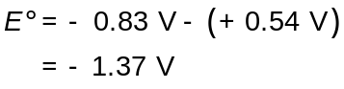

The negative net cell potential indicates that the reaction in the cell is non-spontaneous.

Reflect on the Big Picture

Teachers may wish to have students complete these questions in a variety ways intended to support the student’s ability to develop answers to extended response questions that involve analysis of situations and require descriptive versus numerical answers.

Teachers may wish to have students develop outlines or verbally respond to the questions in order to indicate key concepts prior to developing a formal response.

RBP 1.

Sample Solution

2 NiO(OH)(s) + 2 H₂O(l) + 2 e– → 2 Ni(OH)₂(s) + 2 OH–(aq) Eº_{net} = +0.49 V
Cd(s) + 2 OH–(aq) → Cd(OH)₂(s) + 2 e– Eº_{net} = –0.81 V

net: 2 NiO(OH)(s) + 2 H₂O(l) + Cd(s) → 2 Ni(OH)₂(s) + Cd(OH)₂(s)

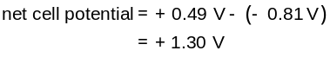

Products of the recharging process are the reactants shown in the half-reactions for the discharging process. The “recharging” process reverses the “discharging” reactions converting electrical energy into chemical potential energy within the products. A Ni-Cd cell functions using a reversible reaction allowing recharging when a minimum (theoretical) of 1.30 V is applied.

RBP 2.

The warning indicates that an explosion might occur, possibly due to the production of a gas inside the cell if an attempt is made to apply a current. This gas could be hydrogen and/or oxygen from the electrolysis of water present in the electrolyte of the cell. It is not physically possible to recharge a dry cell because the reactions must not be reversible and regenerate the products for the spontaneous reaction that occurs during discharging of the cell.

Lesson 4–Commercial Applications of Electrolytic Cells

This lesson introduces applications of electrolytic cells. Both virtual investigations and examples from the text are described. Students will continue to apply their skills in predicting reactions and explaining chemical changes that have been observed.

In the next lesson students will be required to perform quantitative analysis of electrolytic cells. This lesson will ensure students have a good foundation in pre-requisite skills for the analysis of these systems.

Try This

TR 1.

Metal | Initial Mass (g) | Final Mass (g) | Change in Mass (g)
Carbon | 9.76 | 9.87 | 0.11
Qualitative Data | The carbon rod was all black at the start of the experiment. At the end of the experiment, the carbon rod had a bright reddish-brown precipitate on the section that was submerged in the solution of copper(II) ions.
Copper Electrode | 12.07 | 11.96 | 0.11
Qualitative Data | The portion of the copper rod submerged in the solution appeared to be less lustrous than the portion that was not submerged.

TR 2. The carbon electrode changed colour as a copper-coloured, shiny precipitate formed on the electrode. The carbon electrode also increased in mass.

TR 3. The copper electrode decreased in mass.

TR 4. Reduction occurs when atoms or ions gain electrons. In this case the copper(II) ions, Cu²⁺, gained electrons to become copper metal atoms that were added to the carbon electrode. The half-reaction that describes this process is

Cu²⁺(aq) + 2e– Cu(s)

TR 5. Oxidation occurs when an atom or ion loses electrons. In this case the copper metal atoms on the copper electrode lost electrons to form copper ions, Cu²⁺(aq), which entered the solution. Although the atoms and ions are too small to be observed directly, the fact that the copper electrode lost mass as the reaction progressed provides indirect evidence that the copper metal lost electrons to form copper ions.

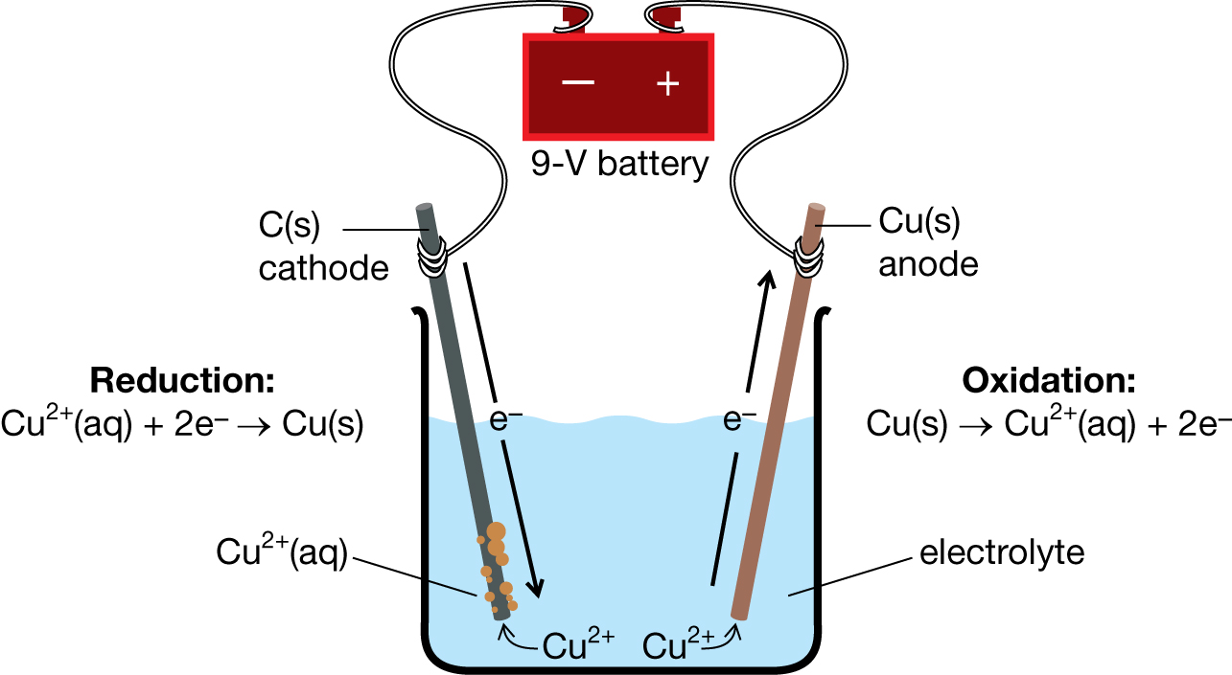

Lesson 5—Quantitative Relationships in Cells

The purpose of this lesson is to introduce students to stoichiometric principles of electrolytic and electric cells. The major focus of the lesson is to develop familiarity with methods to quantify moles of electrons from observable data. Students will also be asked to demonstrate their understanding of general stoichiometric principles throughout the lesson and in the Assignment.

Try This

TR 1.

Answers will vary. Students may have the most difficulty in selecting a system upon which to comment. Teachers may wish to remind students that cells are often characterized by the amperage the cells can produce or the length of time for which the cells can operate.

Values used in the calculation do not have to be researched and authentic. Responses will most likely demonstrate a relationship between the electric current and the quantity of reactants involved, although other possibilities exist. Teachers are encouraged to provide feedback on aspects of the response that are well developed and on aspects that are deficient. Remind students of skills and knowledge that could be used in developing responses.

The following sample responses are provided. Teachers may also wish to use these examples with students as further examples of Program of Studies objective 30-B2.8k.

Sample Solution 1

Calculate the mass of hydrogen necessary to react with 16.0 g of oxygen in a hydrogen-oxygen fuel cell.

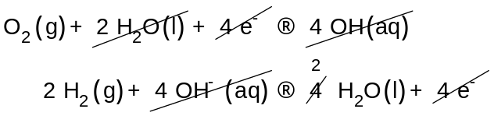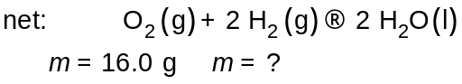

The process to solve for the mass of hydrogen is identical to the process used previously in this course and in Chemistry 20.

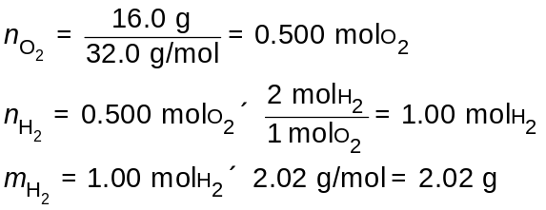

2.02 g of hydrogen are required to completely react 16.0 g of oxygen in the fuel cell.

Sample Solution 2

Calculate the length of time an alkaline dry cell can operate with an amperage of 0.0500 A if 2.15 g of zinc react during the cell’s discharge.

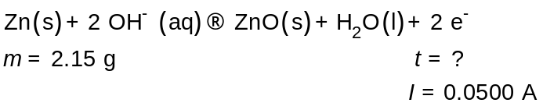
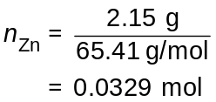

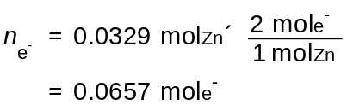

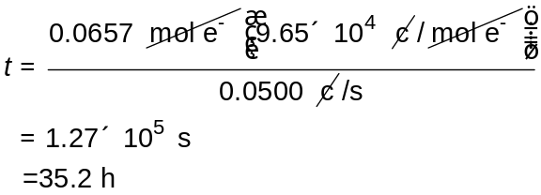

The alkaline cell would operate for 35.2 h.

TR 4.

a.

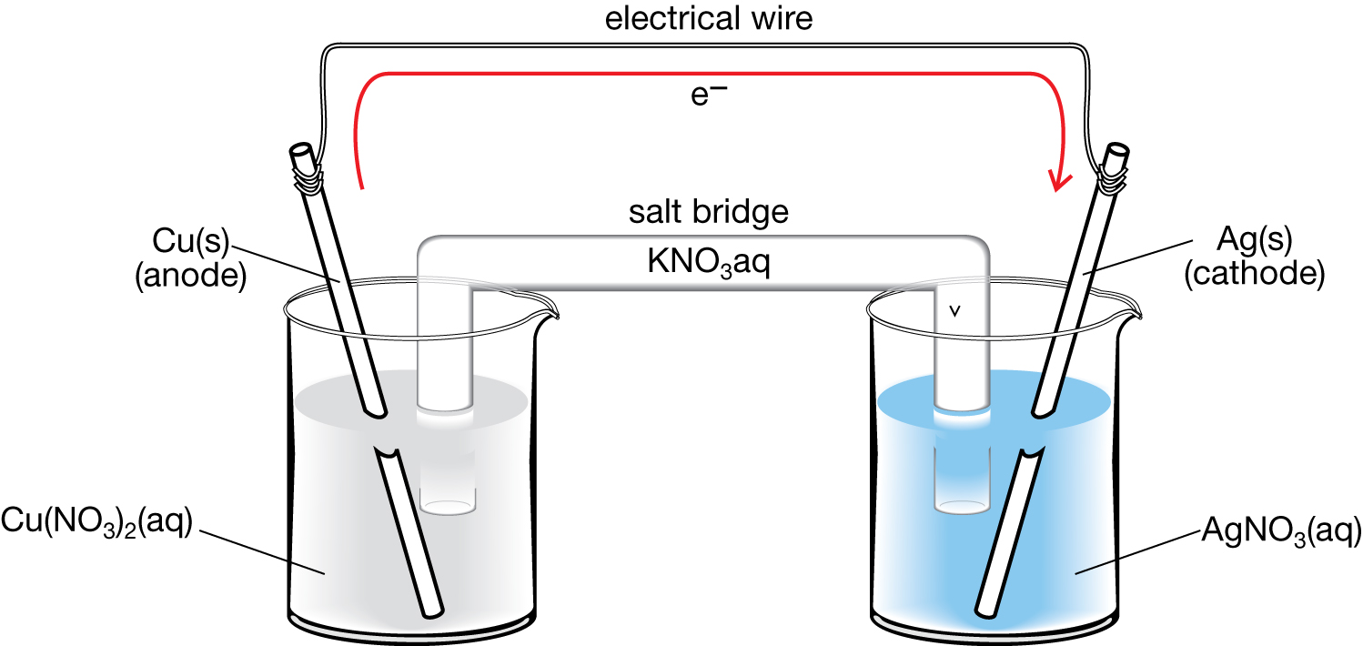

- reduction: Ag⁺ + 1e– → Ag(s)
- oxidation: Cu(s) → Cu²⁺(aq) + Ze⁺

- See the figure in part a.

- See the figure in part a.

TR 5.

- Cations flow toward the cathode of the cell through the ion bridge.

- Anions flow toward the anode of the cell through the ion bridge.

