Module 4: Lesson 5 ASSIGNMENT

Read all parts of your assignment carefully, and record your answers in the appropriate places. If you have difficulty with an assignment, review the relevant sections of the lesson and the textbook. Be sure to proofread your answers carefully before submitting your Assignment Booklet.

Lesson 5 Assignment: Quantitative Relationships in Cells

Use the following information to answer the questions.

Electroplating is a widely used process. One of the most popular electroplating processes involves the plating of two metals, nickel and chromium, in separate vats. Nickel is plated first because it adheres better to iron. Next, the object is moved to a second vat in which a layer of chromium is plated. Half-reactions occurring in each vat are shown below:

plating of nickel: Ni²⁺(aq) + 2 e⁻ → Ni(s)

plating of chromium: Cr₂O₇²⁻(aq) + 14 H⁺(aq) + 12 e⁻ → 2 Cr(s) + 7 H₂O(l)

- The power supply used in commercial electroplating provides each vat with approximately 1.50 x 10³ A of current for 20.0 minutes. In which vat is the greatest mass of metal deposited on a car bumper? Justify your answer.

Answer: (7 marks)

- To save on production costs, most automobile bumpers are never coated with more than 200 g of chromium. In order to plate 200 g of chromium, calculate the length of time for which a standard bumper should be immersed in a chromium vat.

Answer: (4 marks)

- Describe a strategy that can be used in electroplating to maintain the concentration of aqueous ion in the vat in which nickel is plated.

Answer: (2 marks)

- The following observations were collected during the virtual investigation “Electrolytic Cell” in Lesson 4:
Metal | Initial Mass (g) | Final Mass (g) | Change in Mass (g) | Qualitative Data
Carbon | 9.76 | 9.87 | 0.11 | The carbon rod was all black at the start of the experiment. At the end of the experiment, the section that was submerged in the solution of copper(II) ions had a bright reddish-brown precipitate on it.
Copper Electrode | 12.07 | 11.96 | 0.11 | The portion of the copper rod submerged in the solution appeared to be less lustrous than the portion that was not submerged.
Does the data demonstrate the expected stoichiometric relationships for this system? Use the data to justify your answer.

Answer: (6 marks)

Unit B: Review

(2 Marks) | 1. | A student pipeted a 25.0 mL sample of 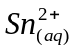 solution from a 500 mL volumetric flask. The sample was then oxidized by titration using 28.4 mL of 0.260 mol/L acidic 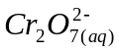 solution from a glass buret.  a) Write a net ionic equation and determine the standard cell potential for this reaction.
(3 Marks) |  | b) Determine the mass of 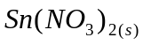 solute that was used to make the 500 mL of the solution.

(3 Marks) | 2. | An antique metal vase was obtained and the owner desired to electroplate it with silver. A power source,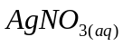, inert electrodes, and other common laboratory equipment are available.  a) Draw and label a diagram to represent the electrolytic cell AND include the minimum voltage necessary to operate the cell.
(2 Marks) |  | b) A common way to clean tarnished silver is to immerse it in a sodium carbonate solution into which a clean piece of zinc has been placed. If the tarnish is composed of 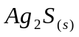, write the half-reactions and the net reaction to show how the cleaning takes place.

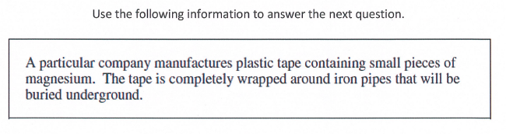

(5 Marks) | 3. | Explain in chemical terms the purpose(s) of each component of the tape. (5 marks)  Your response shoud include:  - an explanation of the corrosion of iron  - an explanation of how the plastic tape and magnesium pieces prevent the corrosion of iron  - relevant half-reaction equations

