Module 5: Lesson 1 ASSIGNMENT

Read all parts of your assignment carefully, and record your answers in the appropriate places. If you have difficulty with an assignment, review the relevant sections of the lesson and the textbook. Be sure to proofread your answers carefully before submitting your Assignment Booklet.

Lesson 1 Assignment: Careers in the Petroleum Industry

(10 marks) | Identify a job in or related to the petroleum industry that interests you. Research the job and create a short write-up that includes the following information:  - brief job description  - education requirements  - duties performed  - locations where the job is performed  - salary  - future career prospects  Indicate and justify whether the job is directly or indirectly related to the petroleum industry.

Answer:

Answers to Try This Question Module 5: Lesson 1-6

Module 5—Hydrocarbons and the Petroleum Industry

Lesson 1—Fossil Fuels

Try This

Answers will vary. Photographs of descriptions may range from direct activity (e.g., drilling, transport, or use of hydrocarbons as a fuel source) to indirect activities and businesses that support the extraction of petroleum (e.g., the assembly and transport of trailers for camp, catering, or manufacturing of drilling equipment).

Lesson 2—Alkanes

Self-Check and Try This

SC 1.–SC 2. and TR 1.–TR 2.

Students construct isomers of pentane and use these examples to demonstrate their ability to classify, name, and represent these molecules. Answers to TR 1– 2 appear in the answer to SC 2.

TR 3

The principle involved in the construction of the molecular models is the principle of chemical bonding, including valence, electron orbitals, and capacity—all of which were learned in Chemistry 20 and are described in Chapter 3 of the textbook.

For example, carbon atoms appear in group 2 of the periodic table, indicating that they have four valence electrons with a capacity to make four bonds to other atoms. Hydrogen appears in group 1, indicating that the atoms have one electron and the ability to make only one chemical bond. Both carbon and hydrogen are non-metallic elements and will therefore bond chemically with covalent bonds, which involve a sharing of a pair of electrons between atoms participating in the bond.

Lesson 3—Alkenes and Alkynes

Try This

TR 1. Constructing Ethene

Ethene has two fewer hydrogen atoms than ethane. This leaves an unbonded electron on each of the carbon atoms. To achieve stability, the carbon atoms form a double bond and share a pair of electrons.
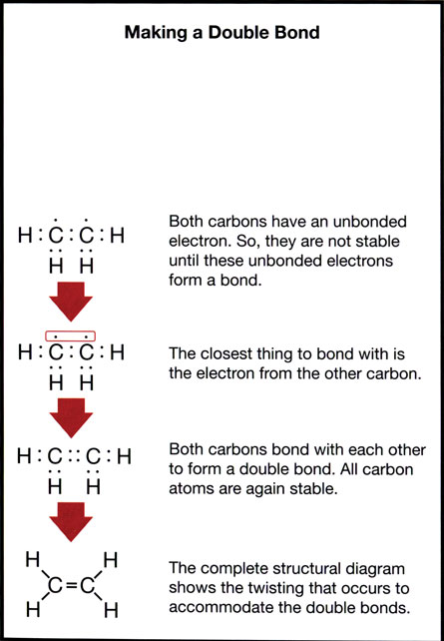

TR 2.

The ethene molecule can be represented in a variety of ways.

Chemical Structural Diagram

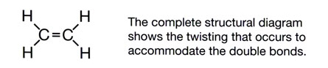

Ball and Stick Model Representation Lewis Formula
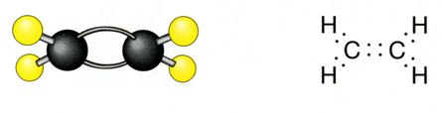
Condensed Chemical Structure for Ethene

CH₂ = CH₂

Lesson 4—Aromatics

This lesson introduces aromatic compounds. The primary emphasis is on understanding the scientific reasoning for classifying these compounds as a distinct class of hydrocarbons and on developing the skills for their nomenclature. In Module 6 students will learn more about the chemical properties of aromatics, including their tendency to undergo substitution reactions despite appearing to be unsaturated.

Try This

Responses should be assessed on whether students are able to associate evidence with aspects of the structure.

Evidence that Supports the Model | Evidence that Does Not Support the Model
consistent with molecular formula C₆H₆ and corresponding molar mass | no evidence that indicates the compound contains multiple bonds based of reactivity (reacts similar to alkanes)
observation that compound is nonpolar | x-ray diffraction evidence indicates that length of all C-C bonds in ring are identical (single and double bonds have different lengths)
evidence that all carbon atoms are identical and are bonded to one hydrogen atom

Lesson 5—Alberta’s Oil Industry

This lesson attempts to clarify possible confusion regarding the composition of oil reserves in Alberta. In this lesson students will also begin to study reactions of hydrocarbons by looking at cracking, reforming, and alkylation reactions. Teachers may want to use this time to emphasize basic themes of conservation, especially to explain the role of hydrogen in each of these reaction types.

Try This

TR 1.

The best conditions for the extraction of bitumen from oil sand are as follows:

- 80°C
- pH 9
- 6 cm air
- 1 mmol/L Ca²⁺

TR 2.

Efficiency is maximized using optimal conditions. Since some grades of oil sand contain a lower proportion of bitumen by mass (lean grades), maximizing efficiency is important. Experimentation with variables such as these may result in identification of a combination of factors that could maximize bitumen extraction with lower costs.

TR 3.

It appears that optimal pH and temperature were used in experiments investigating the effect of air and calcium ion concentration. But there is no set of trials in which all of the optimal conditions were used and compared to other trials.

The major question remains whether combining all the optimal factors will result in optimal bitumen extraction. Also, are other variations between factors investigated to ensure that a similar effect is not seen with “sub-optimal” conditions? Can similar effects be achieved using other factors that might involve lower costs (for example, reduced temperature)?

