Module 6: Lesson 1 ASSIGNMENT

Lesson 1 Assignment: Petrochemicals in Alberta

This assignment is a discovery assignment. There are no incorrect answers as long as you attempt the assignment. Later in the module you will refer back to this assignment and possibly edit it to make it better.

Complete the following steps:

 | Step 1: | Print the chemical formulas that appear at the end of this document. The formulas are for the petrochemicals shown in “Figure 2” on page 413 of the textbook.

 | Step 2: | Use scissors to separate the structural diagrams for each of the petrochemical compounds.

 | Step 3: | Examine the structural formula for each of the compounds.

 | Step 4: | Organize the compounds into groups based on similarities in their structures.

 | Step 5: | Create a heading for each of the groupings and a brief sentence to explain why you grouped each set of compounds the way you did. To get you started here are a few sample headings you could use → Alcohols, Benzene ring, Polymers.

 | Step 6: | Use a digital camera to photograph how the molecules have been grouped OR show your work in a table that has headings for each group and the names of the chemicals that you chose to group together.

Answer:

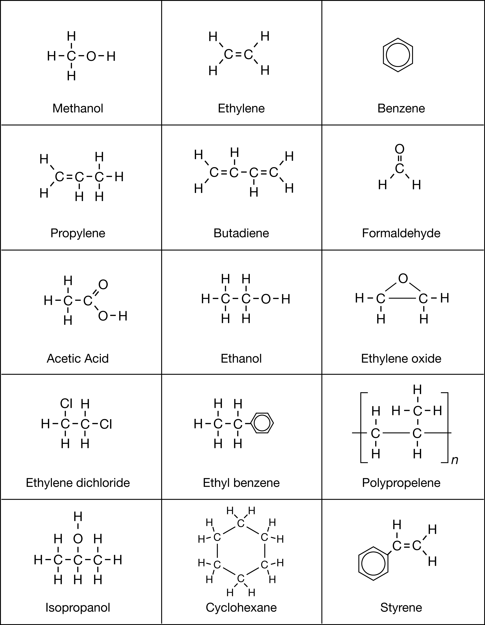
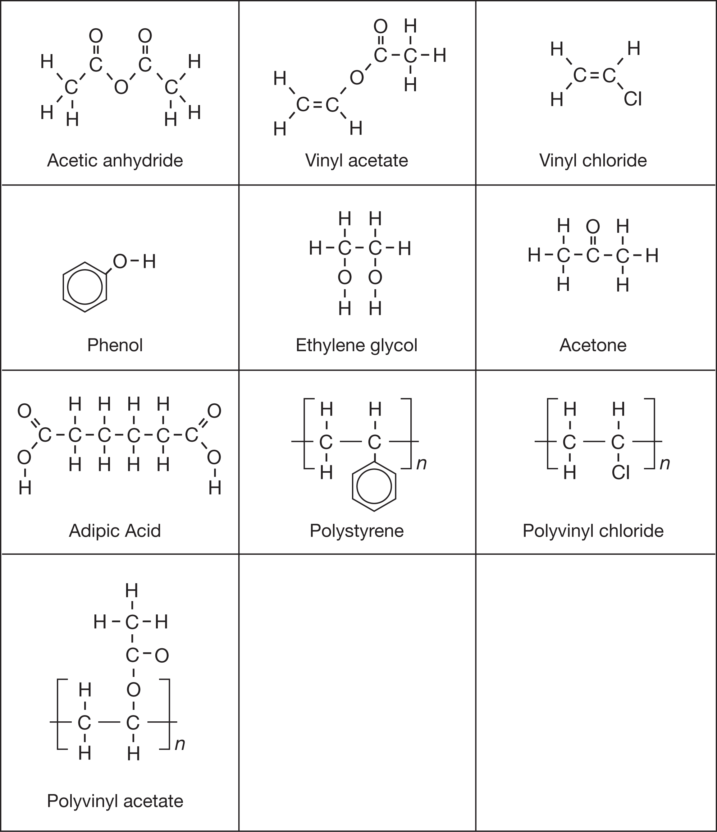

Answers to Try This Question Module 6: Lesson 1,3,6

Lesson 1—Petrochemicals in Alberta

Try This

TR 1.

Students will attempt the “Starting Points” questions on page 410 of the textbook. They will revisit these questions at the end of Lesson 6.

TR 2.

Throughout the first four lessons in this module, students will collect information on how petroleum is used. It is hoped that students will begin to see hydrocarbons from petroleum as more than an energy source; they should start to see the utility of hydrocarbons as a potential raw material for building other materials. This activity asks students to identify the perspective from which a position is presented.

TR 3.

Using the search terms suggested in the student materials should allow students to find materials that investigate the use of petroleum from different perspectives. Again, students should record the perspective used and list examples of information, including how the information is consistent with the given perspective.

Lesson 2—Organic Halides

Try This

Sample Solutions

TR 1.

Methane and the CFC molecule shown are both non-polar compounds, but they differ in molecular mass and number of electrons. The CFC molecule has a larger molecular mass (120.91 g/mol versus 16.05 g/mol) and more electrons (68 versus 10).

Boiling point of molecules is related to intermolecular forces. For non-polar compounds, London forces, which are determined by the number of electrons in a substance, contribute to differences in boiling point. Because the CFC has more electrons than methane, it is expected to have a higher boiling point than methane.

TR 2.

Having been compressed into their liquid form, a refrigerant’s molecules increase in potential energy to overcome intermolecular forces and undergo a phase change. As a liquid vapourizes, it absorbs energy from its surroundings. Since both methane and the CFC molecule vapourize (boil) below the expected temperature of food in a refrigerator, they would draw energy from the food and thereby reduce the food’s temperature.

Reflect and Connect

RC 1.

Students are not expected to submit their work; however, they should consider a range of concerns including, for example, the following:

- levels of stratospheric ozone, which have been affected by chlorine radicals released from CFCs
- persistence of organic halides, particularly organochlorine compounds, in the food chain
- release of chlorine radicals over time, that may be related to higher incidences of cancer
- toxicity due to production of chlorine radicals that become released as organochlorine compounds
- limited lifespan of vinyl plastics due to exposure to UV radiation in sunlight
- limited lifespan of plastics due to poor recycling programs

Try This

Addition Reactions

These questions are intended to be used for formative assessment purposes. Students should notice that the two reactants exist in separate layers prior to mixing, allowing for the observation of a distinct colour change in the bromine layer.

TR 3.

Reaction | Substance | Colour Before Mixing | Colour After Mixing
1 | cyclohexene | colourless | colourless
1 | bromine | brown | colourless
2 | cyclohexane | colourless | colourless
2 | bromine | brown | brown
3 | corn oil | pale yellow | pale yellow
3 | bromine | brown | colourless
4 | octane | colourless | colourless
4 | bromine | brown | brown

TR 4.

C₆H₁₀(l) + Br₂(l) → C₆H₁₀Br₂(l)

Structural diagrams could also be provided. Teachers may wish to ask students to provide their answer in both forms.

TR 5.

Corn oil contains double bonds. The brown colour of the bromine disappeared, which is consistent with the bromine reacting with a double bond, as was the case with cyclohexene.

TR 6.

The 1:1 molar relationship between iodine and double bonds is consistent with the mechanism of an addition reaction. When a double bond reacts, both atoms form the diatomic halogen molecule bond to the adjacent carbons where the multiple bond existed. For each multiple bond broken, one molecule of halogen is required to saturate the carbons.

Reflect on the Big Picture
RBP 1.

The three organic halides in this list are ethylene dichloride, vinyl chloride, and polyvinyl chloride.

Substance | Use | Toxicity | Biodegradable
Ethylene Dichloride | used to make vinyl chloride (removing an HCl molecule), solvent (degreaser and paint remover) | yes, possibly a carcinogen | persistent
Vinyl Chloride | monomer used to make polyvinyl chloride, a plastic | yes, carcinogen | no
Polyvinyl Chloride | PVC plastic, used in clothing, upholstery, flexible materials | not as a polymer  concern over plasticizers, substances added to the PVC to make it more flexible (most notably phthalates)  concern about the burning of PVC plastic to produce toxic organochlorines, notably dioxins | no

Lesson 4—Carboxylic Acids and Esters

Reflect and Connect

RC 1.

Similarities | Differences
Ester, water, alcohol, and carboxylic acid are involved in both reactions.  Reactions involve hydroxyl, carboxyl, and ester functional groups. | The formation of an ester is a synthetic reaction (builds a larger molecule) versus the lower reaction, which is a hydrolysis reaction (breaks apart a molecule).  Ester and water are products of the first reaction and are reactants in the second reaction.  Alcohol and carboxylic acid are reactants of the first reaction and products of the second reaction.  The second reaction involves multiple functional groups.

Lesson 4 Lab: Synthesizing Esters

Atom Economy

This is a new concept, and it is an important component of designing green chemical processes. It is expected that some students will confuse this calculation with the one for percent yield. Teachers may wish to ask students to compare the calculation of atom economy to the calculation for percent yield. Critical differences between these two calculations include the following:

- Atom economy is a theoretical calculation—it does not use values for “yield.”

- Atom economy is useful for considering how much waste is being produced by a process as opposed to how successfully the process occurred.

Try This

TR 1.

If students complete the calculation of atom economy comparing an esterification reaction and a substitution reaction, they may note that the calculation is highly influenced by the molecular mass of the “waste” product.

TR 2.

The difference in molecular mass between water (18.02 g/mol) and hydrogen chloride (36.46 g/mol) is significant and is made even more so, given that the product of many esters (the result of combining an alcohol and an organic acid) are molecules with relatively large molecular masses.

TR 3.

To maximize atom economy, all of the atoms in the reactants need to remain in the desired product. Students may indicate that an “addition” reaction would fit this description since there is only one product. Another strategy to maximize atom economy is to develop processes in which by-products with low molecular mass are produced.

TR 4.

Although atom economy is a strategy to analyze the theoretical efficiency of a chemical process, in general terms, with each step in a process there is a loss of yield. Therefore, there is a concern that a multi-step process could have very low atom economy.

A possible means to improve atom economy for a multi-step process would be for the process to be a synthetic reaction. In each step molecular mass would be added to the desired product. In some types of synthetic reactions, small molecular mass by-products would be produced, if any at all (e.g., esterification in which a water molecule is a product).

Lesson 6—Condensation Polymers

Try This

The Structure of a Polyester

TR 1.

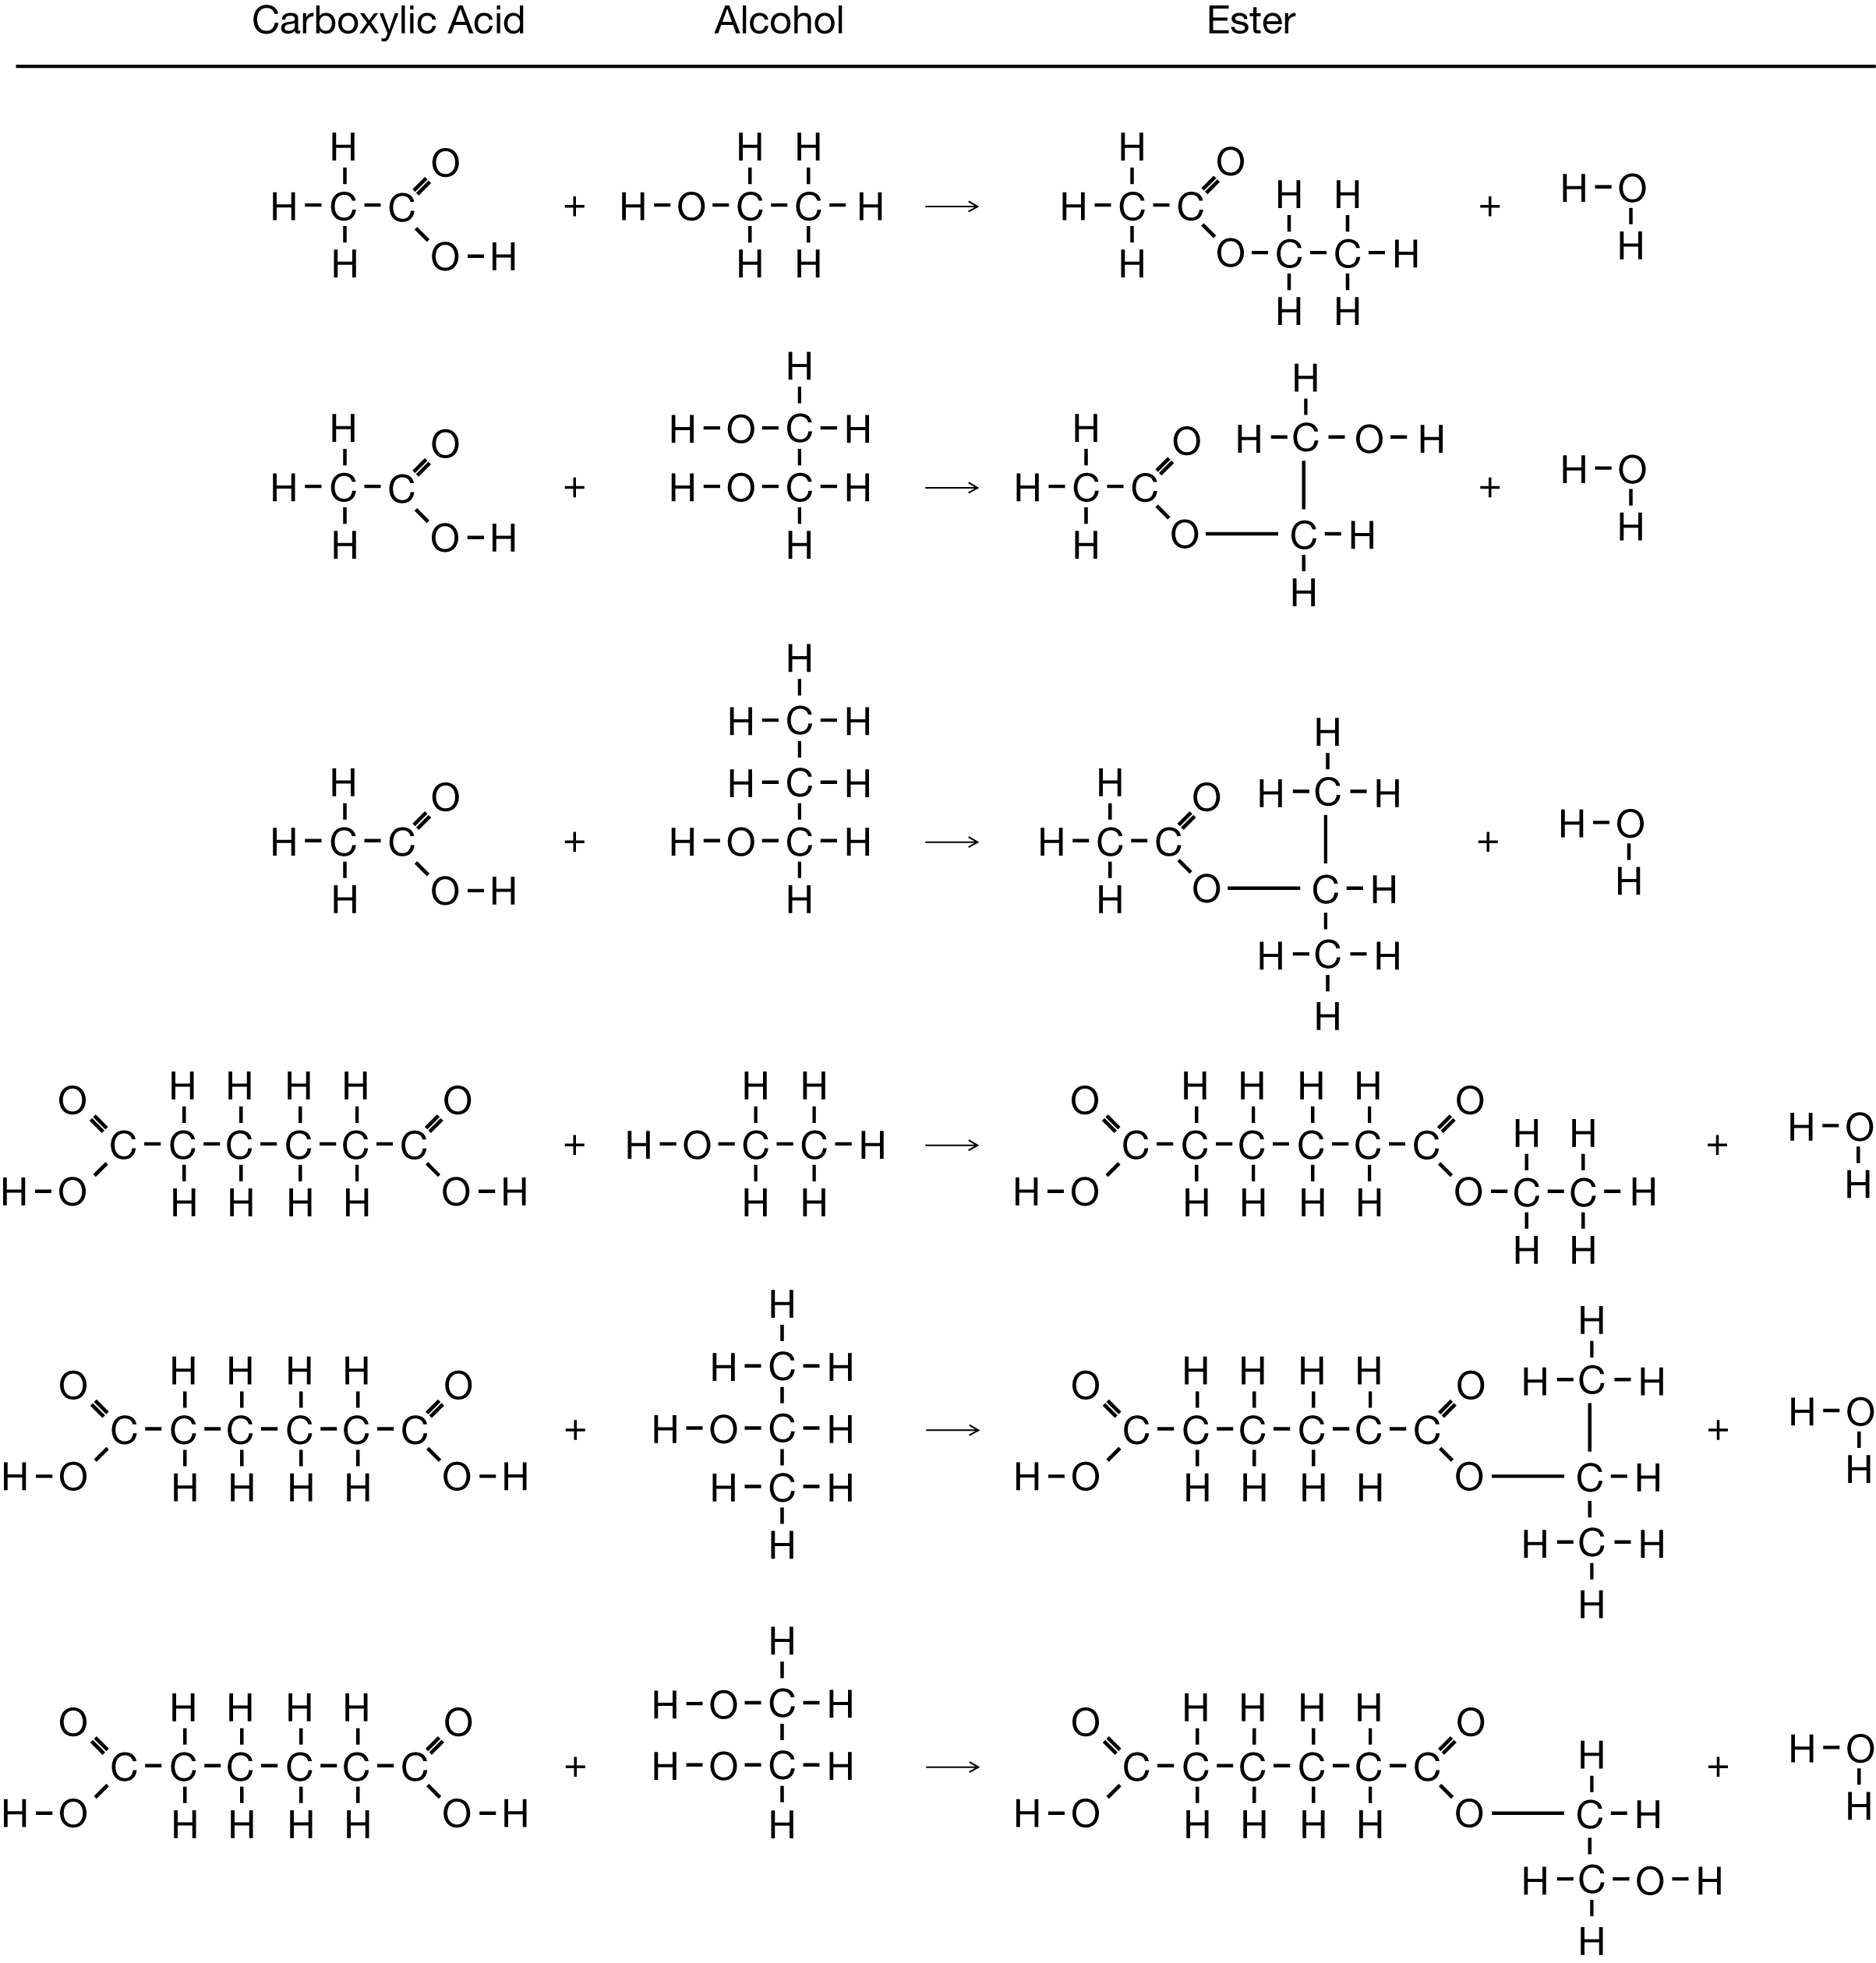
TR 2.

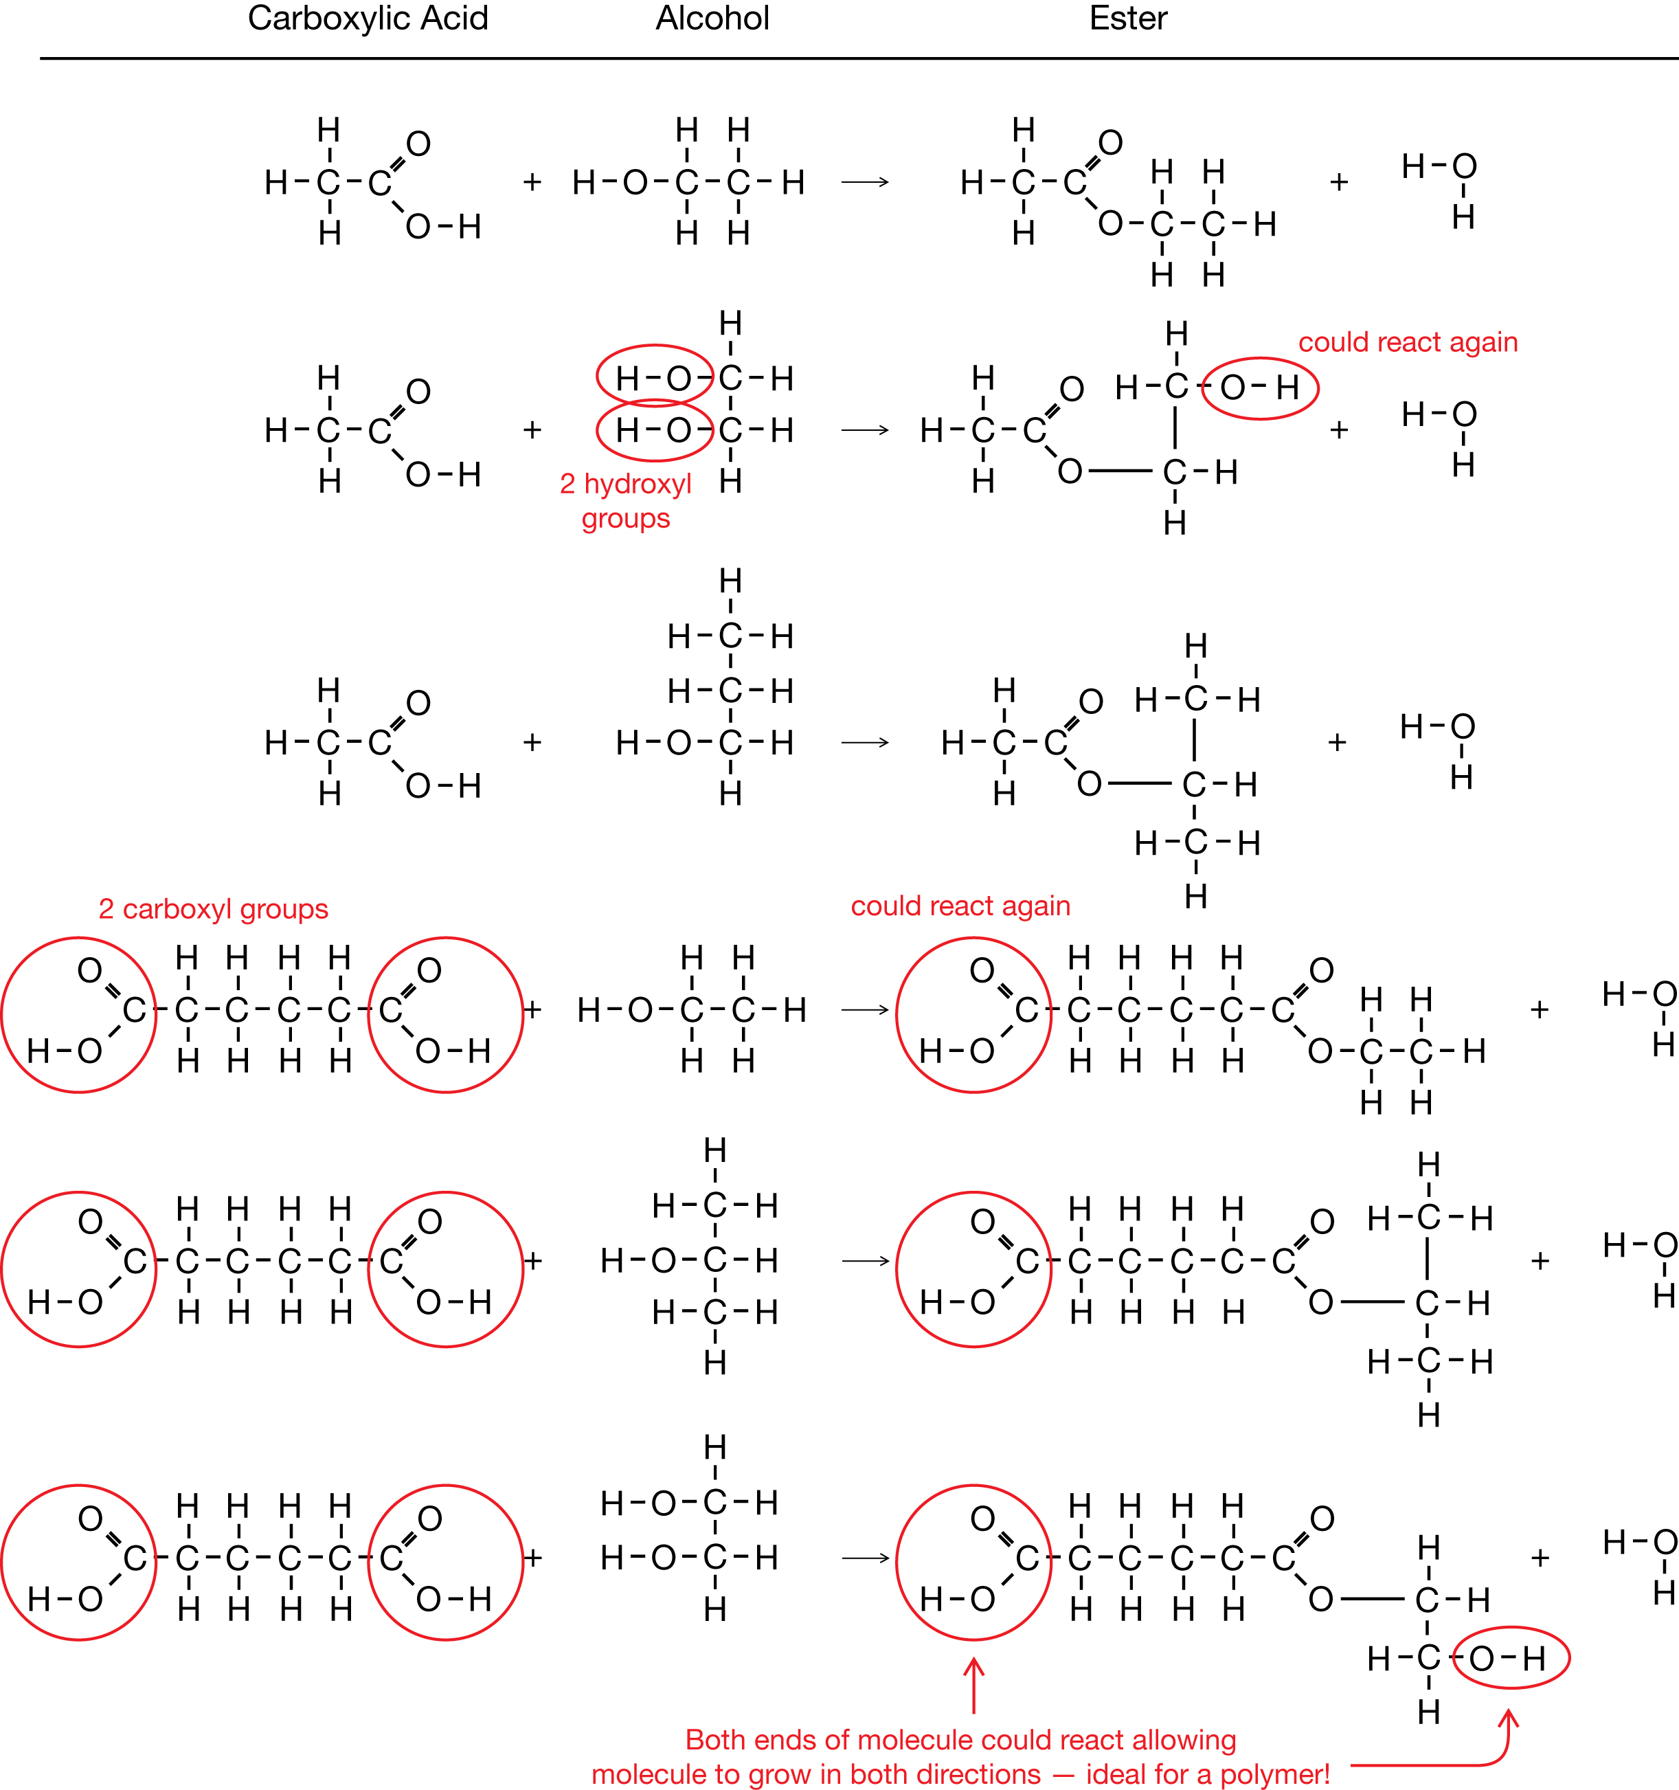

TR 3.

Step 4:

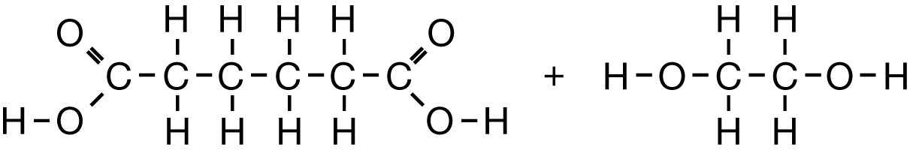

Reaction 1:

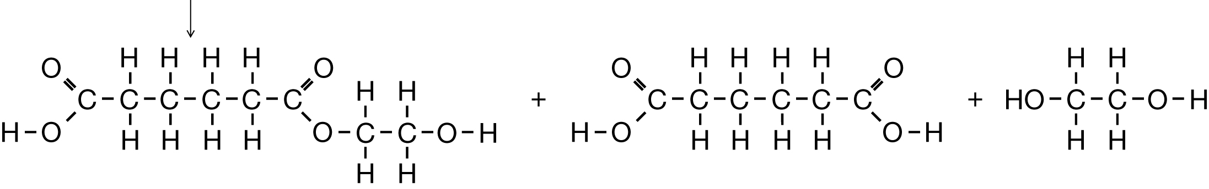

Reaction 2:

