Module 6: Lesson 6 ASSIGNMENT

Read all parts of your assignment carefully, and record your answers in the appropriate places. If you have difficulty with an assignment, go back to the textbook and review the appropriate lesson. Be sure to proofread your answers carefully before submitting your Assignment Booklet.

Lesson 6 Assignment

You have learned about the following types of chemical reactions that involve organic molecules:

- addition
- combustion
- elimination
- esterification
- polymerization

Answer the following questions for each of the following organic molecules, numbered 1–5:

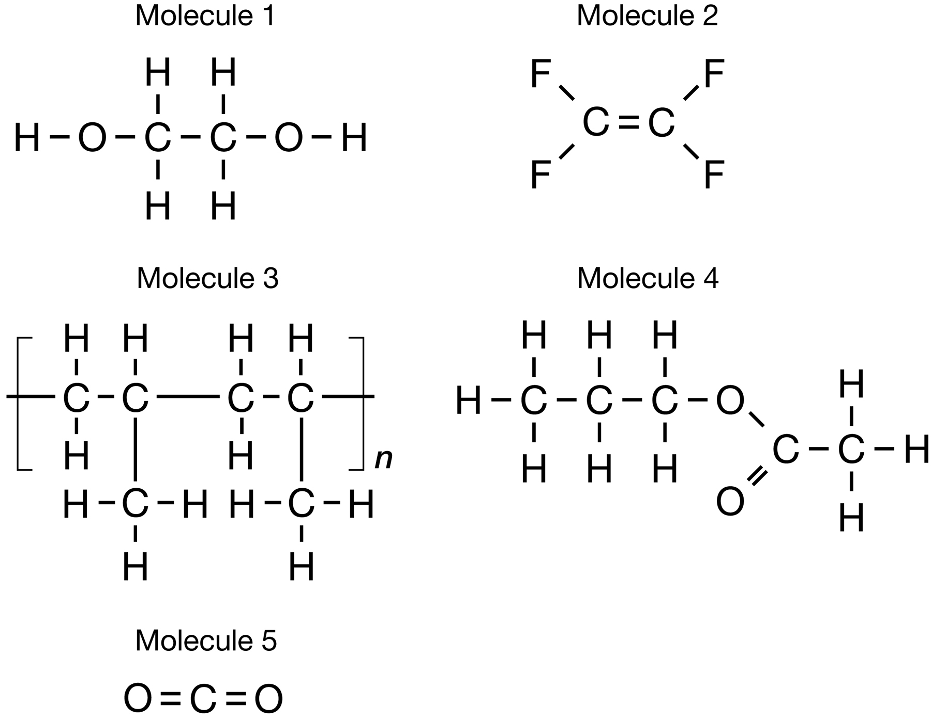

- Identify a reaction type that could be used to produce each molecule.

Answer: (5 marks)

- Write the balanced chemical equation for the production of each molecule using the reaction type identified in question 1. Include the names of all reactants and products.

Answer: (20 marks)

Unit C: Review

Use the following information to answer this question.

Compound | Boiling Point (°C) | Solubility in Water @ 25°C
I butane | -1 | Very low
II butan-1-ol | 118 | High
III dimethylpropane | 9.5 | Very low

(3 Marks) | 1. | Draw structural diagrams each compounds and explain why compound II is more soluble than compound 1 and 3.
(2 marks) | 2. | Explain why the boiling point of compound III is higher than the boiling point of compound I.

Use the following information to answer the next question.

Organic compounds may be classified as Aliphatic compounds or Aromatic compounds. Another classification system classifies organic compounds as hydrocarbons or hydrocarbon derivatives.

(3 Marks) | 3. | Draw and name a six-carbon hydrocarbon compound. Identify if this compound you drew is saturated or unsaturated, and if the compound is an Aliphatic or an Aromatic.
(2 Marks) | 4. | Draw and name a structural derivative of the compound you drew in question 3.

(5 Marks) | 5. | Design an experiment, with results, that will correctly identify three organic compounds. The substances are known to be:  Compound A. pent-2-ene  Compound B. 2-methylbutane  Compound C. pentanoic acid  - Complete the data table below.  - Your response should ALSO include:  - a detailed procedure, with variables identified  - predicted results and how to differentiate the three liquids  - structural formulas and any balanced chemical reactions for support

Substance | Test - | Test - | Test - | Test -
A
B
C

