Module 7: Lesson 3 ASSIGNMENT

Read all parts of your assignment carefully, and record your answers in the appropriate places. If you have difficulty with an assignment, go back to the textbook and review the appropriate lesson. Be sure to proofread your answers carefully before submitting your Assignment Booklet.

(20 marks) |  | Lesson 3 Assignment: Position of an Equilibrium

Mini Investigation: Modelling Dynamic Equilibrium

- Graph the data for System 1. Already done for you.

Answer: (2 marks)
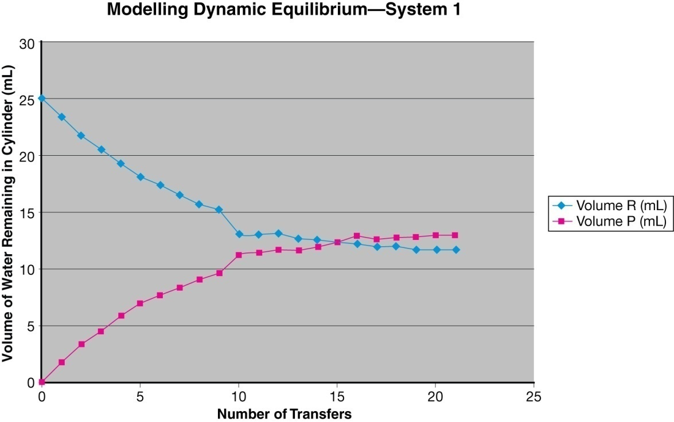

- Graph the data for System 1 with straws switched. Already done for you.

Answer: (2 marks)
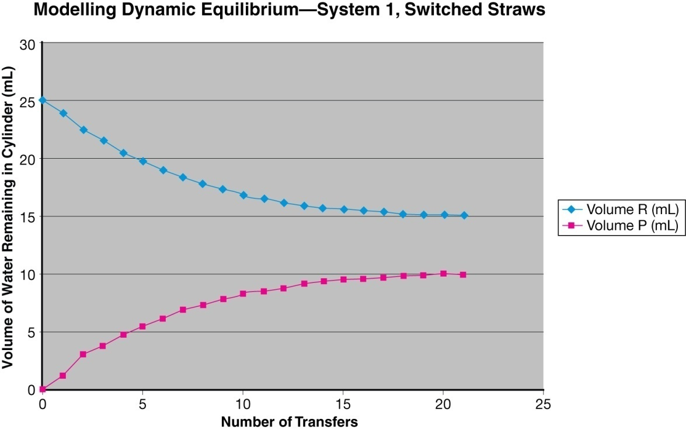

- Answer questions a–e on page 678 of the textbook.

Answer: (10 marks)

- Graph the data for System 2. Already done for you.

Answer: (2 marks)
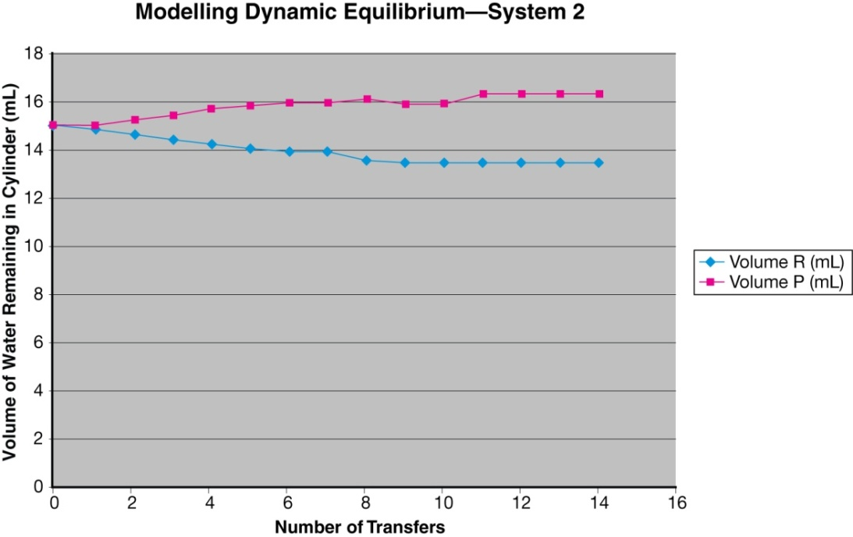

- Graph the data for System 3. Paste a copy of your graph in the space provided.

Answer: (2 marks)
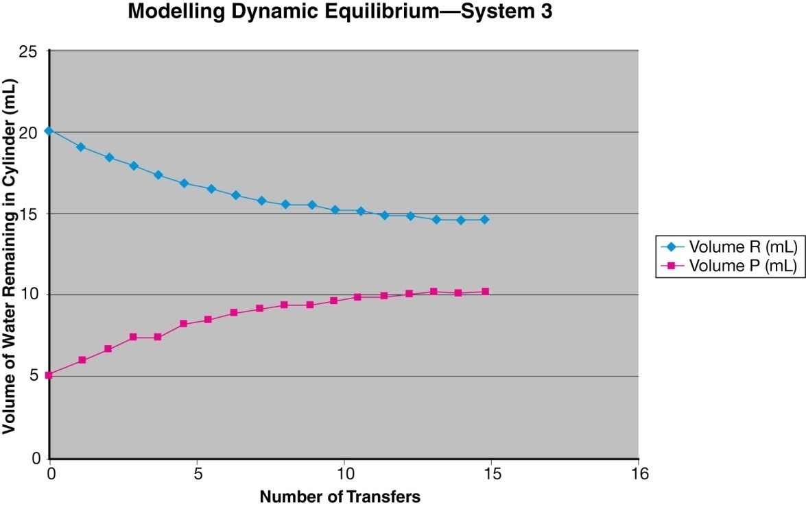

- State a possible hypothesis being investigated using Systems 2 and 3. Did the graphs support the expected results? Use the data to support your opinion.

Answer: (2 marks)

