Module 8: Lesson 2 ASSIGNMENT

Read all parts of your assignment carefully, and record your answers in the appropriate places. If you have difficulty with an assignment, review the relevant sections of the lesson and the textbook. Be sure to proofread your answers carefully before submitting your Assignment Booklet.

Use the following information to answer the first question.

Acid | pH of 0.10 mol/L solution
HNO₃(aq) | 1.0
HNO₂(aq) | 2.2

(15 marks) | 1. | Nitric acid and nitrous acid are two acids associated with acid deposition.

 |  | a. | Use the information in the table to identify which acid is a strong acid and which is a weak acid. Support your reasoning without the use of a calculation.

Answer: (2 marks)

 |  | b. | Support your answer to question 1.a. using a calculation.

Answer: (2 marks)

 |  | c. | Identify one other difference that you would expect if you tested these two solutions. Include the name of the test, the expected results for each solution, and the reasoning for the expected difference.

Answer: (2 marks)

 | 2. | Complete “Section 16.1” question 10 on page 721 of the textbook.

Answer: (4 marks)

 | 3. | Complete “Section 16.1” question 13 on page 721 of the textbook.

Answer: (5 marks)

Answers to Try This Questions Module 8: Lessons 2-7

Module 8—Acid-Base Equilibrium

Lesson 2—Acid Strength and Equilibrium

Discuss

HCl(aq) + H₂O(l) → H₃O⁺(aq) + Cl–(aq)

This is a quantitative (greater than 99%) reaction. This reaction could also be represented with equilibrium arrows and the text “greater than 99%” over the forward reaction.

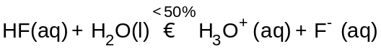

Hydrofluoric acid is a weak acid. Weak acids ionize to a lesser extent than strong acids. This must be represented with equilibrium arrows and a description of the extent of reaction.

Reflect on the Big Picture

The initial reaction of nitrogen and oxygen is endothermic. The addition of energy will shift the first reaction in the forward direction (to the right). By shifting the first reaction, all the other forward reactions in the process will also be favoured. The consequence will favour the production of nitric acid deposits from the atmosphere.

Lesson 3—Brønsted-Lowry Theory

Discuss

D 1. and D 2.

Answers will vary. A sample response is provided.

In the previous lesson students were asked to calculate a percent ionization for acids using pH data. A similar approach can be used to solve this problem.

Provided Information

System | HCl(aq) + H₂O(l) → H₃O⁺(aq) + Cl–(aq)
Concentration of HCl(aq) | 0.0250 mol/L
Solution pH | 1.6

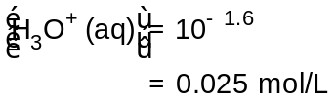

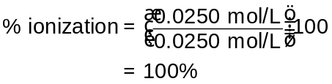

HCl(aq) + H₂O(l) → H₃O⁺(aq) + Cl–(aq) (written as a quantitative reaction)

Provided Information

System | NH₃(aq) + H₂O(l) → NH₄⁺(aq) + OH–(aq)
Concentration of NH₃(aq) | 0.0250 mol/L
Solution pH | 10.8

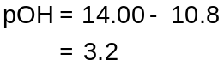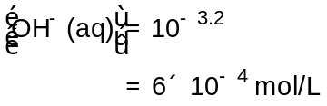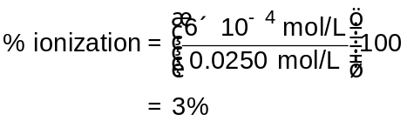

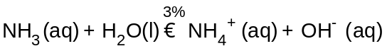

Try This

TR 1.

- HNO₃(aq) + H₂O(l) → H₃O⁺(aq) + NO₃–(aq)
- HNO₂(aq) + H₂O(l) → H₃O⁺(aq) + NO₂–(aq)
- H₂SO₄(aq) + H₂O(l) → H₃O⁺(aq) + HSO₄–(aq)
- H₂SO₃(aq) + H₂O(l) → H₃O⁺(aq) + HSO₃–(aq)

All of the acids listed react with water to form hydronium ions; therefore, their acidity can be explained using the proton transfer concept.

TR 2.
CO₃^{2–}(aq) + H₂O(l) → HCO^{3–}(aq) + OH–(aq)

The reaction with water that occurs in the soil or with lake water produced hydroxide ions. This would account for the higher pH of soil and water that was in contact with this mineral if present in the lake or streambed.

TR 3.

H₃O⁺(aq) + CO₃^{2–}(aq)  H₂O(l) + HCO₃–(aq)

The reaction shows a proton transfer between the hydronium ion produced as a result of the ionization of the acids that contributes to acid deposition and the carbonate present in soil. The result of this reaction is the neutralization of the hydronium ion. The neutralization of the hydronium ion reduces the impact of acid deposition.

A second possible reaction occurs between hydronium and the hydroxide produced by the reaction of carbonate and water. The products are neutral.

H₃O⁺(aq) + OH–(aq) → 2 H₂O(l)

Lesson 4—Predicting AB Equilibrium

Try This

Predicting Acid-Base Reactions

The following major trends are identified from the data:

- Reactions that favour the formation of products occur when the position of the acid is above the conjugate base in the table.

- Quantitative reactions occur when a strong acid (hydronium ion) and a strong base (hydroxide ion) are combined.

- Reactions that favour reactants occur when the position of the acid is below the conjugate base in the table.

- Some substances are listed on both sides of the table (e.g., water); these substances behave as an acid or base depending on the other species with which they are combined.

Reflect and Connect

All four acids will be neutralized by carbonate ions, a relatively strong base. The equilibrium favours the products in all four reactions.

Students are encouraged to update the summaries they began in Lesson 1. Teachers may wish to review the summaries throughout the students’ work in this module.

Lesson 5—Equilibrium Law and the Strength of Acids and Bases

TR 1.

An ICE table was used because equilibrium concentrations for the acid remaining in the system and the conjugate base had not been identified. An ICE table allows for equilibrium concentrations for all species in the system to be determined. Once that information is available, then K_{a} can be calculated.

This question draws the attention of most students to the context and wording of the question. Teachers may wish to remind students that, unless the information identifies the concentrations as being equilibrium concentrations, it is incorrect to assume that they are equilibrium concentrations.

Approximations

This section provides additional support beyond the textbook on the reasoning behind when an approximation can be used.

Try This

TR 2. and TR 3.

Students should be able to identify that a reaction between substances with a greater separation on the Relative Strengths of Acids and Bases table results in a higher percentage reaction and in an equilibrium that favours the products and, in many cases, involves a quantitative reaction.

TR 4.

The simulation provides a means to quickly test combinations of acids and bases listed on the table and to determine the percent reaction. Combinations can include those acids that have already been tested in previous investigations to ensure the results provided by the simulation are consistent with those observed empirically. This would provide confidence in using the results obtained from the simulation to other combinations of acids and bases.

Lesson 6—pH Curves

Try This

Distinctive Aspects  of a pH Curve | Comments
starting pH | indicates the type of solution being titrated  low starting pH = acid; high starting pH = base
appearance of the initial buffering region | flat buffering region or constant slope = strong  non-uniform buffering region (shoulder) = weak
pH at equivalence point | 7 for strong acid, strong base titrations  below 7 for weak base titrated with a strong acid  above 7 for weak acid titrated with a strong base
height of region between buffering regions | strong acid, strong base titration; this region is large (spans many pH units)  weak acid or weak base titration; this region is smaller (spans a few pH units)
number of equivalence points | one equivalence point = monoprotic  more than one equivalence point = polyprotic
ending pH | high = titrant was a strong base  low = titrant was a strong acid

Lesson 7—Buffers

Try This

This simulation is intended to give students an opportunity to investigate how a chemical buffer can be created. Students should identify that a weak acid and conjugate base are required to have both components in the buffer system. Questions may naturally arise regarding the quantities of weak acid and conjugate base used.

Teachers should ask students to consider how the following relationship might be helpful in understanding the aspects of buffer construction:

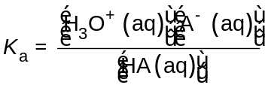

Desired outcomes might be observed when students state the following:

- To make a buffer of a desired pH, pick an acid or a base with a K_{a} that is relatively close to the desired [H₃O⁺(aq)].
- The relative proportions of acid and its conjugate base can adjust the pH; for example, more base relative to the acid will increase the pH.

Such discussion will help students complete Self-Check question 2.

