Module 8: Lesson 4 ASSIGNMENT

Read all parts of your assignment carefully, and record your answers in the appropriate places. If you have difficulty with an assignment, go back to the textbook and review the appropriate lesson. Be sure to proofread your answers carefully before submitting your Assignment Booklet.
(30 marks)

Lab—Testing Brønsted-Lowry Reaction Predictions

(16 marks) | Pre-Lab (Virtual Lab)  - The investigation you will complete involves combining the solutions listed in the tables below. Use the method to predict acid-base reactions to complete the following tasks for each reaction provided:  - Write a balanced chemical equation.  - Indicate the position of equilibrium for the resulting system.  - Predict the result of each reaction.  - Identify the test (smell, glowing splint, pop test, CO₂ test) you could use to support the predicted result of the reaction.  Note: To view the results for the odour of the reactions #1 and #2 be sure to click on the  picture of the ‘Results when Reactants combined’ to get more info. For Reactions #3 and #4 you are on your own to predict.  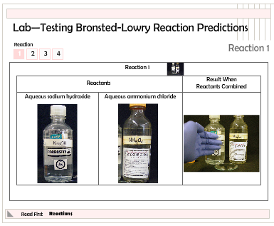  List your answers in the tables provided.

 |  | Reaction 1
 | Reactants |  |  | Predictions
 | Aqueous Ammonium Chloride |  | Aqueous Sodium Hydroxide | Balanced Chemical Equation
 |  |  | Aqueous Sodium Hydroxide | Position of Equilibrium
 |  |  | Aqueous Sodium Hydroxide | Predicted Result
 |  |  | Aqueous Sodium Hydroxide | Test to Confirm

 |  | Reaction 2
 | Reactants |  |  | Predictions
 | Aqueous Sodium Ethanoate |  | Hydrochloric Acid | Balanced Chemical Equation
 |  |  | Hydrochloric Acid | Position of Equilibrium
 |  |  | Hydrochloric Acid | Predicted Result
 |  |  | Hydrochloric Acid | Test to Confirm

 |  | Reaction 3
 | Reactants |  |  | Predictions
 | Aqueous Sodium Hydrogen Carbonate |  | Aqueous Sodium Hydrogen Sulfate | Balanced Chemical Equation
 |  |  | Aqueous Sodium Hydrogen Sulfate | Position of Equilibrium
 |  |  | Aqueous Sodium Hydrogen Sulfate | Predicted Result
 |  |  | Aqueous Sodium Hydrogen Sulfate | Test to Confirm

 |  | Reaction 4
 | Reactants |  |  | Predictions
 | Aqueous Sodium Benzoate |  | Aqueous Sodium Hydrogen Sulfate | Balanced Chemical Equation
 |  |  | Aqueous Sodium Hydrogen Sulfate | Position of Equilibrium
 |  |  | Aqueous Sodium Hydrogen Sulfate | Predicted Result
 |  |  | Aqueous Sodium Hydrogen Sulfate | Test to Confirm

(12 marks) | Observations

Reaction | Reactant 1 | Reactant 2 | After Combination
1
2
3
4

Analysis

- For each reaction performed (Reactions 1–4), indicate whether the observations you made confirm the predictions you made in the Pre-Lab section of this investigation.

Answer: (2 marks)

Submit your completed Assignment Booklet to your teacher
at the end of this lesson.

