Module 8: Lesson 7 ASSIGNMENT

Read all parts of your assignment carefully, and record your answers in the appropriate places. If you have difficulty with an assignment, review the relevant sections of the lesson and the textbook. Be sure to proofread your answers carefully before submitting your Assignment Booklet.

(10 marks) | 1. | Buffers that match the pH of blood and the cytoplasm are commonly required in scientific experiments. If you were studying the effects of lactic acid on muscles and needed to design a buffer that would have a pH of 7.2, what chemical components would you select and in what proportions? Include relevant calculations in your answer.

Answer: (10 marks)

Unit 4: Review

(4 Marks) | 1. | The unique flavor of fruits and berries is due to the presence of esters. These chemical compounds are easily synthesized in the laboratory. For example, ethyl propanoate is responsible for the flavor characteristic to pineapple. It is produced by the following endothermic reaction:  When 7.71 mol of 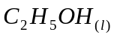 and 7.37 mol of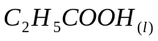 are reacted in a beaker, 4.80 mol of 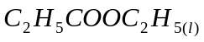 are present when equilibrium is established and the total volume of liquid is exactly 1.00 L.  a) Calculate Kc for this system. Are the reactants or products favored at equilibrium? Hint: This equilibrium is not an aqueous solution and water is a product. Therefore the H₂O is important and needs to be included in the Kc equation.
(1 Marks) |  | b) Explain how to increase the yield of the ester, ethyl propanoate, besides increasing the amounts of reactants.
Use the following information to answer the next question.
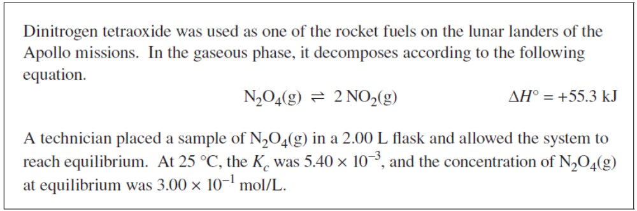

(3 Marks) | 2. | a) Determine the amount, in moles, of NO₂(g) present in the 2.00 L flask at equilibrium.
(2 Marks) |  | b) Identify whether the value of Kc will increase, decrease, or remain the same when heat is added to the system. Support your answer with an explanation.

Use the following information to answer the next question.
A chemist performed three trials of an experiment involving a closed system at equilibrium at 700 K. The system can be represented by the following equation:
The chemist recorded the equilibrium concentrations of each gas in the table.

Trial | [H_{2(g)}] mol/L | [I_{2(g)}] mol/L | [HI_{(g)}] mol/L
1 | 0.165 | 0.0978 | 0.945
2 | 0.103 | 0.179 | 1.013
3 | unknown | unknown | 1.55

(2 Marks) | 3. | a) Calculate the average value for the equilibrium constant, Kc, for the production of HI_{(g)}.
(1 Mark) |  | b) In trial 3, equilibrium was established by allowing a sample of HI_{(g)} to decompose. Calculate the equilbrium concentration of the H_{2(g)} and I_{2(g)} for trial 3.
(2 Marks) |  | c) Identify a stress that would increase the value of the equilibrium constant, and explain how the stress is responsible for the increase.

