Lab Report: Pump Characteristics
Team: The Boys in the Beaker
Mark Heien, Nathan Rodrigue, Gabe Wylie, Tommy Yue
November 10, 2025
Introduction
Pumps are the heart of any plant and in buying a pump, every customer needs to know it’s characteristics. Our problem is we don’t have those characteristics, and we’re reselling surplus pumps. To solve this problem, we will be performing experiments with repeated trials, to determine head pressure and flowrate at different RPMs, and power usage. The goal is to map where each belongs in high-throughput transfer of low-viscosity fluids (centrifugal) vs. accurate dosing or viscous service (PD). We’ll connect the data to transport fundamentals like the Bernoulli equation, mechanical energy balances, and flag common failure modes like cavitation on centrifugal pumps. Mechanistically, pumps convert shaft power to hydraulic power and efficiency is shaft power over hydraulic power, which is known to drop with leakage/recirculation.
In a plant that relies on pumps to move fluids and make products, the reliability of the equipment needs to be as high as possible. This is true whether the plant is a small scale with low startup budget, or large scale with huge startup budget, but regardless the amount that can be paid for certainty is limited, and dependent on priorities at the time of budgeting. To this end, our work will allow our customers to make informed decisions regarding cost, certainty, and needed power by creating transparent pump curves with known amounts of error.

Table 1. Measured and calculated variables with their respective symbols and units.
i = independent variable, p = parameter
Variable | Symbols | Units
Volumetric flowrate (i) | Q | gal/min or SCFM
Pressure-head (p) | P_{h} | kPa
Pressure-discharge (p) | P_{d} | kPa
Voltage (p) | V | V
Current (p) | I | A
Motor speed (i) | N | rpm
Work (p) | W | W, or kg*m²/s³
Efficiency (p) | η | -
After collecting flowrate, pressure change, current, and voltage measurements, we will use the following formulas to calculate head pressure, volumetric flow rate, power and efficiency of the pump:
Head Pressure: $P_{h}= ρgΔH [1]$; Volumetric flow rate: $Q_{actual}=mQ_{measured}+b [2]$;
Power: $W_{in}=F\sqrt{3} I V [3]$; $W_{out}= QΔP [4]$; Efficiency: $η=\frac{W_{out}}{W_{in}} [5]$
Values of m was approximated calibration slope& b was the y intercept of Calibration curve in equation [2].
Given our need for transparency, our assumptions aim to be as conservative as possible, while allowing our group to stay within budget and provide useful information. As such, we will be doing our testing with water, at room temperature, and relatively low pressure. Under these conditions, we will assume that the fluid is incompressible with constant viscosity, single phase and negligible bubbles go into the pumps. For the centrifugal pump, we expect a classic down-sloping head-flow (ΔP-Q) curve; small negative slope at low flow rates, with very fast drop off at high flow rates. Best efficiency lines in 70-80% window, with midrange of flowrate and head pressure. See Figure 2 for an example pump curve. For the positive displacement pump nearly flat ΔP-Q because displacement per revolution is fixed; you pay with slippage at high ΔP, so efficiency (η) falls off sooner and is generally lower.
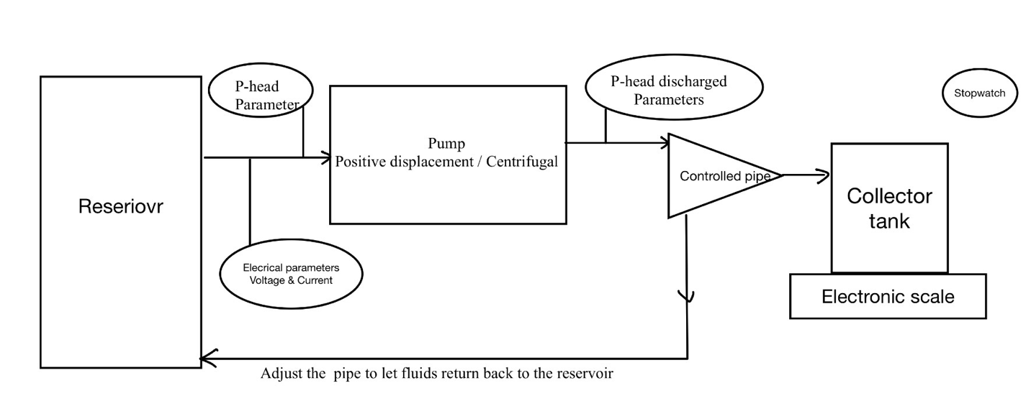
Method
Figure 1. Pump testing apparatus flow diagram.
Beginning with the positive displacement pump, ensure that all equipment is in a safe configuration that won’t splash water when turned on. Follow posted instructions for turning on the equipment. Fill the water reservoir about one third full, then fully open the valve that controls the flowrate. Set N to 500 RPM and wait for flowmeters to stabilize. Record each of the flowmeter readings, discharge pressure, head pressure, voltage, and current. Repeat these measurements in triplicate, wait ~1 minute between each reading. Increase N to 750 RPM and repeat previous measurements, and again for 1000 RPM. Decrease N to 500 RPM and tighten the flowrate valve until the flowmeter displays a value ~15% lower than it was previously. Repeat all previous measurements for the three RPM values. Repeat for 5 total flowrates such that the final flowmeter reading is ~75% lower than the initial flowrate at 500 RPM.
For the centrifugal pump, use N = 1500, 2250, and 3000 RPM, and follow the same procedure as for the positive displacement pump. The water reservoir should always be maintained at 55 gallons, while aiming the outlet pipe towards the edge of the reservoir to avoid bubble flashing into the pump, with similar triplicate measurements. If conducting a “bucket and stopwatch” measurement, refill the reservoir to this level afterwards. See Figure 1 for a schematic describing the equipment.
Last but not least, logging all the instrumental errors for reliable error analysis.
Results
The raw data are shown in full in the attached Excel file. The flowmeters for both the centrifugal and positive displacement (PD) pumps were calibrated by bucket and stopwatch (B&S) measurements to resolve any of their inherent inaccuracies. Then, each pump was run at three RPMs over their allowed range, while flowrate, pressure drop, voltage, and current were measured at different flowrates determined by the restricting valve position. Figure 2 shows the calibration curves for the centrifugal and PD pumps.
a. | b.
Figure 2. (a) Centrifugal pump calibration curve; (b) Positive displacement (PD) pump calibration curve.
As seen in Figure 2b, the PD pump had two flowmeters attached. Vertical error bars are shown due to the multiple B&S trials performed. The CalFlo (GPM) and FP (SCFM) flowmeters had different operational ranges, and during high flowrate testing, the FP meter was at its maximum limit and unusable. During normal testing we opted to use the FP meter readings for further calculations due to its higher precision compared to the CalFlo meter. Seen on the plots, the trendline equations were used to translate raw flowmeter measurements to align with the known B&S measurements shown by the following sample calculation using Equation 2:
$$Actual Flowrate [GPM]=0.4871\left(FP Meter Flowrate [SCFM]\right)+2.7905$$
$$Actual Flowrate=0.4871\left(4.2 SCFM\right)+2.7905=4.84 GPM$$
During the lab, we followed the procedure described in the Introduction to generate pressure drop vs. flowrate data, or pump curves, at several RPMs and flowrates for both pumps. Figure 3 shows the pump and efficiency curves for the centrifugal pump, which resembles the expected plot in Figure 4. Error bars are present on the pump curve data, but our measurements were highly consistent. We opted to make a separate plot for efficiency since overlaying it onto the pump curve would have been tedious.
a. | b.
Figure 3. (a) Centrifugal pump curve [Pa vs. m³/s]; (b) Centrifugal pump efficiency [% vs. m³/s].
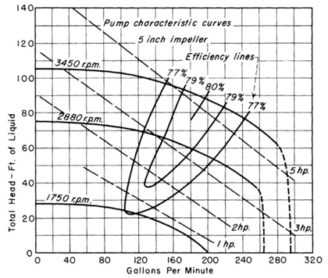
Figure 4. Hypothesized pump curve. (Perry’s)
Next, we tested the PD pump
Error analysis
Results seem expected, only potential deviation is Positive Displacement pump being not perfectly vertical Head Pressure vs Flow Rate graph. This could be explained by fluid being compressible and the pump having an imperfect seal. Standard deviation was calculated and added to the individual measurement error, to form overall error below. Additionally, our error is large enough that we can’t actually claim that it isn’t perfectly vertical.
Error propagated and plotted as error bars using the following 3 equations where the first two are simplifications and the final is the generalization.
$$u\left(y\right)=\sqrt{{(u\left(x_{1}\right))}^{2}+…+{(u(x_{n}))}^{2}}, Y=x_{1}+…+x_{n}$$
$$u\left(y\right)=y\sqrt{{\left(\frac{u\left(x_{1}\right)}{x_{1}}\right)}^{2}+…+{\left(\frac{u\left(x_{n}\right)}{x_{n}}\right)}^{2}}, Y=\frac{x_{1}*…}{x_{n}*…}$$
$$u\left(y\right)=\sqrt{{\left(\frac{∂y}{{∂x}_{1}}u\left(x_{1}\right)\right)}^{2}+…+{\left(\frac{∂y}{{∂x}_{n}}u\left(x_{n}\right)\right)}^{2}}, Y=f(x_{1},…,x_{n})$$
As an example, calculation, when propagating error in calibration curves for centrifugal pump, we used all three equations. First equation three was used with mass and time.
$$u(\dot{V)}=\sqrt{{\left(\frac{∂\dot{V}}{∂m}u\left(m\right)\right)}^{2}+{\left(\frac{∂\dot{V}}{∂t}u\left(t\right)\right)}^{2}}=\sqrt{{\left(\frac{1}{∂t}u\left(m\right)\right)}^{2}+{\left(\frac{∂\dot{V}}{∂t}u\left(t\right)\right)}^{2}}=\sqrt{{\left(\frac{1}{10.38s}*0.01lb\right)}^{2}+{\left(\frac{\frac{3.659lb}{s}}{10.38s}*0.041s\right)}^{2}}=0.0145lb/s$$
This is one trial measurement error, of which only the maximum trial measurement error will be used going forward. When the maximum measurement error is found, is the added to std dev. Yielding calibration error of 0.155 lb/s. Next, this error is added to measurement error in flow meter by the additive formula, corrected using the general formula with calibration slope, and made into power uncertainty with multiplicative formula.
Discussion
Calibration and data quality. We benchmarked the panel flowmeters via bucket-and-stopwatch trials and then used the trend fits to translate raw readings. On the PD rig, we prioritized the CalFlo (gpm) readings when available and used the FP meter (SCFM) where CalFlo lacked a value (e.g., 503 rpm, point #1). The error sheet shows dominant contributors of ±1.25 gpm (CalFlo), ±1.0 gpm (FP), ±0.5 on pressure (manual & digital), and ±0.041 s on timing; these were propagated into the plotted error bars. This gave stable averages across triplicates and kept interpretation focused on physics rather than meter noise.
Centrifugal pump (CP) performance. The measured head–flow families at 1500/2250/3000 rpm show the expected downward slope with increasing Q, and the whole curve shifts upward with speed:
- 1500 rpm: ~13.1 gpm at 35 kPa up to ~33.5 gpm at 18.3 kPa.
Fluid power peaks near 28 gpm at ~24 kPa (≈0.042 kW).
- 2250 rpm: ~19.8 gpm at 69.3 kPa up to ~52.2 gpm at 30 kPa.
Fluid power peaks near 42.8 gpm at ~43 kPa (≈0.127 kW).
- 3000 rpm: ~26.6 gpm at 117 kPa up to ~70.0 gpm at 43.7 kPa.
Fluid power peaks near 50.4 gpm at ~81 kPa (≈0.259 kW).
The slopes (ΔP vs. Q) steepen with speed (≈−0.81, −1.21, −1.68 kPa/gpm at 1500/2250/3000 rpm), consistent with pump affinity behavior. Electrical inputs tracked this trend (≈95 V & 2.75–2.9 A at 1500 rpm; 133–135 V & 3.6–4.17 A at 2250 rpm; 178–179 V & 4.8–5.8 A at 3000 rpm). Suction readings were near flooded conditions at low flows and dipped into slight vacuum at higher flows (down to about −four on the gauge that records vacuum in inHg at ~57.6 gpm/3000 rpm). We noted the onset of oscillation around 35 gpm (3000 rpm) and ~37 gpm (2250 rpm)—a practical marker to avoid continuous operation right at those conditions on our rig.
Positive-displacement (PD) pump performance. As expected, flow is nearly set by RPM and only weakly dependent on discharge pressure across our tested range:
- Average flows (CalFlo): 5.53 gpm @ 503 rpm, 9.07 gpm @ 754 rpm, 15.91 gpm @ 1095 rpm (linear fit R²≈0.99).
- Within each RPM, increasing discharge pressure from ~6–9 psi (503 rpm), ~11.5–16 psi (754 rpm), and ~18–26 psi (1095 rpm) produced only small flow changes (e.g., at 1095 rpm: 16.4 → 15.5 gpm as pressure rose 18.2 → 26.1 psi, ≈5–6 % drop), consistent with slip/internal leakage effects.
Uncertainty & limitations. Largest contributors were flowmeter resolution (especially on PD at the top end), pressure gauge resolution, and small transients when stepping the valve. Lacking motor power factor, we report fluid power (ΔP·Q) rather than overall efficiency; the BEP region is still evident from the CP power envelopes and the expected “mid-flow sweet spot.”
Interpretation vs. objectives. The CP family of curves provides a usable spec window at each RPM (with clear mid-flow power peaks), while the PD curves confirm near-constant displacement per revolution with modest pressure-dependent slip. These data directly support the “what should we buy/use these for?” decision.
Recommendations
For end-use/application (what to sell these for):
• Centrifugal pump: Position for high-throughput transfer of water-like fluids where the duty point sits near the mid-flow region of the measured curves at the chosen RPM (best efficiency), not at shutoff (low-flow recirculation) or far-right run-out (inefficient, low head). Emphasize flooded suction and clean, bubble-free inlets to avoid cavitation and performance scatter.
• PD pump: Market for accurate metering/dosing and viscous or moderate-pressure service where near-constant flow per RPM is valuable. Note that slip will grow with discharge pressure; recommend a relief/bypass line, a simple suction strainer, and (for pulsation-sensitive systems) a dampener.
Operating guidance for buyers:
• Choose RPM to place the operating point on the centrifugal curve close to the measured efficiency peak; avoid throttling so hard that the pump lives at low-flow recirculation.
• For PD service above moderate ΔP, expect a small RPM increase to maintain set flow; verify with an inline flow indicator (our calibration shows metering is stable in the primary range).
Improvements for future testing (so next users can tighten specs):
• Add suction-side pressure logging to estimate NPSH margins and document cavitation-free limits explicitly.
• Record true input power (V, A, and power factor) to refine efficiency.
• Expand high-flow calibration points on the PD rig (or select a meter with headroom beyond the top test condition).
• Automate data capture (time-synchronized ΔP, Q, V, I, RPM) to eliminate valve-step transients and further shrink error bars.
Future Work (Viscosity): To broaden the marketability of the positive displacement pump, a future experiment could characterize its performance with a more viscous fluid (e.g., a known concentration water-glycol mixture). This would provide invaluable data for customers in chemical or food processing.
Future Work (Instrumentation): To more accurately quantify the positive displacement pump's slip and the centrifugal pump's efficiency, a future test should utilize instrumentation with a lower uncertainty. Specifically, a differential pressure transducer with a higher resolution and a flow meter with a smaller full-scale error would significantly reduce the propagated error in the final performance curves.
The centrifugal pump is ideal for high-volume water transfer in HVAC systems, while the positive displacement pump suits precise chemical dosing in processing plants.

References
Perry’s Chemical Engineers’ Handbook, 8th Ed. (2007)
LearnChemE: https://learncheme.com/
Prybutok, A. (2025). Lecture 9: Combined uncertainty and error propagation (Part 1) [PowerPoint slides]. CHEM E 436, University of Washington. (Formulas you used for combined uncertainty/propagation.)
Karassik, I. J., Cooper, P., Heald, C. C., & Messina, J. P. (2017). Pump handbook (5th ed.). McGraw-Hill Education.

