Lab Report – Transport December 1, 2025
The Boys in the Beaker
Mark Heien, Nathan Rodrigue, Gabe Wylie, Tommy Yue
Abstract
This study established thermal conductivity and diffusivity values for brass alloy and obtained working fluid viscosity measurements to enable heat-exchanger design and pump performance calculations. The custom brass-rod apparatus operated through unsteady steam heating and steady-state water cooling methods to determine thermal properties. Scientists used the semi-infinite solid correlation to measure thermal diffusivity by analyzing early-time temperature data and they used steady-state axial gradients with water-side heat removal to determine thermal conductivity. The falling-sphere viscometer operated under complete gravity–buoyancy–drag force equilibrium to determine the viscosity of water, salt water, glycerol, and 5W-30 motor oil by monitoring sphere movement. The brass alloy showed thermal conductivity and diffusivity that were lower than reported in literature, but the low-viscosity fluids failed to follow Stokes-flow behavior because of poor alignment and Reynolds number effects. The researchers suggest three main improvements for future measurements to minimize systematic errors: better insulation, improved flow alignment, and optimized operating conditions.
Introduction
Heat exchangers are vital components of systems that rely on a cooling operation for regular use, such as in refrigeration, HVAC systems, and combustion engines. Because their thermal properties determine heat-transfer efficiency, equipment sizing, and whether systems can operate safely without overheating. Our company is in the process of developing a new brass alloy material for use as a heat exchanger. Measuring the alloy’s conductivity and diffusivity ensures it meets the thermal-loading requirements expected in industrial heat-exchange applications. Material choice is important because it must be able to transfer enough heat so that the equipment at hand does not overheat. Due to budget constraints, a homemade testing apparatus was developed using an insulated cylindrical rod made of our brass alloy. A reliable and repeatable procedure is necessary so that the measurements reflect actual material behavior rather than variability in operator technique or boundary conditions. Unfortunately, little documentation was prepared regarding the use of the apparatus, and in order to test the thermal properties of the alloy, we developed a procedure of our own. A reliable procedure is important for creating reproducible results. Using principles including Fourier’s law of heat conduction and the semi-infinite solid correlation, we were able to use flowing steam and water at opposite ends of the rod to create a constant temperature boundary condition and measure heat flow. The semi-infinite assumption is valid only before the heat front reaches the final thermocouple, allowing early-time temperature data to be related directly to diffusivity. Thermocouples along the length of the rod were used to measure temperature change along the rod with respect to time. The unsteady-state behavior between the time of the steam first contacting the rod and the furthest thermocouple changing temperature was used to determine the rod’s thermal diffusivity. Thermal conductivity was calculated from steady-state data obtained when water was flowing at the opposite end of the rod and thermocouples were no longer changing their reading.
Another component of this experiment was determining the viscosity of several fluids for heat exchanger use. Viscosity is essential for pump sizing, estimating pressure drop, and determining flow regimes in heat-transfer equipment. Heat exchangers often operate with several fluids used to transfer heat between sources and sinks. Fluid viscosity is also important for pump sizing and determining required pump diameters. If pumping equipment is not sufficient to transfer a certain fluid, then either a different pump or fluid must be used for the process. To evaluate viscosity, we used fluids in graduated cylinders of known height and measured the time for a small sphere to fall from the surface of the fluid to the bottom of the cylinder. The falling-sphere method is appropriate here because viscosity can be inferred from the balance of gravitational, buoyancy, and viscous drag forces on the sphere. After calculating the density of the fluids and spheres, a gravity-drag-buoyancy force balance was conducted to determine viscosity of tap water, salt water, glycerol, and 5W-30 motor oil using high-density precision beads and larger, less dense nylon beads. See Table 1 for the symbols and units of various experimental variables.
Table 1. Measured and calculated variables with their symbols and units.
Variable | Symbol | Units | Variable | Symbol | Units
Sphere mass x | m_{s} | kg | Sphere sink distance * | L_{s} | m
Sphere diameter x | D_{s} | m | Sphere sink velocity * | v_{s} | m/s
Fluid mass x | m_{f} | kg | Viscosity | µ | Pa*s
Fluid volume x | V_{f} | m³ | Steam pressure x | P_{s} | Pa
Fluid density | ρ_{f} | kg/m³ | Mass flowrate x | $$\dot{m}$$ | kg/s
Sphere sink time * | t_{s} | s | Uns. St. Time x | t_{US} | s
x = independent variable, * = dependent/measured variable
After measuring sphere mass and diameter, fluid mass and volume, and sink height and time of the spheres in the fluids, we used Equations 1, 2, and 3 to determine viscosity. The viscosity term in Equation 1 was a controllable variable which was determined by minimizing the SSR between the sphere’s theoretical position and actual position. Theoretical position was calculated using Equations 1-3, and actual position was determined by the position and time measurements. In Equation 1, the drag term (6*π*r*v*μ) was derived using the assumption of Stokes/creeping flow (Re << 1). The validity of this assumption is discussed in the Discussion section.
$$\begin{aligned}F=\left( ρ_{sphere}-ρ_{liquid}\right)*g*V-6*π*r*v*μ\#1\end{aligned}$$
$$\begin{aligned}v_{n+1}=\frac{F}{m}*∆t+v_{n}; v_{0}=0 is assumed\#2\end{aligned}$$
$$\begin{aligned}P_{n+1}=v_{n+1}*∆t+P_{n}\#3\end{aligned}$$
Where F is the force on the sphere (N), g is the acceleration due to gravity (m/s²), V is the sphere volume (m³), r is the radius of the sphere (m), v is the sphere velocity (m/s), µ is the fluid viscosity (Pa*s), m is the sphere mass (kg), Δt is the change in time over which the sphere moves (s), and P is the position of the sphere in the graduated cylinder (m). “n+1” subscripts indicate new values made by the iteration.
Since the brass rod is insulated, we assumed that the brass rod was a semi-infinite solid before heat reaches the final thermocouple.¹ Once the final thermocouple was affected by the heat transfer, the correlation was no longer valid. Equation 4 was used to find thermal diffusivity using our Python script:
$$\begin{aligned}\frac{T-T_{s}}{T_{i}-T_{s}}=\operatorname{erf}\left(\frac{x}{2\sqrt{αt}}\right)→α={\left(\frac{{\left({erf}^{-1}\left(\frac{T-T_{s}}{T_{i}-T_{s}}\right)\right)}^{-1}*x}{2\sqrt{t}}\right)}^{2}\#4\end{aligned}$$
Where T = temperature (°C) at a specific position and time, T_{s} = surface temperature, T_{i} = initial temperature, x = position along rod (m), α = thermal diffusivity (m²/s), and t = time (s). See Figure A1 in the Appendix for a description of the semi-infinite solid correlation.
At steady-state, when the water is on and temperature along the rod is constant, we can relate the heat transfer to the water ($\dot{q}$) to the heat flux over the rod by Equation 5.
$$\begin{aligned}\dot{q}=\dot{m} C_{P}ΔT=A_{C}\left(-k\frac{dT}{dx}\right)→k=-\frac{\dot{m} C_{P}ΔT}{A_{C}} {\left(\frac{dT}{dx}\right)}^{-1}\#5\end{aligned}$$
Where $\dot{m}$ is the mass flowrate (kg/s) of water, C_{P} is the heat capacity of water (J/kg/°C), ΔT is the temperature change (°C), A_{C} is the cross-sectional area of the rod (m²), dT/dx is the temperature gradient (°C/m) along the rod, and k is the thermal conductivity (W/m/°C).
Methods
The heat rod apparatus consisted of a brass rod with seven thermocouples positioned at known distances along its length, and two thermocouples which measured the inlet and outlet temperature of tap water. The rod was heated on one end using steam from the city line, while the opposite end was cooled during steady-state analysis by tap water flow. The steam line was allowed to drain for ~30 minutes before beginning the experiment to remove any condensation. Temperatures were recorded using data acquisition software connected to the laboratory computer. A diagram of the apparatus is provided in Figure 1.
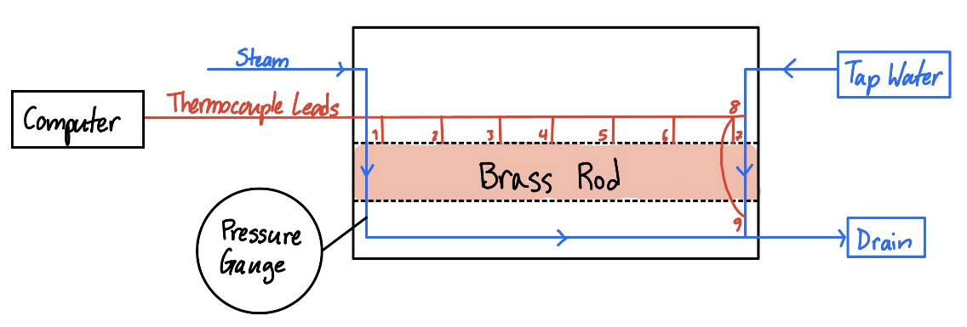
Figure 1. Brass-rod thermal property measurement apparatus.
The falling sphere viscometer setup utilized graduated cylinders filled with the aforementioned test fluids and spheres of varying sizes and masses. Additional equipment included a digital stopwatch for measuring sink times, a precision scale for determining sphere and fluid masses, and calipers for measuring sphere dimensions.
Thermal Property Measurements
For the unsteady-state analysis, the brass rod was initially at room temperature throughout its length. The data acquisition software was set to record temperature at 3-second intervals from all thermocouples along the length of the rod. The experiment began by opening the steam valve to supply consistent heating to the left end of the brass rod, with the temperature of the steam determined via the attached pressure gauge and NIST saturated steam properties. The time between the initial steam activation and the last thermocouple changing its reading was measured to capture the time-dependent temperature profile at each measurement location.
Steady-state behavior was analyzed after the unsteady-state portion of the experiment. Once the heat transferred sufficiently through the brass rod, we turned on the faucet which allowed tap water to flow along the right end of the rod. After 30-45 minutes, a stable temperature gradient along the rod was established, and this steady-state behavior was recorded. Inlet and outlet water temperatures were documented at this point for heat flow calculations.
Viscosity Measurement
Four test fluids were selected for viscosity determination: water, salt water, glycerol, and 5W-30 motor oil. The two spheres used were small, high-density precision BBs, and larger, low-density nylon beads. These fluids and spheres were chosen to span a wide range of expected viscosities and validate the method across different flow regimes. For water, we expected very low viscosity and high sphere velocity, so we used the largest graduated cylinder available to minimize stopwatch error. For the more viscous fluids, smaller cylinders and beakers were used since we had more time to measure the sinking behavior.
The density of each sphere was calculated from mass and diameter measurements to enable subsequent viscosity calculations. The measurement zone spanned the full height of each cylinder, from the fluid surface to the bottom of the cylinder. The vertical distance was measured precisely using a measuring tape.
For each fluid-sphere combination, the spheres were gently released at the center of the fluid surface to minimize initial edge effects. The stopwatch started when the sphere was released at the surface and stopped when it reached the bottom. This process was repeated thirty times for each combination to assess measurement precision and calculate statistical parameters. Five fluid–sphere combinations were tested: Tap water–BB, tap water–nylon bead, salt water–BB, glycerol–BB, and motor oil–BB. After ~10 spheres had accumulated at the bottom of the vessel, the fluid was poured back into its container, and the spheres were poured into a separate beaker to be cleaned.
Results
For the viscosity portion of the experiment, the densities of each test fluid and sphere were found from averages of triplicate measurements of mass and volume. These values were compiled in Table 2.
Table 2. Densities of fluids and spheres.
 | Tap Water | Salt Water | Glycerol | Motor Oil | Precision BB | Nylon Bead
Density(kg/m³) | 942.2 | 1073.4 | 1193.5 | 807.7 | 2315.7 | 1255.4
Using Equations 1, 2, and 3, we determined the viscosities of fluids using the spheres described in the Methods. Table 3 shows the values obtained from these calculations. Two values are present for the viscosity of tap water since we tested this fluid with both spheres.
- Fluid & bead densities
- Viscosities
  - Why is water negative
- Thermal diffusivities and why it’s super low
- Thermal conductivity
  - Table of results from each lab period
Error Analysis & Statistics
For the viscosity measurements, a statistical analysis was performed on N=30 trials for each fluid-sphere pair. The Glycerol-BB combination yielded the highest precision, with a standard deviation of 0.06 Pa·s (5% relative error). In contrast, the low-viscosity fluids (water) tested with high-density BBs exhibited extremely high variance (Standard Deviation $σ> 100\backslash \%$ of the mean) and significant bias away from literature values. The Standard Error (SE) for the Glycerol measurements was calculated as:
$$SE=\frac{σ}{\sqrt{N}}=\frac{0.055}{\sqrt{30}}=0.010\text{ Pa}⋅\text{s}$$
This confirms that the random error in the manual timing method is low enough to produce reliable data, provided the flow regime assumptions (Stokes flow) are met.
For thermal conductivity, the primary source of error is the heat loss through the insulation. The calculation assumes perfect adiabatic conditions (all heat from steam goes to water). In reality, heat is lost to the environment, which effectively reduces the calculated Q or alters the gradient $dT/dx$. Since the measured k (97.1 W/m·K) is lower than the literature value (115 W/m·K), it suggests that the heat conducted through the brass was less than what was assumed, or that contact resistance at the steam interface lowered the effective driving force.

Discussion
- Stokes flow assumption not valid for fluids with viscosity <0
The falling-sphere method needs the sphere–fluid system to stay under the creeping-flow threshold for Reynolds numbers to be valid. The combination of water with a dense steel BB produced Reynolds numbers that exceeded Stokes' drag limits, which resulted in unphysical viscosity measurements. The experiment used a bigger lightweight nylon bead to achieve lower sphere speed and reduced Reynolds number, which created an appropriate model for measuring viscosity accurately. The method produces accurate results only when researchers choose appropriate sphere densities and diameters and column heights that maintain Reynolds numbers below 1.
The thermal conductivity of the brass alloy was measured to be 97.1 W/m·K using the steady-state method. While this value is reasonably close to the literature value for brass (115 W/m·K), the 15% discrepancy highlights the limitations of the 'homemade' apparatus. The primary issue is likely imperfect insulation. The steady-state equation assumes that the heat flux is constant along the entire length of the rod. However, as the rod temperature (up to 100°C) is significantly higher than the ambient air, radial heat loss occurs through the insulation. This loss results in a non-linear temperature gradient and an underestimation of the conductivity.
Additionally, the Steady-State method proved to be more robust than the Unsteady-State (semi-infinite) method for this apparatus. The semi-infinite assumption is only valid for a short time window t < 200 s) before the heat pulse reaches the end of the rod. In our experiment, the rapid heating of the highly conductive brass meant that this time window was very short, making the curve-fitting for thermal diffusivity $\left(α\right)$ highly sensitive to noise in the initial startup data. Therefore, we recommend the steady-state method for routine quality control of the alloy, as it relies on a stable, time-independent gradient that is easier to measure with standard thermocouples.

Recommendations
• Improvement 1: "Use a larger column diameter or lighter spheres (e.g., Teflon instead of Steel) for testing water to ensure Reynolds number $Re < 1$."
• Improvement 2: "Improve the rod insulation or use a 'Guard Heater' to prevent radial heat loss, which caused the conductivity to be underestimated."

References
- Bergsman, D. 2024. Semi-infinite Solids. Correlations and Equations (p. 15). University of Washington.
Appendix
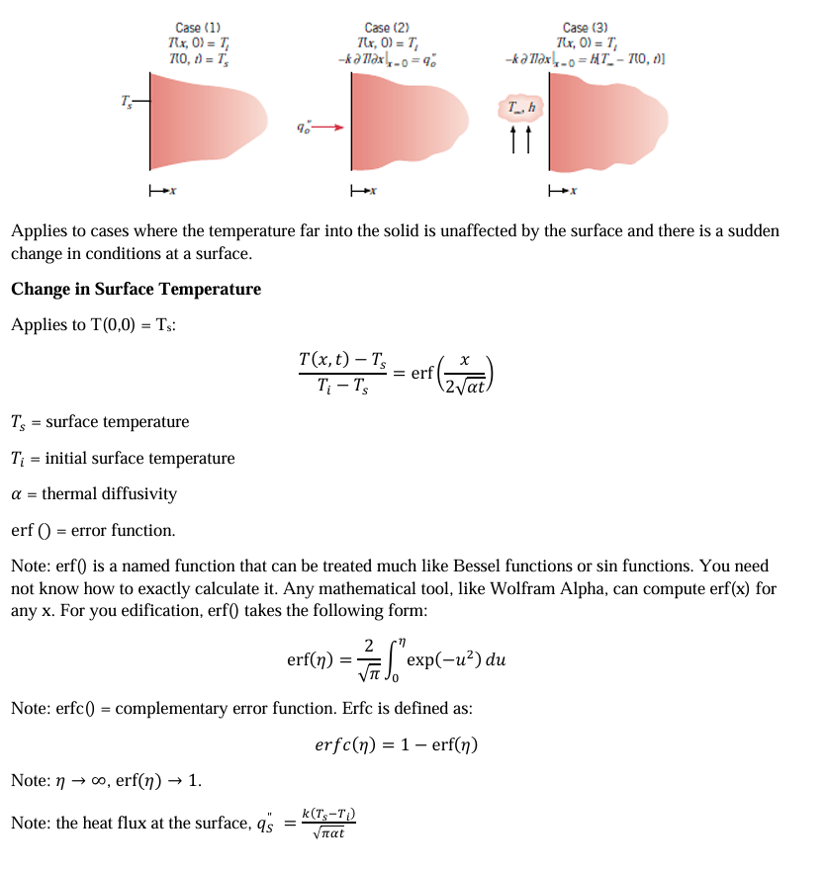
Figure A1. Semi-infinite solid correlation.¹

