To: Engineering Management
From: Pump It Real Good (Mark Heien, El Hadj Diallo, Michael Nguyen, Tommy Yue)
Date: 2026-02-03
Re: Gas-Liquid Absorber Lab 1 – Hydrodynamic Operating Limits + CO2 Uptake Screening

Problem Statement

Determine the stable hydrodynamic operating window of the countercurrent packed absorber (loading/flooding limits) and quantify how CO₂ uptake responds to gas and liquid flow settings under stable operation. $1,2$

Overview

This unit is a countercurrent packed absorber used to pull CO₂ out of an air stream using either water or reactive aqueous NaOH. In practice, you’re balancing a tug-of-war: push gas too hard and the column hits a hydrodynamic cliff (flooding/instability), but push liquid too soft and you leave mass-transfer potential on the table. (Appendix Fig. A0). [2]

Approach
We (1) verified the CO₂ mixing setpoint by comparing flow-predicted inlet CO₂ to analyzer readings (Appendix Fig. A1; raw mixing points in Appendix Table A1), (2) mapped hydrodynamic behavior with a flooding sweep at fixed liquid flow (Appendix Fig. A2; raw sweep points in Appendix Table A2), and (3) collected screening absorption data and analyzed performance using solute-free operating-line methods (Appendix Figs. A3–A4).

Data reduction (what we computed from raw readings): For each absorption run, we used inlet/outlet CO₂ vol% to compute % removal and a capture rate (g/min) by pairing composition change with the gas flowrate. In parallel, we converted gas mole fractions to solute-free ratios $Y=y/(1-y)$so the absorber behavior could be diagnosed on a straight-line operating basis (slope ~ $L/V$on the solute-free form). This gives us two complementary “views” of the same system: (i) performance metrics that management cares about (% removed, g/min captured), and (ii) absorber geometry (how close we are to equilibrium / minimum solvent rate).

Results / Findings
Key takeaway: Liquid flow is the CO₂ capture dial, but gas flow sets a hard ceiling via flooding behavior.
- CO₂ analyzer bias vs rotameter prediction: A02 reads higher than flow-predicted inlet CO₂ with best-fit $y=1.070x+0.333\left(R^{2} = 0.9934\right)$; see Fig. A1. Interpretation: The high linearity is good news (trends are credible), but the offset means absolute values should be treated as screening-level unless we calibrate before each session.
- Flooding/instability indicator: At $L=15$L/hr, the top pressure indicator increases nonlinearly with gas flow, with an inflection near ~70 NL/min; see Fig. A2. Interpretation: That “curve steepening” is exactly what we want to catch early—once pressure starts accelerating with small gas increases, the column is signaling that liquid holdup/interaction is changing rapidly and we’re entering the unstable region where operability and mass-transfer quality degrade.
- Absorption lever: liquid rate: For air=20 NL/min and CO₂=4 NL/min (inlet ~16.7 vol%), increasing liquid from 7 to 25 L/hr improved removal from ~4% to ~46.6% and increased capture to ~4.0 g/min (Table A3, Fig. A3). Interpretation: Under stable hydrodynamics, the system behaves “as advertised”: more liquid improves wetting/contact and effectively increases available mass-transfer capacity, so removal climbs monotonically with L across the tested range.
- Operating-line diagnosis: A Y–X plot for the best-performing fixed-gas condition indicates $L/V≈25.84$, close to the minimum solvent rate $\left(L_{min}/V ≈ 25.84\right)$using an effective linear equilibrium slope $m≈50.5$estimated from the data; see Fig. A4. Interpretation: When $L/V$sits near $L_{min}/V$, you’re operating in a “solvent-limited / pinch-like” regime: removal becomes very sensitive to liquid rate (which matches our trend), and you should not expect near-complete CO₂ removal without increasing L or changing the solvent chemistry.

Numbers that matter:
At the fixed gas setpoint (Air=20 NL/min, CO₂=4 NL/min; inlet ≈16.7 vol%), the column transitions from “barely sipping CO₂” at L=7 L/hr (≈4.0% removal; ≈0.37 g/min captured) to meaningfully productive capture by L=15 L/hr (≈28.0% removal; ≈2.50 g/min) and reaches our best observed performance at L=25 L/hr (≈46.6% removal; ≈4.02 g/min). Fig. A3 visualizes this as a clean monotonic trend with liquid flow.
One useful operational framing: the increase from 7 → 15 L/hr gives the biggest “step change” into useful performance (from ~0.37 to ~2.50 g/min), while 15 → 25 L/hr continues improving capture but with a more incremental “polishing” effect (2.50 → 4.02 g/min). That’s exactly the kind of trend you want before doing solvent comparisons: it tells you where to spend runtime and where returns start to flatten.

Operational window (shortened)
- Gas-side ceiling (at L = 15 L/hr): The top pressure indicator rises from 9.4 cm H₂O (50 NL/min) to 11.7 (55) and 13.4 (60), showing a clear steepening beyond ~55 NL/min (Fig. A2). A practical operating target is ≤50 NL/min at this liquid rate.
- Hydrodynamics are coupled: Flooding behavior depends on both gas and liquid flow. If L is increased materially above 15 L/hr, re-check ΔP vs gas flow before assuming the same gas ceiling.
- Liquid-side lever: Use liquid flow to tune capture; under the tested gas setpoint, increasing L increased removal and capture (Appendix Table A3, Fig. A3). For solvent comparisons, use mid-to-high L (15–25 L/hr) to avoid being trivially solvent-limited.
- Measurement sanity check: A02 reads high vs flow prediction (fit y = 1.070x + 0.333, R² = 0.9934; Fig. A1). Zero/span A02 each session and log calibration points before treating analyzer values as design-grade.

Why the Y–X plots matter:
The absorber Y–X diagrams translate raw vol% readings into driving-force geometry. On a solute-free basis, the operating line slope is effectively $L/V$, and the equilibrium relationship provides a ceiling on how low the outlet gas can go for a given solvent condition. When the operating line hugs the equilibrium line, the driving force is tiny—so you “pay” for removal with a large number of stages/transfer units. That’s why the per-run diagrams are a useful diagnostic: they help distinguish whether we’re limited by (i) hydrodynamics (can’t push gas without instability), (ii) solvent rate (need more L), or (iii) chemistry/equilibrium (need a better solvent or reactive capture to move the equilibrium line). In other words, the Y–X plot turns the run from “it worked / it didn’t” into “here’s what constraint is actually binding.”

Conclusion
The column exhibits a clear pressure-rise inflection at high gas rates, establishing an upper bound on air flow for stable operation at the tested liquid rate. Within stable regions, increasing liquid rate is a strong lever for increasing CO₂ capture, and operating-line analysis suggests our best fixed-gas run is near minimum solvent rate, consistent with moderate (not near-complete) removal.

Limitations
- Analyzer bias: A02 reads systematically higher than rotameter-based inlet predictions; calibration drift and humidity effects may contribute, so absolute removal values are screening-level (Appendix Fig. A1; Table A1).
- Flow/standard-state assumptions: Gas flows reported as NL/min depend on standard conditions; small deviations in temperature/pressure propagate into capture-rate calculations. This is acceptable for screening, but should be controlled if we want design-grade mass-transfer coefficients.
- Equilibrium assumption: the Y–X slope $m$was inferred from bottom-end data; validating with Henry’s-law estimates or an equilibrium test would strengthen $L_{min}$claims. $1$
- Single-point runs: most conditions lack replicates, so run-to-run variability and drift cannot yet be quantified.

Suggestions
- Hold a flooding margin: keep F2 at least ~10–15% below the pressure inflection for the chosen F1 (re-evaluate if L changes).
- Calibrate A02 each session (zero/span) and confirm with a mid-point inlet mix verification run.
- Next step: matched water vs. NaOH runs with replicates; report % removal, g/min captured, and $L/V$(and NTU/HTU if feasible) to enable solvent comparison.

Appendix
A) Equations
Eqn 1. Solute-free gas and liquid ratios:
Y = y/(1-y), X = x/(1-x)
where y is gas-phase mole fraction CO₂ and x is liquid-phase mole fraction CO₂.
Eqn 2. Overall solute balance (solute-free basis):
V' (Y_{in} - Y_{out}) = L' (X_{N} - X₀)
Eqn 3. Linear equilibrium model (for Y–X plots):
Y* = m X
Eqn 4. Minimum solvent rate (linear equilibrium, X0 ≈ 0):
L_{min}/V' = (Y_{in} - Y_{out}) / (Y_{in}/m - X0)
B) Tables
Table A1. CO₂ mix verification dataset (flow-predicted inlet vs analyzer).
Air (NL/min) | CO₂ (NL/min) | Pred inlet CO₂ (vol%) | A02 CO₂ (vol%)
40 | 1 | 2.44 | 2.5
40 | 1.5 | 3.61 | 3.9
40 | 2 | 4.76 | 5.3
40 | 2.5 | 5.88 | 6.7
40 | 3 | 6.98 | 8
40 | 3.5 | 8.05 | 9.3
40 | 4 | 9.09 | 10.4
35 | 4 | 10.3 | 11.7
30 | 4 | 11.8 | 13.1
20 | 4 | 16.7 | 17.5

Table A2. Flooding sweep dataset (pressure indicator vs gas flow, L=15 L/hr).
L (L/hr) | Air F2 (NL/min) | Top pressure indicator (cm H₂O)
15 | 7.6 | 0.2
 | 10 | 0.4
 | 15 | 0.8
 | 20 | 1.6
 | 25 | 2.3
 | 30 | 3.9
 | 35 | 4.5
 | 40 | 6.1
 | 45 | 7.7
 | 50 | 9.4
 | 55 | 11.7
 | 60 | 13.4
 | 65 | 15.7
 | 70 | 18.6

Table A3. Fixed-gas absorption dataset (Air=20 NL/min, CO2=4 NL/min).
L (L/hr) | CO₂ in (vol%) | CO₂ out (vol%) | Removal (%) | CO₂ captured (g/min) | L/V (solute-free)
7 | 16.7 | 16 | 4 | 0.374 | 7.24
10 | 16.7 | 14.7 | 11.8 | 1.09 | 10.3
15 | 16.7 | 12 | 28 | 2.5 | 15.5
20 | 16.7 | 10.1 | 39.4 | 3.44 | 20.7
25 | 16.7 | 8.9 | 46.6 | 4.02 | 25.8

C) Figures
Figure A0. Where the CO₂ actually goes: process flow diagram for the packed absorber loop (F1 liquid, F2 air, F3 CO₂, A02 analyzer; Z≈1.05 m packed section).
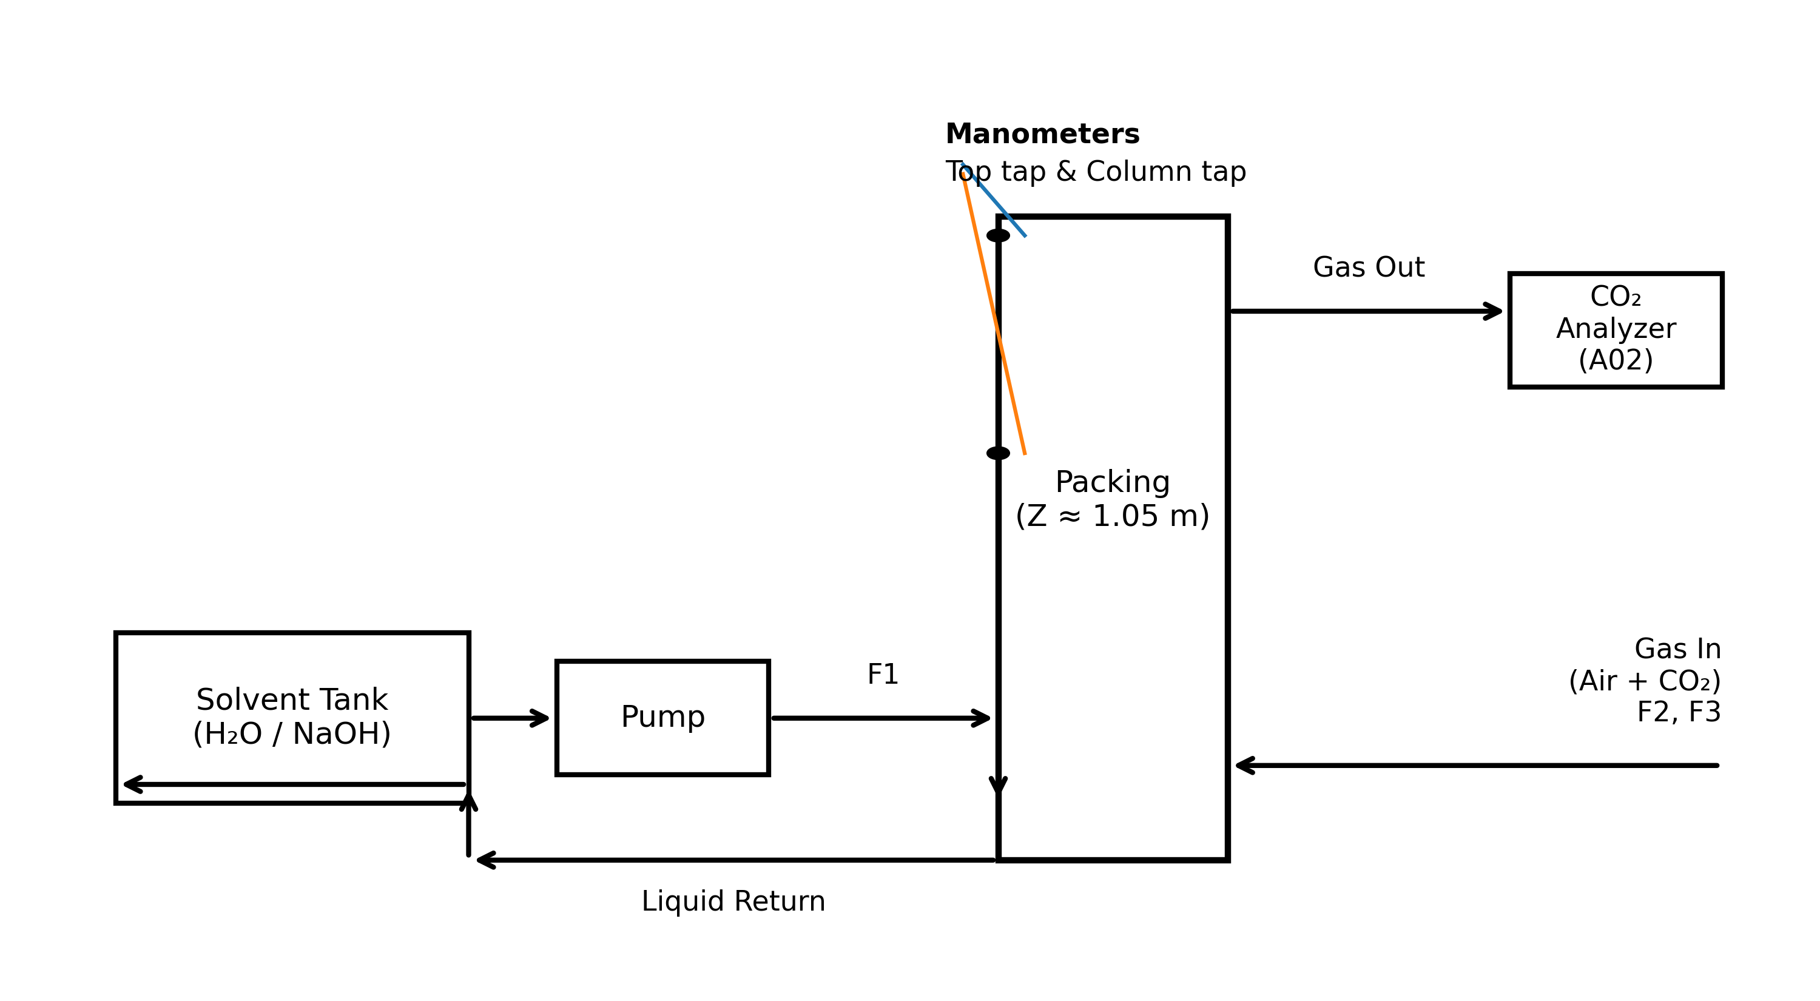

Figure A1. Trust the trend, not the absolute: A02 reads ~7% high with a +0.33 vol% offset vs. rotameter-mixed inlet CO₂, but tracks linearly (R²≈0.99).
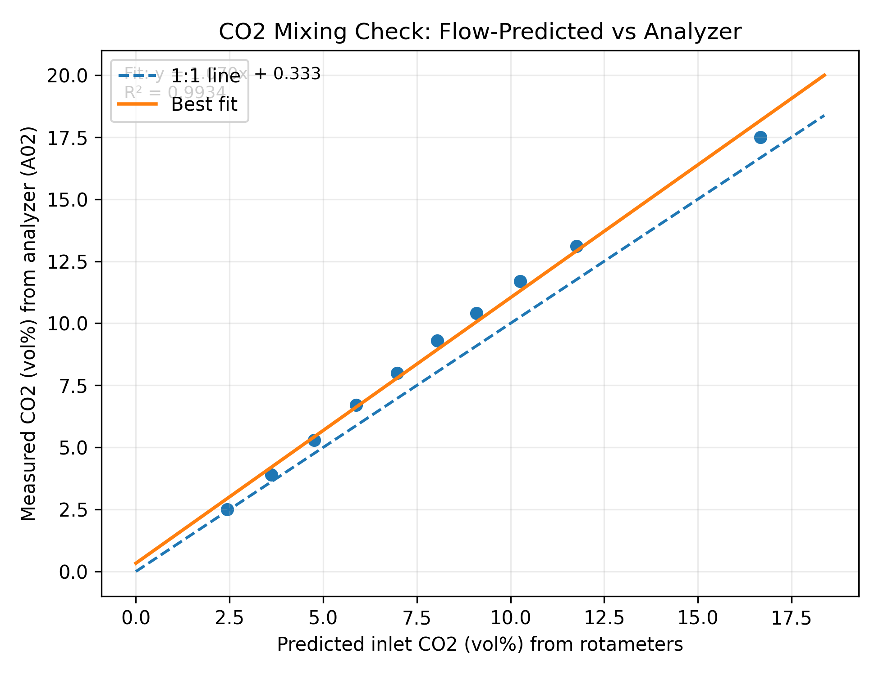

Figure A2. Flooding warning light: top pressure indicator bends upward near F2 ≈ 70 NL/min at L = 15 L/hr—incipient loading/flooding signature.
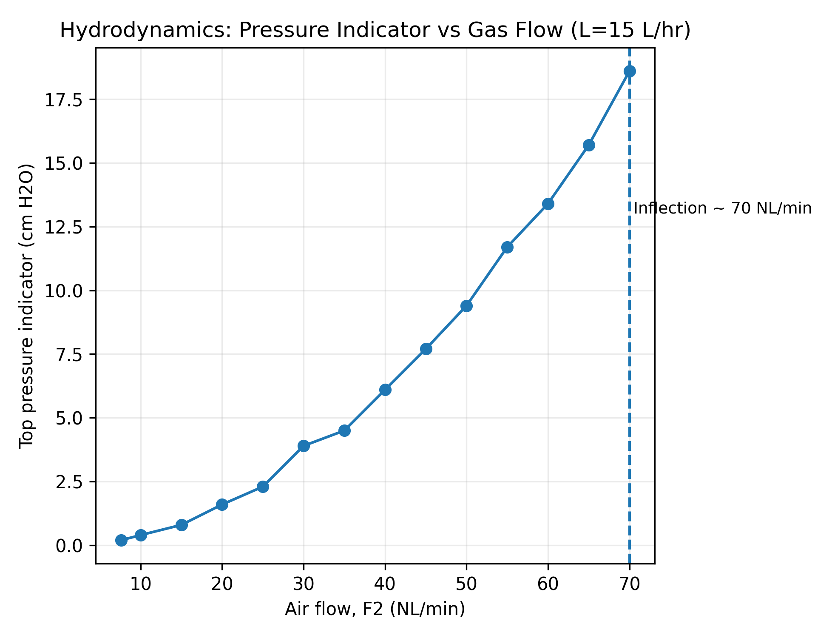
Figure A3. Liquid rate is the throttle: CO₂ removal climbs from ~4% to ~47% as F1 increases from 7 to 25 L/hr at fixed gas feed.
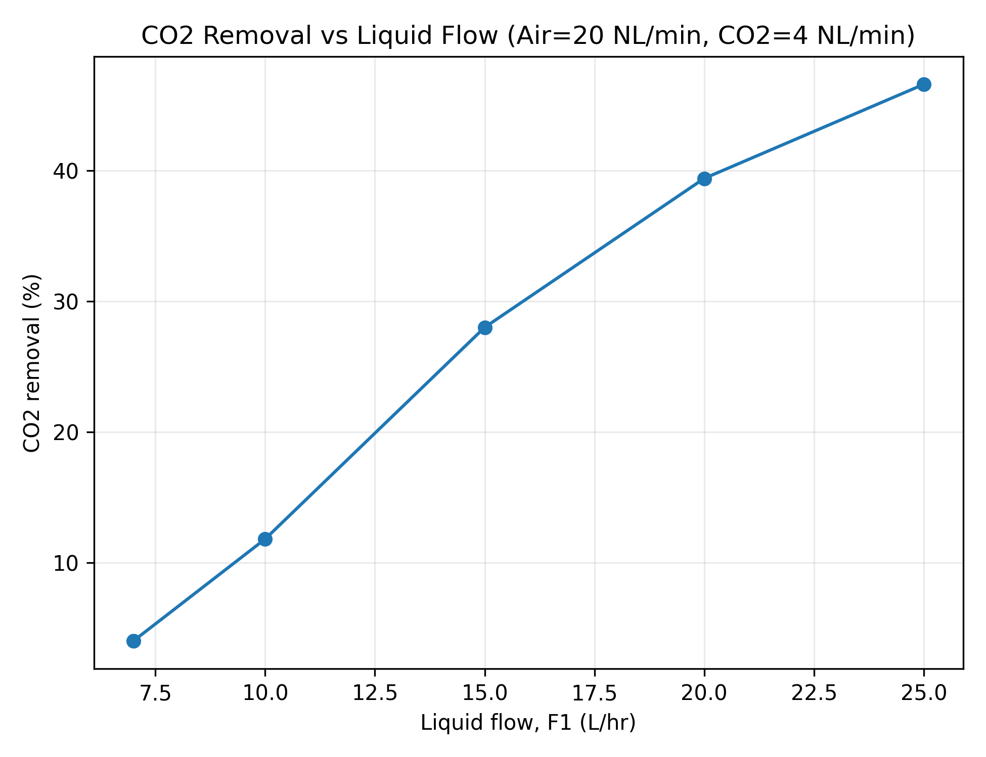

Figure A4. Y–X operating-line view: the best fixed-gas condition sits near L_min; increasing L/V shifts the operating line away from equilibrium and buys more capture.
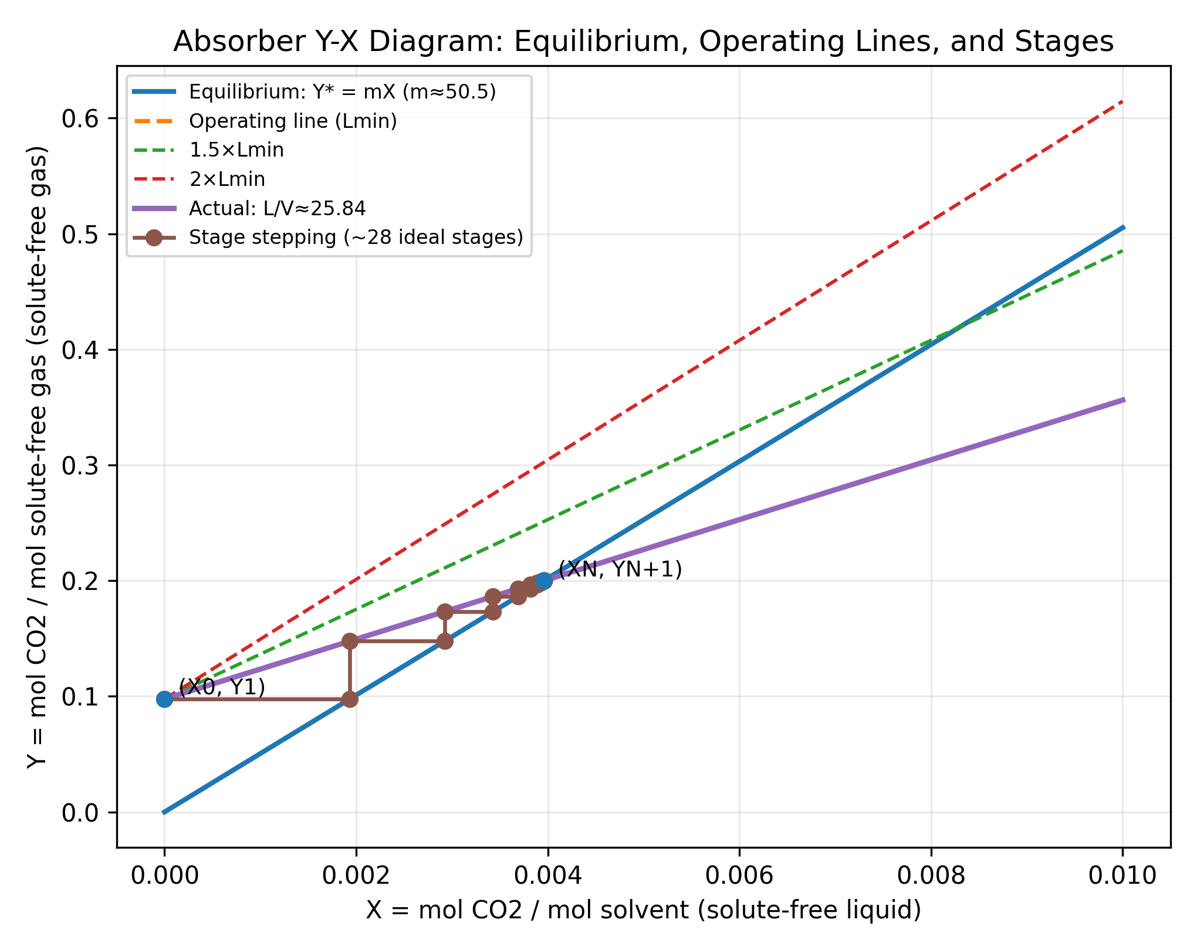

D) Literature Cited
[1] Seader, J.D.; Henley, E.J.; Roper, D.K. Separation Process Principles, 3rd ed.; Wiley: Hoboken, NJ, 2016; Chapter 6 (Absorption and Stripping).
[2] University of Washington, Department of Chemical Engineering. Gas–Liquid Absorber Standard Operating Procedure (SOP), CHEM E Unit Operations Laboratory.

