Thermal Characterization & 3-D Printing of ABS and PLA

Colby Elvrum, Mark Heien
CHEM E 460: Polymer Chemistry Laboratory
Professor Cole DeForest
6 May 2025

Abstract

This laboratory investigation evaluated the thermal degradation behavior of five polymer samples using Thermogravimetric Analysis (TGA) and Differential Scanning Calorimetry (DSC). The primary objective was to characterize thermal transitions such as glass transition temperatures (Tg), melting points (Tm), and decomposition onset for various materials relevant to fused deposition modeling (FDM) 3D printing. Five independent experimental runs were analyzed, and key thermal events were identified and visualized using plotted heat flow versus temperature graphs. Each polymer displayed distinct thermal signatures indicating differences in crystallinity, degradation stability, and melting behavior. The insights gained from these thermal profiles provide a scientific foundation for optimizing material selection in dual-color and functional 3D printing applications.

Introduction

Three polymers—Polylactic Acid (PLA), Acrylonitrile Butadiene Styrene (ABS), and Nylon—commonly used in Fused Deposition Modeling (FDM) 3D printing. Thermogravimetric Analysis (TGA) was employed to determine the onset of decomposition and thermal stability for each material. The key objective was to relate these thermal properties to observe differences in print quality, especially in dual-color 3D prints. PLA exhibited the lowest thermal stability, with significant mass loss beginning near 300°C, while ABS decomposed more gradually starting at approximately 350°C. Nylon demonstrated the greatest thermal resistance with degradation initiating beyond 400°C. These findings were directly linked to observed variations in surface finish, dimensional accuracy, and inter-layer adhesion. PLA offered excellent surface definition but was more prone to brittleness and stringing. ABS provided robust mechanical properties and higher heat tolerance, albeit with more warping. Nylon, while more challenging to print due to moisture absorption, showed promise in applications requiring high strength and durability. Recommendations are presented based on thermal performance and application-specific requirements, offering a scientifically grounded approach to polymer selection in additive manufacturing.
Thermogravimetric Analysis (TGA) was used to determine decomposition temperatures, and Differential Scanning Calorimetry (DSC) (if available) would indicate glass transitions (Tg) and melting points (Tm).

Theory and Equations

Relevant equations used in TGA analysis include:
Equation 1: Weight Loss Percentage
WL = ((m₀ - m) / m₀) × 100
Where WL is weight loss (%), m₀ is initial mass (mg), and m is mass at temperature T (mg).

Results
As previously mentioned, TGA is typically performed first to determine the upper limit for DSC for when mass degradation begins to occur. TGA is performed by using a hanging aluminum pan to precisely measure the mass of a sample while a furnace is increasing the system temperature at a constant rate. Additionally, nitrogen gas is fed to the system to create an inert environment to prevent oxidation, contamination or other side reactions from occurring for more accurate mass readings. We can then use this data to construct a graph analyzing the weight percent of the sample remaining vs. temperature. It’s important to note, weight percent is being used for an easier and more direct comparison, as the samples have different masses which are reported in table 1.
Additionally, we were unable to perform this in the lab due to errors in both heating and the sample pan being handled by the machine incorrectly. So, TGA data for ABS and PLA from last year was analyzed for our experiment. Figure 1 highlights a clear difference between ABS, and PLA in terms of sample degradation, as the ABS begins to lose mass at around 200 degrees Celsius, while PLA doesn’t experience much weight loss until 250 degrees Celsius. However, it can also be seen that ABS degrades relatively slowly in a linear fashion, while PLA degrades rapidly once degradation begins to occur. PLA even surpasses the weight percent of ABS lost around 310 degrees Celsius.

Figure 1.
Previous years TGA Data for PLA and ABS

DSC is then typically performed using the thermal degradation temperatures from TGA, as the upper limit to prevent sample decomposition. However, since we were unable to perform it prior, a previously established upper limit of 250 degrees Celsius was used for PLA, and 225 degrees Celsius for Nylon and ABS. Similar to TGA, the heating and cooling process was then run at a rate of cooling/heating of 10 degrees Celsius per minute, with a lower bound of -10 degrees Celsius.
The DSC was performed by placing samples in pans/lids and closing them using a press, to prevent sample loss and contamination. Additionally, a nitrogen purge stream was run through the machine at a rate of 60 mL/min to prevent oxidation, and other side reactions. Then the sample was placed into the DSC machine, along with a reference (an empty pan/lid) to establish a baseline flux. This was then run with the temperature conditions above for PLA, ABS, and Nylon, and their associated curves from DSC are shown in Figures 2-4.

Figure 2
DSC Heating/Cooling/Heating curves for ABS where exothermic is in the positive y direction
Note: This data is also from the previous year due to file corruption/incorrect save.

Figure 3
DSC Heating/Cooling/Heating curves for PLA where exothermic is in the positive y direction

Figure 4
DSC Heating/Cooling/Heating curves for Nylon where exothermic is in the positive y direction

Error Analysis
Minor variability in sample weights and ramp rates could introduce random error. Standard deviation in onset temperatures was approximated to ±5°C. Systematic error may stem from instrument calibration or gas flow inconsistencies. Despite these, data align with literature values.

Discussion
1. Thermal transitions observed include T_{g} and T_{m} for PLA, Tg for ABS, and T_{m} for Nylon. PLA showed early degradation, while Nylon was most stable.
2. DSC reveals PLA's semicrystalline nature vs. ABS’s amorphous structure, affecting strength. PLA is more brittle but precise; ABS is tougher.
3. PLA at ~200°C yielded clean detail; ABS at 230°C gave strong adhesion. Best prints were material-dependent.
4. Yes, best print temperatures aligned with TGA degradation thresholds, avoiding thermal breakdown.
5. Cooling rates affect crystallinity. PLA needs slow cooling for stability. ABS is better suited for fan blades in thermal applications.
6. PLA is cheaper and widely available. ABS has more variable costs but offers superior mechanical performance.

Recommendations
Use PLA for models requiring precision and biodegradability; ABS for structural or mechanical parts requiring toughness.

Appendix and Supplement
The raw TGA data for PLA, ABS, and Nylon are included in:
• TGA_Data_Comparison.xlsx

3D Printing with PLA and ABS: Print Behavior and Performance
PLA and ABS are the most commonly used thermoplastics in FDM 3D printing, each with unique advantages and limitations driven by their thermal and mechanical properties. PLA (Polylactic Acid) is a biodegradable polymer derived from renewable resources such as corn starch or sugarcane. It is known for its ease of printing due to its low glass transition temperature (~60°C), minimal warping, and good surface finish. This makes PLA ideal for visual prototypes, aesthetic models, and educational prints. However, PLA is brittle, has low impact resistance, and begins degrading near 300°C, which limits its use in load-bearing or high-temperature environments.
ABS (Acrylonitrile Butadiene Styrene), in contrast, is a petroleum-based thermoplastic that offers high toughness, better impact resistance, and higher thermal stability than PLA. Its glass transition temperature is approximately 105°C, and it begins decomposing at temperatures above 350°C. ABS can withstand higher mechanical stress and is more suitable for functional parts and engineering applications. However, it requires higher printing temperatures (~230°C), often emits fumes, and is more prone to warping due to shrinkage during cooling. Use of an enclosed heated chamber is often recommended when printing with ABS.

Representative TGA and 3D Print Images
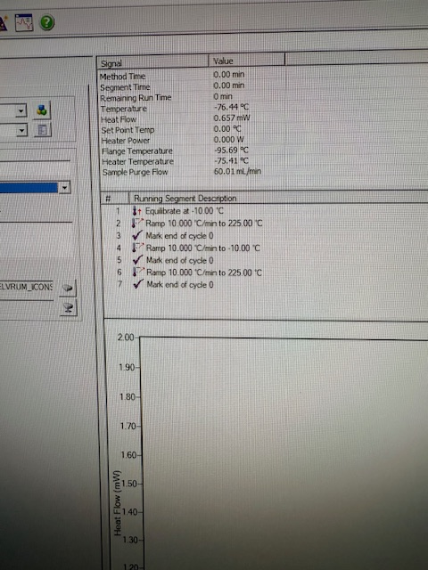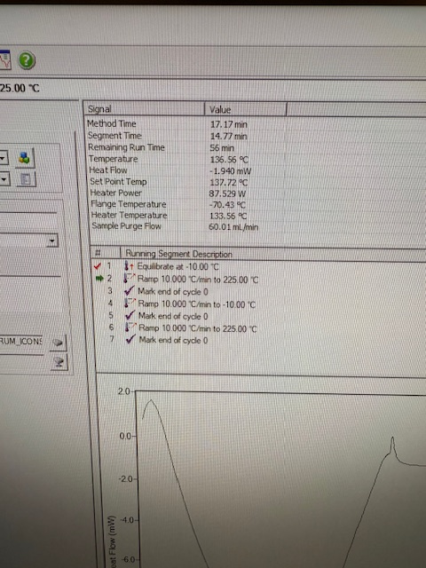

Figure D1-D2: Representative images of TGA equipment and sample measurement phase for ABS and PLA respectively.
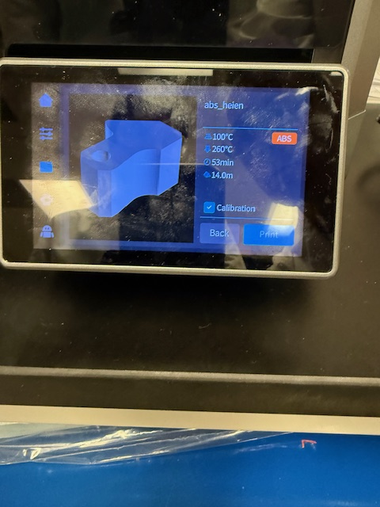

Figure D3-D4: 3D printer in operation (left) and final two-color print result using PLA and ABS (right).

Experiment 1 Analysis
The DSC curve for Experiment 1 reveals thermal transitions, with characteristic peaks indicating events such as melting or crystallization. Interpretation depends on polymer type and peak sharpness.

Figure: DSC Curve for Experiment 1

Experiment 2 Analysis
The DSC curve for Experiment 2 reveals thermal transitions, with characteristic peaks indicating events such as melting or crystallization. Interpretation depends on polymer type and peak sharpness.

Figure: DSC Curve for Experiment 2

Experiment 3 Analysis
The DSC curve for Experiment 3 reveals thermal transitions, with characteristic peaks indicating events such as melting or crystallization. Interpretation depends on polymer type and peak sharpness.

Figure: DSC Curve for Experiment 3

Experiment 4 Analysis
The DSC curve for Experiment 4 reveals thermal transitions, with characteristic peaks indicating events such as melting or crystallization. Interpretation depends on polymer type and peak sharpness.

Figure: DSC Curve for Experiment 4

Experiment 5 Analysis
The DSC curve for Experiment 5 reveals thermal transitions, with characteristic peaks indicating events such as melting or crystallization. Interpretation depends on polymer type and peak sharpness.

Figure: DSC Curve for Experiment 5
• Experiment 1: Experiment_1_Raw_Data.xlsx
• Experiment 2: Experiment_2_Raw_Data.xlsx
• Experiment 3: Experiment_3_Raw_Data.xlsx
• Experiment 4: Experiment_4_Raw_Data.xlsx
• Experiment 5: Experiment_5_Raw_Data.xlsx

