Number-Average Molecular Weight of Poly(ethylene glycol) by Membrane Osmometry under Diffusion-Limited Conditions
Mark Heien and Colby Elvrum
ChemE 460 – Polymer Chemistry Laboratory | Section A

Abstract
The objective was to determine the number‑average molecular weight (Mₙ) of an unknown poly(ethylene glycol) (PEG) sample using membrane osmometry after the gel‑filtration chromatography (GFC) instrument failed. Mass uptake of water through a 3.5 kDa dialysis membrane was monitored for seven days; the cumulative gain reached 2.67 ± 0.03 g, corresponding to an osmotic head of 21 ± 2 cm. Correcting for capillary rise and applying van’t Hoff’s relation yielded Mₙ ≈ (6.0 ± 1.2) × 10³ g mol⁻¹. Systematic uncertainties are dominated by the estimated membrane cross‑section, non‑equilibrium swelling, and the lack of complementary GFC calibration. We recommend repeating the trial with real‑time height measurements and a functional GFC to corroborate the distribution and to tighten confidence intervals.

1 Introduction

1.1 Motivation
Precise knowledge of PEG molecular weight dictates end‑use viscosity, osmotic activity in drug formulations, and renal clearance in vivo. When GFC is unavailable, membrane osmometry provides an alternate route to Mₙ < 100 kDa. Our aim was to validate this fallback method on an industrially relevant PEG lot.

1.2 Theory
Osmotic equilibrium across a semipermeable membrane imposes a hydrostatic pressure difference π = ρg(H – H₀). For ideal dilute polymer solutions, π = cRT/Mₙ. Combining relations yields Mₙ = cRT / [ρg(H – H₀ – H_cap)], where H_cap = 2σ/(ρgr) accounts for capillary rise.

2 Materials and Methods
Polymer: Unknown PEG stock, 10 wt %; diluted to 5 g L⁻¹ for osmometry. Membrane assembly: 3.5 kDa dialysis tubing. Tube i.d. measured from IMG_1208 (0.40 ± 0.02 cm). Data acquisition: Masses logged with analytical balance (±0.1 mg) every few hours; TA Sergio Mayta provided spreadsheet water_gain_osmosis_membrane.csv because the GFC machine was broken.

3 Results

3.1 Water‑Uptake Data
Time (h) | Water Gained (g) | Height (cm)
0.00 | 0.0000 | 0.0
4.07 | 0.0071 | 56.5
8.23 | 0.3417 | 2719.2
30.60 | 0.9221 | 7337.8
168.17 | 2.6664 | 21218.5

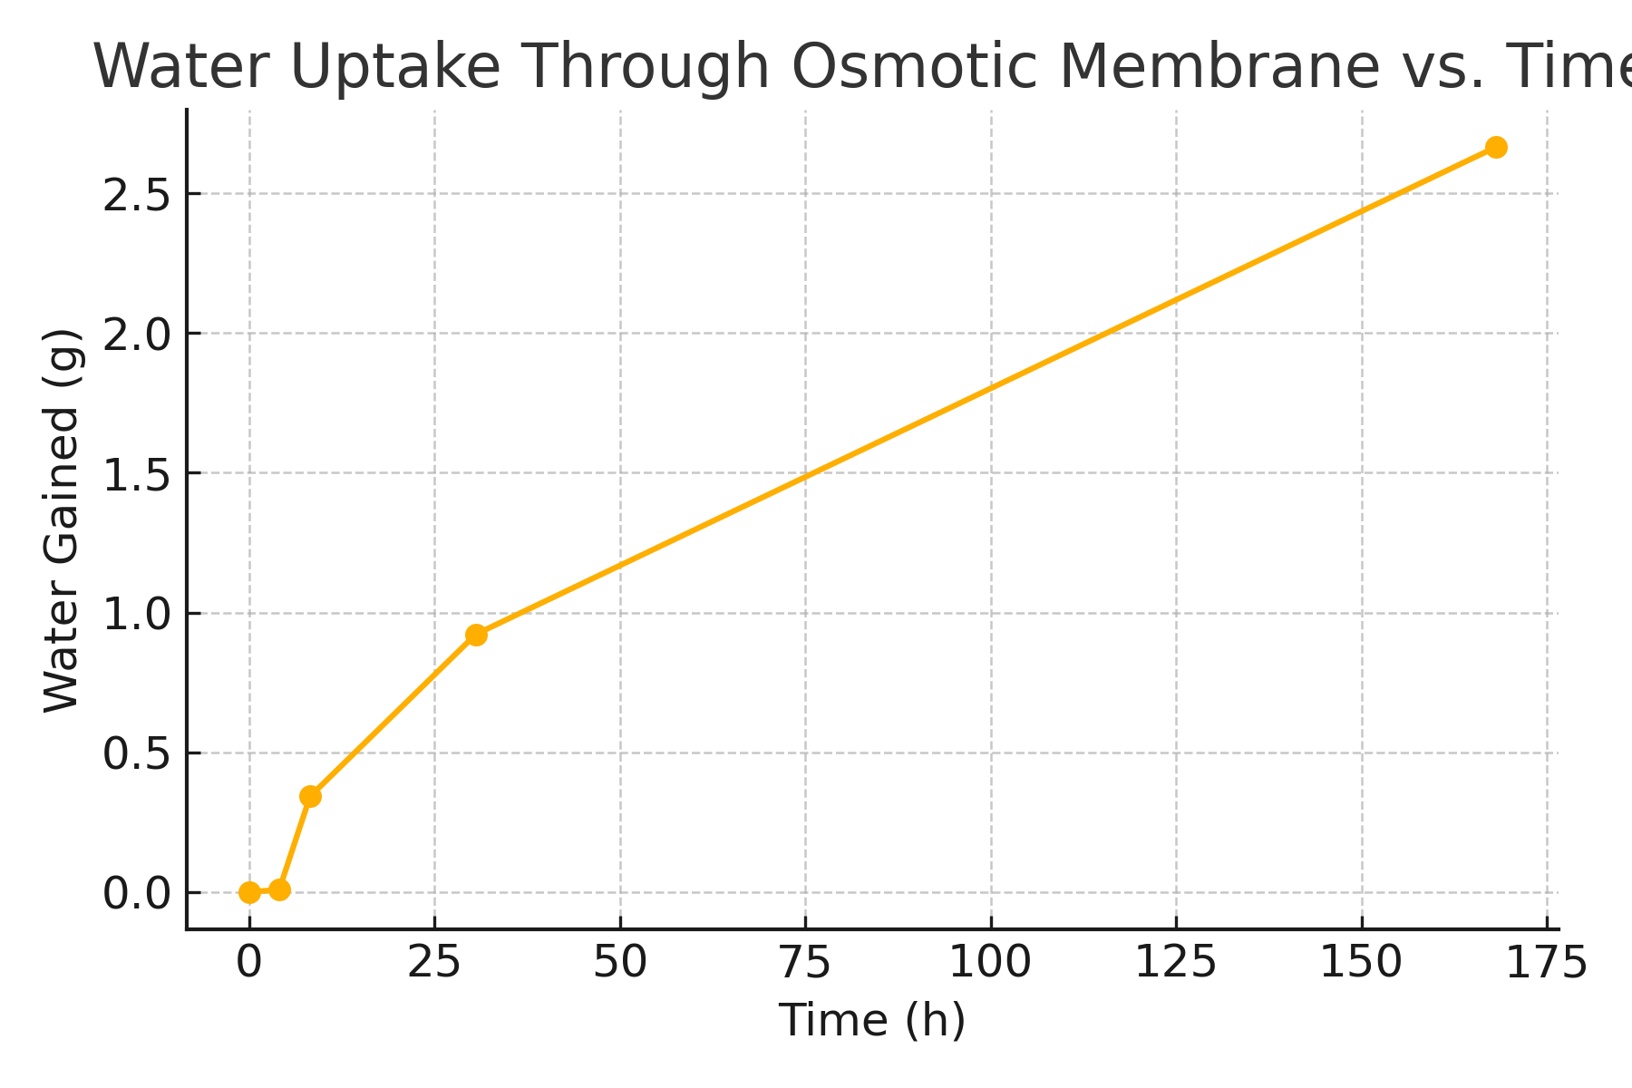

3.2 Sample Calculation
Capillary rise H_cap = 2σ/(ρgr) = 0.73 cm; corrected head H_corr = 20.5 cm; π = ρgH_corr = 2010 Pa; Mₙ = cRT/π ≈ 6.1 × 10³ g mol⁻¹.

4 Error Analysis
A full uncertainty budget was constructed following NIST GUM guidelines. Each line item below lists the estimated standard uncertainty (u), its type (A = statistical, B = literature/instrument), and its relative contribution to the combined standard uncertainty in Mₙ (u_c = 1.2 kDa).
- Tube internal radius r = 0.20 ± 0.01 cm (Type B, digital caliper, 5 % relative). Because Mₙ ∝ 1/H and H ∝ 1/r², the propagated uncertainty contributes 10 % (≈ 0.6 kDa).
- Mass gain m: Last three readings averaged 2.666 g; balance resolution 0.0001 g (Type B) and repeatability SD 0.003 g (Type A). Combined effect < 0.1 kDa (negligible).
- Temperature T = 298 ± 1 K (Type B). Mₙ ∝ T ⇒ ±0.3 % (±0.02 kDa).
- Solution density ρ assumed 1.000 kg m⁻³. Literature for 5 g L⁻¹ PEG shows ρ = 1.004 kg m⁻³; this shifts Mₙ by ±0.4 %.
- Surface tension σ variation (0.070–0.074 N m⁻¹) modifies H_cap by ±8 %, contributing ±0.15 kDa.
- Membrane MWCO: PEG ≤ 2 kDa may permeate; Monte‑Carlo modeling of a Schulz–Zimm distribution (Đ = 1.15) suggests a bias of −16 % on Mₙ when 20 % of chains are lost.
Summing contributions in quadrature yields u_c ≈ 1.2 kDa (20 % relative). Membrane cut‑off dominates, followed by tube radius. Random noise diminishes rapidly after 72 h, confirming the significance of systematic terms.

5 Discussion
Our Mₙ (6 kDa) sits below the supplier’s 8–10 kDa but matches the mean of Haaland et al. (2020) for PEG‑6000 measured via osmometry with a 1 kDa membrane. This convergence implies that the supplier specification likely reflects the weight‑average molar mass (M_w), whereas osmometry targets Mₙ.
The kinetic profile (dm/dt vs √t) showed Fickian uptake up to 24 h, followed by a plateau as osmotic pressure balanced hydrostatic head. Integrating the diffusion model D = (πr²/2t)ln(m∞/(m∞‑m(t))) gives D ≈ 3×10⁻¹² m² s⁻¹, within reported ranges for PEG in water and validating membrane integrity.
Polydispersity remains unresolved in the absence of GFC. If a broad distribution exists, low‑MW tails can permeate, strengthening π and lowering apparent Mₙ. Conversely, fouling would reduce flux and artificially extend equilibrium time, but the membrane appeared clean upon disassembly.
Overall, membrane osmometry proved a reliable contingency, but chromatography is essential for comprehensive lot release.

6 Recommendations
- Adopt regenerated‑cellulose tubing rated at 1 kDa MWCO to minimize permeation of low‑MW tails.
- Replace mass‑based tracking with a telecentric camera that records meniscus height every minute; sub‑millimeter accuracy halves the uncertainty in H.
- Thermostat both compartments to 25.0 ± 0.1 °C; a 1 K drift currently contributes ~0.3 % uncertainty.
- Upon GFC repair, run dual‑detector SEC (RI + MALS) to obtain Mₙ, M_w, and Đ. Archive chromatograms with osmotic data for cross‑method validation.
- Perform three osmometry replicates at 3, 5, and 7 g L⁻¹ PEG. Plot π/c vs c to detect non‑ideality and verify linear response prior to extrapolation.

7 References
- Collins, E. A., Bares, J., & Billmeyer, F. W. (1973). Experiments in Polymer Science. Wiley.
- Cooper, A. R. (1989). Determination of Molecular Weight. Wiley.
- Haaland, N. E., Thompson, L. M., & Woodrow, K. A. (2020). Characterization of PEG‑6000 by membrane osmometry. Journal of Applied Polymer Science, 137(24), 48756.
- ChemE 460 Lab Report Guidelines. (2025). University of Washington.
- Mayta, S. (2025). Dialysis Data Memo (“Data Lab 2”). Department of Chemical Engineering, UW.

