MENU

APPETIZERS
Protein Structure and Function
Mammalian Cell Culture

ENTREE
Reactor Operation

DESSERTS
Product Harvest
Product Application

TABLE FOR TWO
Michael Nguyen
Mark Heien

COOK LEVEL
Rare

DINING EXPERIENCE
Essay

Protein Structure and Function
Proteins are an important major molecule for life that do many of the jobs inside cells. They are like the cell’s workers, machines, messengers, and building materials. Some proteins help speed up chemical reactions, some help cells communicate, some move molecules from one place to another, and others give cells and tissue their shape and strength. A key idea is that a protein’s shape determines its function. Proteins are made up of smaller building blocks called amino acids. There are 20 common amino acids which can then join together through peptide bonds to form long chains called polypeptides.¹ Each amino acid has a side chain, called a R group, that gives it unique chemical properties. Some side chains interact well with water, while others avoid water and tend to fold toward the inside of the protein.² Because of these interactions, the amino acid sequence helps determine the final three dimensional shape of the protein.³
A protein can have many levels of structure. The primary structure is essentially the way the amino acids are arranged and their sequence. The secondary structure is the way the primary structure arranges as a result of regular hydrogen bonds forming between the backbone and other parts of the protein. This bonding pulls the protein into specific shapes, such as a helical structure, known as 𝛼-helices shown in Figure 1, or pleated sheats, known as 𝛽-sheets.¹ The tertiary structure is the overall 3D shape of one protein chain, which is held together by interactions like hydrogen bonds, ionic attractions, hydrophobic interactions, van der Waals forces, and disulfide bonds.¹⁻³ Some proteins also have quaternary structure, where multiple protein chains join together to form one working protein. An example would be hemoglobin, which carries oxygen in the blood.²
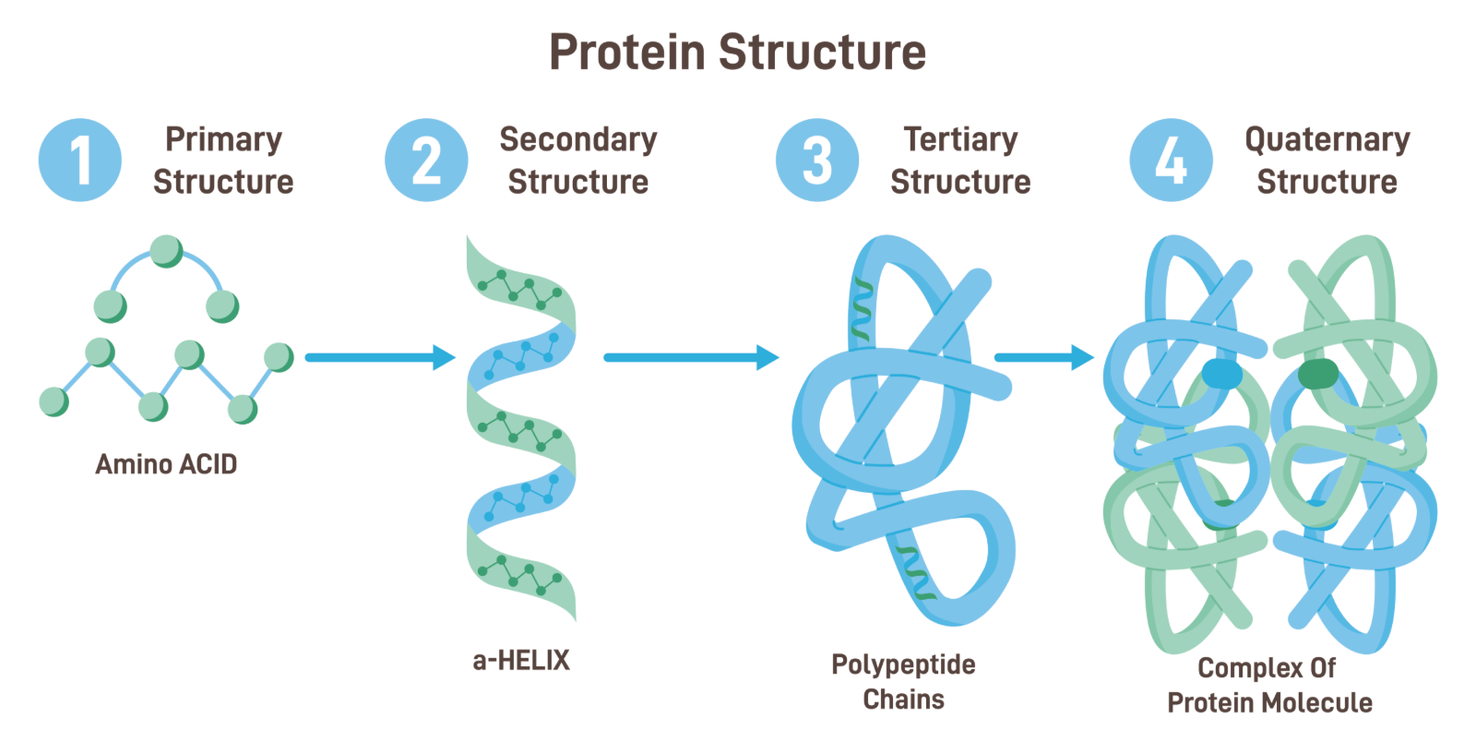
Figure 1. Visual summary of a protein’s structural levels.¹
Different types of proteins have structures that match their functions. For example, enzymes are compact and rounded (globular) because their shape creates an active site where reactions happen.^{2,3} Membrane proteins sit in or near cell membranes and help move substances or receive signals.² Fibrous proteins are long and strong, making them useful for support, like keratin in hair and nails or collagen in connective tissue.³ If a protein loses its correct shape, it could stop working. This is called denaturation and can happen because of things like heat, extreme pH, or certain chemicals.^{1,3} In the body, changes in protein shape can also cause disease. In sickle cell disease, one amino acid change in hemoglobin changes the protein’s behavior and affects the shape of red blood cells.² Proteins are essential because their specific structures allow them to carry out specific jobs.
Mammalian Cell Culture
Mammalian cell culture is the process of growing animal cells outside of the body in a controlled environment. These cells are useful because they can make complex proteins that are hard for simpler cells, like bacteria, to make correctly. In cell culture, the cells are grown in a liquid called media. The media gives the cells nutrients, salts, and other materials they need to stay alive and grow. Cell culture is useful because the environment around the cells can be controlled, including temperature, pH, oxygen, and nutrient levels.¹
A simple way to think about mammalian cells is that they are tiny factories. The media is like the food and supply system for the factory. If the cells are not kept in the right conditions, they may grow poorly, stop making products, or die. A common example is CHO cells, which are often used to make recombinant proteins and antibodies.²
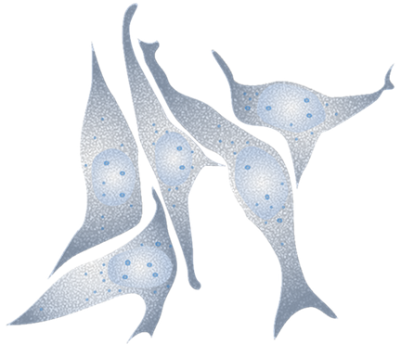
Figure 2. Chinese hamster ovary (CHO) cells. Image source: DBCLS/Wikimedia Commons, CC BY 3.0.
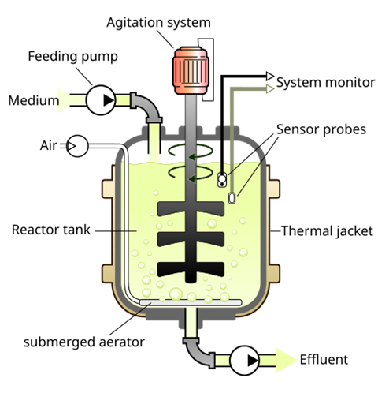
Figure 3. Basic bioreactor setup used to control the environment for growing cells. Image source: YassineMrabet/Wikimedia Commons, CC BY-SA 3.0.
Reactor Operation
Reactor operation is the step where the cells are grown in a controlled tank called a bioreactor. A bioreactor is a container designed to keep living cells healthy while they grow and make products. The bioreactor controls important conditions such as mixing, temperature, oxygen and nutrients. Bioreactors can be operated in batch, fed-batch, and continuous.
In a batch process, all of the nutrients are added at the beginning. After that, nothing else is added except control materials like gases, acids, or bases. This can be depicted in Figure 4. The process continues until the nutrients are all used. Batch operation is simple, shorter, and easier to manage, but it usually gives lower biomass and product yields because the cells eventually run out of nutrients or stop growing efficiently.⁵
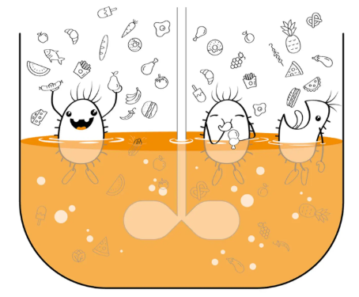
Figure 4. Batch Reactor Operation Graphic.⁵
In a fed-batch process, nutrients are added during the run instead of only at the beginning. This helps keep the cells productive for a longer time and can lead to higher product amounts. The progression of the fed-batch is depicted in Figure 5. Fed-batch operations are most useful when too much nutrients at once could slow growth or cause unwanted byproducts. Fed-batch is typically more complicated since the feeding strategy has to be controlled carefully.⁵
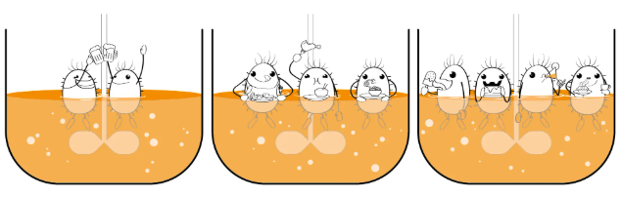
Figure 5. Fed-batch Reactor Operation Graphic.⁵
In a continuous process, fresh medium is added while the culture broth is removed at the same rate. This can be depicted in Figure 6. This keeps the reactor volume constant and allows the system to operate near steady state. Running a continuous operation can help improve productivity and reduce downtime from cleaning and restarting the reactor, but it is harder to maintain for long periods of time.⁵
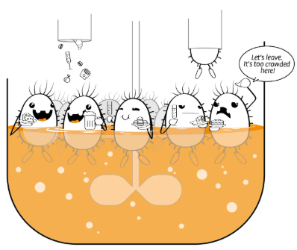
Figure 6. Continuous Reactor Operation Graphic.⁵
Product Harvest
In biochemical engineering, product harvest is the step where the desired product is separated from the bioreactor mixture. This mixture can contain various things like cells, cell debris, proteins, nutrients, salts, and liquid waste. The most common method for product harvest is centrifugation. Centrifugation uses high-speed spinning to separate materials by their densities. Denser solids move outwards toward the wall, while the lighter liquid remains closer to the center where it can then be collected.⁴
A tubular bowl centrifuge is the simplest configuration and is a tall, narrow sedimentation centrifuge that gives strong separation for mixtures that have low amounts of solids.⁴ A common setup for a tubular bowl centrifuge is described in Figure 7. It is most useful for removing cells or debris from a liquid product stream. The disadvantage is that the solids tend to collect on the wall and must be removed manually, so it is better for a small scale or low solid operation.⁴
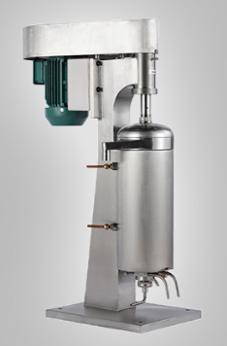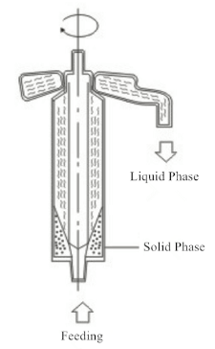
Figure 7. Tubular Bowl Centrifuge Setup Diagram.⁴
The disk stack centrifuge is very common in industry and is useful when a liquid feed contains only a small amount of liquid.. It contains 100 or more thin disks stacked together, which make separation faster because solid particles do not have to travel as far before separating.⁴ A common setup for a disk stack centrifuge is described in Figure 8. As the bowl spins, solids move outward and collect near the outside of the bowl, while the clarified liquid exits from the top. Disk stack centrifuges are good for clarifying low-solid streams, but are not as ideal for feeds with lots of solids where cleaning downtime lowers the efficiency.⁴
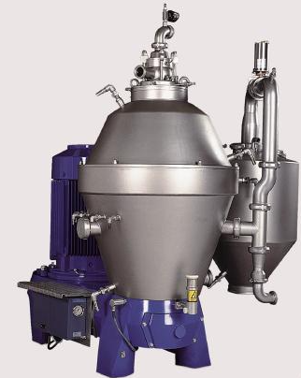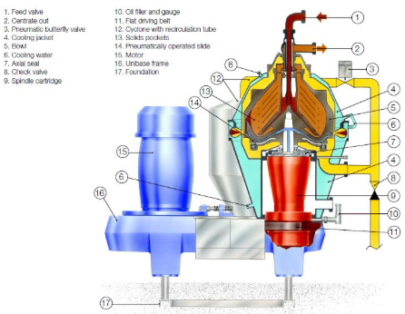
Figure 8. Disk Stack Centrifuge Setup Diagram.⁴
Product Application

References
- “Protein Structure.” Student Academic Success, 15 Jan. 2025, www.monash.edu/student-academic-success/chemistry/medicinal-chemistry/protein-structure.
- Alberts, Bruce. “The Shape and Structure of Proteins.” National Library of Medicine, Garland Science, 2002, www.ncbi.nlm.nih.gov/books/NBK26830/.
- Stollar, Elliott J, and David P Smith. “Uncovering Protein Structure.” Essays in Biochemistry, vol. 64, no. 4, 25 Sept. 2020, pp. 649–680, www.ncbi.nlm.nih.gov/pmc/articles/PMC7545034/, https://doi.org/10.1042/ebc20190042.
- “Centrifuges – Visual Encyclopedia of Chemical Engineering Equipment.” Encyclopedia.che.engin.umich.edu, encyclopedia.che.engin.umich.edu/centrifuges/.
- Allman, Tony. “The Difference between Batch, Fed-Batch, and Continuous Processes | INFORS HT.” Infors-Ht.com, 2020, infors-ht.com/en/blog/the-difference-between-batch-fed-batch-and-continuous-processes.

