Olefin Recovery Optimization in Catalytic Fast Pyrolysis of Mixed Plastic Waste
Based on: Yadav et al. (2023), Energy Environ. Sci., 16, 3638–3653
Mark Heien, El Hadj Souleymane Sr, Tommy Yue, Michael Nguyen
ChemE 485 | Prof. Carothers | Spring 2026 | University of Washington
A. Problem Definition
Industry context: Waste plastics accumulate in landfills at over 27 million tons per year in the U.S. alone. Catalytic fast pyrolysis (CFP) is one of the few chemical recycling technologies capable of converting mixed post-consumer plastics into commodity chemicals. Yadav et al. (2023) published a comprehensive TEA and LCA of a 240 metric tons per day CFP facility in Energy & Environmental Science, modeling four product scenarios. Their base case (Case B) predicts a BTX minimum selling price (MSP) of $1.07/kg—approximately 1.6× the virgin BTX price of $0.68/kg.
Design question: How does the olefin recovery fraction in the cryogenic separation train affect the BTX MSP, and how does crude oil price volatility shift the optimal design point?
Why this matters: The paper’s sensitivity analysis examined feedstock cost (±51%), downstream capital (−32%), IRR, and crude oil price, but never optimized the olefin recovery fraction. Yet the olefin separation train accounts for $10.4M (20% of total installed capital), operates at extreme cryogenic conditions (−103°C, 37 bar), and contributes 12–48% of environmental impacts across LCA categories. Furthermore, co-product revenue ($82M/yr) nearly offsets total OPEX ($84M/yr), making the olefin recovery decision a critical economic lever—especially under volatile crude oil markets where co-product prices can swing 3×.
Method justification (Decision Matrix): The paper provides clear economic equations and correlations (OPEX, capital breakdown, co-product pricing as a function of WTI crude oil), satisfying the criteria for Method 3—Python-based sensitivity analysis. This enables running dozens of scenarios across two dimensions (recovery fraction × oil price) without requiring a full Aspen flowsheet.
B. Process Overview
The Case B mixed-product process converts 240 TPD of mixed plastic waste through five major unit operations, shown in Figure 1. Feedstock bales from a materials recovery facility (MRF) undergo shredding, drying, and PVC dechlorination at 300°C. The pre-processed feed enters an in situ circulating fluidized-bed pyrolysis reactor at 670°C, 3 bar, with <2 s residence time, using a blend of spent FCC catalyst and ZSM-5 zeolite (C/F ratio = 6). The pyrolysis effluent splits into a gas phase (47 wt%) and liquid phase (50 wt%), with 3 wt% char combusted for process heat. Olefins (35 wt% of feed) are recovered via a cryogenic train operating from −20°C to −103°C at up to 37 bar. BTX aromatics (22 wt%) are recovered by extractive distillation with sulfolane solvent.
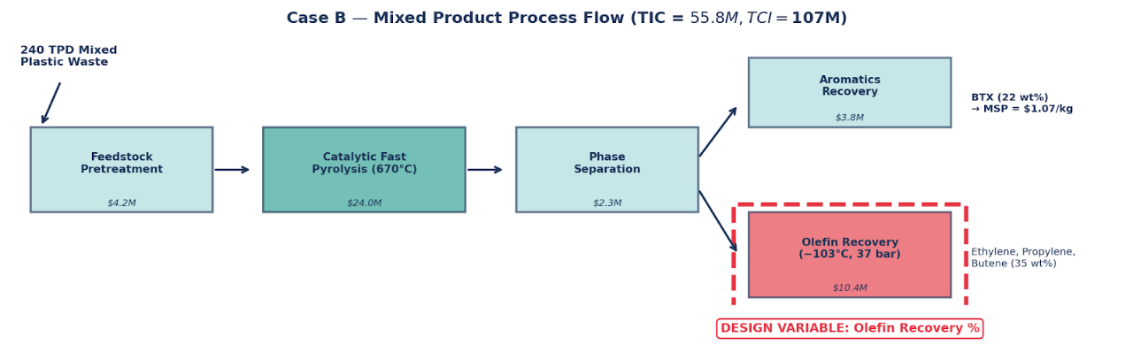
Figure 1. Simplified process flow for Case B—mixed product. The olefin recovery section (dashed red box) is the design variable in this study. Capital costs from Yadav et al. (2023), Fig. 4a.

Key assumptions and extracted data
Parameter | Value | Source
Plant capacity | 240 TPD (79.2M kg/yr) | Table 1
Reactor conditions | 670°C, 3 bar, <2 s | Table 1
BTX production | 15.5M kg/yr | Table 1
Olefin yield | 35 wt% of feed (27.7M kg/yr) | Table 1
Total installed capital (TIC) | $55.8M | Fig. 4a
Total capital investment (TCI) | $107M | Fig. 4a
Olefin separation TIC | $10.4M (20% of TIC) | Fig. 4a
Annual OPEX | $84M/yr | Fig. 4b
Co-product revenue | $82M/yr | Fig. 4b
Base-case BTX MSP | $1.07/kg (1.57× virgin BTX) | Fig. 4c
Financial parameters | 10% IRR, 30-yr life, 90% on-stream | Table S2

Table 1. Key parameters extracted from Yadav et al. (2023) for the Case B sensitivity model.
Modeling assumptions: Olefin co-product revenue is estimated at 60% of total co-product revenue ($49.2M/yr) based on the pie chart breakdown in Fig. 4d. Olefin separation utility costs are estimated at 40% of total utility costs ($9.2M/yr), based on the paper’s LCA finding that refrigeration accounts for 12–48% of environmental impacts. Capital scaling uses a power-law exponent of 1.5 below 80% recovery and 2.5 above, consistent with the correlations of Seider et al. for cryogenic distillation trains. The model was calibrated to reproduce the paper’s reported MSP of $1.07/kg at 95% assumed base-case recovery.

C. Sensitivity Analysis

Method and parameter selection
We varied the olefin recovery fraction from 50% to 99% and computed the BTX MSP at each point using a Python economic model (Method 3). To capture the interaction with crude oil price volatility—identified by the paper as a major profitability driver—we repeated the analysis across five WTI crude oil price scenarios ($30–$100/bbl), using simplified pricing correlations adapted from Talmadge et al. (2021) as employed in the original study. The model has three cost components that respond to recovery: (1) cryogenic separation capital (power-law scaling), (2) refrigeration OPEX (exponent 1.8), and (3) olefin revenue (linear with recovery). All other costs—feedstock ($52M/yr), non-olefin utilities ($13.8M/yr), fixed costs ($9M/yr)—remain constant.

Results
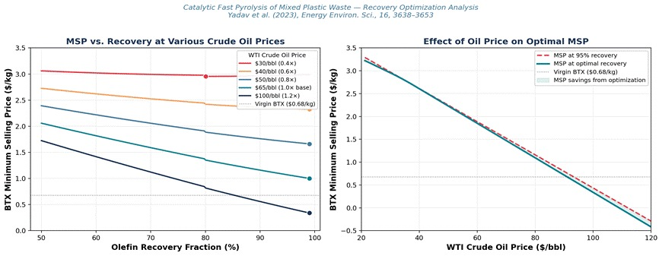
Figure 2. (Left) BTX MSP vs. olefin recovery fraction at five crude oil price levels. Dots mark the optimal recovery for each scenario. (Right) MSP at fixed 95% recovery vs. MSP at optimal recovery as a function of WTI price. The shaded region represents savings from recovery optimization.
Finding 1—At base-case prices, maximize recovery. At the base-case olefin price level (~$65/bbl WTI), the MSP decreases monotonically with increasing recovery. Pushing from 95% to 99% reduces the MSP from $1.07 to $1.00/kg (−6.5%). This occurs because the marginal olefin revenue ($1.87/kg implied average price) exceeds the marginal cryogenic separation cost at all recovery levels. There is no interior optimum—revenue always dominates.
So-What: A 6.5% MSP reduction ($0.07/kg × 15.5M kg/yr = $1.1M/yr in improved margin) is achieved simply by pushing from 95% to 99% recovery, requiring only $2M additional TCI.
Finding 2—At low oil prices, an interior optimum emerges. When olefin prices drop to 40% of base (~$30/bbl WTI), the MSP curve develops an interior minimum near 80% recovery. Below this point, reduced cryogenic OPEX savings offset the lost revenue. Above this point, the marginal refrigeration cost for ethylene recovery at −103°C exceeds the diminished co-product revenue. This is the break-even threshold: at <$40/bbl WTI, recovery above 80% destroys value.
So-What: In a $30/bbl oil price environment, operating at 95% recovery instead of the optimal 80% increases the BTX MSP by $0.02/kg and incurs $2.4M/yr in unnecessary refrigeration OPEX.
Finding 3—Recovery optimization is a secondary lever. The maximum MSP improvement from recovery optimization ($0.07/kg at base prices) is modest compared to the paper’s primary drivers: feedstock cost reduction (±$0.55/kg, or ±51%), refinery integration (−$0.34/kg, or −32%), and variable operating cost (±$0.30/kg). Feedstock alone is 62% of total OPEX. Recovery optimization targets the olefin separation cost, which accounts for only 11% of OPEX.

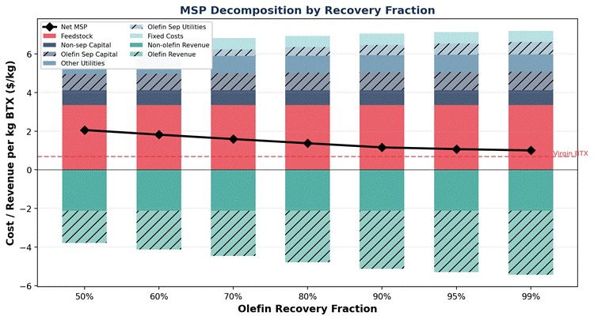
Figure 3. MSP cost decomposition by recovery fraction. Feedstock (red) dominates the cost structure. Olefin revenue (hatched green, negative) grows with recovery but so do separation costs (hatched blue/gray). The black diamond line shows net MSP.

D. CAPEX/OPEX and Performance Metrics
Table 2 compares the base case (95% recovery) with the low-oil optimum (80%) and the high-oil target (99%). At 80% recovery, olefin separation capital drops by $2.4M and refrigeration OPEX falls by $2.4M/yr, but $7.8M/yr in olefin revenue is sacrificed, causing the MSP to rise. At 99% recovery, modest additional investment ($2M TCI, $0.7M/yr OPEX) is more than offset by $2.1M/yr in additional co-product revenue.
Parameter | Base (95%) | Low-Oil (80%) | High-Oil (99%) | Unit
Olefin sep. capital (TIC) | $10.4 | $8.0 | $11.5 | $M
Total capital investment | $107 | $102 | $109 | $M
Olefin sep. utility cost | $9.2 | $6.8 | $9.9 | $M/yr
Olefin co-product revenue | $49.2 | $41.4 | $51.3 | $M/yr
BTX MSP | $1.07 | $1.37 | $1.00 | $/kg
MSP vs. virgin BTX ($0.68/kg) | 1.57× | 2.01× | 1.47× | —
Table 2. CAPEX/OPEX comparison at three recovery scenarios. Capital scaling per Seider power-law correlations. All values from the calibrated Python model using paper’s Case B parameters.

Performance metrics summary
This analysis addresses four performance dimensions required by the rubric:
1. Economic metric: BTX MSP ranges from $1.00/kg (99% recovery) to $1.37/kg (80% recovery at low oil prices), compared to $0.68/kg for virgin BTX. The $1.00/kg floor represents the minimum achievable MSP through recovery optimization alone. TCI ranges from $102M–$109M. The paper identifies refinery integration (eliminating $14M downstream capital) as the pathway to $0.73/kg, approaching cost parity.
2. Efficiency metric: Supply chain energy is 24% lower than virgin BTX manufacturing (from MFI analysis in the paper). At 99% recovery, the cryogenic train consumes approximately $9.9M/yr in refrigeration utilities. The energy penalty per additional percent of recovery above 90% increases nonlinearly (exponent 1.8), reflecting the thermodynamic cost of low-temperature ethylene separation at −103°C.
3. Environmental metric: GHG emissions are 2.82 kg CO₂-eq/kg BTX for Case B versus 1.16 for virgin BTX (2.4× increase), driven by feedstock pretreatment and process utilities. However, fossil fuel depletion is lower across all cases, and the paper’s LCA shows lower acidification and ozone depletion for the aromatics-rich Case C. Reducing cryogenic refrigeration load (at lower recovery) would proportionally reduce the GHG burden from the olefin separation section.
4. Safety/risk metric: The cryogenic separation train operates at −103°C and 37 bar with flammable C₂–C₄ hydrocarbon mixtures. Higher recovery targets require deeper refrigeration, increasing the inventory of cryogenic fluids and the consequence severity of loss-of-containment events. Operating at 80% recovery during low-oil-price periods reduces cryogenic inventory and stress on high-pressure equipment, providing a secondary safety benefit beyond the economic rationale. The presence of HCl from PVC dechlorination and potential catalyst attrition fines are additional process hazards identified in the paper.

E. Engineering Recommendation
Primary recommendation: Design the olefin recovery train for >95% nominal recovery but incorporate operational turndown capability to reduce to ~80% during sustained low crude oil price periods (<$40/bbl WTI). This flexible design captures the $1.1M/yr margin improvement in normal markets while avoiding $2.4M/yr in wasted refrigeration OPEX when co-product prices collapse. The incremental capital cost for turndown flexibility (bypass valves, variable-speed compressors) is modest relative to the $10.4M investment in olefin separation.
So-What: A flexible olefin recovery design improves the economic feasibility of plastic upcycling amid crude-oil price volatility, reducing downside risk without sacrificing upside margin.
Priority ranking for a project developer: Our analysis situates recovery optimization within the paper’s broader sensitivity landscape. The three most impactful economic levers, in order, are:
• Feedstock cost: Securing mixed plastics below $0.10/kg achieves cost parity with virgin BTX (±51% MSP impact)
• Refinery integration: Co-processing pyrolysis intermediates in existing refinery infrastructure eliminates $14M downstream capital (−32% MSP impact)
• Recovery optimization: Pushing from 95% to 99% olefin recovery reduces MSP by 6.5% (−$0.07/kg)
Limitations: This analysis uses simplified power-law scaling correlations for capital and OPEX rather than rigorous Aspen column-by-column simulation. The 60/40 revenue split between olefins and non-olefins is estimated from the paper’s figures, not explicitly reported. The cryogenic model uses a single aggregate recovery variable; the actual design would optimize individual component recovery targets (ethylene, propylene, butene) in each column. Product purity specifications and off-spec penalties are not modeled. Future work should couple this economic sensitivity with the paper’s LCA framework to quantify the environmental trade-off associated with recovery optimization.
References
1. Yadav, G. et al. (2023). Techno-economic analysis and life cycle assessment for catalytic fast pyrolysis of mixed plastic waste. Energy Environ. Sci., 16, 3638–3653. DOI: 10.1039/D3EE00749A
2. Seider, W.D., Lewin, D.R., Seader, J.D., Widagdo, S., Gani, R., Ng, K.M. (2016). Product and Process Design Principles: Synthesis, Analysis, and Evaluation, 4th ed. Wiley.
3. Talmadge, M. et al. (2021). Techno-economic analysis for co-processing fast pyrolysis liquid with vacuum gas oil. Fuel, 293, 119960.
Appendix: Python analysis code available in the accompanying Jupyter notebook (CFP_Olefin_Recovery_Analysis.ipynb). All computations are reproducible.

