
Team Apple⁴
University of Washington,
Dept of Chemical Engineering

June 8th, 2026

Dear Seattle Gas Light Company,
Enclosed is a report with a proposal to bring the Gas Works Coal Gasification plant into the future with a retrofit to produce ethanol via fermentation from local apple waste products. This will improve the company’s sustainability efforts by allowing the use of sustainable feedstock and reducing pollution. This report is proposed by Team Apple⁴.

We are seeking an investment of $147m to complete the retrofit laid out in this report due to required specialized equipment. Our process includes an acidic and heat pretreatment to hydrolyze polysaccharides, followed by fermentation and finally purification. We would be able to reuse cooling, separation systems, and purification units from current coal plant infrastructure. We would be able to produce 11.4m gallons of ethanol at 95.3 mol% purity. We would need to sell our product well above market rate with a minimum selling price of $4.28. While this process shows little economic viability, we would be able to create 60 FTE jobs once the plant is functional after five years.
We cannot recommend immediate investment in our plant due to low economic viability, but with further research and work we believe this to be a viable process utilizing a promising feedstock and look forward to future endeavors with you.
Sincerely,
Team Apple⁴
Retrofitting Seattle Gas Works Plant for Ethanol Production from Apple Pomace
ChemE 486 – Process Design II
Spring 2026
Date of Submission: June 8th, 2026
Team A
Team Name: Apple⁴
Authors:
Angelina Pamatian,
Lorrie Welch,
Alpha Arestun,
Mark Heien

Executive Summary
By partnering with Team Apple⁴, Gas Works Coal Gasification plant can be brought into the future to produce cleaner fuel by utilizing a feedstock that is both local and sustainable.
The process and retrofit, timeline and cost, environmental impacts, safety, and recommendations are discussed in this report.
Process and Retrofit
Our proposed retrofit involves fermentation of apple pomace to ethanol. The pomace contains a high level of cellulose polysaccharides, about 21% dry weight, that require hydrolyzation in a pretreatment step with a combination of sulfuric acid and heat. After sufficient time, the slurry that contains monosaccharides of glucose is sent to a fermenter where it is inoculated with the strain S. cerevisiae of yeast and set to ferment. Carbon dioxide and VOCs are produced in the fermentation process. Post-fermentation, separation of water and the produced ethanol is necessary. Existing infrastructure that can be incorporated into our plant are cooling, separation systems, and purification units. This process should produce 11.4 million gallons of ethanol a year at a purity of 95.3 mol% ethanol.
Timeline and Cost
We are seeking a total capital investment of $147m and are projecting work to be complete and have an up and running bioethanol plant in five years. Of that $147m, our expected fixed capital investment is $133.6m and are estimating $83.5m of that to be from total direct cost. Our annual operating costs are $31.7m/year. Due to these costs, our MSP is $4.28/gal. A major factor in long-term profitability is the selling cost of ethanol, which at the time of this report is $2.02/gal so our process is not currently economically viable.

Environmental Impacts
This process produces 32k tons of CO₂ per year as well as VOCs including small amounts of acetaldehyde as byproducts of fermentation. There is a plan to sequester CO₂ onsite, and a scrubber would be required to remove VOCs. This process generates 50-100k tons of spent yeast per year in addition to the spent apple pomace; this waste has the potential to be sold as livestock feed. This process would also halt some gaseous fumes that are being released into the environment due to current coal gasification processes, improving local air quality.
Safety
This process involves the use of sulfuric acid, high temperatures and pressures and the production of ethanol, all of which introduce important safety considerations and the team has taken steps to reduce the possible hazards of these materials through a LOPA. Main safety implementations are sulfuric acid hazard minimalization by specialized equipment for dilution, installation of appropriate sensors and valves to prevent and mitigate operational failures and fire suppression systems in the facility.
Recommendation
At present, we cannot recommend investment in this project due to high costs, feedstock requirements amounting to 300k tons/year, and low profitability. However, we believe there are significant benefits including job creation, low feedstock cost and general environmental benefits that upon further research for process improvements could make this a promising endeavor.

Table of Contents
Introduction and Project Objectives 8
Process Description 9
Process Detail for Coal Gasification Plant 14
Process Flow Diagram for processes and utilities areas 14
Material Balance for Major Streams 14
Sized equipment list 16
Process Detail for Retrofitted Plant 17
Process flow diagram 17
Material balance 17
Sized equipment list 19
Description of components used for optimization 19
Differences 19
Comparison of Economics and Technoeconomic Analysis 20
Capital Cost Estimate 21
Operating Cost and Variable-Cost Analysis 23
Minimum Selling Price and Comparison to Competing Industries 24
Policy and Low-Carbon Fuel Credit Pathway 27
Modern Retrofit versus 1900s Coal-to-City-Gas Profitability 28
Environmental Analysis and Life Cycle Analysis 28
Carbon Emissions, Water Usage and Energy Efficiency 29
By-Product Formation 29
By-Product Volume and Disposal 30
Process Safety 30
LOPA and Pressure Relief Valve Sizing 30
Sulfuric Acid Handling 30
Pretreatment with P&ID 32
Neutralization and Separation 34
Fermentation 34
Distillation and Purification 34
General Responses 34
Atmospheric Detonation of Distillation Inventory 35
Summary of Personnel Hazards. 35
Timeline 37
Conclusions 38
Additional Considerations and Improvements 38
Feedstock 38
Potential Co-Products 38
Summary and Recommendations 39
Appendix 42
Appendix A: Cost of Production Spreadsheet for economic analysis 42
Appendix [LETTER]: Twenty-Year After-Tax Cash Flow 42
Appendix B: Justifications for all stated assumptions 44
Appendix C: Relevant Calculations 44
Appendix D: Historical Records and data used in Coal Plant design 45

Table of Tables
Table 1: Overall Composition of Apple Pomace 11
Table 2: Compositions of the Major Streams in the Coal Gasification Plant in mole fractions 14
Table 3: Operating Conditions and Mass Flows of the Major Coal Gasification Streams 15
Table 4: Sized Equipment List for the Original Coal Gasification. 16
Table 5: Compositions of the Major Streams of the Retrofitted Plant in Mole Fractions 17
Table 6: Operating Conditions and Mass Flows of the Major Streams in the Retrofitted Plant 18
Table 7: Sized Equipment list of the Retrofitted Plant 19
Table 8: Design and Financial Basis for Techno-Economic Analysis 20
Table 9: Retrofit Capital Cost Estimate by Process Area 21
Table 10: Capital cost summary (AACE Class 4/5, ±50%) 22
Table 11: Annual Operating Cost 23
Table 12: One-at-a-time Sensitivity of MSP ($/gal) 26
Table 13: Era Comparison of the Coal-Gas Baseline and the Ethanol Retrofit 28
Table 14: Twenty-Year After-Tax Discounted Cash Flow 43
Table 15: Proximate analyses Data of Blue Canyon Coal in Whatcom County⁷ 45
Table 16: Chemical Composition of Subbituminous Coal⁴² 46

Table of Figures
Figure 1: A map of railways in Washington State 14
Figure 2: Process Flow Diagram for Coal Gasification Plant 15
Figure 3: Process Flow Diagram for Bioethanol Fermentation Plant 18
Figure 4: Tornado diagram of MSP sensitivity (CRF method, base $4.28/gal) 25
Figure 5: MSP Sensitivity Spider Plot 26
Figure 6: LOPA 29
Figure 7: P&ID 32
Figure 8: Explosion area 34
Figure 9: Gantt Chart Timeline 37
Figure 10: 20-year Discounted Cash Flow at the $2.02/gal Market Price 42

Introduction and Project Objectives
Gas Works Park in Seattle was originally a coal gasification plant developed by the Seattle Gas Light Company¹. This plant was critical for early urban infrastructure, as it provided a reliable source of fuel for lighting, heating, and cooking ¹.
In 1937, the facility converted to crude oil following new advancements². The plant produced city gas used for lighting from 1906-1956; it stopped production due to new natural gas options. The original feedstock used by Seattle Gas Works was coal and while it provided a reliable source of energy, it is a nonrenewable source and is associated with greenhouse gas emissions, particulate pollution, acid rain formation, and environmental contamination³. Because of this we want to retrofit the plant and replace the feedstock with apple pomace, which is a more sustainable alternative. Washington state is a major producer of apples and apple products, generating significant quantities of apple pomace as a waste stream. When apples are processed into commercial products such as juice, cider, vinegar, approximately 25-30% of the apple becomes pomace⁴. Apple pomace contains sugars, fibers, and other organic compounds that can be converted into valuable products⁴. So, rather than disposing of this material through landfilling or composting, it can be utilized as renewable feedstock for biofuel production.
The primary product selected for this retrofit is ethanol. Ethanol is widely used as a transportational fuel blend stock, industrial solvent, disinfectant, and chemical intermediate⁵. More than 98% of gasoline sold in the United States contains ethanol, demonstrating the strong demand for this product⁵. In Washington State, approximately 280 million gallons of ethanol were consumed in 2023, further demonstrating the importance of ethanol as fuel⁶. Ethanol produced from apple pomace also supports circular-economy principles by converting an agricultural waste stream into a valuable renewable fuel. Additionally, retrofitting the existing Seattle Gas Works plants saves on capital cost as we are repurposing instead of constructing an entirely new facility.
In summary, the objective of this project is to evaluate the feasibility of retrofitting the historical Seattle Gas Works coal gasification plant into a bioethanol production facility utilizing apple pomace as the primary feedstock.

Process Description
Process Description Overview
The original Seattle Gas Works plant converted coal to city gas through a coal gasification process. The proposed retrofit replaces coal with apple pomace, a local waste generated by Washington’s vast apple processing industry and converts it into ethanol. The retrofitted process consists of feed preparation, pretreatment, fermentation, and downstream purification steps. Overall, the process will transform the apple biomass into simple sugars which can then be metabolized by yeast to produce ethanol. To minimize new equipment requirements, several pieces of the original Seattle Gas Works plant will be repurposed for the retrofit, including most of the cooling, separation systems, and purification units.
Summary of the Coal Gasification Plant Process
The coal gasification process first starts out with subbituminous coal from the Blue Canyon Coal Co. in Whatcom County². The coal used can contain impurities such as phosphorus, nitrogen, oxygen, moisture, and sulfur. Based on historical data for the coal from the Blue Canyon Coal mines (Table A1), it tells us that the coal contained 1.79% moisture, 31.48% volatile matter, 62.74% fixed carbon, 3.68% ash, and 0.31% sulfur, with a heating value of approximately 11,910 BTU/lb⁷. The first row of Table A1 was used because the data was collected in 1923, which better matches the operating period of the Seattle Gas Works plant. For the ultimate coal composition, Blue Canyon Coal Co. specific data could not be found. Therefore, another subbituminous coal analysis was used as a reference assumption. Based on Table 2 in the appendix, the assumed elemental composition was 58.3% carbon, 6.0% hydrogen, 29.5% oxygen, and 1.3% nitrogen⁸.
Now that our feedstock has been characterized, the coal gasification process can be described. Once the coal arrives at the gas work plant by train, it gets loaded to the coal oven section which consists of nine horizontal retorts. These retorts are long sealed D-shaped chambers where the coal can be heated². The process first began with the blowing phase, where air was introduced to raise the temperature inside the retorts. Literature indicates that it requires a minimum temperature around 840$℃$ for chemical reaction¹³. Once the ovens reached the desired temperature, the air flow was reduced, and steam was added to drive gas production reactions. As the ovens gradually cooled during gas production, the process switched back to the blowing phase to reheat the retorts. These two phases continuously alternated, with some retorts in the blowing phase while others produced gas, ensuring a steady production of city gas². The gas leaving the ovens is “foul gas” meaning it has yet to be purified, thus still containing contaminants. The foul gas first goes into a collecting main that is a large pipe that gathers gas from many ovens into one main line. The gas then goes to primary coolers, where the gas temperature was reduced to allow tar and other condensable compounds to condense⁸. Note that historical operating temperatures for the Seattle Gas Works primary coolers could not be located. Therefore, a primary cooler outlet temperature of 30$℃$ was assumed based on literature describing coal-gas tar recovery systems in crude gas is cooled to 25-35$℃$ to condense tar and ammonia prior to separation⁹. Continuing on after this, the gas passes through an exhauster which is a large fan, to keep the gas moving through the system. Next, a tar extractor removes tar droplets from the gas stream. The condensed tar and liquids were sent through circulating tanks, pumps, decanters, and tar storage tanks. The gas stream continues to be moved to an ammonia washer and ammonia liquor storage units to remove ammonia compounds. Light oil scrubbers were then used to remove lighter hydrocarbons and oils before the purified city gas was sent to the gas holder for storage and distribution^{2,8}. The average composition of the manufactured city gas was approximately 5% CO₂, 5% N₂, 0.5% O₂, 36% CO, 45% H₂, 8% CH₄, and 0.5% of light hydrocarbons¹².
The coal gasification process is governed by several reactions occurring simultaneously within the coal retorts. When air is first introduced into the retorts, oxygen reacts with carbon through the producer gas reaction shown in Equation 1. This equation is critical because it’s an exothermic reaction releasing 110.4kJ/mol of heat, which supplies the thermal energy necessary to sustain subsequent gasification reactions¹⁰ ¹¹.
$$\begin{aligned}2C+O_{2} →2CO \#\left(1\right)\end{aligned}$$
After the coal beds reach a high enough temperature, steam is introduced, allowing the water gas and steam gasification reactions shown in Equation 2 and 3 to occur.
$$\begin{aligned}C+H_{2}O →CO+ H_{2} \#\left(2\right)\end{aligned}$$
$$\begin{aligned}C+ {2H}_{2}O →CO_{2}+ {2H}_{2} \#\left(3\right)\end{aligned}$$
These reactions are endothermic reactions feeding off the heat acquired from the first stage. Equation 2 required 135.0 kJ/mol of energy and Equation 3 requires 96.6 kJ/mol. Furthermore, Equation 4 is the water gas shift reaction converts carbon monoxide and steam into carbon dioxide and hydrogen and is exothermic releasing 38.4 kJ/mol of heat¹⁰ ¹¹.
$\begin{aligned}CO+ H_{2}O →CO_{2}+ H_{2} \#\left(4\right)\end{aligned}$
An additional methanation reaction may occur in hydrogen rich conditions as shown in Equation
5.
$\begin{aligned}{CO+3H}_{2} → H_{2}O+CH_{4} \#\left(5\right)\end{aligned}$
Stoichiometric and thermodynamic analyses indicate that the coal gasification performance is strongly controlled by both mass conservation and heat balance within the reactor¹⁰ ¹¹.
Summary of the Retrofitted Process
The sustainable feedstock that will be used in this retrofit is apple pomace, sourced from apple juice facilities in Washington State. Apple pomace is a waste product from manufacturing processes, such as those to make apple products such as apple juice, applesauce and apple cider vinegar. As with most natural feedstocks, the composition of apple pomace is highly variable due to factors such as different manufacturing processes and crop variabilities year-to-year. Apple pomace contains skin and flesh (93-97%), stems and leaves (1%), and seeds (2-4%) and due to its high sugar content across these features in the forms of glucose and cellulose as well as other nutrients, apple pomace makes an excellent feedstock for fermentation¹¹. Estimations of composition are detailed in Table 1¹².
Table 1: Overall Composition of Apple Pomace
Component | Composition (wt% DWB)
Cellulose | 21
Hemicellulose | 3.7
Arabinan | 4.4
Galactan | 3
Pectin | 14.4
Fructose | 19.2
Sucrose | 1.0
Ethanol | 0.9
Lignin | 24.7
Ash | 2.2

Additionally, the apple pomace is received as unprocessed feedstock with a moisture content of approximately 66.4-78%¹³. Due to the high moisture content, it has a high tendency to spoil during storage, thus the pomace is first dried before being sent to a storage unit. This step improves feedstock stability and ensures a reliable supply year-round for downstream processing.
The apple pomace is to be sourced directly from fruit processing facilities in Eastern Washington and transported by rail to the Seattle site (Figure 2). A significant amount of apples are sourced from Washington’s Yakima Valley and companies that have an apple pomace supply in Washington are Tree Top, which has locations in Selah, Wenatchee, and Prosser, FruitSmart in Prosser and Grandview, and NeilJones in Vancouver, WA^{14–16}.
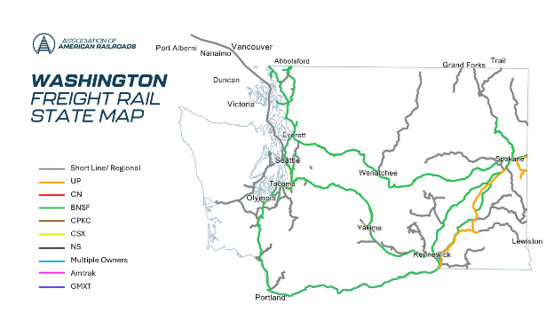
Figure 1: A map of railways in Washington State
Vancouver, Washington is near Portland, Selah is near Wenatchee, and Prosser is south of Yakima, along the rail. Image by Association of American Railroads¹⁷.

After leaving the storage unit, the dried apple pomace will undergo a dilute acid hydrolysis using sulfuric acid.^{18,19} The purpose of the step is to disrupt the lignin-cellulose network in apple pomace³¹. Through hydrolysis the complex carbohydrates can convert into simple sugars like glucose. We chose to do a dilute acid hydrolysis instead of the popular enzymatic hydrolysis route because it offers a shorter processing time and cost less as it uses very little of a cheap acid, overall reducing production cost^{18,19}. In addition, based on literature data, the pretreatment is carried out using 1.5 g sulfuric acid per 100mL of water at a reaction temperature of 91$℃ ADDIN ZOTERO_ITEM CSL_CITATION \{"citationID":"H3crkob4","properties":\{"unsorted":false,"formattedCitation":"\backslash \backslash super 18\backslash \backslash nosupersub\{\}","plainCitation":"18","noteIndex":0\},"citationItems":[\{"id":271,"uris":["http://zotero.org/groups/6502282/items/DAU3BJJR"],"itemData":\{"id":271,"type":"article-journal","container-title":"Biomass and Bioenergy","DOI":"10.1016/j.biombioe.2023.106757","ISSN":"09619534","journalAbbreviation":"Biomass and Bioenergy","language":"en","page":"106757","source":"DOI.org (Crossref)","title":"Evaluation of apple pomace biochemical transformation to biofuels and pectin through a sustainable biorefinery","volume":"172","author":[\{"family":"Vaez","given":"Safoura"\},\{"family":"Karimi","given":"Keikhosro"\},\{"family":"Denayer","given":"Joeri F.M."\},\{"family":"Kumar","given":"Rajeev"\}],"issued":\{"date-parts":[["2023",5]]\}\}\}],"schema":"https://github.com/citation-style-language/schema/raw/master/csl-citation.json"\}$¹⁸. The hydrolysate is subsequently cooled to 30$℃$ which is the ideal fermentation temperature for the brewer’s yeast, Saccharomyces cerevisiae¹⁹. The stream then goes through a solid-liquid separator to remove the biomass solid from the liquid¹⁸. Next, the sugar rich liquid then gets sent to a continuous stirred-tank reactor (CSTR) where brewer’s yeast is added, which ferments the glucose into ethanol and carbon dioxide according to Equation 6.
$$\begin{aligned}C_{6}H_{12}O_{6}→{2C}_{2}H_{5}OH+{2CO}_{2} \#\left(6\right)\end{aligned}$$
Following fermentation, almost all of the carbon dioxide produced leaves the reactor through a vapor stream while the remaining liquid product streams gets heated to 85$℃.$This temperature was selected because ethanol has a boiling point of 78.4$℃$ whereas water of 100$℃,$making ethanol more volatile^{30,29}. Thus, we picked this temperature to vaporize the mixture and improve separation of the ethanol from the water. The remaining liquid then enters the first distillation column where an initial ethanol enrichment is achieved. Water is removed through the bottoms stream while the ethanol rich stream is sent to a second distillation column for further purification. This second distillation column helps further remove the water and other impurities to produce the final ethanol product. The purified product steam exits the process at a flow rate of approximately 4,715 kg/hr and a purity of 95.3mol% ethanol.

Process Detail for Coal Gasification Plant

Process Flow Diagram for processes and utilities areas
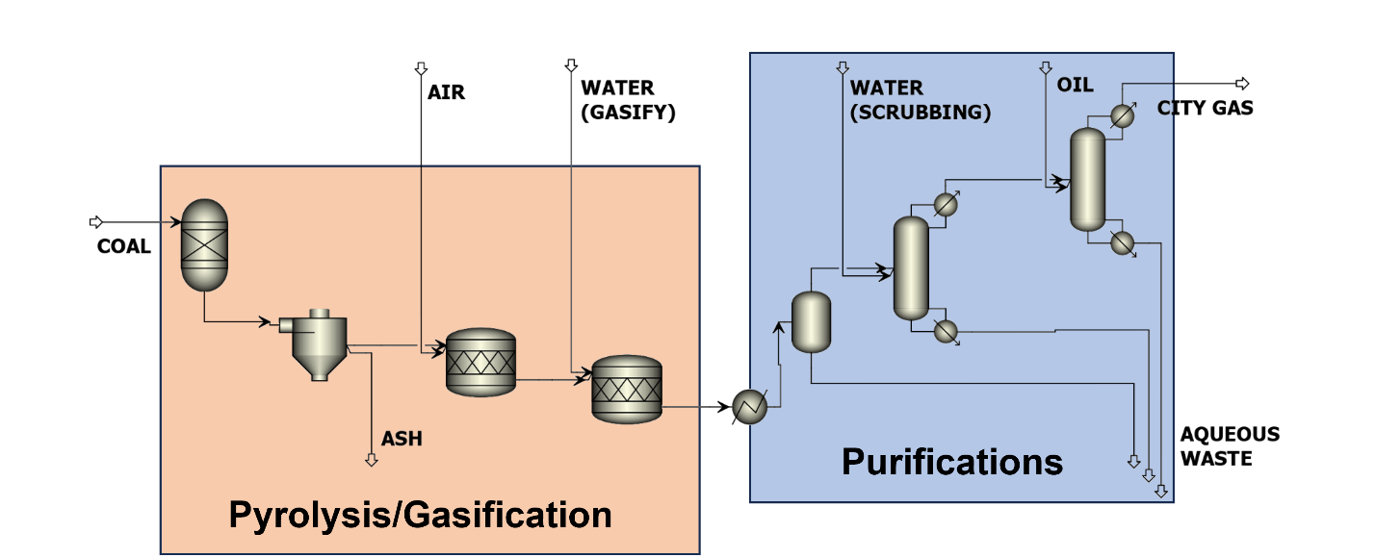
Figure 2: Process Flow Diagram for Coal Gasification Plant

Material Balance for Major Streams
Table 2: Compositions of the Major Streams in the Coal Gasification Plant in mole fractions
Components | Coal Stream | Air Stream | Steam Stream | Raw Gas | Tar | Aqueous waste-1 | City Gas
$$H_{2}$$ | 0.34 | 0 | 0 | 0.34 | 1.6e-07 | 1.6e-07 | 0.45
$$CO$$ | 0 | 0 | 0 | 0.17 | 4.6e-08 | 4.6e-08 | 0.22
$${CO}_{2}$$ | 0 | 0 | 0 | 0.079 | 1.9e-06 | 1.9e-06 | 0.10
$${CH}_{4}$$ | 0 | 0 | 0 | 0.0070 | 2.8e-10 | 2.8e-10 | 0.0091
$$H_{2}O$$ | 0.011 | 0 | 1 | 0.32 | 0.99 | 0.99 | 0.10
$$N_{2}$$ | 0.0053 | 0.81 | 0 | 0.0822 | 2.7e-08 | 2.7e-08 | 0.107
$$O_{2}$$ | 0.11 | 0.19 | 0 | 0 | 0 | 0 | 0
$$C$$ | 0.53 | 0 | 0 | 0 | 0 | 0 | 0
$${NH}_{3}$$ | 0.0014 | 0 | 0 | 0.00066 | 0.00028 | 0.00028 | 0.00077
Benzene | 0.00074 | 0 | 0 | 0.00036 | 4.7e-13 | 4.7e-13 | 0.00047
Naphthalene | 0.0014 | 0 | 0 | 0.00065 | 8.8e-09 | 8.8e-09 | 0.00086

Table 3: Operating Conditions and Mass Flows of the Major Coal Gasification Streams
Major Stream | T ($℃$) | P (atm) | Mass Flow (kg/hr)
Coal Feed | 700 | 1 | 1900
Air Feed | 25 | 1 | 1000
Steam Feed | 100 | 1 | 3200
Raw gas leaving rectors | 880 | 1 | 6100
Aqueous waste-1 | 50 | 1 | 208
Tar | 50 | 1 | 1513
City Gas | 50 | 1 | 4663

Sized equipment list
Table 4: Sized Equipment List for the Original Coal Gasification.
Equipment | Function | Size/capacity^{20–22}
Horizontal coal Retorts | Where the coal was heated | D shaped vessel 22ft long, 22 inches wide, and 18 inches high
Primary Cooler | Condensed the tar | 40 ft
Ammonia scrubber | Removed the ammonia | 48ft (11.5 diameter)
Light Oil Scrubber | Removed the light oils | 80 ft
Piping | Plated steel that connects the towers | 3/16 inch
Compressor | Moved the gas along through the system. | 3000 hp
Boiler House with two boilers | Housed to boilers providing steam | 5,720 sq ft (40ft x 143ft)
Pump House | Housed the pumps and compressors | 7,340 sq ft (48 x 153ft)
City Gas Storage Unit | Stored the final city gas product | Holds 3 million cubic ft

Process Detail for Retrofitted Plant

Process flow diagram
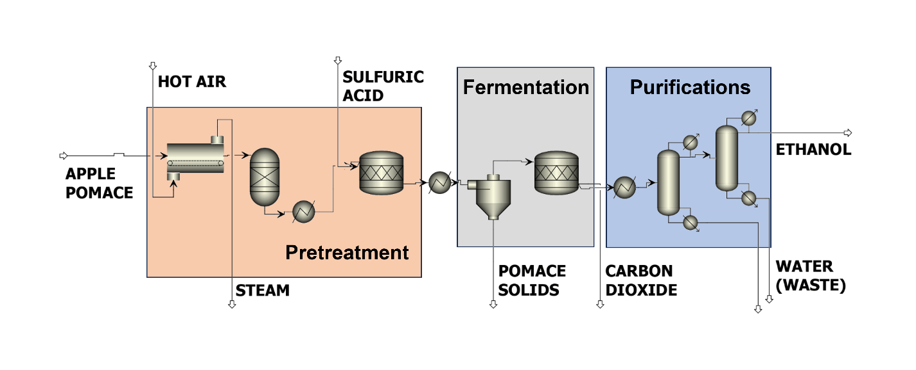
Figure 3: Process Flow Diagram for Bioethanol Fermentation Plant

Material balance
Table 5: Compositions of the Major Streams of the Retrofitted Plant in Mole Fractions
Components | Dried Apple Pomace | Dilute Sulfuric Acid | Stream leaving hydrolysis reactor | Stream leaving fermentation reactor | CO₂ Waste | Final Ethanol Product
Water | 0 | 0.997211 | 0.017 | 0.022 | 0.0019 | 0.029
Ethanol | 0.046 | 0 | 0.045 | 0.71 | 0.0766 | 0.95329
Glucose | 0.25 | 0 | 0.30 | 0.039 | 3.9e-12 | 4.9e-145
Sucrose | 0.0069 | 0 | 0 | 0 | 0 | 0
Cellulose | 0.31 | 0 | 0.27 | 0.019 | 0 | 0
CO₂ | 0 | 0 | 0 | 0.011 | 0.921 | 0.0173
Lignin | 0.17 | 0 | 0.17 | 0.017 | 0 | 0
Pectin | 0.027 | 0 | 0.26 | 0.0018 | 0 | 0
Xylose | 0 | 0 | 0.051 | 0.069 | 5.5e-11 | 0
Arabinose | 0 | 0 | 0.054 | 0.073 | 2.5e-9 | 4.2e-98
Galactose | 0 | 0 | 0.03 | 0.040 | 1.1e-9 | 5.15e-129
Arabinan | 0.079 | 0 | 0.023 | 0.0016 | 0 | 0
Galactan | 0.044 | 0 | 0.013 | 0.00091 | 0 | 0
Xylan | 0.066 | 0 | 0.013 | 0.00091 | 0 | 0
H₂SO₄ | 0 | 0.0028 | 0.00053 | 0.00071 | 1.1e-10 | 2.64e-94

Table 6: Operating Conditions and Mass Flows of the Major Streams in the Retrofitted Plant
Major Stream | T ($℃$) | P (atm) | Mass Flow (kg/hr)
Dried Apple Pomace Feed | 33.86 | 1 | 39994
Dilute Sulfuric Acid | 25 | 1 | 700
Stream leaving hydrolysis reactor | 91 | 1 | 40694.3
Liquid stream leaving fermentation reactor | 30 | 1 | 11134.1
CO₂ Waste | 30 | 1 | 4709.12
Final Ethanol Product | 19.7 | 1 | 4715.31

Sized equipment list
Table 7: Sized Equipment list of the Retrofitted Plant
Equipment^{20–22} | Size/capacity^{20–22} | New or reused^{20–22}
Pump house | 7,340 sq ft (48 x 153ft) | reused
Boiler House with two boilers | 5,720 sq ft (40ft x 143ft) | reused
Compressor | 3000 hp | reused
Piping | 3/16 inch | reused
Ammonia scrubber | 48ft (11.5 diameter) | reused
Light Oil Scrubber | 80 ft | reused
Apple Pomace Storage Tank |  | new
Solid-Liquid Separator |  | new
Fermentation CSTR |  | new
Ethanol Product Storage unit | Holds 3 million cubic ft | reused

Description of components used for optimization

Differences

Comparison of Economics and Technoeconomic Analysis
All of the economic results in this section come from our apple-pomace techno-economic model (the AP_ sheets in our workbook), which we built on top of our converged Aspen Plus simulation.¹ Our design produces about 11,426,405 gal/yr of fuel ethanol from roughly 297,795 k wet t/yr of apple pomace, running at 85% uptime (7,446 h/yr). We evaluated it over a 20-year plant life at a 10% discount rate, a 21% tax rate, 7-year straight-line depreciation, and CEPCI cost escalation (567 to 797.9). These are the numbers we use in the cover letter and executive summary, replacing the earlier corn-stover placeholder values. Our headline result is that the plant is technically and environmentally strong but not profitable at the current ethanol price without a low-carbon-fuel credit; the rest of this section shows how we get there. Table 6 collects the design and financial basis so the reader can audit every number that follows.
Table 8: Design and Financial Basis for Techno-Economic Analysis
Basis item | Value
Ethanol production | 11,426,405 gal/yr (95.3 mol%)
Apple pomace feedstock | 297,795 wet t/yr
On-stream time | 85% uptime (7,446 h/yr)
Plant life | 20 years
Discount rate | 10%
Tax rate | 21%
Depreciation | 7-year straight line
Cost basis / escalation | CEPCI 567 → 797.9
Estimate class | AACE Class 4/5 (±50%)
Market ethanol price | $2.02/gal

Capital Cost Estimate
We estimated the purchase cost of each new process area using the six-tenths scaling rule and a CEPCI escalation factor (Equation 7), starting from NREL biochemical design area costs2 and adjusting them to today's dollars using the cost-index ratio.⁴ We took the factor method, the six-tenths exponent, and the installation (bare-module) factors of 2.0 to 3.0 from standard practice.³ Because we are retrofitting the historic Lake Station works, we reuse the cooling-water system, the product purification and storage tankage, the rail spur, and the outside-battery-limits infrastructure, so we did not charge new equipment capital for them; our new spending is concentrated in feed handling, dilute-acid pretreatment, fermentation, solids separation, neutralization, the distillation polish, and the molecular sieve. Because we chose dilute-acid hydrolysis, we avoid any enzyme-reactor capital and enzyme cost. We estimate the total capital investment at about $147.0M (an AACE Class 4/5 estimate, with roughly ±50 % uncertainty), which is well below the corn-stover base case.
C_{a} = C_{b}(A_{a}/A_{b})^{0.6}(I_{a}/I_{b}) (7)
where C is equipment cost, A is capacity, I is the CEPCI index, and the subscripts a and b denote the new and reference cases.
Table 9: Retrofit Capital Cost Estimate by Process Area
Process area | Purchased ($) | Installed ($)
Feed receiving/storage | $1,354,210 | $2,708,421
Slurry preparation | $947,947 | $2,369,868
Pretreatment | $2,717,642 | $6,794,106
Neutralization & conditioning | $823,835 | $2,306,738
Fermentation | $3,432,646 | $9,611,410
Solids separation | $2,031,316 | $4,468,894
Distillation | $6,097,772 | $18,293,315
Molecular sieve dehydration | $2,286,664 | $5,945,328
Product storage/loading | $1,219,554 | $2,439,109
Wastewater treatment | $1,671,167 | $3,676,568

Table 8 builds the installed equipment cost up to total capital investment using standard direct, indirect, and working-capital factors.
Table 10: Capital cost summary (AACE Class 4/5, ±50%)
Capital summary | Subtotal | Value
Fixed capital investment (FCI): $133.6m | $133.6M
Total direct cost (TDC) | $83.5M
ISBL (installed process equipment) |  | $58.6M
OSBL (25% of ISBL) |  | $14.7M
Additional direct (17.5% of ISBL) |  | $10.3M
Indirect cost (60% of TDC) |  | $50.1M
Working capital (10% of FCI) |  | $13.4M
Total capital investment (TCI) |  | $147.0M

Operating Cost and Variable-Cost Analysis
Our annual operating cost is about $31.7M/yr, which works out to $2.77/gal of total operating cost and $1.66/gal of cash variable cost. Our biggest costs are buying and hauling the feedstock: apple pomace is wet and low-density, so getting 297,795k wet t/yr to the Seattle site is our single largest cost block (about $13.4M/yr combined). Our fixed costs (maintenance at 3% of FCI, insurance and taxes, labor for the 60 people we plan to employ, and overhead) account for most of the remainder. We list steam and natural gas as a process-heating placeholder until we export the Aspen energy balance; adding a charge for on-site drying of the wet pomace to the plant adds roughly 1.0 to 1.3 million GJ/yr and would dominate utilities. Please see Appendix A for our full 20-year cash flow.
Table 11: Annual Operating Cost
Operating cost item | Annual cost | Basis
Apple pomace feedstock | $6.0M | wet t/yr x $/wet t
Transportation | $7.4M | wet t/yr x $/wet t
Acid / base chemicals | $0.2M | kg/yr x $/kg
Steam / natural gas | $2.4M | GJ/yr x $/GJ
Electricity | $0.7M | kWh/yr x $/kWh
Cooling water | $0.3M | m3/yr x $/m3
Wastewater treatment | $0.5M | m3/yr x $/m3
Solids handling/disposal | $1.5M | wet t/yr x $/wet t
Operating labor | $3.9M | FTE x $/FTE-yr
Maintenance | $4.0M | % of FCI
Insurance/taxes | $0.9M | % of FCI
Plant overhead | $2.3M | % of labor
Administrative/distribution/R&D | $1.5M | annual estimate
Total annual operating cost | $31.7M

Minimum Selling Price and Comparison to Competing Industries
We computed the minimum ethanol selling price (MSP) two ways. The annualized capital (capital recovery factor) method (Equations 8 and 9) gives $4.28/gal with a capital recovery factor of 0.1175. The after-tax discounted-cash-flow method, the price that drives our 20-year NPV to zero, gives $4.89/gal; it is higher because it carries the construction-period discounting and the tax burden. Both are well above the current fuel-ethanol price of $2.02/gal.⁶

CRF = r(1+r)^{n} / [(1+r)^{n} − 1] (8)
MSP = (TCI × CRF + OPEX − credits) / production (9)
where r is the discount rate, and n is the plant life in years. At our basis, CRF – 0.1175 annualizes the 147.0M TCI to about 17.3M/yr, which combines the $31.7M/yer OPEX over 11.43M gal/yr to give $4.28/gal.
Sensitivity Analysis
We varied each major input individually and recomputed the MSP. The tornado-diagram (Figure 4) ranks variables by how much they swing the MSP: annual ethanol production, total OPEX, feedstock transport, and total capital investment are the largest levers, while electricity, wastewater, and a small co-product credit barely move it. The spider plot (Figure 5) shows the same five strongest levers as full trajectories from their low to high values; we keep each variable’s true direction, so more ethanol yield and longer plant life slope downward while OPEX, transport, TCI, and the discount rate slope upward. The decisive feature is the gap to the dotted market line: even our most favorable swing only reaches about $3.73/gal, so no one variable, within a realistic range, closes the gap to $2.02/gal on its own.

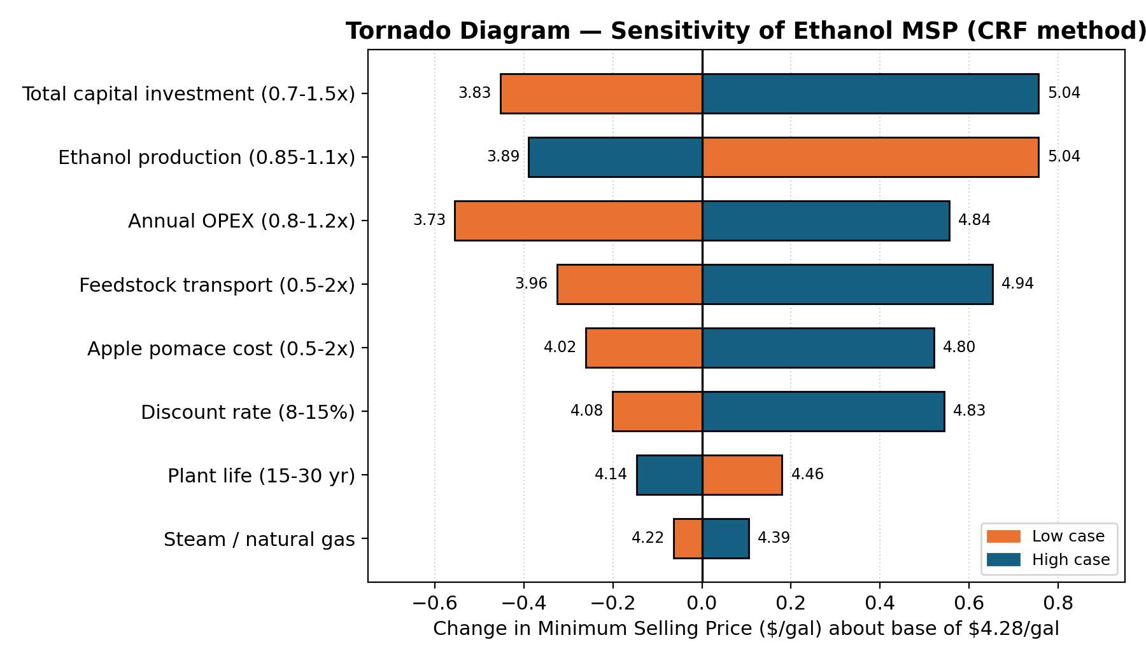
Figure 4: Tornado diagram of MSP sensitivity (CRF method, base $4.28/gal)

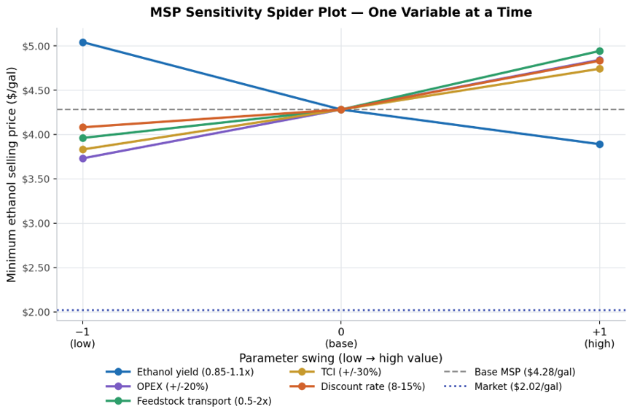
Figure 5: MSP Sensitivity Spider Plot
Lines fan out from the base case; no single lever reaches the $2.02/gal market line

Table 11 lists every variable we tested, with the corrected TCI range at
Table 12: One-at-a-time Sensitivity of MSP ($/gal)
Variable (low to high case) | MSP at low | Base | MSP at high
Total capital investment | $3.83 | $4.28 | $5.04
Annual OPEX | $3.73 | $4.28 | $4.84
Annual ethanol production | $5.04 | $4.28 | $3.89
Discount rate | $4.08 | $4.28 | $4.83
Plant life | $4.46 | $4.28 | $4.14
Coproduct/policy credit | $4.28 | $4.28 | $4.20
Apple pomace feedstock cost | $4.02 | $4.28 | $4.81
Feedstock transport cost | $3.96 | $4.28 | $4.94
Steam/natural gas cost | $4.22 | $4.28 | $4.39
Electricity cost | $4.27 | $4.28 | $4.31
Wastewater treatment cost | $4.27 | $4.28 | $4.31

Policy and Low-Carbon Fuel Credit Pathway
The single most important lever we have is not a process variable at all — it is the low-carbon-fuel policy stack that apple-pomace ethanol qualifies for and corn ethanol does not. Because our feedstock is a cellulosic waste residue rather than a food crop, the fuel generates D3 (cellulosic biofuel) RINs under the federal Renewable Fuel Standard, which have traded at roughly $2.45–$3.00 each, compared with about $0.72 for the D6 corn-ethanol RIN. On top of that, the low carbon intensity we report in our environmental section (about 21 g CO₂e/MJ in the no-fossil-drying case, roughly 78% below gasoline) earns a larger 45Z Clean Fuel Production Credit and qualifies the fuel for Washington’s Clean Fuel Standard and California’s LCFS, both of which pay in proportion to carbon-intensity reduction.
Stacked together, these credits are plausibly worth $2–$3+/gal — the same order of magnitude as our $2.26/gal gap between the $4.28/gal MSP and the $2.02/gal market price. We deliberately kept the base-case MSP credit-free and tested only a token credit in Table 11, so our headline numbers are conservative; the policy stack is treated separately here because it is a strategic and feedstock-qualification choice rather than a knob on the flowsheet. The practical conclusion is that the realistic route to viability runs through carbon intensity: if we electrify the dryer to hit the low-CI pathway, the credit value alone can close most or all of the gap to market, which is why we recommend it as the team’s priority next step.

Modern Retrofit versus 1900s Coal-to-City-Gas Profitability
The original Lake Station works turned coal into city gas in the early 1900s. When we compare that plant with our retrofit, the difference is as much about the market as the process. The coal-gas plant was a regulated municipal utility making an essential, locally distributed product with no real substitute, and it was paid on a cost-of-service basis, so its return was effectively guaranteed. We are doing the opposite: making a globally traded commodity fuel as a small, high-cost producer, and we are a price taker at about $2.02/gal against corn ethanol (~$1.5 to 2.2/gal) and cellulosic ethanol (~$2.15/gal).
Table 13: Era Comparison of the Coal-Gas Baseline and the Ethanol Retrofit
Metric | 1900s coal to city gas | Modern pomace to ethanol
Business model | Regulated utility, cost-of-service | Commodity fuel, price taker
Feedstock | Coal (~170 t/day) | Apple pomace (~960 t/day, wet)
Product energy export | ~85 GJ/h (city gas) | ~120 GJ/h (ethanol)
Unit cost vs. price | Recovered via tariff | MSP $4.28 > price $2.02
Profitability | Assured return | Unprofitable at design scale
In short, our plant is the better engineering and environmental option but the worse business: the 1900s plant earned a guaranteed margin in a protected market, while we have to compete on price and still pay to collect and dry a wet, scattered by-product. To close the gap, we would need a much larger scale, near-zero-cost local feedstock, saleable co-products (pectin, butanol, recovered CO₂, or animal feed), or a low-carbon-fuel policy credit.

Environmental Analysis and Life Cycle Analysis
Potential Environmental Concerns with Apple Pomace Utilization
Bioethanol production, while more sustainable than utilizing nonrenewable resources, is not without environmental impacts that need consideration. Typically, the growing of crops for and production of bioethanol can cause issues such as “land use changes, eutrophication, excessive water use, biodiversity loss, and hazardous air emissions at production sites,” ²³ some of which are likely mitigated using a waste product as a feedstock. However, our process has environmental impacts such as production of CO₂ and volatile organic compound (VOC) production, high electricity and water consumption, and organic waste production.

Carbon Emissions, Water Usage and Energy Efficiency
We are expecting unfortunately high carbon dioxide emissions for this process due to the breakdown of organic material and energy requirements to breakdown the cellulose. Carbon dioxide is a chemically stable leaving group in the biochemical mechanism of the decomposition of glucose into ethanol²⁴ and thus will be produced at the same stoichiometric levels as ethanol. Due to this, we are expecting carbon emissions from this aspect to be on the order of 32k metric tons (See Appendix C for calculations). Our current process has significant energy requirements required to chemically break down cellulose. Our current model suggests an energy requirement that is [to be determined] which translates to [to be determined] carbon emissions. We have explored other enzymatic decomposition of polysaccharides rather than thermolysis which would require less energy and with further process improvements we strongly believe this could be a possibility. No substantial effort has been made yet to optimize energy usage, but the team does have plans to sequester the CO₂ onsite with cyanobacteria.

By-Product Formation
The most significant by-product of this process is carbon dioxide. This team has explored the possibility of on-site sequestration of this CO₂ via cyanobacteria. However, this is a complex biological process with several mechanistical steps and thus waste streams are subject to having the metabolic intermediate components. The final steps of the biochemical process are the formation of acetaldehyde followed by the reduction of acetaldehyde to ethanol²⁵. While the yeast S. cerevisiae is used due to its high conversion of glucose to ethanol, there is likely to be some acetaldehyde in the waste, especially as VOCs²³. A scrubber will need to be added to our process to remove these VOCs. Additionally, a significant waste product from this process is the spent yeast and apple pomace solids at the end of the fermentation process.

By-Product Volume and Disposal
At present process levels of 300k tons/yr of apple pomace, our process generates an enormous amount of waste. With production of 11.4m gal/year, we are estimating approximately 50k-100k tons of waste yeast per year in addition to the spent apple pomace given beer-brewing spent yeast estimations²⁶. Brewery waste can be sold as livestock feed²⁷ but due to the sulfuric acid pretreatment, the team would prefer to perform bench-scale operations to determine the specific pH and composition before fully recommending the sale of the generated waste for this purpose.
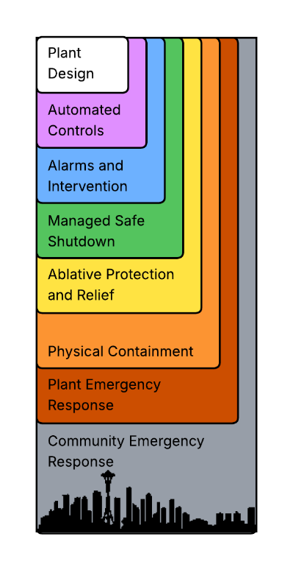
Local Impacts
A concern regarding the Gas Works Coal Gasification plant is the gaseous fumes that are created and escape during the coal burning process. Naturally, our process would cease the production of these fumes. This process does however generate CO₂ and VOCs that will have an impact on local air quality. While our team is seeking ways to scrub and capture these emissions, it is very likely that some will escape. Additionally, in the event of a natural disaster such as a major earthquake or major plant failure, a significant amount of emissions could be released into the local environment.
Figure 6: LOPA

Process Safety
This section will be ordered by hazard, using a bottom-up Layers of Protection Analysis (LOPA) for each. Layers are enumerated from (L1) to (L8), representing Plant Design to Community Emergency Response accordingly.

LOPA and Pressure Relief Valve Sizing

Sulfuric Acid Handling
(L1) The process as declared uses a 1.5wt% sulfuric acid solution, which is to be diluted on-site, as water is easily accessible. This necessitates storing a variable volume of nearly pure sulfuric acid, and deciding on a process to dilute it, which is surprisingly easy to handle. The mechanism of corrosion is an electrochemical reaction where hydrogen ions can freely dissociate into water, which then pull electrons from the material of the tank, before becoming hydrogen gas and escaping. This is most dangerous at medium dilutions of sulfuric acid but becomes almost entirely inert at low concentrations (such as in the process) where this effect is negligible, or at high purity (stock) where there is no medium for the hydrogen ions to dissociate into. Nonetheless, all processes that involve sulfuric acid are to be made of acid-resistant stainless steels, like Alloy 20 or Incoloy 825 plating²⁸. Additionally, to avoid corrosion in the storage tank due to sulfuric acid’s tendency to absorb water vapor from the air and form dilute regions within itself, the head space within the sulfuric acid tank needs to be blanketed with relatively inert gases like nitrogen, and else sealed from the open air, even when refilling. The fragility of acid-inert materials like glass or certain plastics makes them ill-advised for storage, especially because sulfuric acid is significantly denser than water.
The pH of the diluted acid is approximately 1, making it very acidic and a hazard for personnel. (L2) To avoid unnecessary contact, the dilution process itself can be controlled by a valve limiting the gravity-driven flow of sulfuric acid stock into a closed mixing vessel, before being pumped directly into the process. Because this task can be automated, this subprocess can thus be isolated from personnel, which can be taken a step further by keeping the storage and dilution tanks in a room separated from the main process, with a pipe running through the wall. Temperature controls for the room are required, as the freezing point of pure sulfuric acid is [10C, cite this], meaning exposure of the process to nighttime temperatures are enough to cause issues. Any hands-on maintenance requires personal protective equipment of a full body suit, and sufficient face coverings.
(L3) Important sensors for both control and safety include a height monitor for the tank (which could be done by weight, or an internal radar), a flowmeter for the water input, and a way to test for the composition of the sulfuric acid (either a direct pH sensor, or possibly a densitometer). While allowing the tank to be fully empty shouldn’t cause catastrophic failures, it’s something that should be avoided anyways. (L4) The valve should be fail-closed, and be sized such that even if opened completely, the diluted sulfuric acid cannot exceed a composition of 2wt%, a conservative bound to limit corrosion. Heat of dilution is estimated to be negligible, and the stream is due to be heated anyways. Sealing the sulfuric acid tank from the atmosphere requires pressure controls for the headspace, and to maintain the nitrogen blanket. A sensor should be set to keep the head barely above atmospheric pressure, and an overpressure failure should be tolerated by the storage tank itself. (L 5) A single-use pressure relief valve might make the problem worse, if it exposes sulfuric acid to open air.
(L 6) Finally, in the possibility of catastrophic puncturing of the storage tank, or possibly earthquake damage, the floor should be made of concrete and recessed into the ground to contain the spill. While setting up a drainage system for the room is possible, any outflow must be sent to a storage tank below the ground to prevent environmental contamination. Finally, fire is unlikely to be an issue with this unit, as the production of hydrogen gas likely means the storage tank has already been compromised.

Pretreatment with P&ID
The pretreatment vessel operates using 140C superheated sulfuric acid, under enough pressure to keep it liquid, and continuously stirred. This was chosen to reduce the cost of the process, as enzymatic pretreatments were deemed too slow, and too expensive. (L 1) To run this as a continuous process, sealed screw conveyers for both feed and outlets are required to maintain pressure. The reactor material remains the same sort of stainless steel, for the same reasons given previously.
(L 2, 3) Sensors must be set for temperature and pressure, and a pressure relief valve must be placed on the reactor itself, and potentially on the screw feed systems in the unlikely case of a jam. A level sensor is required to make sure the reactor doesn’t accumulate material and eventually backflow or burst. The arrangement described here is given in Figure X. (L 5, 6) Finally, reinforced shielding should be placed around the reactor, both for insulation, and for blast protection in case of rupture. This is the most that can be done to physically isolate the process.
Because the reaction contains no volatile, or reasonably combustible materials, fire hazards should be negligible. The reaction thermodynamics as compared to heat dissipation are currently unknown, so both a heater and cooling jacket are included in the design for finer controls. Personnel should be kept physically separated from heat exchanging units.
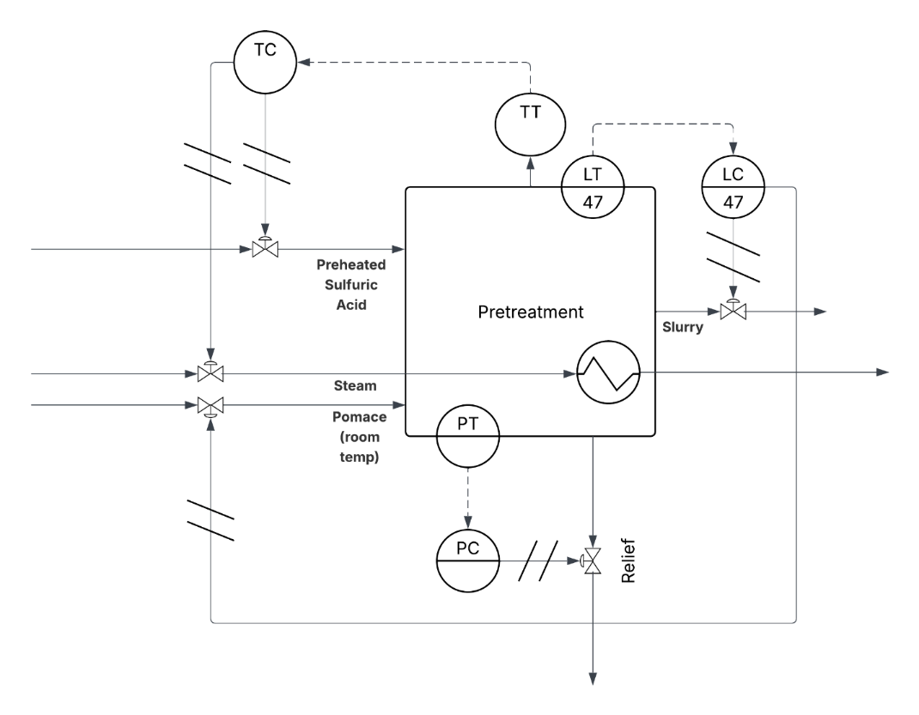
Figure 7: P&ID
The liquid pressure relief system on the is sized using the method published by AIChE²⁹, and from the Aspen, conditions inside the tank are assumed to have a liquid velocity of 120gpm, a specific gravity of 1.5, and a saturated water pressure of 52psig for 140C. An overpressure of 10% was allotted before activation. Apple pomace is assumed to be modellable using applesauce, with a non-Newtonian viscosity approaching 100 mPa*s per a study done of child-friendly foods, and it is further assumed that liquid speeds inside the pretreatment tank are sufficient to approximate as its asymptote.³⁰
Iterative calculations between the Reynolds number of the liquid passing through the valve and the valves area depending on a viscosity correction factor determined by the Reynolds number resulted in values that did not lie on the provided correlation graph, halting further inquiry. Due to the sheer viscosity of the liquid, a hypothetical relief valve is likely to exceed a foot in diameter, and multiple should be set throughout the 54000L-ish pretreatment tank. In an emergency, or under uncontrolled heating, the plant is better with this modification than not, but it leaves much to be desired.

Neutralization and Separation
Prior to this step, the slurry is cooled to human-safe temperatures and pressures, and the pH is brought to slightly acidic conditions using a stream of bubbled ammonia. Ammonia is notably caustic and toxic, and this reaction can be contained entirely within a stripping column, which should be set with temperature, pressure, and height sensors regardless. While ammonia can be flammable, there shouldn’t be open sparks, and it should remain entirely sealed in the stripper. Regardless, a chemical sensor can be placed nearby in case of a leak, and to mitigate possible asphyxiation.
The physical separation itself likely occurs by a physical filter, or by continuous centrifugation. Beyond mechanical failure and possibly getting too close to the spinning part of a centrifuge, the most dangerous thing is the liquid, which is a mild irritant at worst.

Fermentation
This process occurs at 30C and atmospheric conditions. While yeast is a biological agent, brewer’s yeast is noted to not be hazardous. Rather, the worst that can happen is human contamination of the fermentation tank. This can be countered by occasional sampling of the tanks during fermentation for other species. The carbon dioxide produced per tank during the entire fermentation cycle should be captured and should not become an asphyxiation hazard.

Distillation and Purification
The fermented liquid is then passed through a distillation column, hot enough to cause burns. Vapor contained by units, keep away from touch. Zeolite is used as condensation, needs periodic cleanout because the substrate needs to be regenerated. Best is to make this section modular. The final storage of ethanol prior to shipping involves filling a rotation of barrels and exchanging it from empty ones from the barge that transports these to the gasoline refinery. This prevents the possibility of a single large leak from a storage silo, and each barrel should be investigated for leaks before and after filling, before being placed in storage, away from any flames.

General Responses
(L 4, 7) Safe shutdown of the plant involves shutting down all units, closing all valves involved in transfer. A full-plant fire suppression system is required, as well as shutdown and evacuation drills for all personnel during orientation, and yearly otherwise. PPE is required for interacting with all processes. Regular inspection of the plant is required. Sectional lockdowns are unlikely to be of any benefit.

Atmospheric Detonation of Distillation Inventory
(L 8) For lack of current distillation sizing, the following calculation models spontaneous combustion of an hour’s production of pure ethanol, stored in a silo at ground level. This approximates the worst-case scenario of ethanol vapor overflowing from a distillation unit and combusting in air.
Assuming an hour of production, the ethanol generated would produce the same force as 27 tons on TNT (see Appendix C for calculation)³¹. An attempt to scale this number into a blast radius or other estimate of damage was made using an online tool called “nukeblastsimulator.com” using reference data for real-world explosives, overlaid onto a map, as shown in Figure [6]. The closest analogue is a conventional explosive slightly below the calculated number, but the takeaways remain similar.
Anything within the red zone would be completely levelled, orange would sustain significant damage, and grey would be minor, like shattered windows and toppled furniture. While the plant would likely be levelled, the worst of the blast would otherwise be completely contained within the gasworks site.

(L 8) The only useful city-wide response is post-explosion evacuation, to avoid any smoke hazards from the plant. Otherwise, the nearest hospitals are in the University of Washington to the east, or Kaiser Permanente to the southeast. The nearest fire station is Seattle 9 in Fremont, or 17 and 22 in University District and Eastlake respectively.
Figure 8: Explosion area

Summary of Personnel Hazards.
- Strong acids, mitigated by sealed containers, autonomous processes and PPE.
- Strong acids under high temperatures and pressures, mitigated by same.
- Toxic gases, mitigated by sealing.
- High temperatures in distillation.

Timeline
In theory, every biorefining facility must be registered under Title 40, Part 80 of the Code of Federal Regulations, including what feedstock they consume and what fuel or additive they produce.³² It does not seem to keep track of a date of registration, preventing any extrapolation therein. Another database includes a similar list, and easily distinguishes cellulosic refineries from each other, but investigations into each plant do not return dates of when ground-breaking started, to when they were completed.³³ A final attempt to trace land deeds was not successful, and thus, all that remains is to theorize.
Much of the information involved with biorefinery design and construction is either paywalled, or company secrets. However, as much of this process is analogous to other biorefineries or even breweries, the construction of the plant is expected to proceed without significant impediments.
Using the time spent writing this report as evidence, a fully-fledged proposal could be realized with an additional six months of focus, and the resources to test almost all assumptions for the properties of apple pomace that could only be assumed here. Highest among these is a holistic verification of all proposed pretreatments with a standardized apple pomace stock. Should this proposal be accepted, then plant design is likely to take another six months to a year, alongside permit negotiations with local and federal governments.
Even if the construction goes well, the construction phase can range from anywhere between a year to five, especially since political turbulence remains unpredictable and manufacturers may come and go. Finally, to verify the plant is stable, incremental startup tests are expected to take another six months to a year before it can be declared as fully operational.
Bioethanol production can be considered a mature industry, given that alcohol itself has been made for much of human history, and the process for fuel-grade quality has existed for at least twenty years, judging by the founding dates of some of the above companies. The average for the above reckonings estimates five years between initial conception to a full facility, give or take two years, assuming that the gasworks site is allowed to be developed into such a plant. This is visualized as a Gantt chart on Figure XYZ, with major goals listed under each phase.

Figure 9: Gantt Chart Timeline

Conclusions

Additional Considerations and Improvements
Our team has thoughtfully considered possible improvements to our process for future research.
Feedstock
A significant issue we have noted is the illogical feedstock requirement, which in our present model is approximately 300K tons/year and amounts to roughly half of the entire pomace production of Washington State. We believe this amount could be significantly reduced to a reasonable amount with further process improvements. Additionally, apple pomace is largely produced seasonally and thus we wanted to consider other feedstock options in the event of a feedstock restriction like a bad crop year or spoilage. Grape pomace has many similar properties^{34–36} to apple pomace in composition and locality: it is high in similar cellulose and hemicellulose structures to apple pomace and is produced in high volumes at Washington’s many wineries and can be explored as a feedstock addition.
Potential Co-Products
There are potential co-products that could be incorporated into our process. Pectin is often isolated from apple pomace, can be obtained with similar acidification processes^{37,38} and both products have been isolated simultaneously from pomegranates³⁹. Additionally, common co-products of bioethanol fermentation can be produced with the addition of more yeast species, butanol⁴⁰ being the most promising possibility.
Unmodelled Molecular Sieve Drying
To obtain fuel-grade ethanol, further purification is required. Further drying of the ethanol liquor must be done with zeolite molecular sieves, as the current modelled purity is an azeotropic mixture. Cost estimations for a packed zeolite column, and the amount of energy required to regenerate the filter were not accomplished within this report.

Summary and Recommendations
Our retrofit of Gas Works Coal Gasification Plant to produce bioethanol would produce 11.9m gallons of ethanol a year at a purity of 95.3 mol% and would require a capital investment of $147m. Our MESP is $4.28 which is well above the market rate of ethanol of $2.02. Our current model also requires an illogically large feedstock amount of 300k tons/year which is about half of the total pomace generated in Washington State. We are also carbon footprint to be 32K tons CO₂. Despite these challenges, our plant would provide 60 FTE jobs, would allow the reuse of certain existing infrastructure, and would offer considerable environmental impacts.
At present, we cannot recommend investment in this project due to high costs, impossible feedstock requirements, and low profitability. However, our team recognizes that more research needs to be completed to increase process productivity, reduce energy costs, and incorporate co-products into our process. Apple pomace is a promising feedstock for this process we urge the use of this feedstock in future endeavors.
References
(1) Gas Works Park (Seattle). https://www.historylink.org/File/20978 (accessed 2026-05-31).
(2) Eggers, D. D. Coal Gasification and Liquefaction; Seattle Public Library Pamphlet: Seattle, WA, 1998.
(3) Ecological Effects of Ammonia. Minnesota Department of Agriculture. https://www.mda.state.mn.us/ecological-effects-ammonia (accessed 2026-05-31).
(4) Selmi, H.; Presutto, E.; Totaro, M.; Spano, G.; Capozzi, V.; Fragasso, M. Apple Waste/By-Products and Microbial Resources to Promote the Design of Added-Value Foods: A Review. Foods 2025, 14 (11), 1850. https://doi.org/10.3390/foods14111850.
(5) Alternative Fuels Data Center: Ethanol Fuel Basics. https://afdc.energy.gov/fuels/ethanol-fuel-basics (accessed 2026-04-14).
(6) U.S. Fuel Ethanol Plant Production Capacity. https://www.eia.gov/petroleum/ethanolcapacity/ (accessed 2026-04-14).
(7) Vonheeder, E. R. Coal Reserves of Whatcom County; Washington State Department of Natural Resources: Olympia, Washington.
(8) Meade, A. Modern Gasworks Practice; Benn Brothers, limited, 1921.
(9) Li, J.; Xin, X.; Lei, J. Simulation and Design of Tar Recovery and Gas Decarbonization Process. IOP Conf. Ser. Earth Environ. Sci. 2019, 227, 042023. https://doi.org/10.1088/1755-1315/227/4/042023.
(10) Wei, J. A Stoichiometric Analysis of Coal Gasification. Ind. Eng. Chem. Process Des. Dev. 1979, 18 (3), 554–558. https://doi.org/10.1021/i260071a034.
(11) Ginni, G.; Adish Kumar, S.; Mohamed Usman, T. M.; Pakonyi, P.; Rajesh Banu, J. Integrated Biorefineries of Food Waste. In Food Waste to Valuable Resources; Elsevier, 2020; pp 275–298. https://doi.org/10.1016/B978-0-12-818353-3.00013-4.
(12) Magyar, M.; da Costa Sousa, L.; Jin, M.; Sarks, C.; Balan, V. Conversion of Apple Pomace Waste to Ethanol at Industrial Relevant Conditions. Appl. Microbiol. Biotechnol. 2016, 100 (16), 7349–7358. https://doi.org/10.1007/s00253-016-7665-7.
(13) Jung, J.; Cavender, G.; Zhao, Y. Impingement Drying for Preparing Dried Apple Pomace Flour and Its Fortification in Bakery and Meat Products. J. Food Sci. Technol. 2015, 52 (9), 5568–5578. https://doi.org/10.1007/s13197-014-1680-4.
(14) Our Facilities. https://treetop.com/about-us/facilities/.
(15) About. https://www.fruitsmart.com/about.
(16) Pacific Northwest Fruit Packing & Processing. https://neiljonesfoodcompany.com/northwest-packing/.
(17) Washington Freight Rail State Map. https://www.aar.org/washington/.
(18) Vaez, S.; Karimi, K.; Denayer, J. F. M.; Kumar, R. Evaluation of Apple Pomace Biochemical Transformation to Biofuels and Pectin through a Sustainable Biorefinery. Biomass Bioenergy 2023, 172, 106757. https://doi.org/10.1016/j.biombioe.2023.106757.
(19) Humbird, D.; Davis, R.; Tao, L.; Kinchin, C.; Hsu, D.; Aden, A.; Schoen, P.; Lukas, J.; Olthof, B.; Worley, M.; Sexton, D.; Dudgeon, D. Process Design and Economics for Biochemical Conversion of Lignocellulosic Biomass to Ethanol: Dilute-Acid Pretreatment and Enzymatic Hydrolysis of Corn Stover; National Renewable Energy Laboratory: Golden, CO, USA, 2011. https://doi.org/10.2172/1013269.
(20) Davies, G. Time-Lapse Transformation of an Industrial Skyline: Construction of a Gasholder at the Cambridge University & Town Gas-Light Company in the 1920s, 2020.
(21) Russell, T. The History and Operation of Gasworks (Manufactured Gas Plants), 2013.
(22) Report on Designation: Gas Works Park. https://www.seattle.gov/documents/Departments/Neighborhoods/HistoricPreservation/Landmarks/RelatedDocuments/gas-works-park-designation.pdf.
(23) Mahdavi, M.; Rashidi, A.; Dvorak, B.; Hassan, A. Review of Industrial Bioethanol Production with a Focus on Volatile Fermentation Byproducts. Clean. Eng. Technol. 2026. https://doi.org/https://doi.org/10.1016/j.clet.2026.101200.
(24) Ordonez, E. Pretreatment and Enzymatic Saccharification Approaches and Several Cellulosic Substrates for the Biofuel Industry. CHEM 693 Review Paper, California State East Bay University, Deaprtment of Chemistry and Biochemistry, 2021.
(25) Yan, S. The Biochemical Basis of Ethanol Fermentation and Its Industrial Applications. Biol. Evid. 2024. https://doi.org/10.5376/be.2024.14.0025.
(26) Jaeger, A.; Arendt, E. K.; Zannini, E.; Sahin, A. W. Brewer’s Spent Yeast (BSY), an Underutilized Brewing By-Product. Fermentation 2020, 6 (4), 123. https://doi.org/10.3390/fermentation6040123.
(27) Suszkiw, J. Recycling Used Beer Yeast for Environmental Protection. Agricultural Reserach Service U.S. Department of Agriculture. https://www.ars.usda.gov/news-events/news/research-news/2022/recycling-used-beer-yeast-for-environmental-protection/.
(28) National Renewable Energy Laboratory. Biorefinery Analysis Process Models: DW1910A--Direct Port of DW1102A to Aspen Plus V10. https://www.nlr.gov/extranet/biorefinery/aspen-models/ (accessed 2026-05-24).
(29) Crowl, D. A.; Tipler, S. A. Sized Equipment List for the Original Coal Gasification. AIChE. 2013, pp 68–76.
(30) Kersten, E.; Barry, A.; Klein, S. Physicochemical Characterisation of Fluids and Soft Foods Frequently Mixed with Oral Drug Formulations Prior to Administration to Children. Pharmazie 2016, No. 3, 122–127. https://doi.org/10.1691/ph.2016.5145.
(31) Nuke Blast Simulator. https://nukeblastsimulator.com/ (accessed 2026-06-08).
(32) About the EPA Fuels Registration Dashboard. https://awsedap.epa.gov/public/extensions/otaqreg/otaqreg.html.
(33) Map of U.S. Ethanol Biorefineries. https://ethanolrfa.org/resources/us-ethanol-and-alcohol-to-jet-biorefineries.
(34) Gowman, A.; picard, M.; Rodriguez-Uribe, A.; Misra, M.; Khalil, H.; Mohanty, A. K. Physiochemical Analysis of Apple and Grape Pomaces. BioResources 2019, 14 (2), 3210–3230.
(35) Valiente, C.; Arrigoni, E.; Esteban, R. M.; Amado, R. Grape Pomace as a Potential Food Fiber. J. Food Sci. 1995, 60 (4), 818–820. https://doi.org/10.1111/j.1365-2621.1995.tb06237.x.
(36) Gracey, P. R.; Tako, E. Apple and Grape Pomace: Emerging Upcycled Functional Ingredients in Processed Meat Products, Designed to Increase Polyphenol and Fiber Contents. Sustain. Food Technol. 2025, 3 (4), 861–874. https://doi.org/10.1039/D5FB00040H.
(37) Edwards, M. C.; Doran-Peterson, J. Pectin-Rich Biomass as Feedstock for Fuel Ethanol Production. Appl. Microbiol. Biotechnol. 2012, 95 (3), 565–575. https://doi.org/10.1007/s00253-012-4173-2.
(38) Mahmoud, M. H.; Abu-Salem, F. M.; Azab, D. E.-S. H. A Comparative Study of Pectin Green Extraction Methods from Apple Waste: Characterization and Functional Properties. Int. J. Food Sci. 2022, 2022, 1–9. https://doi.org/10.1155/2022/2865921.
(39) Talekar, S.; Patti, A. F.; Vijayraghavan, R.; Arora, A. An Integrated Green Biorefinery Approach towards Simultaneous Recovery of Pectin and Polyphenols Coupled with Bioethanol Production from Waste Pomegranate Peels. Bioresour. Technol. 2018, 266, 322–334. https://doi.org/10.1016/j.biortech.2018.06.072.
(40) Jin, Q.; Qureshi, N.; Wang, H.; Huang, H. Acetone-Butanol-Ethanol (ABE) Fermentation of Soluble and Hydrolyzed Sugars in Apple Pomace by Clostridium Beijerinckii P260. Fuel 2019, 244, 536–544. https://doi.org/10.1016/j.fuel.2019.01.177.
(41) Ethanol. https://webbook.nist.gov/cgi/cbook.cgi?ID=C64175.
(42) Davis, J. D.; Parry, V. F. Carbonizing Properties of a Subbituminous Coal from Puritan Mine, Dacono, Weld County, Colo.; Report of investigations / United States Department of the Interior, Bureau of Mines ;3428; U.S. Dept. of the Interior, Bureau of Mines: Washington, D.C., 1939.

Appendix

Appendix A: Cost of Production Spreadsheet for economic analysis

Appendix [LETTER]: Twenty-Year After-Tax Cash Flow
We spend capital 40/40/20% over years 0 to 2, and we start operating and earning revenue in year 3. We use 7-year straight-line depreciation, a 21% tax rate, and we recover working capital in the final year. Values are in $millions at the $2.02/gal market price. Our cumulative NPV never becomes positive, confirming that the plant is not viable at this scale without the changes we noted above.
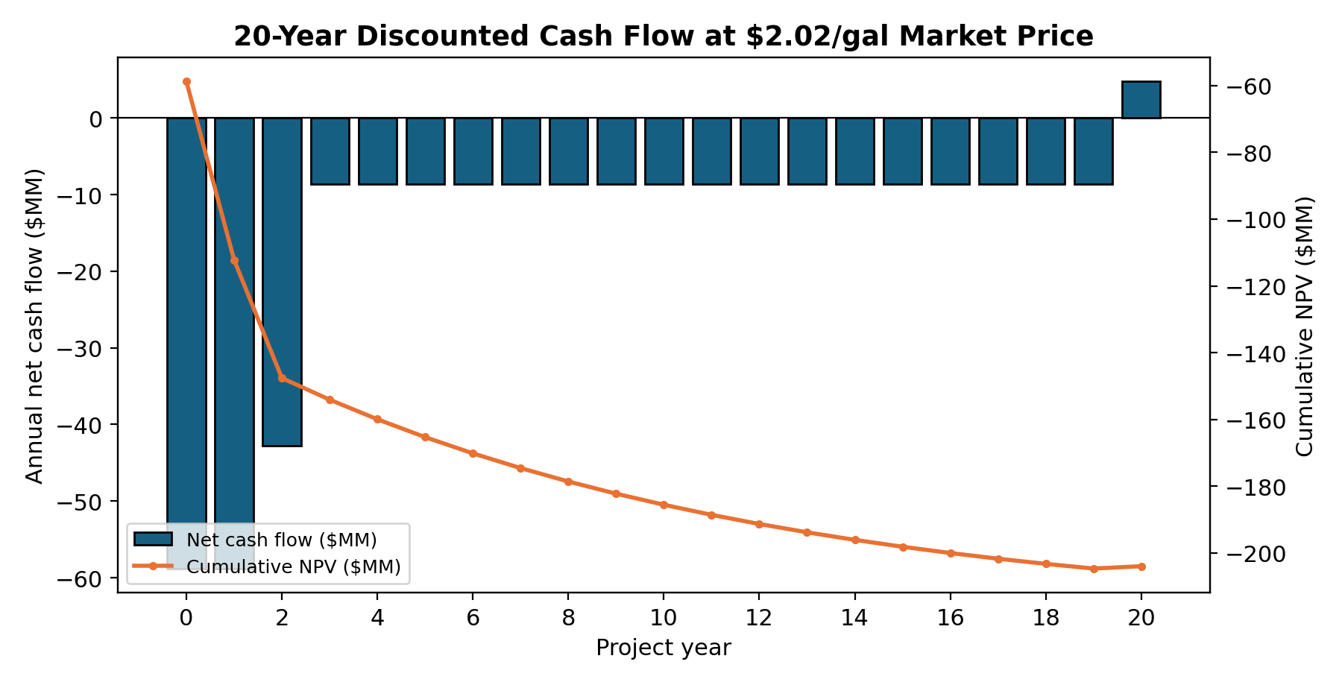
Figure 10: 20-year Discounted Cash Flow at the $2.02/gal Market Price

Table 14: Twenty-Year After-Tax Discounted Cash Flow
Yr | Capital | Revenue | OPEX | Deprec. | Taxes | Net CF | Cum. NPV
0 | $-58.8M | $0.0M | $0.0M | $0.0M | $0.0M | $-58.8M | $-58.8M
1 | $-58.8M | $0.0M | $0.0M | $0.0M | $0.0M | $-58.8M | $-112.3M
2 | $-42.8M | $0.0M | $0.0M | $0.0M | $0.0M | $-42.8M | $-147.6M
3 | $0.0M | $23.1M | $31.7M | $19.1M | $0.0M | $-8.6M | $-154.1M
4 | $0.0M | $23.1M | $31.7M | $19.1M | $0.0M | $-8.6M | $-159.9M
5 | $0.0M | $23.1M | $31.7M | $19.1M | $0.0M | $-8.6M | $-165.3M
6 | $0.0M | $23.1M | $31.7M | $19.1M | $0.0M | $-8.6M | $-170.1M
7 | $0.0M | $23.1M | $31.7M | $19.1M | $0.0M | $-8.6M | $-174.6M
8 | $0.0M | $23.1M | $31.7M | $19.1M | $0.0M | $-8.6M | $-178.6M
9 | $0.0M | $23.1M | $31.7M | $19.1M | $0.0M | $-8.6M | $-182.2M
10 | $0.0M | $23.1M | $31.7M | $0.0M | $0.0M | $-8.6M | $-185.5M
11 | $0.0M | $23.1M | $31.7M | $0.0M | $0.0M | $-8.6M | $-188.6M
12 | $0.0M | $23.1M | $31.7M | $0.0M | $0.0M | $-8.6M | $-191.3M
13 | $0.0M | $23.1M | $31.7M | $0.0M | $0.0M | $-8.6M | $-193.8M
14 | $0.0M | $23.1M | $31.7M | $0.0M | $0.0M | $-8.6M | $-196.1M
15 | $0.0M | $23.1M | $31.7M | $0.0M | $0.0M | $-8.6M | $-198.1M
16 | $0.0M | $23.1M | $31.7M | $0.0M | $0.0M | $-8.6M | $-200.0M
17 | $0.0M | $23.1M | $31.7M | $0.0M | $0.0M | $-8.6M | $-201.7M
18 | $0.0M | $23.1M | $31.7M | $0.0M | $0.0M | $-8.6M | $-203.2M
19 | $0.0M | $23.1M | $31.7M | $0.0M | $0.0M | $-8.6M | $-204.6M
20 | $13.4M | $23.1M | $31.7M | $0.0M | $0.0M | $4.8M | $-203.9M

Appendix B: Justifications for all stated assumptions

Appendix C: Relevant Calculations

Calculation to show carbon emissions:
$$59.9 gal*95\% purity=5.69*{10}^{7 }gal EtOH$$
$$5.69*{10}^{7 }gal EtOH*6.551 \frac{lbs}{gal}*0.45\frac{kg}{lb}*1000\frac{g}{kg}*\frac{1 mol EtOH}{46.07 g}=7.4*{10}^{8} mol EtOH$$
$$7.4*{10}^{8} mol CO2*\frac{44.01 g}{1 mol CO2}*\frac{1 ton}{1000000g}=32,500 ton CO2$$
$$11.4m gal*\frac{3.785L}{gal}*\frac{0.789kg}{L}*\frac{1000g}{1kg}*\frac{1 mol EtOH}{46.069g}*\frac{1 mol CO2}{1 mol EtOH}*\frac{44.01 g}{1 mol CO2}*\frac{1 ton}{1000000g}=32,500 ton CO2$$
Calculation to show force in terms of amount of TNT in an hour of ethanol production:
$$11.4m gal*\frac{3.785L}{gal}*\frac{0.789kg}{L}*\frac{1000g}{1kg}*\frac{mol}{46.069g}*\frac{1367kJ}{mol}*\frac{gJ}{1m kJ}*\frac{ton TNT}{4.184gJ}*\frac{1}{365*24}=27 tons TNT,$$
The above properties of ethanol are sourced from NIST.⁴¹ The last term scales it down to an hour of production.

Appendix D: Historical Records and data used in Coal Plant design
Table 15: Proximate analyses Data of Blue Canyon Coal in Whatcom County⁷
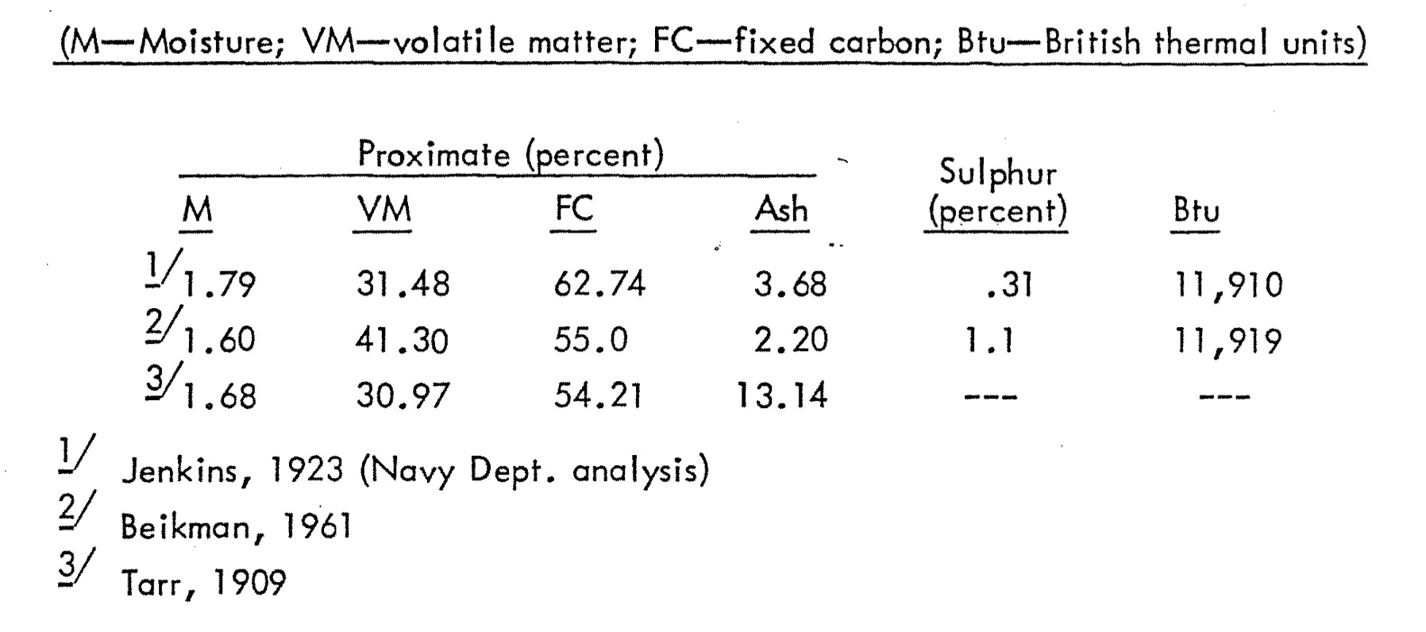
Source: https://dnr.wa.gov/sites/default/files/2025-04/ger_ofr75-9_coal_whatcom_co_62k.pdf

Table 16: Chemical Composition of Subbituminous Coal⁴²
