ChemE 486 - Process Design II
Report #1: Motivation and Background on Sustainable Feedstock and Product
Team A - Apple
Conversion of Apple Pomace to Ethanol via Fermentation
Alpha Arestun, Mark Heien, Angelina Pamatian, Lorrie Welch
Department of Chemical Engineering, University of Washington
April 17, 2026
Prepared to follow the rubric's hourglass model: Gas Works Park and coal gasification -> sustainable feedstock motivation -> Team Apple's specific ethanol pathway.

Executive framing. This report starts broad with the fossil-fuel and site history of Gas Works Park, then narrows to Team Apple’s assigned pathway: using Washington apple pomace as a sustainable feedstock for ethanol production by fermentation. The goal is to show not only that the chemistry is plausible, but that the feedstock-product pairing is strong on regional relevance, circular-economy logic, and retrofit motivation.
1. Introduction and History of Gas Works Park and Coal Gasification
Seattle’s Gas Works Park is the broad end of this project’s hourglass. The site began as a manufactured-gas plant in 1906 on the north shore of Lake Union. It supplied Seattle with gas until 1956, first through coal gasification and later through oil-based gas manufacture. After the plant shut down, the City of Seattle began acquiring the property in 1962, and the park that emerged from the cleanup and redesign opened to the public in the mid-1970s. That history matters because our design problem starts from a real industrial site with a real fossil-fuel legacy, real contamination, and real evidence of how process technology can shape a city for better and for worse.^{1,2}
In process-design terms, the historical plant took a carbon-rich feed, converted it into a usable fuel gas, cleaned it enough for distribution, and managed the unwanted side streams as best the era allowed. The Seattle facility originally used coal delivered by rail, as reflected by the surviving concrete trestles that once discharged coal into hoppers on site. The plant later shifted toward crude oil when oil became cheaper than coal in 1937, and by the postwar period the site had become strongly associated with odors, fumes, and heavily polluted soil.^{1,2} That industrial sequence - feed handling, thermal conversion, gas cleanup, storage, and byproduct management - is the pattern our team is now re-examining through a sustainability lens.
Manufactured gas, or “town gas,” was a combustible mixture used for lighting, heating, and industrial energy service before pipeline natural gas became widely available. In gasification language, the important reactants are a carbonaceous solid feed such as coal, plus steam and a limited supply of oxygen or air. The target products are carbon monoxide and hydrogen, usually grouped as synthesis gas or syngas, with methane and carbon dioxide often present as well. The undesirable outputs include ash or slag, sulfur-bearing compounds, particulates, tars, wastewater, and contaminated solids that must be managed somewhere in the system.^{1,6}
Coal gasification itself is a partial-oxidation process rather than full combustion. Instead of burning coal completely to carbon dioxide and water, the process reacts coal with steam and a controlled, sub-stoichiometric oxygen supply at high temperature to form a combustible intermediate gas. NETL describes gasification as a flexible platform for converting solid fuels such as coal into syngas that can be routed to power generation or to higher-value products such as hydrogen, liquid fuels, ammonia, and fertilizer.⁶ A modern coal-gasification plant typically includes coal preparation, oxygen or air supply, the gasifier itself, raw-gas cooling, particulate and sulfur removal, and then downstream conversion or energy use. The core reactions include combustion to supply heat, the water-gas reaction, the Boudouard reaction, and the water-gas shift:
C + O₂ -> CO₂
C + H₂O -> CO + H₂
C + CO₂ -> 2CO
CO + H₂O -> CO₂ + H₂
That chemistry shows why gasification was historically attractive: it turns a solid fossil feed into a much more versatile process intermediate. It also shows why the retrofit challenge is substantial. Team Apple is not merely changing a feedstock. We are changing the dominant chemistry, reaction conditions, and process philosophy of the site.⁶
2. Motivation for Sustainable Feedstocks
Coal still attracts industrial interest for one simple reason: it is carbon dense and well understood. EIA describes coal as a sedimentary rock with high carbon and hydrocarbon content that formed from ancient plant matter under pressure and heat over millions of years. That same description also explains why coal is fundamentally misaligned with a sustainability-first design project: it is nonrenewable on any human timescale.³ The feedstock is finite, geographically extracted, and tied to long supply chains rather than a renewable annual production cycle.
The downsides of coal as a feedstock are environmental, economic, and strategic. Environmentally, coal mining disturbs land, affects water quality, and can release methane. Coal use also produces large carbon dioxide emissions and other pollutants. EIA notes that coal remains relatively inexpensive to produce and convert to useful energy, but it also states plainly that producing and using coal affects the environment.⁴ Those effects are not theoretical. Gas Works Park itself became a local reminder of how an industrially valuable plant can leave behind oil-soaked soils, tar, cinders, ash, carbon black, and a long remediation burden.¹
From an economic standpoint, the coal story is no longer just “cheap feedstock in, useful energy out.” The real cost picture includes fuel price, emissions controls, solids handling, wastewater treatment, and long-term cleanup liability. EIA’s Annual Coal Report for 2024 lists an average sales price of $86.72 per short ton for bituminous coal and $37.85 per short ton for thermal coal.⁵ Those prices are not catastrophic by themselves, but they are only one layer of the problem. A coal-to-syngas system also requires high-temperature materials, oxygen or air delivery, gas cleanup, and some plan for carbon emissions. In other words, coal does not arrive alone. It arrives with a whole process burden attached.
The syngas question is slightly more nuanced. Syngas is not inherently bad; in fact, it is one of the most versatile intermediates in industrial chemical engineering. The issue is the source of the carbon and the cleanup burden required to make that syngas usable. Coal-derived syngas is valuable, but it carries with it fossil carbon, sulfur and trace contaminant removal requirements, high thermal severity, and strong pressure to add carbon capture if a future-facing plant is supposed to remain credible. That combination narrows the economic window quickly.^{4,6} For a class project centered on sustainable transformation, coal is useful as a baseline and historical reference, but it is not persuasive as the end point.
That is why the project needs a different feedstock logic. We need something renewable, locally available, underused, and chemically convertible. Ideally, it should also help solve a waste problem instead of creating one. Apple pomace checks those boxes well. It shifts the design frame from extractive fossil carbon to circular biogenic carbon, and that shift is exactly where Team Apple’s project becomes interesting.
Table 1. Coal versus apple pomace as feedstocks for the Team Apple design problem.
Criterion | Coal | Apple pomace | Why it matters here
Origin | Fossil carbon formed over millions of years | Annual agricultural byproduct from apple processing | Sets up the core renewable-vs-fossil contrast
Typical process fit | High-temperature thermochemical conversion | Biochemical conversion after sugar release | Explains why the retrofit changes process philosophy, not just feed input
Key liabilities | CO₂ emissions, pollutants, cleanup burden, ash/tar legacy | High moisture, seasonality, variability, storage issues | Coal's burden is climate and cleanup; pomace's burden is handling and conditioning
Regional relevance | Not a signature Washington agricultural product | Directly tied to Washington's apple economy | Strengthens the case for a local circular-economy retrofit
Main opportunity | Mature conversion history | Waste valorization into a market-ready fuel and chemical | Supports the Team Apple motivation section

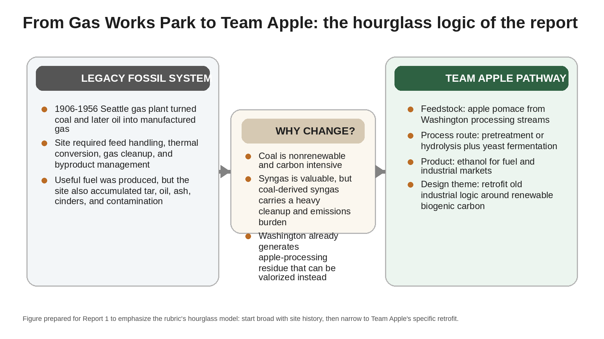
Figure 1. Custom hourglass schematic linking Gas Works Park history, the motivation for changing feedstocks, and Team Apple’s apple-pomace-to-ethanol pathway.
3. Introduction to Apple Pomace as a Sustainable Feedstock
Apple pomace is the solid and semi-solid residue left after apples are pressed for juice, cider, concentrate, or other processed products. It typically contains peel, pulp, seeds, stems, free sugars, cellulose, hemicellulose, pectin, and lignin.^{7,8} Depending on the processing line, pomace can represent roughly a quarter to a third of the incoming apple mass, and because it leaves the press wet, sticky, and biologically active, it can quickly become a disposal problem instead of an asset.⁷
For Team Apple, the Washington connection is a major strength. The U.S. Apple Association’s 2025 outlook projected Washington as the nation’s top producer with more than 190 million bushels valued at nearly $2.3 billion.⁹ The Northwest Horticultural Council reports that 29.3% of the 2024/25 Washington apple crop was exported, and the Washington State Department of Agriculture reports apples as a top state food-and-agriculture export worth $845 million in 2024.^{10,11} That scale matters. It means the feedstock is not a niche laboratory curiosity. It is tied to one of Washington’s largest agricultural systems.
Compared with coal, apple pomace offers a much stronger sustainability case. It is renewable on an annual timescale, it is a byproduct of an existing food industry, and using it does not require separate land, fertilizer, or irrigation solely to make fuel feedstock. Just as important, the apples are not being grown primarily for ethanol. The ethanol route recovers value from residue left after the food-processing value has already been captured.^{7,8}
Apple pomace also has real process-level advantages. Reviews describe it as a chemically rich biomass containing both readily available sugars and lignocellulosic fractions that can be converted to additional fermentable sugars after pretreatment and hydrolysis.^{7,8} That means it is not just a waste stream - it is a mixed biochemical resource. It can support ethanol production, pectin extraction, antioxidant recovery, biogas generation, and other integrated uses.
This feedstock is not frictionless. Apple pomace is wet, seasonal, compositionally variable, and expensive to haul long distances without stabilization. Its moisture content is often high enough to make transport and storage awkward, and its composition changes with variety, processing method, and harvest conditions.^{7,8} So the honest answer is that apple pomace is better than coal for the goals of this assignment, but it replaces a fossil-carbon problem with a feed-handling and biochemical-conversion problem. That is still a trade worth making, especially because the new problem is more compatible with circular manufacturing and regional agriculture.
That combination - renewable origin, local relevance, waste-diversion value, and demonstrated chemical utility - is why apple pomace qualifies as a sustainable feedstock for Team Apple. It is already used or studied for multiple chemical-production routes, and the literature now clearly treats it as a legitimate biorefinery feed rather than as mere refuse.^{7,8}
4. Introduction to the Product: Ethanol
The assigned product for Team Apple is ethanol, a smart first target. Ethanol is a familiar molecule, a high-volume commodity, and a product with multiple established uses. The Department of Energy’s Alternative Fuels Data Center notes that ethanol has a higher octane number than gasoline and is routinely blended into lower-octane gasoline to reach the standard 87-octane fuel sold as E10.¹² In the United States, ethanol is already embedded in the transportation fuel system rather than sitting off to the side as a specialty product.
Current demand is substantial. EIA reports that as of January 1, 2025, the United States had 191 fuel-ethanol plants with a combined production capacity of 18,477 million gallons per year.¹³ That one figure answers a large part of the market-size question by itself: ethanol is already a national-scale product with mature logistics, blending infrastructure, and sustained demand. It also means Team Apple is not proposing a product that needs a brand-new market to exist. The market is already there.
The uses of ethanol extend beyond gasoline blending. Ethanol is also used as an industrial solvent, disinfectant, and chemical intermediate, and it can serve as a precursor to products such as ethylene, acetaldehyde, and acetic acid.¹² That breadth helps the economics, because it gives the product more than one potential outlet. It also fits the assignment well. A retrofit project aimed at a realistic industrial future should ideally target something with multiple uses, not a molecule that only works under one narrow market scenario.
How is ethanol typically produced today? In the United States, the dominant route is fermentation of first-generation feedstocks such as corn, followed by distillation and dehydration.^{12,13} That route is well established, but it is not the cleanest sustainability story available. First-generation ethanol continues to raise questions about land use, fertilizer inputs, and the food-versus-fuel debate. By contrast, ethanol made from apple pomace is a second-generation or waste-derived route. It does not depend on planting a crop primarily to make fuel, and it uses carbon already moving through Washington’s food-processing economy.^{7,8}
There is also a practical market argument in Washington. The Washington Department of Ecology states that the state’s Clean Fuel Standard is designed to reduce the carbon intensity of transportation fuels, stimulate low-carbon fuel production, and push fuel suppliers toward lower-carbon blending and production choices.¹⁴ Ethanol is already part of that conversation. A locally sourced, lower-carbon ethanol pathway tied to an agricultural byproduct could therefore fit both a state policy signal and a regional feedstock base.
For an order-of-magnitude product-price snapshot, Nebraska’s state energy data reported an average ethanol rack price of $1.99 per gallon in March 2026.¹⁵ That is not a universal netback price and it should not be treated as a full techno-economic result, but it is useful for framing the product as a real traded commodity. In other words, ethanol is attractive here because it is familiar, big enough to matter, and established enough to make the retrofit discussion credible from day one.
5. Introduction to the Fermentation Process Method
Team Apple’s assigned process route is fermentation, and that assignment fits the feedstock well. Fermentation uses microorganisms to convert sugars into ethanol and carbon dioxide under relatively mild conditions. The core stoichiometry is simple and recognizable:
C₆H₁₂O₆ -> 2C₂H₅OH + 2CO₂
For glucose, the theoretical maximum yield is 0.511 g ethanol per g glucose, although practical yields are lower because some substrate is diverted to cell maintenance and growth.¹⁶ That equation is familiar, but the real design challenge lies upstream of it: apple pomace is not pure glucose. It is a mixed biomass that includes free sugars and structural carbohydrates, so the process must be built to make those sugars accessible before fermentation can do its job.
This is where the state of the art matters. Magyar et al. showed that apple pomace can be converted to ethanol at industrially relevant conditions, reporting about 134 g ethanol per kg of dry apple pomace and ethanol concentrations around 53 g/L under high-solids processing conditions.¹⁶ Parmar and Vasantha Rupasinghe demonstrated that enzyme-assisted hydrolysis followed by fermentation can increase sugar release and improve ethanol production from pomace.¹⁷ More recently, Ma et al. reported that subcritical-water pretreatment coupled with hydrolysis and fed-batch semi-simultaneous saccharification and fermentation produced ethanol titers up to 66.40 g/L.¹⁸ The literature is saying something pretty clear here: apple pomace to ethanol is no longer just conceptually possible. It is already a technically credible conversion route with multiple viable pretreatment strategies.
Is the process catalytic? Yes, but not in the way a fossil-fuel catalytic reactor would be. The key catalytic agents are biological and biochemical: enzymes such as cellulases, pectinases, and beta-glucosidases are used to release fermentable sugars, and the actual fermentation is typically carried out by yeast, most often Saccharomyces cerevisiae.¹⁶⁻¹⁸ This distinction matters because it changes the hardware, safety profile, and utilities picture. Instead of high-temperature refractory gasifiers and sulfur cleanup trains, Team Apple is looking toward hydrolysis, fermentation vessels, distillation, and liquid/solid handling.
Typical processing conditions are dramatically milder than coal gasification conditions. Enzymatic hydrolysis is often carried out near 40 °C in mildly acidic solution, while fermentation commonly runs near 30 °C and around atmospheric pressure.^{16,17} Even the more aggressive pretreatment approaches in the literature are modest when compared with gasification. Ma et al., for example, used subcritical-water pretreatment around 180 °C for 10 min before downstream biochemical conversion.¹⁸ That is serious processing, but it is still nowhere near the thermal severity or gas-cleanup burden of a coal-gasification system.
The chemistry can also be described in process sequence. First, polymeric carbohydrates such as cellulose, often represented as (C₆H₁₀O₅)ₙ, are hydrolyzed to monomeric sugars such as glucose. Second, glucose is fermented to ethanol and carbon dioxide. In structural terms, the target product is CH₃CH₂OH. The coproduct CO₂ leaves with the gas phase, while residual solids and liquid side streams remain available for further treatment or valorization.^{8,16,19} That is one of the strongest reasons fermentation suits apple pomace so well: it can be built into a broader biorefinery logic rather than forcing every carbon atom into a single product stream.
Recent integrated analyses reinforce that point. Rebolledo-Leiva et al. modeled an apple-pomace biorefinery that combined ethanol production with vinasse treatment and biogas generation, showing that integrated coproduct handling improved environmental performance.¹⁹ That pushes Team Apple toward a bigger design mindset: not simply “Can pomace ferment?” but “How should the whole process be organized so the feedstock is used well?” That is exactly the right kind of question for this course.
Table 2. Representative literature on converting apple pomace to ethanol.
Reference | Approach | Representative conditions | Design takeaway
Magyar et al. (2016) | Enzymatic hydrolysis and fermentation at industrially relevant solids loading | Up to ~53 g/L ethanol; ~134 g ethanol/kg dry pomace | Apple pomace can support technically credible ethanol titers under process-relevant conditions
Parmar and Rupasinghe (2013) | Enzyme-assisted hydrolysis plus yeast fermentation | Hydrolysis near 40 C, pH 4.0; fermentation with S. cerevisiae | Sugar-release strategy strongly affects downstream ethanol performance
Ma et al. (2024) | Subcritical-water pretreatment plus fed-batch semi-simultaneous saccharification and fermentation | Pretreatment about 180 C for 10 min; ethanol up to 66.40 g/L | Pretreatment choice can materially raise titer and improve whole-feed utilization
Rebolledo-Leiva et al. (2024) | Integrated biorefinery with ethanol plus residual-stream valorization | Conceptual plant-scale analysis including vinasse management and biogas | Coproduct handling matters; the best design may not be ethanol-only

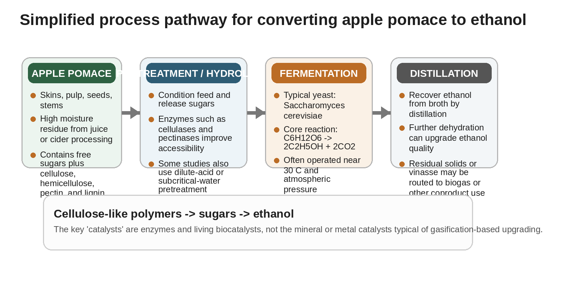
Figure 2. Custom simplified process pathway for apple pomace to ethanol by fermentation.
6. Problem Statement
In our own words, the objective of this project is to take the logic of an old fossil-fuel conversion site and move it toward something that makes sense for a lower-carbon future. For Team Apple, that means designing a retrofit pathway in which a plant originally framed around coal gasification is reimagined to process apple pomace and produce ethanol by fermentation. The deeper point is not just to swap one feed for another. It is to test whether existing industrial logic - utilities, site infrastructure, material flow, and regional supply chains - can be redirected from fossil carbon toward renewable carbon.
Why retrofit an existing plant instead of pretending we are building on a blank piece of land? Because retrofits force better engineering questions. They require us to think about what can be reused, what cannot, what a brownfield site offers, and where the old process creates friction for the new one. Martinkus and Wolcott argue that repurposing existing industrial facilities can reduce startup and infrastructure burdens, though the benefit depends strongly on what assets are already in place and how compatible they are with the new technology.²⁰ Seider et al. make the same point more broadly in design terms: process design is iterative, economically aware, and shaped by existing constraints, not just ideal chemistry on paper.²¹
There are real benefits to updating a plant rather than starting from zero. Existing industrial land may already have utility access, transportation links, storage areas, and a history of process use. Reusing those elements can reduce duplication of infrastructure and help make a project more credible. There is also a symbolic benefit: instead of allowing fossil-era industrial logic to end as contamination and obsolescence, the retrofit concept tries to turn that legacy into a bridge toward circular manufacturing.^{1,14,20}
At the same time, the challenges are not small. A coal-gasification plant is built around dry or slurry feed handling, hot conversion, raw-gas cleanup, and often pressurized systems. A fermentation plant needs hydrolysis, biological reactors, liquid handling, separations, and careful control of water and residence time. The temperature regime changes. The phase behavior changes. The materials issues change. The site may also carry legacy contamination that complicates redevelopment. And the feedstock itself is variable, seasonal, and wet, which means storage and preprocessing are not side notes - they are core design issues.^{1,7,8}
That is the design problem Team Apple will carry forward this quarter. We are not simply making a case that apple pomace is “greener.” We are making the harder argument that a local agricultural residue can justify a serious chemical-engineering retrofit pathway, one that produces a useful modern product and improves the carbon logic of the plant at the same time. Put bluntly, the historical plant turned fossil carbon into city gas. Our job is to show that a smarter version of that industrial instinct can turn Washington apple waste into ethanol instead.
References
1. Ott, Jennifer Gas Works Park (Seattle); HistoryLink, 2020. https://www.historylink.org/File/20978 (accessed 2026-04-14).
2. Seattle Parks and Recreation; Patano Studio Architecture; Harrison Design Gas Works Park Comfort Station and East Entry: Landmarks Presentation; City of Seattle, 2017. https://www.seattle.gov/documents/Departments/ParksAndRecreation/Projects/Gas%20Works/Presentation-Landmarks_June2017.pdf (accessed 2026-04-14).
3. U.S. Energy Information Administration Coal Explained; EIA, n.d.. https://www.eia.gov/energyexplained/coal/ (accessed 2026-04-14).
4. U.S. Energy Information Administration Coal and the Environment; EIA, n.d.. https://www.eia.gov/energyexplained/coal/coal-and-the-environment.php (accessed 2026-04-14).
5. U.S. Energy Information Administration Annual Coal Report 2024; EIA, 2025. https://www.eia.gov/coal/annual/pdf/acr.pdf (accessed 2026-04-14).
6. National Energy Technology Laboratory Gasification Systems; U.S. Department of Energy, n.d.. https://netl.doe.gov/carbon-management/gasification (accessed 2026-04-14).
7. Gołębiewska, E.; Kalinowska, M.; Yildiz, G. Sustainable Use of Apple Pomace (AP) in Different Industrial Sectors. Materials 2022, 15 (5), 1788. https://doi.org/10.3390/ma15051788
8. Costa, J. M.; Ampese, L. C.; Ziero, H. D. D.; Sganzerla, W. G.; Forster-Carneiro, T. Apple Pomace Biorefinery: Integrated Approaches for the Production of Bioenergy, Biochemicals, and Value-Added Products - An Updated Review. Journal of Environmental Chemical Engineering 2022, 10, 108358. https://doi.org/10.1016/j.jece.2022.108358
9. U.S. Apple Association Industry Outlook 2025; U.S. Apple Association, 2025. https://usaa.memberclicks.net/assets/Industry%20Outlook%202025%20FINAL.pdf (accessed 2026-04-14).
10. Northwest Horticultural Council Apple Fact Sheet; Northwest Horticultural Council, 2025. https://nwhort.org/industry-facts/apple-fact-sheet/ (accessed 2026-04-14).
11. Washington State Department of Agriculture Export Statistics; Washington State Department of Agriculture, 2025. https://agr.wa.gov/departments/business-and-marketing-support/international/statistics (accessed 2026-04-14).
12. U.S. Department of Energy, Alternative Fuels Data Center Ethanol Fuel Basics; AFDC, n.d.. https://afdc.energy.gov/fuels/ethanol-fuel-basics (accessed 2026-04-14).
13. U.S. Energy Information Administration U.S. Fuel Ethanol Plant Production Capacity; EIA, 2025. https://www.eia.gov/petroleum/ethanolcapacity/ (accessed 2026-04-14).
14. Washington State Department of Ecology Clean Fuel Standard; Washington State Department of Ecology, 2026. https://ecology.wa.gov/air-climate/reducing-greenhouse-gas-emissions/clean-fuel-standard (accessed 2026-04-14).
15. Nebraska Department of Water, Energy, and Environment Ethanol and Unleaded Gasoline Average Rack Prices; State of Nebraska, 2026. https://dwee.nebraska.gov/state-energy-information/energy-statistics/fuels/ethanol/ethanol-and-unleaded-gasoline-average-rack-prices (accessed 2026-04-14).
16. Magyar, M.; da Costa Sousa, L.; Jin, M.; Sarks, C.; Balan, V. Conversion of Apple Pomace Waste to Ethanol at Industrial Relevant Conditions. Applied Microbiology and Biotechnology 2016, 100 (16), 7349-7358. https://doi.org/10.1007/s00253-016-7665-7
17. Parmar, I.; Vasantha Rupasinghe, H. P. Bio-Conversion of Apple Pomace into Ethanol and Acetic Acid: Enzymatic Hydrolysis and Fermentation. Bioresource Technology 2013, 130, 613-620. https://doi.org/10.1016/j.biortech.2012.12.084
18. Ma, X.; Ma, Y.; Zhang, L.; Lü, J.; Ma, S.; Lei, J.; Wang, Y.; Liu, M.; Lü, X.; Wang, X. Subcritical Water Pretreatment of De-Pectin Apple Pomace for Ethanol Conversion and Whole Components Utilization. Industrial Crops and Products 2024, 216, 118720. https://doi.org/10.1016/j.indcrop.2024.118720
19. Rebolledo-Leiva, R.; Estévez, S.; Hernández, D.; Feijoo, G.; Moreira, M. T.; González-García, S. Apple Pomace Integrated Biorefinery for Biofuels Production: A Techno-Economic and Environmental Sustainability Analysis. Resources 2024, 13 (11), 156. https://doi.org/10.3390/resources13110156
20. Martinkus, N.; Wolcott, M. A Framework for Quantitatively Assessing the Repurpose Potential of Existing Industrial Facilities as a Biorefinery. Biofuels, Bioproducts and Biorefining 2017, 11 (2), 295-306. https://doi.org/10.1002/bbb.1742
21. Seider, W. D.; Lewin, D. R.; Seader, J. D.; Widagdo, S.; Gani, R.; Ng, K. M. Product and Process Design Principles: Synthesis, Analysis, and Design, 4th; Wiley: Hoboken, NJ, 2017.

