Aspen Plus V14 Build Guide
Pre-1937 Seattle Gas Works Coal Gasifier
Step-by-step click-through with annotated screenshots from Lab 4 and Lab 5

This guide walks you through building a coal-gasification model in Aspen Plus V14 on the UW College of Engineering Virtual Desktop (COE-VDI). Screenshots are pulled directly from Dr. Rorrer's Lab 4 (Nonconventional Feedstock) and Lab 5 (Reactors in Aspen) decks, with red arrows added at the spots that trip students up most often. Steps that don't have a screenshot in the Labs are described in text with the exact menu path in monospace.
Target product: 170,000 Nm³/day city gas at 0 °C and 1 atm (~7,083 Nm³/h, ~316 kmol/h). Target composition: H₂ 50, CO 40, CO₂ 5, CH₄ 3, N₂ 2 (mol %). The model uses the COAL → RYIELD → RGIBBS → cooler/flash → SEP cleanup architecture from Section 6.2 of your working package.
Prerequisites
- UW COE-VDI access via Horizon Client (preferred) or web browser. URL: https://www.engr.washington.edu/mycoe/computing/studentresources/coevdi.html
- Aspen Plus V14 installed on the VDI image (verify by opening the Start Menu)
- Your design basis numbers handy: coal 7,100 kg/h, steam 6,250 kg/h at 184 °C / 10.3 bar, gasifier 1,050 °C / 1.1 bar
- Roughly 1.5 to 3 hours for a first build, including debugging
Save your work every five minutes (Ctrl+S). VDI sessions occasionally drop and you do not want to redo this.

Step 1. Create a new simulation
Open Aspen Plus V14 from the Start Menu. On the start screen, you'll see the New / Open / Save panel on the left and template tiles in the center.
Click on Chemicals with Metric Units. This template auto-populates global units to °C, bar, kg/hr, kmol/hr, Gcal/hr — exactly what your closure calculations are based on.
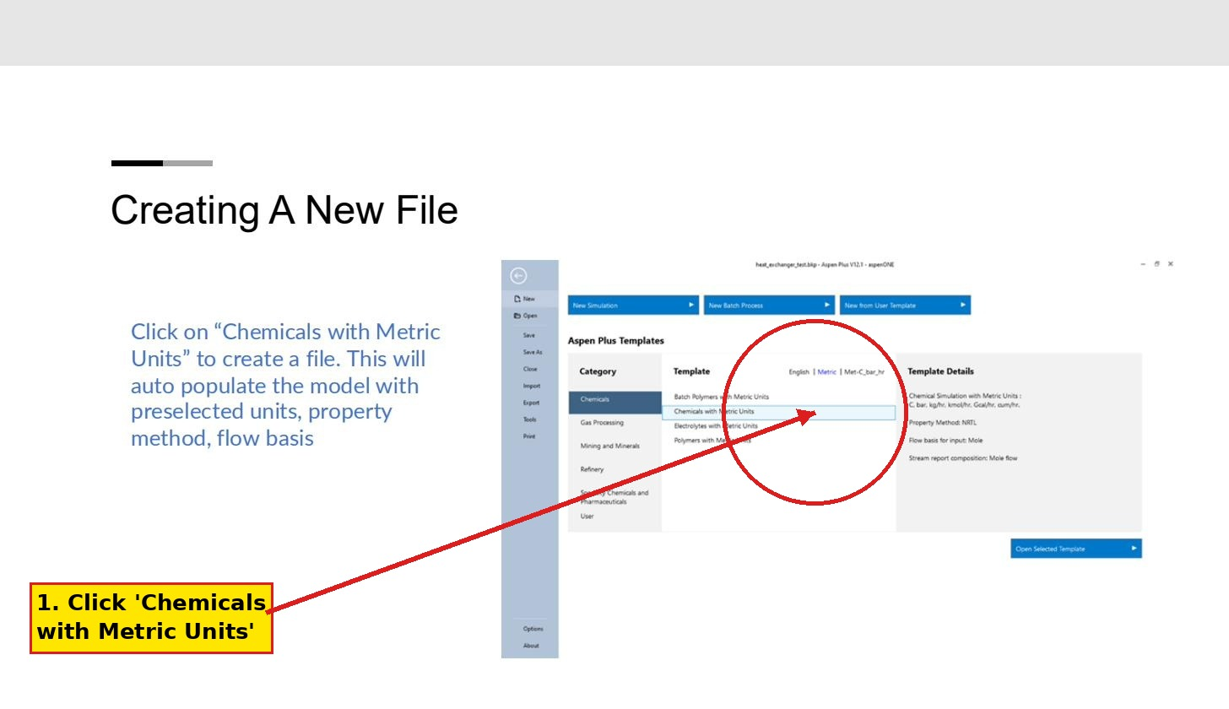
Step 1 — start screen with the correct template highlighted.
Click Open Selected Template at the bottom right. You'll land in the Properties environment with an empty Components list.
Save immediately as GasWorks_Baseline.bkp (File → Save As). The .bkp extension is the human-readable backup format; .apw is the binary working file. Save as both if you want a portable copy.

Step 2. Add components
Navigate to Properties → Components → Specifications (left navigation tree).
In the Component ID column, type COAL and press Tab. The Type column will show a dropdown — click it and select Nonconventional. This is the key click; if you leave it as Conventional, none of the coal property models will work later.
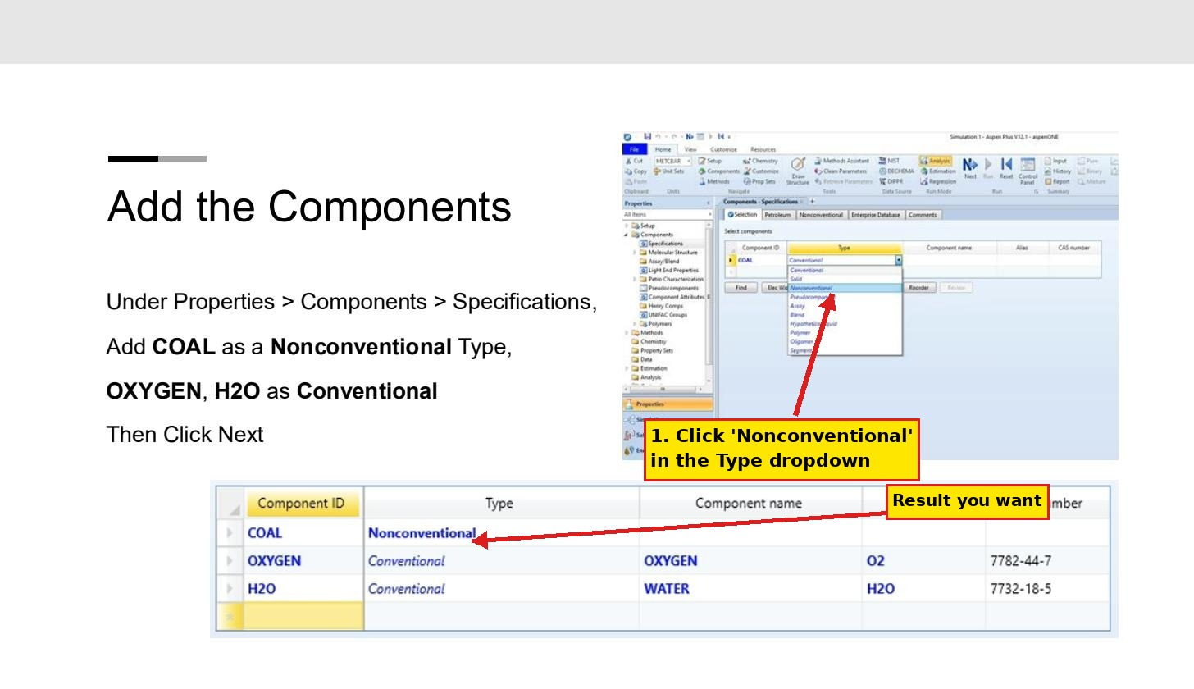
Step 2 — components list. Set COAL as Nonconventional.
Add the rest of the components. Type the Component ID exactly as listed; Aspen will fill in the Component name and Alias automatically when it recognizes a CAS-database species:
COAL Nonconventional
ASH Nonconventional
C Solid
H2 Conventional
CO Conventional
CO2 Conventional
CH4 Conventional
H2O Conventional
O2 Conventional
N2 Conventional
H2S Conventional
NH3 Conventional
GOTCHA: If you accidentally hit Enter inside the Type cell instead of clicking the dropdown, Aspen will leave it as Conventional. Double-click the Type cell to open the dropdown again.

Step 3. Set property methods
Go to Properties → Methods → Specifications. On the Global tab, set Method filter to COMMON and Base method to PR-BM. PR-BM (Peng-Robinson Boston-Mathias) handles the high-temperature gas phase well and is the standard choice for gasification.
For the nonconventional COAL component, you need to assign two property models. Navigate to Properties → Methods → NC Props. Pick COAL in the Component dropdown, then in the lower table set:
Enthalpy: HCOALGEN
Density: DCOALIGT
Repeat for ASH (it should also use HCOALGEN / DCOALIGT or the simpler defaults).
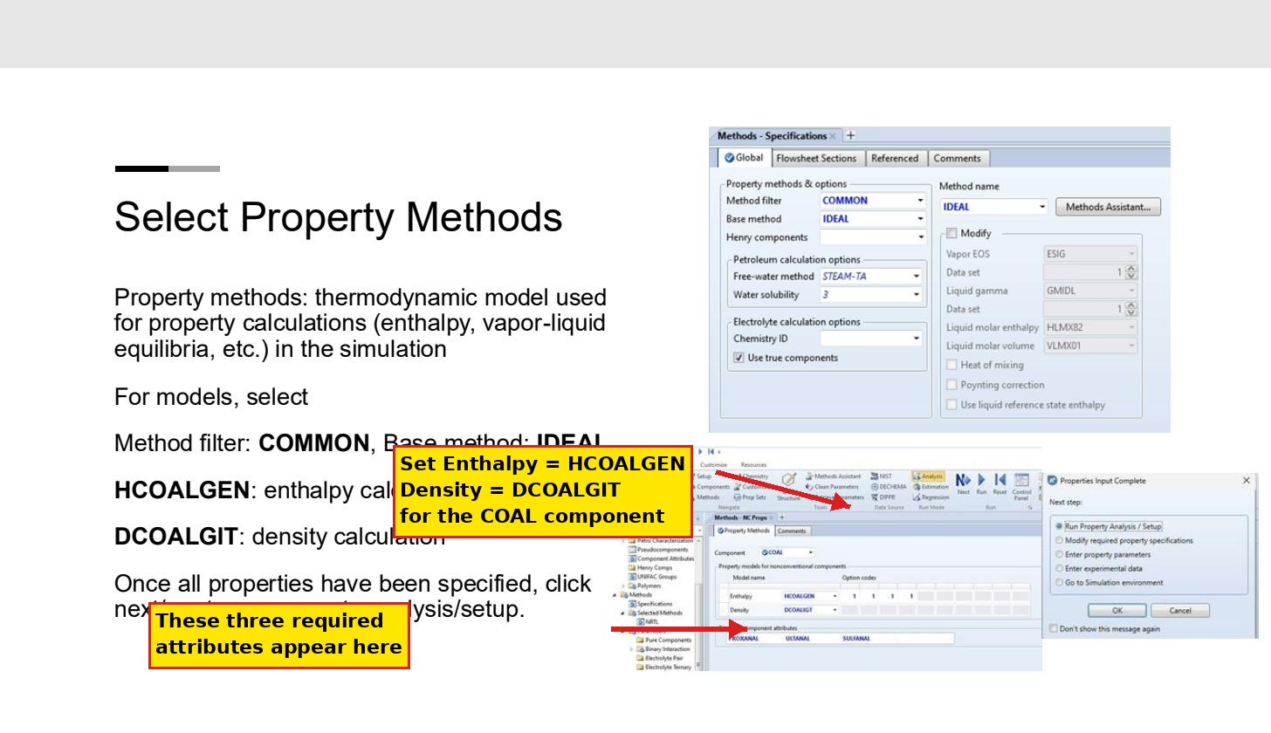
Step 3 — global property method on the left, NC component-specific models on the right. The "Required component attributes" row at the bottom (PROXANAL, ULTANAL, SULFANAL) is where Aspen tells you which attribute sets to populate next.
Click Run Property Analysis / Setup when the dialog pops up. It will tell you which component attributes are still missing — that is your cue for Step 4.

Step 4. Set the stream class to MIXCINC
Switch to the Simulation environment (button at the bottom-left of the navigation tree). Then go to Setup → Specifications → Global tab.
Find Stream class in the Global settings panel. Change it from CONVEN to MIXCINC. While you're there, change Flow basis to Mass.
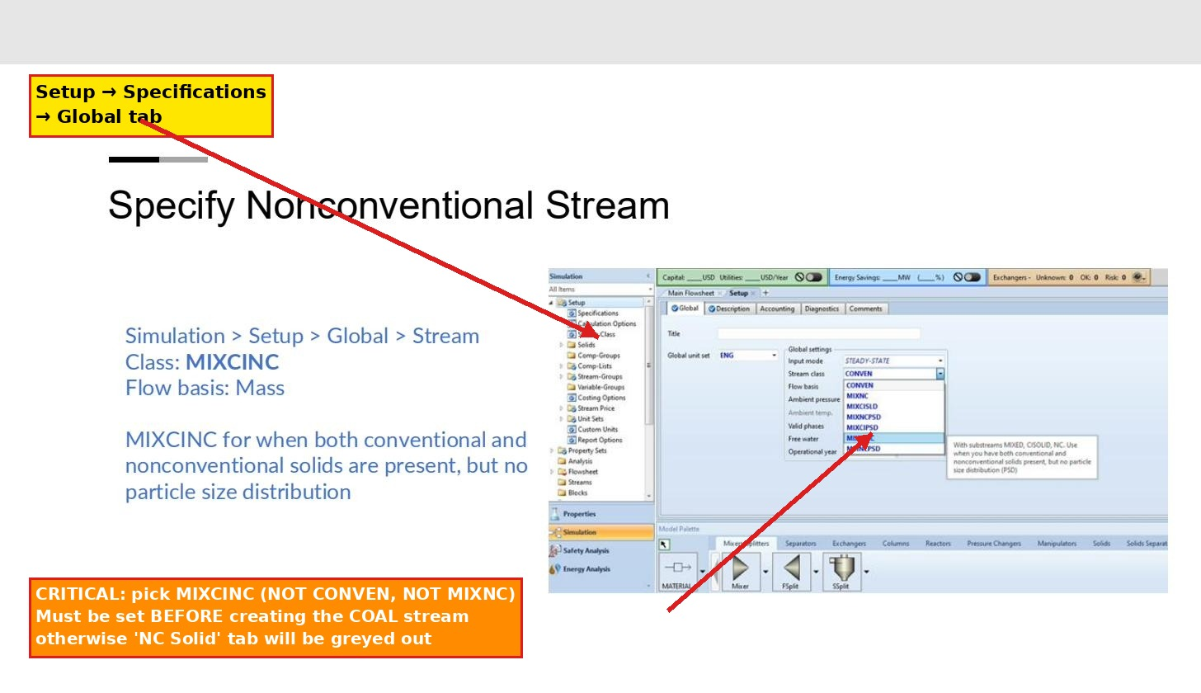
Step 4 — stream class dropdown. MIXCINC is the option you want for combined conventional + nonconventional solids.
GOTCHA: This step must come BEFORE you create any feed streams. If you set up the COAL stream first and THEN come back here, the NC Solid tab on the COAL stream will have been created as Mixed-only and you'll have to delete and recreate it.
MIXCINC stands for Mixed + Conventional Inert + Nonconventional. Use it whenever both conventional gas/liquid species and nonconventional solids are present, but you don't need particle-size distribution tracking. MIXNCPSD is the version with PSD; you don't need that for this report.

Step 5. Enter the coal characterization (PROXANAL, ULTANAL, SULFANAL)
Navigate to Properties → Components → Component Attributes. Pick COAL from the Component ID dropdown, then in the Attribute ID dropdown select PROXANAL. Enter values, then switch the Attribute ID to ULTANAL and enter those, then SULFANAL.
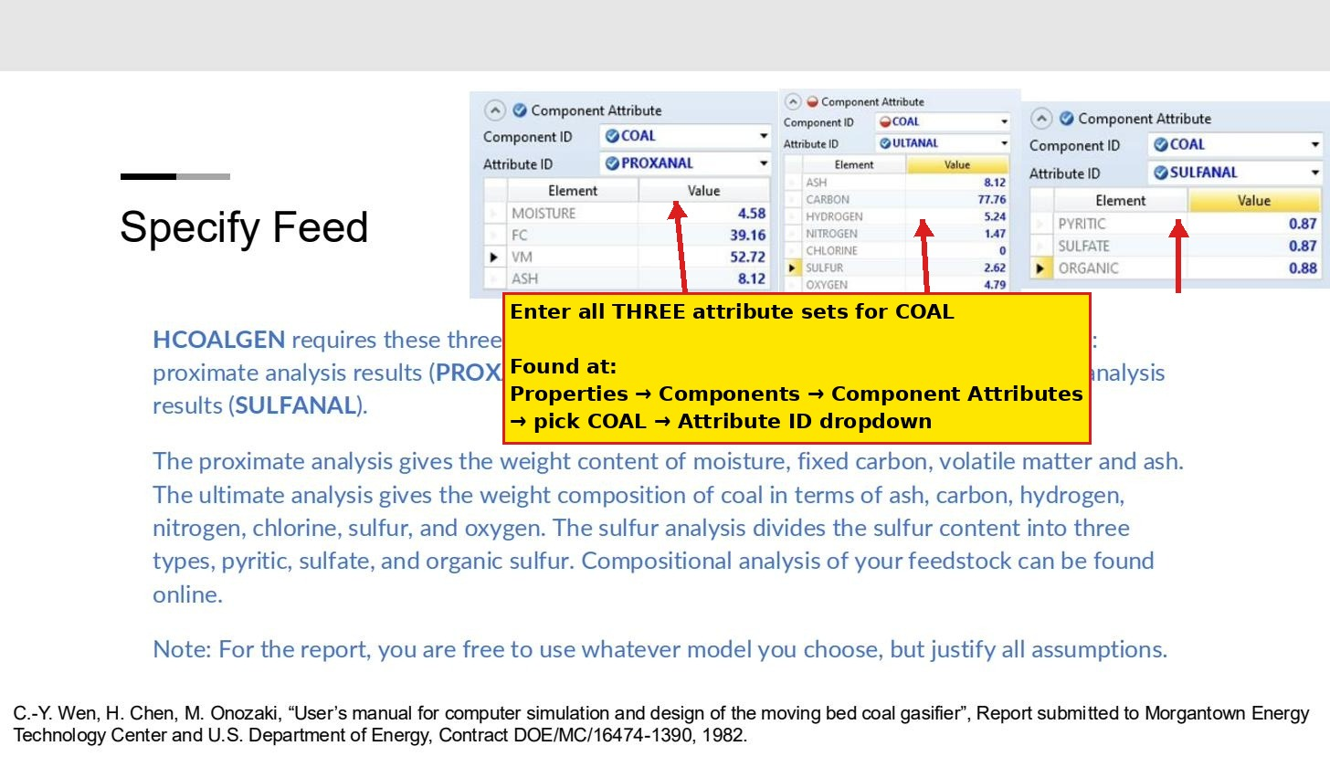
Step 5 — three attribute panels you must populate for COAL. The example values are from the Wen et al. moving-bed gasifier reference and are shown here for layout; replace with your own design-basis numbers below.
Use the Renton/Newcastle sub-bituminous coal numbers from your Base_Assumptions sheet:
PROXANAL (wt %, as-received) | ULTANAL (wt %, dry)
Moisture: 20  FC: 37  VM: 33  Ash: 10 | Ash: 10  Carbon: 65.7  Hydrogen: 5.0  Nitrogen: 1.1  Chlorine: 0.05  Sulfur: 0.4  Oxygen: 17.75
SULFANAL splits the 0.4 wt % sulfur three ways: Pyritic 33, Sulfate 33, Organic 34 (each as % of total S).
GOTCHA: PROXANAL must sum to 100. ULTANAL ash must equal PROXANAL ash. If they don't match, Aspen accepts the input but the property analysis fails silently with an unhelpful error like 'Property analysis convergence failed' on Run.

Step 6. Run property analysis
Click the blue Next arrow at the top, or use Run → Property Analysis. You should see a green check on every component. If any component shows red, fix the issue (usually a missing attribute or a typo in the ULTANAL / PROXANAL totals) before proceeding.
When the dialog asks 'What's next?', choose Go to Simulation environment.

Step 7. Add the reactor blocks
In the Simulation environment, you'll see the Main Flowsheet workspace and the Model Palette at the bottom. Click the Reactors tab on the palette.
Drag these blocks onto the flowsheet, in this layout (left to right):
- RYIELD — name it R-101 (decomposes COAL into elemental species)
- Mixer (under Mixers/Splitters) — name it M-101 (combines decomposed coal with steam)
- RGIBBS — name it R-201 (the gasifier)
- Heater (under Exchangers) — name it E-201 (cools raw gas to 40 °C)
- Flash2 (under Separators) — name it V-301 (knocks out water/tar)
- Sep (under Separators) — name it SEP-301 (final H₂S/NH₃/tar cleanup)
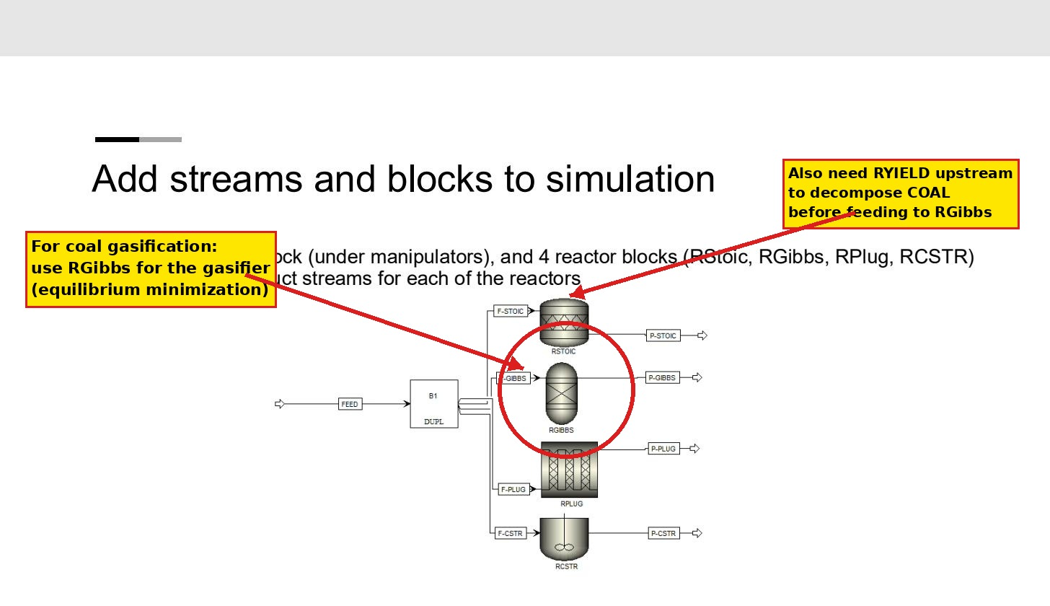
Step 7 — Lab 5 example showing where the reactor blocks live in the palette. RGibbs is the second one from top in the example. You only need RYIELD + RGIBBS for your gasifier; the others are for the cleanup train.
To rename a block, right-click it on the flowsheet and choose Rename Block. To connect blocks, click the Material stream icon on the palette (small arrow in the Streams area) and click on the source block's outlet port, then on the target block's inlet port. Aspen highlights valid ports in red as you hover.

Step 8. Configure feed streams
You need three feeds: COAL (S-COAL), STEAM (S-STEAM), and optionally AIR (S-AIR for blow-phase trim). Click each stream on the flowsheet to open its specification dialog.
This is the place that trips people up most: the COAL stream specs go on the NC Solid tab, not the Mixed tab. Steam and air go on the Mixed tab.
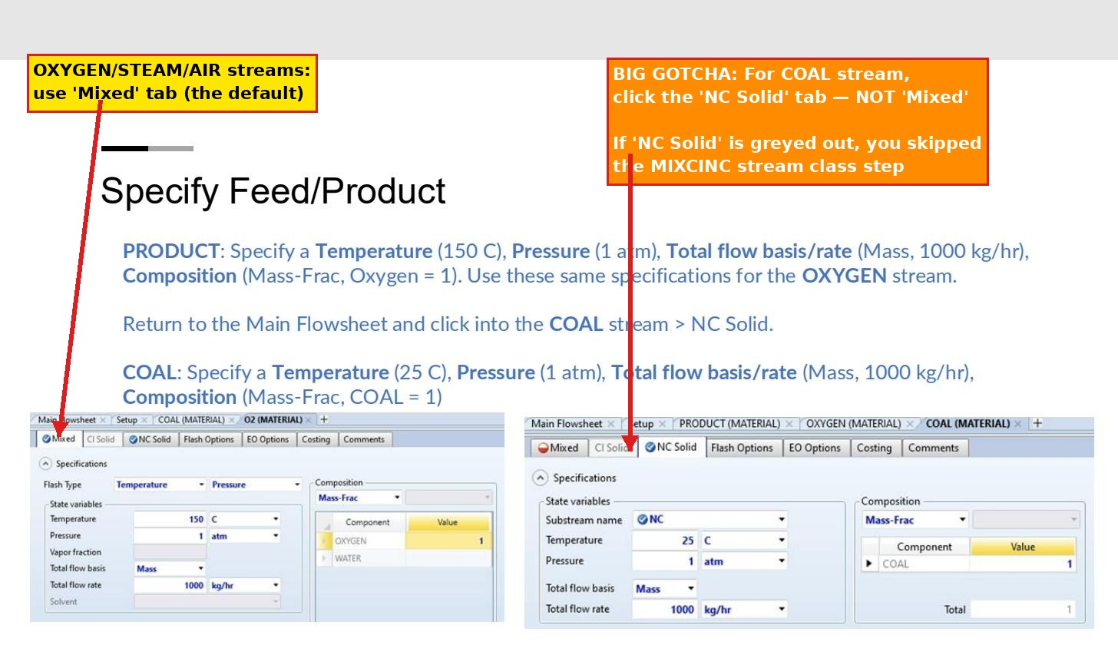
Step 8 — left panel shows OXYGEN on the Mixed tab; right panel shows COAL on the NC Solid tab. Tab strip is at the top of each stream's specification window.
For the COAL stream (NC Solid tab):
Substream: NC
Temperature: 25 °C
Pressure: 1.013 bar
Total flow: Mass, 7100 kg/hr
Composition: Mass-Frac, COAL = 1
For the STEAM stream (Mixed tab):
Temperature: 184 °C
Pressure: 10.3 bar
Total flow: Mass, 6250 kg/hr
Composition: Mass-Frac, H2O = 1
If you also use a small AIR stream for trim:
Temperature: 25 °C
Pressure: 1.013 bar
Total flow: Mass, 3500 kg/hr (or smaller, treat as a tuning knob)
Composition: Mass-Frac, O2 = 0.232, N2 = 0.768
GOTCHA: If the NC Solid tab on the COAL stream is greyed out, you skipped Step 4 (MIXCINC stream class). Go back, fix it, then delete and recreate the COAL stream — Aspen does not re-tab existing streams when you change the global stream class.

Step 9. Configure RYIELD (R-101)
Click R-101 → Specifications. Set:
Operating conditions:
Temperature: 25 °C
Pressure: 1 atm
Yield specifications (Component yields per kg COAL feed):
ASH 0.10
H2O 0.20
C 0.591
H2 0.040
N2 0.0088
O2 0.142
S 0.0034 (or distribute to H2S if you have S species)
These yields are derived from your ULTANAL composition on a dry basis, with the moisture released as water. For a self-consistent model, attach a Calculator block (Flowsheeting Options → Calculator) that reads the COAL stream's ULTANAL attribute and computes yields automatically — but for a first pass, hard-coded values are fine.
R-101 just decomposes the coal into elemental species at ambient conditions; the actual reaction heat is handled by R-201 (RGIBBS).

Step 10. Configure RGIBBS (R-201) — the gasifier
This is the most important block in the model. Click R-201 to open its specification panel.
On the Specifications tab:
Calculation option: Calculate phase equilibrium and chemical equilibrium
Pressure: 1.1 bar
Temperature: 1050 °C
Phases: Vapor only (uncheck solid solutions)
Then click the Products tab — this is the step students miss.
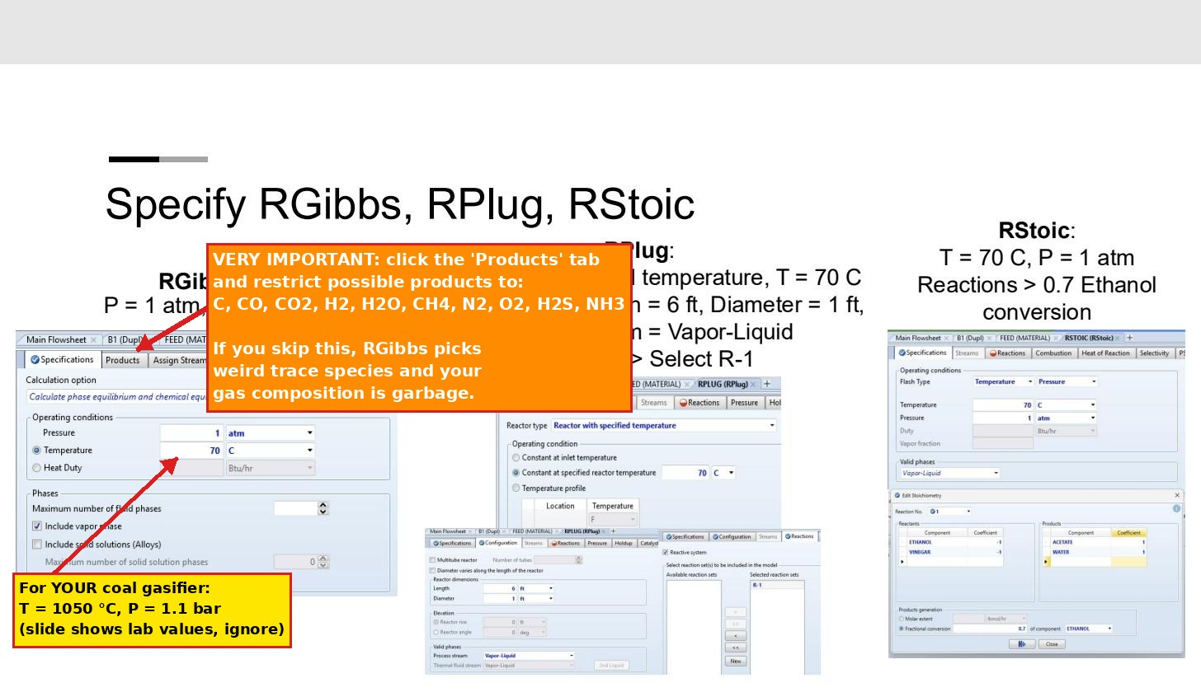
Step 10 — RGIBBS panel on the left. The Products tab next to Specifications is where you restrict the equilibrium product set. The Lab 5 slide shows a 70 °C / 1 atm example; ignore those numbers — your gasifier runs at 1050 °C / 1.1 bar.
On the Products tab, change the dropdown to Identify possible products and add this list:
C, CO, CO2, H2, H2O, CH4, N2, O2, H2S, NH3
Then click the Inerts tab and add ASH so it doesn't try to react.
GOTCHA: If you skip the Products restriction, RGIBBS will minimize Gibbs free energy across every species in your component list and pick weird trace species (like methanol, formic acid, or formaldehyde) that have no business being there. Your H₂/CO ratio will be wrong by 20 to 40 % and your closure will look terrible. Always restrict products.
Connect a Mixer (M-101) before R-201 if you haven't already, with S-DECOMP (R-101 outlet) and S-STEAM both feeding in. M-101 just combines streams at 1 atm — no spec needed beyond default.

Step 11. Configure E-201 (Heater) and V-301 (Flash2)
E-201 cools the raw gas from 1050 °C to 40 °C, knocking most of the steam back to liquid water and condensing tar. Click E-201:
Specification: Temperature, Pressure
Temperature: 40 °C
Pressure: 1.05 bar (small pressure drop)
Valid phases: Vapor-Liquid
V-301 is a flash drum that physically separates the cooled stream into vapor (raw gas going forward) and liquid (water + dissolved NH₃ + condensed light tar). Click V-301:
Flash Type: Temperature, Pressure
Temperature: 40 °C
Pressure: 1.05 bar
Valid phases: Vapor-Liquid
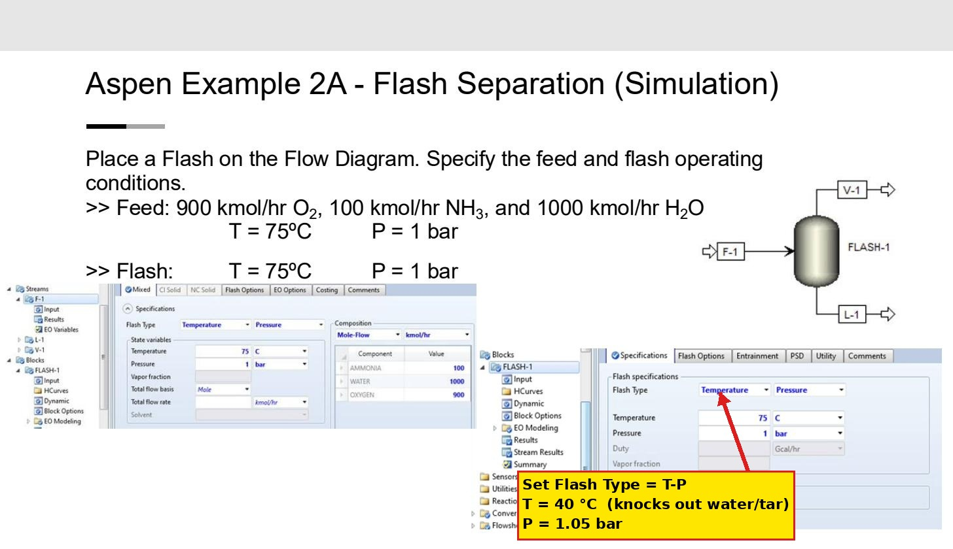
Step 11 — flash specifications panel. Notice it takes T-P spec; T = 40 °C is what condenses water out.

Step 12. Configure SEP-301 (final cleanup)
SEP is a generic separator that lets you specify component-by-component split fractions to outlets. Connect V-301's vapor outlet to SEP-301's inlet. Add two outlet streams: S-PRODUCT (clean city gas) and S-CONTAM (waste).
Click SEP-301 → Specifications and set the split fractions to S-CONTAM:
Component Split fraction to S-CONTAM
H2S 0.99 (FeOx drybox is highly effective)
NH3 0.95 (residual ammonia after liquor scrubbing)
H2O 0.05 (residual moisture)
H2 0.00 (keep all in product)
CO 0.00
CO2 0.00
CH4 0.00
N2 0.00
Anything not in the table defaults to 0 split (fully retained in product), which is what you want.

Step 13. Add the production-target Design Spec
This step makes the model hit your 170,000 Nm³/day target. Navigate to Flowsheeting Options → Design Spec → New, give it a name (e.g., GAS_TARGET).
On the Define tab, create a sampled variable:
Type: Stream-Var
Stream: S-PRODUCT
Variable: STDVOL-FLOW
Units: cum/day (this is m³/day at standard conditions)
On the Spec tab:
Spec: (the variable you defined)
Target: 170000
Tolerance: 1700 (1 % tolerance)
On the Vary tab:
Type: Stream-Var
Stream: S-STEAM
Variable: MASS-FLOW
Lower: 4000
Upper: 9000
GOTCHA: Aspen's STDVOL is referenced to 60 °F / 1 atm by default. Your design basis is 0 °C / 1 atm. You may need to adjust the Aspen reference conditions (Setup → Report Options → Stream → Standard conditions) or convert the target. 170,000 Nm³/day at 0 °C ≈ 169,250 m³/day at 60 °F. Close enough that the 1 % tolerance will catch either.

Step 14. Run the simulation
Use the convergence ladder — don't try to run the whole flowsheet at once. Build up:
- Disable everything except R-101. Run. Verify S-DECOMP composition matches your yields.
- Enable M-101 and R-201. Run. Verify raw gas H₂/CO ratio is reasonable (1.0–1.5 for a steam-only gasifier).
- Enable E-201 and V-301. Run. Verify most of the water condenses out.
- Enable SEP-301. Run. Verify product gas composition.
- Enable the Design Spec last. Run. Steam flow should converge to a value between 5,000 and 7,500 kg/h.
To enable/disable a block, right-click it on the flowsheet and toggle Active. Reset the simulation between runs (Run → Reset) to clear any cached results that might cause spurious convergence behavior.
The status bar at the bottom shows convergence: Results Available with a green check is what you want. Yellow check means it converged but with warnings (read them — usually about minor mass imbalances in trace components). Red X means failure; the Control Panel (View → Control Panel) shows the error log.

Step 15. Export results
After a successful run, navigate to Results Summary → Streams in the left tree. Right-click anywhere on the table and choose Display Options to set Material > All. Then File → Export → Excel.
Open the Excel file and copy the Material columns (Mass Flow, Molar Flow, Mass Fraction, Temperature, Pressure, Vapor Frac, Enthalpy Flow) into the Stream_Table_Template tab of your workbook. The Mass_Energy_Closure tab will recalculate automatically.
Also export screenshots for your appendix (per Lecture 8 — minimum: PFD + stream tables; recommended: also components, property methods, COAL attributes, RGIBBS spec, Run Status):
- File → Export → Image (or use the Snipping Tool / Win+Shift+S) for the flowsheet
- Screenshots of the Components, Methods, Component Attributes, and RGIBBS specification windows
- The final Run Status bar showing Results Available

Validation checklist
After your model runs, check these targets against the workbook. Acceptable tolerance is in the rightmost column.
Quantity | Workbook target | Tolerance
S-PRODUCT mass flow | 4,883 kg/h | ±5 %
S-PRODUCT molar flow | 316 kmol/h | ±5 %
S-PRODUCT MW | 15.45 kg/kmol | ±2 %
H₂ in product | 50 mol % | ±5 pp
CO in product | 40 mol % | ±5 pp
Gasifier T | 1050 °C | fixed
Gasifier P | 1.1 bar | fixed
Cold-gas efficiency | 66 % | 60–70 %
Mass closure | 0.87 % | <2 %
Energy closure | ~0 % | <5 %
Production | 170,000 Nm³/day | ±5 %

Common errors and fixes
Error | Fix
"NC Solid tab is greyed out" | Set Stream Class to MIXCINC in Setup → Specifications → Global before creating the COAL stream. If you already created it, delete and recreate.
"PROXANAL/ULTANAL inconsistent" property analysis error | Check that PROXANAL sums to 100 wt % and that ULTANAL ash equals PROXANAL ash. They have to match exactly.
RGIBBS picks weird species (HCN, CH₃OH, formaldehyde, etc.) | On the Products tab of R-201, change to "Identify possible products" and list only: C, CO, CO2, H2, H2O, CH4, N2, O2, H2S, NH3.
All the steam stays vapor in V-301 | Outlet temperature is too high. Make sure V-301 Flash Type = T-P and T = 40 °C. Check Valid Phases is Vapor-Liquid, not Vapor-Only.
Production rate is off by a factor of ~10 | Aspen STDVOL default is 60 °F, your spec is 0 °C. Either adjust the target or change Setup → Report Options → Stream → Std cond.
Negative or unreasonably large enthalpy on COAL stream | HCOALGEN not assigned to COAL. Properties → Methods → NC Props → set Enthalpy = HCOALGEN per component, not just globally.
Design Spec does not converge | Widen the Vary bounds (e.g., 3000 to 12000 kg/h on steam). Loosen the tolerance to 2 %. If still failing, run open-loop first to confirm the target is achievable.
"DCOALIGT requires component attributes" error | Coal density model is asking for PROXANAL/ULTANAL/SULFANAL. You skipped Step 5 — go back to Components → Component Attributes and fill them in.

If you hit something not in this list, the Aspen Control Panel (View → Control Panel) shows the full error log. Errors usually point to the specific block; check that block's Specifications and Streams tabs for unfilled fields (red asterisks).

