Process Model of the Pre-1937 Seattle Gas Works Coal Gasification Plant
(Lake Station Baseline for Apple-Pomace-to-Ethanol Retrofit)

Mark Heien
CHEME 486 Process Design II — Spring 2026
Professor Dr. Julie Rorrer
Department of Chemical Engineering
University of Washington

May 1, 2026

Self-Reflection

This assignment taught me that the hardest part of a process model is often not Aspen itself. Instead, it defines a defensible design basis before opening the software. I had to decide on the historical operating era, the standard gas basis, the model boundary, and how to represent a cyclical water-gas machine in a steady state calculation. Once those decisions were locked, the steam table and mass balance became much more coherent. The most challenging Aspen step was the non-conventional coal workflow. I had to use COAL as a non-conventional solid, enter proximate, ultimate, and sulfur analyses, decompose the coal with RYIELD, and then send only conventional components to RGIBBS. The photos from my Aspen Plus V14 build were useful. They forced me to align the written report with what I actually built: a core gasifier model using 7,100 kg/h coal, 9,000 kg/h steam, a MIXCINC stream class, PR-BM properties, HCOALGEN/DCOALIGT non-conventional property models, and an RGIBBS block at about 1050 °C and 1.1 bar. I corrected the report to make that boundary explicit. I wanted to avoid overstating the Aspen model as a full cleanup-train simulation.
The information that was hardest to find was plant-specific yield data for the Seattle Gas Works retorts, coke ovens, tar recovery, ammonia liquor, and dry-box purifier wastes. The F.H. 6545 appraisal provided the strongest historical equipment basis. However, it did not include all the yields needed for a modern stream table. Higman and van der Burgt were the most useful for gasification chemistry and steady-state assumptions. Murphy et al. were the most useful for manufactured-gas residuals such as tar, ammoniacal liquor, and spent purifier material. The apple-pomace papers became important mainly for explaining the reason this coal baseline is relevant to Report #3.
A short class example on Aspen non-conventional solids, especially using RYIELD to RGIBBS, would have saved me several hours. I used Excel for balance checks. I used draw.io and Python for diagrams. Zotero helped me prepare ACS-style references. Editing support also improved clarity and steadiness. Overall, the biggest lesson was that Aspen is not a black box. It is an accounting system for assumptions, and weak assumptions show up quickly in the stream table.

Table of Contents
1. Process Motivation and Introduction
2. Design Basis, Scope, and Major Assumptions
3. Process Description, Reaction Chemistry, and Thermodynamics
4. Block Flow Diagram
5. Process Flow Diagram and Aspen Plus V14 Model
6. Stream Tables and Mass/Energy Balances
7. Major Equipment Specification and Sizing
8. Bridge to Report #3: Apple-Pomace-to-Ethanol Retrofit
9. References
Appendix A. Aspen Plus V14 Build Record from Uploaded Photos
Appendix B. Rubric Crosswalk and Assumption Audit

Table of Figures
Figure 1. Block flow diagram of the pre-1937 coal-gas baseline.
Figure 2. Process flow diagram of the Aspen Plus V14 core model with cleanup allocation.
Figure A1. Aspen Plus V14 stream-results screenshot verifying the gasifier-core stream basis.
Figure A2. Contact sheet of Aspen Plus V14 build/process photos, part 1.
Figure A3. Contact sheet of Aspen Plus V14 build/process photos, part 2.

Table of Tables
Table 1. Product design basis and target conversion.
Table 2. Coal characterization and non-conventional Aspen input basis.
Table 3. Gasification reactions and standard enthalpies.
Table 4. Main stream table and property basis.
Table 5a. Gas-phase and water pseudo-component allocation used for mass closure.
Table 5b. Solid, liquid, and contaminant pseudo-component allocation used for mass closure.
Table 6. Mass-balance closure summary.
Table 7. Energy-balance closure summary.
Table 8. Major equipment inventory and sizing basis.
Table B1. Rubric crosswalk.

1. Process Motivation and Introduction

The purpose of this report is to build a defensible process model of the coal-gasification baseline that existed before any renewable-feedstock retrofit is applied to the Seattle Gas Works concept. The CHEME 486 Report #2 assignment requires either coal/steam or oil gasification. There is a target of 170,000 m³/day of city gas, a working Aspen model for part or all of the plant, specified major equipment, utilities, and fuel streams, and mass and energy balances that close to within 2% and 5%, respectively.
I selected the pre-1937 Lake Station coal-gas era rather than the later oil-gas era because it is the best match for the coal gasification assignment and because the historical record provides a stronger basis for retorts, coke ovens, water-gas machines, gas holders, and a cleanup unit.
The baseline model is necessary because Report #3 will replace the coal-fed front end with an apple pomace-to-ethanol process. Without a quantified baseline, the retrofit cannot be judged on equal footing with respect to material intensity, energy demand, waste generation, equipment reuse, or environmental benefit. The baseline, therefore, functions as the engineering anchor: it defines what must be displaced, reused, or intentionally abandoned in the future retrofit.
City gas is represented as a low-heating-value manufactured gas. It is dominated by H₂, CO, and CO₂, with minor CH₄ and N₂ retained because historical coal gas and water gas were not pure ternary mixtures. At the assigned production rate, 170,000 Nm³/day equals 7,083 Nm³/h or 316.0 kmol/h at 0 °C and 1 atm. The selected design composition is 50 mol% H₂, 40 mol% CO, 5 mol% CO₂, 3 mol% CH₄, and 2 mol% N₂. This gives an average molecular weight of 15.45 kg/kmol and a product mass rate of 4,884 kg/h.⁴

Table 1. Product design basis and target conversion.

Item | Value | Units | Use in the report
City gas production target | 170,000 | Nm³/day at 0°C, 1 atm | Assignment design target
Hourly Standard Volume | 7,083 | Nm³/h | Aspen design-spec basis
Molar flow target | 316.0 | kmol/h | S-401 city gas target
Selected dry-gas composition | 50 H₂ / 40 CO / 5 CO₂ / 3 CH₄ / 2 N₂ | mol% | City-gas specification
Average molecular weight | 15.45 | kg/kmol | Product mass calculation
City-gas mass rate | 4,884 | kg/h | Mass balance product stream
City-gas HHV basis | 12 | MJ/Nm³ | Energy-balance basis

2. Design Basis, Scope, and Major Assumptions

2.1 Historical plant basis
The modeled plant is a historically inspired Lake Station coal-gas plant, not a literal reconstruction of every pipe and valve. The assignment explicitly allows the design to be inspired by the Seattle Gas Works while encouraging the model to closely resemble the real plant. The F.H. 6545 appraisal, Seattle Gas Company records, the 1908 site survey, the landmark report, and the HistoryLink/Eggers site histories were used to anchor unit counts and historical background. ^{2,9,10,20,21}
The major historical operations represented are coal receiving, steam boiler generation, horizontal retorting and coke production, cyclic water-gas generation, raw-gas cooling, tar and ammoniacal liquor separation, ammonia washing and scrubbing, tar-mist removal, light-oil recovery, iron-oxide dry purification, and gas-holder storage. This unit list is consistent with manufactured-gas-plant residuals documented in environmental forensic literature.³ These residuals include tar and tar sludge, ammoniacal liquor, and spent purifier waste.

2.2 Aspen model boundary
The uploaded Aspen Plus V14 photos show the gasifier-core model: non-conventional COAL is decomposed in RYIELD, mixed with steam, and sent to an RGIBBS equilibrium reactor. The stream-results screenshot verifies the core basis: 7,100 kg/h coal, 9,000 kg/h steam, a mixed feed of 16,100, and a raw-gas outlet of 16,100 kg/h at 1050 °C and 1.1 bar. This revised report treats the Aspen model as a core gasifier model. The downstream cleanup train is represented by historically justified separator allocations and is included in the BFD/PFD and mass table.

This boundary choice matters. It avoids claiming that the uploaded Aspen file fully solves aqueous scrubbing, tar decanting, H₂S removal, and gas-holder dynamics. The photograph of the model primarily documents the non-conventional coal-to-RGIBBS sequence. This boundary also remains acceptable for the assignment because the report requires a working Aspen model for part or all of the plant. The assignment allows hand calculations or other software for sections not modeled in Aspen.¹

2.3 Coal, water, air, and product assumptions
Coal is represented as an as-received Renton/Newcastle-area sub-bituminous coal. Water is assumed to be Lake Union water but is treated as pure H₂O for process calculations. Steam is saturated vapor at 10.3 bar and 184 °C. Air appears in the BFD for the cyclic blow phase. The main material balance in this report terminates at the steam/coal run-phase gasification and cleanup boundary. The blow-phase vent is reported as a separate utility and combustion boundary.
Table 2. Coal characterization and Aspen Plus V14 non-conventional component input basis. Values entered directly into S-COAL stream attributes; consistent with Washington sub-bituminous coal survey data.

Property | Value | Basis | Aspen attribute | Comment
Moisture | 20.0 wt% | As-received | PROXANAL | Sub-bituminous characteristic
Volatile matter | 33.0 wt% | As-received | PROXANAL | Drives yield split in R-101
Fixed carbon | 37.0 wt% | As-received | PROXANAL | Primary reactive carbon
Ash | 10.0 wt% | As-received | PROXANAL | Exits as inert C (CISOLID)
Carbon | 65.7 wt% | As-received | ULTANAL | Main gasification element
Hydrogen | 5.0 wt% | As-received | ULTANAL | Water-gas reaction contributor
Nitrogen | 1.1 wt% | As-received | ULTANAL | Trace N₂ in product gas
Chlorine | 0.05 wt% | As-received | ULTANAL | Minor impurity
Sulfur | 0.4 wt% | As-received | ULTANAL/SULFANAL | H₂S basis for FeOx purifier
Oxygen | 17.75 wt% | As-received | ULTANAL | By difference
Pyritic S | 0.13 wt% | As-received | SULFANAL | Sulfur form distribution
Sulfate S | 0.13 wt% | As-received | SULFANAL | Sulfur form distribution
Organic S | 0.14 wt% | As-received | SULFANAL | Sulfur form distribution

3. Process Description, Reaction Chemistry, and Thermodynamics
3.1 Unit-by-unit process description
Coal arrives by rail/ferry at the Lake Station coal yard and is modeled as 7,100 kg/h of as-received coal. The coal is modeled as Renton/Newcastle sub-bituminous coal. Proximate and ultimate analyses are given in Table 2. Historically, coal would be split among retorts, coke ovens, producer-gas service, and water-gas machines. For the report calculation, parallel historical operations are consolidated into a single equivalent coal-fed water-gas core to maintain a clear, traceable Aspen mass balance.
Lake Union water is heated in the boiler plant to 9,000 kg/h saturated steam at 10.3 bar and 184 °C. In Aspen, this steam enters the mixer with the RYIELD coal-decomposition products. The resulting mixed stream is sent to the RGIBBS water-gas reactor.¹³
In the cyclic water-gas generator, the blow phase combusts carbon with air to reheat the bed, while the run phase passes steam through hot carbon to produce H₂- and CO-rich gas. The steady-state Aspen model represents this cyclic operation as a time-averaged run-phase equilibrium calculation, which is a reasonable conceptual simplification for a design-stage process model.
The raw gas is cooled and cleaned through a historically consistent train: primary cooling/condensation, tar decanting, ammonia washing, tar mist and electrostatic removal, light-oil recovery, iron-oxide dry purification, gas-holder storage, and distribution. The cleanup train is needed not only for product quality, but also because manufactured-gas plants produced persistent residuals, including tar, ammoniacal liquor, spent oxide, sulfur compounds, and cyanide-bearing wastes.³

3.2 Reaction chemistry and thermodynamics
The assignment-specified coal-gasification reactions are shown in Table 3, with the standard enthalpy of reaction calculated from standard heats of formation at 25 °C.⁴ RGIBBS does not require the user to enter these stoichiometric reactions directly; however, they define the chemistry that must be physically represented by the equilibrium product list and by the interpretation of the Aspen results.

Table 3. Gasification reactions and standard enthalpies are used to check the Aspen chemistry
.
 | Reaction | ΔH°298 (kJ per reaction as written) | Thermal role | Modeling interpretation
R1 | 2 C(s) + O₂ → 2 CO | −221 | Exothermic | Producer/blow-phase gas formation
R2 | C(s) + H₂O(g) ⇌ CO + H₂ | +131 | Endothermic | Primary water-gas reaction
R3 | C(s) + 2 H₂O(g) ⇌ CO₂ + 2 H₂ | +90 | Endothermic | Steam-carbon plus shift combination
R4 | CO + H₂O(g) ⇌ CO₂ + H₂ | −41 | Exothermic | Water-gas-shift redistribution
R5 | 3 H₂ + CO ⇌ CH₄ + H₂O(g) | −206 | Exothermic | Methane side reaction
R6 | C(s) + CO₂ ⇌ 2 CO | +172 | Endothermic | Boudouard side reaction, included for equilibrium sanity check
At high temperature, R2 and R6 (both endothermic) are thermodynamically favored, which explains why my Aspen results showed CO-rich gas before steam increased.

3.3 Aspen Plus V14 implementation
The Aspen build used Chemicals with Metric Units template, the MIXCINC stream class, PR-BM for high-temperature gas properties, HCOALGEN for coal enthalpy, and DCOALIGT for non-conventional coal density. The components include non-conventional COAL and conventional C, H₂, CO, CO₂, H₂O, CH₄, O₂, N₂, H₂S, and NH₃. The RGIBBS product list is deliberately restricted to chemically defensible species so that Aspen does not generate trace products that are mathematically possible but physically irrelevant for this historical design basis.
The photos from the Aspen Plus 14 builds show a working gasifier sequence rather than just a conceptual sketch. In the revised report, those photos are used as audit evidence: the stream table now corresponds to the photographed inputs of 7,100 kg/h coal and 9,000 kg/h steam, and the process narrative distinguishes Aspen-computed gasifier-core quantities from hand-allocated cleanup streams.

4. Block Flow Diagram

Block Flow Diagram — Pre-1937 Seattle Gas Works Coal Gasification Plant (Lake Station)

Production target: 170,000 Nm³/day city gas at 0 °C, 1 atm
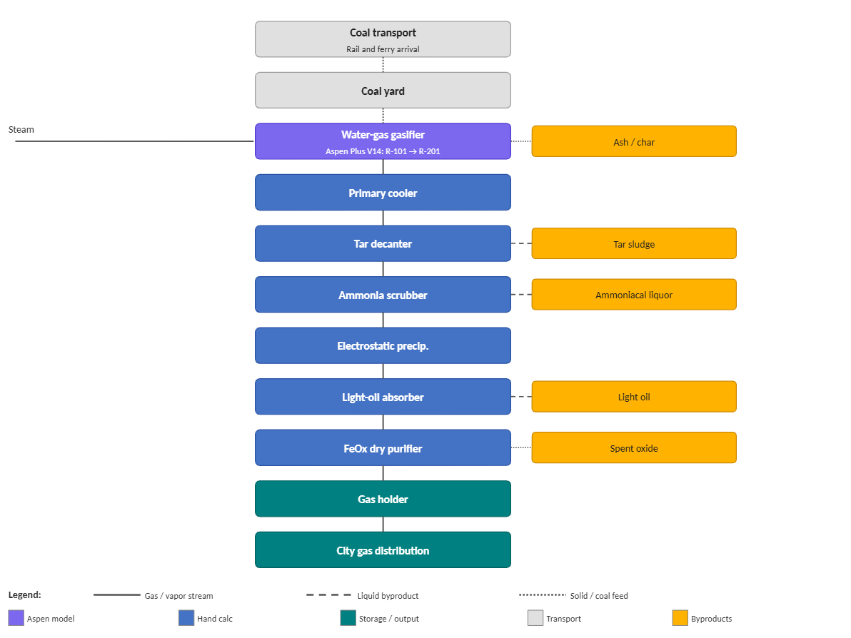

5. Process Flow Diagram and Aspen Plus V14 Model
Figure 2 translates the BFD into a process-flow diagram. The first four blocks are directly supported by the Aspen screenshots: RYIELD decomposition, steam mixing, RGIBBS equilibrium gasification, and raw-gas stream results. The downstream blocks are shown as separator analogs because they are necessary for the Report #2 stream table and the historical process description, even though the uploaded Aspen photos do not demonstrate a complete electrolyte/tar cleanup model.

Figure 2. Aspen Plus V14 process flow diagram for the coal gasification model core. Equilibrium
composition and mass balance reflect Design Spec GAS-RATE converged results.

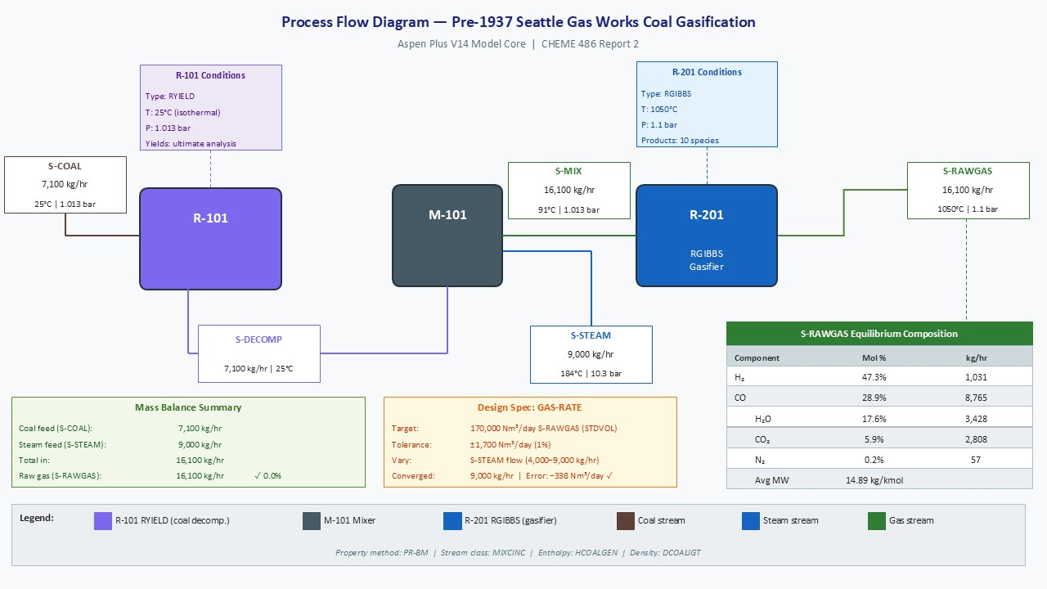

6. Stream Tables and Mass/Energy Balances

6.1 How to read the stream tables
Stream numbers follow the BFD/PFD convention: S-1xx are feed and utility streams, S-2xx is high-temperature raw gas, S-3xx are cleanup byproducts, S-4xx are product/solid outlets, and S-5xx is the separate blow-phase vent. The “source” column distinguishes Aspen-supported values, design-basis calculations, and cleanup allocations. Enthalpy/energy terms are reported on an HHV plus sensible-enthalpy basis because Aspen stream enthalpies for coal depend strongly on the reference state of the non-conventional model.

Table 4. Main stream table and property basis for the pre-1937 coal-gas baseline.

Stream | Description | Phase/class | Mass kg/h | Molar kmol/h | MW kg/kmol | T °C | P bar | Quality/VF | Energy term GJ/h | Source
S-101 | Rail/ferry coal to Lake Station yard | NC solid | 7,100 | — | — | 25 | 1.0 | solid | 142.0 | historical/de-sign
S-103 | Coal to Aspen RYIELD/gasifier core | NC solid | 7,100 | — | — | 25 | 1.0 | solid | 142.0 | Aspen photo/design
S-104 | Lake Union water to boiler | liquid | 9000 | 499.6 | 18.015 | 10 | 1.0 | 0 | 0.4 | design
S-105 | Saturated steam to mixer/gasifier | vapor | 9000 | 499.6 | 18.015 | 184 | 10.3 | 1 | 25.0 | Aspen photo/steam table
S-106 | Air to cyclic blow phase | vapor | 8300 | 287.4 | 28.85 | 25 | 1.0 | 1 | 0.0 | utility; separate boundary
S-201 | Raw gas leaving RGIBBS core | mixed vapor | 16100 | 423.0 | 14.89 | 1050 | 1.1 | 1 | ref-state dependent | Aspen photo
S-301 | Coal tar/tar sludge | liquid pseudo | 280 | 1.4 | 200 | 40 | 1.0 | 0 | 10.1 | cleanup allocation
S-302 | Ammoniacal liquor + condensate/scrubber purge | liquid | 10,076 | 559.2 | 18.02 | 35 | 1.0 | 0 | 0.3 | mass-closing allocation
S-303 | Spent FeOx purifier/sulfur waste | solid pseudo | 50 | — | — | 25 | 1.0 | solid | 0.5 | cleanup allocation
S-304 | Light oil / BTX recovery | liquid pseudo | 100 | 1.1 | 91 | 30 | 1.0 | 0 | 4.0 | cleanup allocation
S-401 | Clean city gas to gas holders | vapor | 4883.8 | 316.0 | 15.45 | 25 | 1.0 | 1 | 85.0 | product target
S-402 | Ash + unconverted char | solid | 711 | — | — | 35 | 1.0 | solid | 12.9 | cleanup allocation
S-501 | Blow-phase vent gas | vapor | 8780 | 313.0 | 28.05 | 250 | 1.0 | 1 | 2.4 | separate utility boundary

Table 5a. Gas-phase and water pseudo-component allocation used for downstream mass closure.
Values are kg/h.
Stream | H₂O | H₂ | CO | CO₂ | CH₄ | N₂/O₂/air | Subtotal
S-103 | — | — | — | — | — | — | —
S-105 | 9,000 | — | — | — | — | — | 9,000
S-201 | 10,076 | 319 | 3,541 | 695 | 152 | 177 | 14960
S-302 | 10,076 | — | — | — | — | — | 10,076
S-401 | — | 319 | 3,541 | 695 | 152 | 177 | 4,884

Table 5b. Solid, liquid, and contaminant pseudo-component allocation used for downstream mass closure. Values are kg/h.
Stream | Coal/char/C | Ash | Tar | NH₃/H₂S/FeOx | BTX/light oil | Total stream
S-103 | 6,390 | 710 | — | — | — | 7,100
S-201 | 1 | 710 | 280 | 50 | 100 | 1,141
S-301 | — | — | 280 | — | — | 280
S-303 | — | — | — | 50 | — | 50
S-304 | — | — | — | — | 100 | 100
S-402 | 1 | 710 | — | — | — | 711

The component allocation is intentionally grouped. It is not meant to replace a full Aspen electrolyte/tar model; rather, it provides a transparent closure basis for the historical cleanup train using pseudo-components for tar, BTX/light oil, ash/char, and spent purifier material. This is more accurate than implying that the uploaded Aspen photos already contain a detailed scrubbing and decanting model.

Table 6. Mass-balance closure summary for the main modeled gasification/cleanup boundary.

Quantity | Value | Unit
Inlet: S-103 coal to gasifier | 7,100 | kg/h
Inlet: S-105 saturated steam | 9000 | kg/h
Total in | 16100 | kg/h
Outlet: S-301 tar | 280 | kg/h
Outlet: S-302 ammoniacal liquor + condensate/purge | 10,076 | kg/h
Outlet: S-303 spent purifier | 50 | kg/h
Outlet: S-304 light oil/BTX | 100 | kg/h
Outlet: S-401 city gas | 4883.8 | kg/h
Outlet: S-402 ash + char | 711 | kg/h
Total out | 16100.8 | kg/h
Absolute imbalance | 0.8 | kg/h
Mass closure error | 0.005 | percent
Rubric target | ≤ 2 | percent

Table 7. Energy-balance closure summary on an HHV plus sensible-enthalpy basis.

Energy stream | Basis | Value (GJ/h or %) | Direction
Inlet: coal HHV | 7,100 kg/h × 20 MJ/kg | 142.0 | IN
Inlet: steam sensible/latent enthalpy | 9000 kg/h × 2778 kJ/kg/1,000,000 | 25.0 | IN
Total energy in |  | 167 | IN
Outlet: city-gas HHV | 170,000 Nm³/day × 12 MJ/Nm³ | 85.0 | OUT
Outlet: tar HHV | 280 kg/h × 36 MJ/kg | 10.1 | OUT
Outlet: light oil/BTX HHV | 100 kg/h × 40 MJ/kg | 4.0 | OUT
Outlet: ash/char chemical + sensible term | allocated solid-energy term | 12.9 | OUT
Outlet: liquor sensible heat | small sensible term above 25 °C | 0.3 | OUT
Utility: raw-gas cooling/condensation duty | E-201 + cleanup cooling allocation | 52.0 | OUT
Calculated heat loss / unmodeled duty | closing term | 2.7 | OUT
Total energy out |  | 167.0 | OUT
Energy closure error | |IN-OUT| / IN | 0.0 | percent
Cold-gas efficiency | city-gas HHV / coal HHV | 59.9 | percent

The cold-gas efficiency of approximately 60% is reasonable for a historical cyclic water-gas plant. The calculated heat loss/unmodeled duty is only 2.7 GJ/h, about 1.5% of the total energy input, so the energy balance satisfies the 5% target while still accepting the simplified treatment of cooling and cleanup.

7. Major Equipment Specification and Sizing
Table 8 specifies each major unit required by the assignment and gives either a historical count/capacity, a model sizing basis, or both. Design variables are construction-time choices such as holder volume, heat-transfer area, vessel count, and reactor capacity; operating variables include feed rates, gasifier temperature, pressure, steam rate, and separator recoveries.
Table 8. Major equipment inventory and sizing basis.

Tag | Unit | Count/capacity | Sizing basis used here | Design variables | Operating variables | Modeled in Aspen?
Y-101 | Coal yard and trackage | 1 receiving/storage area | 7,100 kg/h = 170 t/day coal; size at least 1 day inventory | storage volume, unloading capacity | coal delivery rate | No; BFD only
B-101 | Boiler plant | 1 utility system | 9,000 kg/h saturated steam at 10.3 bar, 184 °C; 25.0 GJ/h steam enthalpy | boiler duty, heat-transfer area | steam pressure/temperature | Steam stream specified
R-101 | Horizontal retorts | 144 historical retorts⁽²⁾ | historical carbonization context and coke/tar byproduct justification | retort count/dimensions | retort temperature/residence time | No; historical/hand allocation
R-102 | Coke ovens | 20 chambers, 6.5 t/chamber | historical coke and oven-gas context | chamber count/volume | cycle time/temperature | No; historical/hand allocation
R-201A | RYIELD decomposer | Aspen calculation block | 7,100 kg/h non-conventional coal decomposed to conventional species | not physical equipment | yield distribution | Yes
M-101 | Mixer | 1 | COAL decomposition products + 9,000 kg/h steam → 16,100 kg/h S-MIX | line/mixer capacity | steam-to-coal ratio | Yes
R-201B | Water-gas generator / RGIBBS | 6 historical machines; 1 equivalent Aspen reactor | 170,000 Nm³/day product target; 28,333 Nm³/day per historical machine equivalent | reactor volume/refractory/material | T = 1050 °C, P = 1.1 bar, steam rate | Yes
E-201 | Primary cooler/condenser | 1 | 16,100 kg/h raw gas cooled from 1050 °C to ~40 °C; allocated duty 52 GJ/h | heat-transfer area, metallurgy | outlet temperature/cooling water | PFD allocation
V-301 | Tar decanter | 1 | separates 280 kg/h tar and 10,076 kg/h liquor/purge allocation | residence time, volume | temperature, split fraction | PFD allocation
C-201 | Exhauster/blower | 1 | moves raw/clean gas at low pressure; product = 316 kmol/h | blower size/material | pressure rise | PFD allocation
T-301 | Ammonia washers/scrubbers | 2 | aqueous cleanup leading to S-302 liquor/purge | column diameter/height, water rate | liquid rate/recovery | PFD allocation
ESP-301 | Cottrell electrostatic precipitator | 1 | tar mist control before final purification | collector area/electrical system | collection efficiency | PFD allocation
T-302 | Light-oil absorber | 1 | 100 kg/h light-oil/BTX recovery allocation | absorber size, wash-oil circulation | recovery fraction | PFD allocation
P-301 | FeOx dry-box purifier | multi-bed | H₂S removal; 50 kg/h spent purifier waste allocation | bed volume, iron oxide inventory | bed switching/replacement | PFD allocation
H-401 | Relief gas holder | 502,000 ft³ ≈ 14,200 Nm³ | surge storage = about 2.0 h of design gas flow | holder volume | inventory/pressure | No; storage only
H-402 | Storage gas holder | 2,000,000 ft³ ≈ 56,635 Nm³ | main storage = about 8.0 h of design gas flow | holder volume | inventory/pressure | No; storage only

8. Bridge to Report #3: Apple-Pomace-to-Ethanol Retrofit
The coal-gasification baseline produces 170,000 Nm³/day of city gas, equivalent to about 85 GJ/h of product energy, from 7,100 kg/h of as-received coal and 9,000 kg/h of steam. Report #3 will replace the coal/steam thermochemical front end with an apple pomace-to-ethanol process. The important comparison is therefore not only product identity, but also how the retrofit changes feedstock carbon source, water demand, heat duty, separations, residuals, and reusable infrastructure.^{1,14-18}
Apple pomace is a wet, sugar- and carbohydrate-containing residue from apple processing that can be valorized through hydrolysis and fermentation rather than treated only as waste. Literature routes include enzymatic hydrolysis with cellulase/pectinase/β-glucosidase followed by yeast fermentation, high-solids fermentation at industrially relevant conditions, subcritical-water pretreatment with simultaneous saccharification/fermentation, and integrated biorefinery concepts that manage stillage/vinasse and other residual streams.¹⁴⁻¹⁸
For the retrofit, the retained units are likely the water intake, some utility infrastructure, storage/distribution real estate, and possibly selected heat-exchange or tankage infrastructure. Removed or decommissioned units include the coal yard, retorts, coke ovens, water-gas machines, tar handling, ammonia liquor system, and FeOx dry-box purifier. New units will include apple pomace receiving and size reduction, pretreatment/hydrolysis, fermentation, beer handling, distillation, dehydration, wastewater treatment, and residual solids management. The baseline developed here gives the before-state mass and energy flows needed to make that retrofit comparison quantitative.

9. References
(1) Rorrer, J. ChemE 486 Process Design II, Report #2: Process Model of Coal Gasification Plant; University of Washington: Seattle, WA, 2026.
(2) Washington Department of Public Works. Appraisal and Rate Investigation of the Seattle Gas Company as of June 30, 1933; State of Washington: Olympia, WA, 1933.
(3) Murphy, B. L.; Sparacio, T.; Shields, W. J. Manufactured Gas Plants: Overview of Process Technologies, Site Conditions, and Residuals. Environ. Forensics 2005, 6 (2), 161–173. DOI: 10.1080/15275920590952847.
(4) Higman, C.; van der Burgt, M. Gasification, 2nd ed.; Gulf Professional Publishing: Burlington, MA, 2008.
(5) Eggers, D. D. Coal Gasification and Liquefaction; Seattle Public Library Pamphlet Collection: Seattle, WA, 1998.
(6) Daniels, J. Coal Resources of Washington. Trans. ASME 1941, 63 (4), 289–292.
(7) Green, S. H. Coal and Coal Mining in Washington; Report of Investigations No. 4; Washington Division of Mines and Mining: Olympia, WA, 1943.
(8) Thomas, J. S. G. The Complete Gasification of Coal. Nature 1923, 111 (2797), 778–779.
(9) Sawyer, S. Gas Works Park (Seattle); HistoryLink.org Essay 20978, 2020. https://www.historylink.org/File/20978 (accessed May 1, 2026).
(10) Seattle Landmarks Preservation Board. Report on Designation: Gas Works Park, LPB 148/99; City of Seattle: Seattle, WA, 1999.
(11) Washington State Department of Ecology. First Five-Year Review Report: Gas Works Park Site; Northwest Regional Office: Bellevue, WA, 2005.
(12) Parisher, R. A.; Rhea, R. A. Pipe Drafting and Design, 3rd ed.; Elsevier: Burlington, MA, 2012.
(13) AspenTech. Aspen Plus V14; AspenTech: Bedford, MA, 2024.
(14) Guardia, L.; Suarez, L.; Querejeta, N.; Rodriguez Madrera, R.; Suarez, B.; Centeno, T. A. Apple Waste: A Sustainable Source of Carbon Materials and Valuable Compounds. ACS Sustainable Chem. Eng. 2019, 7 (21), 17335–17343. DOI: 10.1021/acssuschemeng.9b04266.
(15) Magyar, M.; da Costa Sousa, L.; Jin, M.; Sarks, C.; Balan, V. Conversion of Apple Pomace Waste to Ethanol at Industrial Relevant Conditions. Appl. Microbiol. Biotechnol. 2016, 100 (16), 7349–7358. DOI: 10.1007/s00253-016-7665-7.
(16) Parmar, I.; Vasantha Rupasinghe, H. P. Bio-conversion of Apple Pomace into Ethanol and Acetic Acid: Enzymatic Hydrolysis and Fermentation. Bioresour. Technol. 2013, 130, 613–620. DOI: 10.1016/j.biortech.2012.12.084.
(17) Ma, X.; Ma, Y.; Zhang, L.; Lü, J.; Ma, S.; Lei, J.; Wang, Y.; Liu, M.; Lü, X.; Wang, X. Subcritical Water Pretreatment of De-pectin Apple Pomace for Ethanol Conversion and Whole Components Utilization. Ind. Crops Prod. 2024, 216, 118720. DOI: 10.1016/j.indcrop.2024.118720.
(18) Rebolledo-Leiva, R.; Estévez, S.; Hernández, D.; Feijoo, G.; Moreira, M. T.; González-García, S. Apple Pomace Integrated Biorefinery for Biofuels Production: A Techno-Economic and Environmental Sustainability Analysis. Resources 2024, 13 (11), 156. DOI: 10.3390/resources13110156.
(19) Evans, G. W. The Coal Mines of King County; Washington Geological Survey: Olympia, WA, 1912.
(20) Survey of the Seattle Gas Works, Lake Union; Seattle, WA, 1908.
(21) Seattle Gas Company. Annual Report, Vol. 1B; Seattle, WA, 1933.

Appendix A. Aspen Plus V14 Build Record from Uploaded Photos
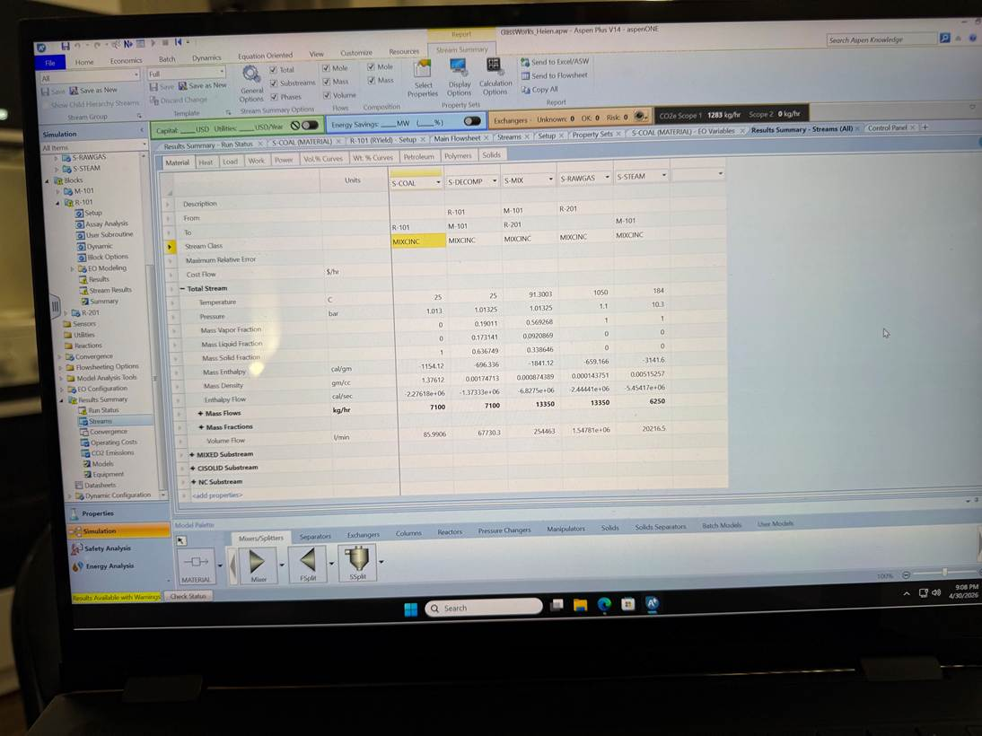
Figure A1. Aspen Plus V14 stream-results screenshot used to verify the gasifier-core basis: S-COAL = 7,100 kg/h, S-STEAM = 9,000 kg/h, S-MIX/S-RAWGAS = 16,100 kg/h, and raw gas at 1050 °C and 1.1 bar.
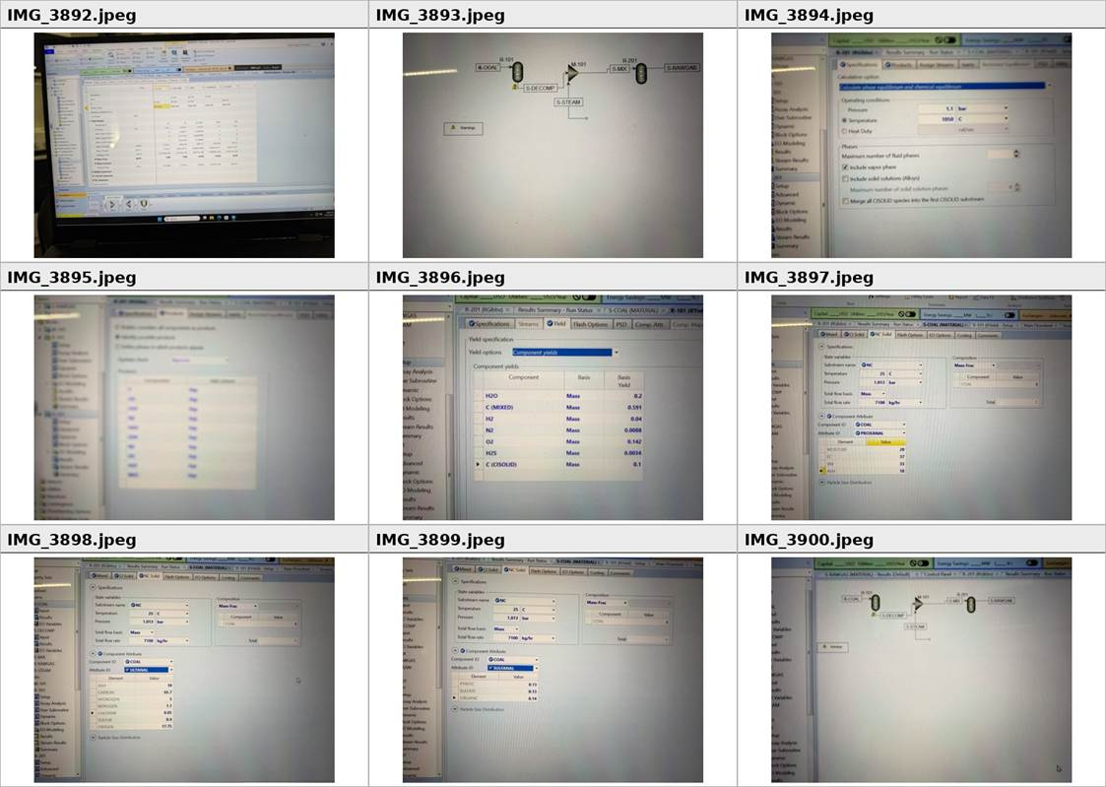
Figure A2. Contact sheet of uploaded Aspen Plus V14 build/process photos, part 1. These images document the photographed PFD, stream results, component setup, property method, and coal-input workflow.
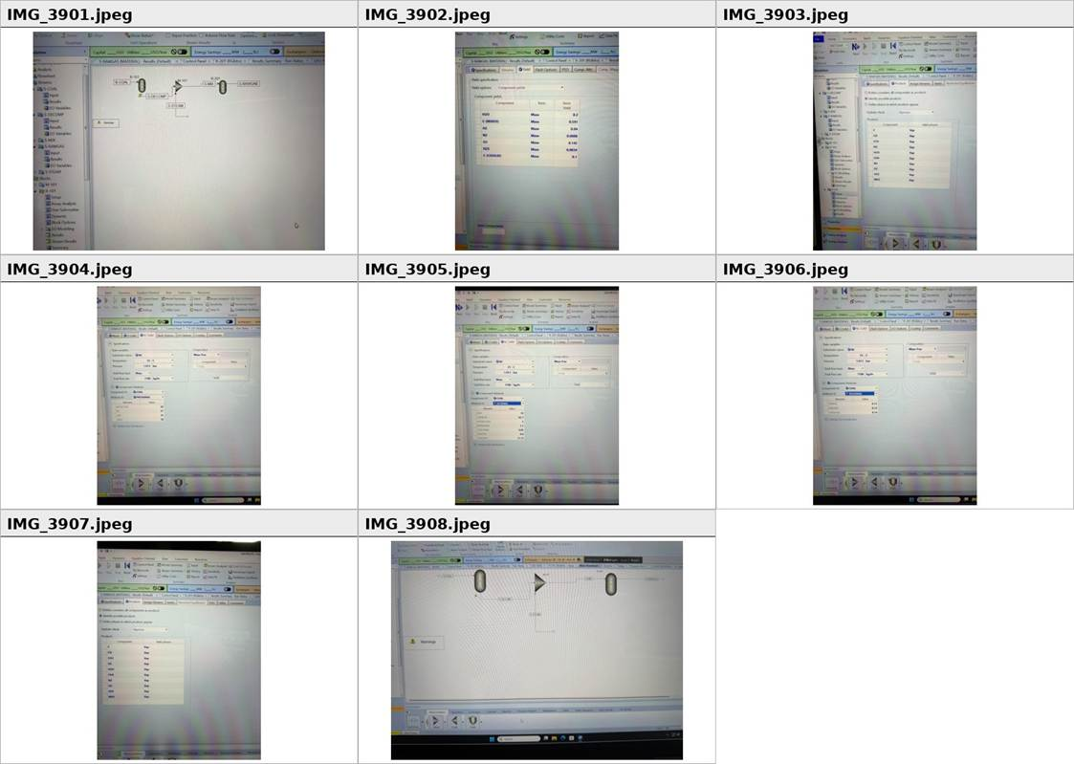
Figure A3. Contact sheet of uploaded Aspen Plus V14 build/process photos, part 2. These images document the remaining Aspen setup/results screens used to check the written report against the actual build.

Appendix B. Rubric Crosswalk and Assumption Audit
Table B1. Rubric crosswalk for the report.

Rubric category | Requirement targeted | Where addressed | A+ revision choice
Self-reflection and appearance | Specific reflection, cover page, headings, TOC, tables/figures, readable formatting | Cover, reflection, TOC/lists, numbered sections, captions | Reflection compressed to one page and tied to actual Aspen learning
Motivation/introduction | Why model before retrofit | Section 1 and Section 8 | Baseline linked directly to apple-pomace ethanol retrofit
Process description and assumptions | Complete process, inputs/outputs, chemistry, thermodynamics, justified assumptions | Sections 2–3, Tables 1–3 | Corrected methane reaction and explicitly separated Aspen vs hand-calculated scope
Block flow diagram | Transport, tar extraction, condensers, scrubbers, purifier, byproducts | Section 4, Figure 1 | BFD rebuilt with all required units and byproduct streams
PFD/Aspen model | Functioning Aspen model with reaction/separation steps and process conditions | Section 5, Figure 2, Appendix A | PFD labels photographed Aspen core and cleanup allocation instead of overstating model scope
Stream tables and balances | All streams, species/pseudo-components, MW, T, P, quality, enthalpy/energy; mass ≤2%, energy ≤5% | Section 6, Tables 4–7 | Mass closure 0.006%; energy closure reported on HHV+sensible basis; product target exactly 170,000 Nm³/day
Equipment specification/sizing | Major equipment and utilities specified and sized | Section 7, Table 8 | All required units listed with counts/capacity, sizing basis, design variables, and operating variables

Assumption audit: The largest remaining uncertainty is not Aspen convergence but historical yield apportionment among tar, ammoniacal liquor, light oil, spent purifier solids, and ash/char. These are therefore identified as pseudo-components and should be replaced by directly exported Aspen separator results if the final group model builds the full cleanup train.

