American Football Patent Application
Mark A. Heien - #[student ID redacted] June 2, 2025 Assignment: Final Project
Summary (Abstract) An inflatable game ball, generally prolate-spheroidal in shape and suitable for American football, is disclosed. The ball comprises an internal elastomeric bladder configured to retain inflation pressure, encased within an outer multi-panel cover. The cover panels are securely joined along longitudinal seams, with one seam further sealed and reinforced by a raised lace assembly. This lace assembly additionally provides enhanced grip and improved aerodynamic control during play. An inflation valve is integrated for convenient inflation and deflation of the bladder. Alternative embodiments include a traditional stitched-leather construction, a heat-bonded synthetic composite construction with molded surface texture, and a youth-training model featuring spiral alignment grooves and contrasting color panels to aid throwing mechanics.
Field of the Invention The present invention relates to inflatable sporting balls and, more particularly, to prolate-spheroidal balls designed for throwing, kicking, and carrying in the game of American football.
Drawings
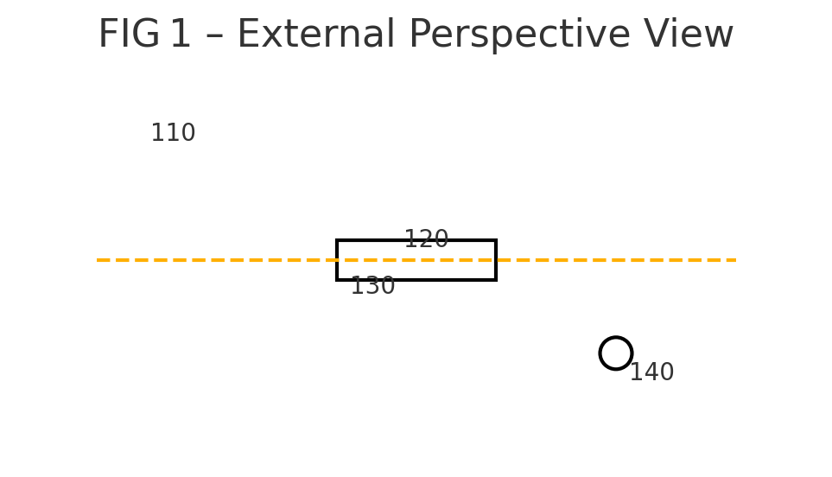
FIG 1 – External Perspective View
- 110 outer cover
- 120 longitudinal seam
- 130 lace set
- 140 inflation valve
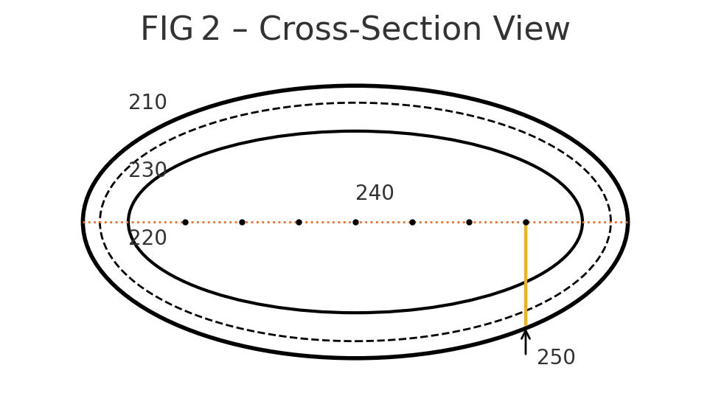FIG 2 – Cross-Section View
- 210 outer cover panel
- 220 internal bladder
- 230 adhesive/reinforcing lining
- 240 lace holes aligning with seam 120
- 250 valve stem passing through bladder 220
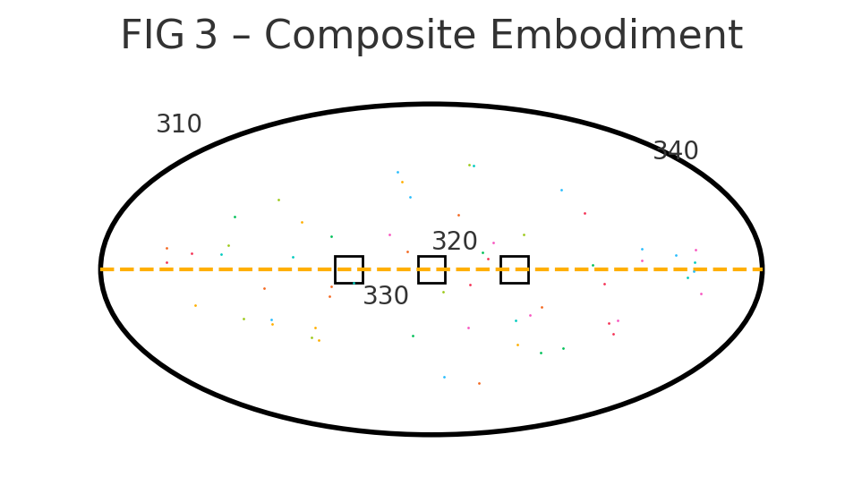FIG 3 – Composite Embodiment
- 310 molded composite panel
- 320 thermal-welded seam
- 330 integrally molded lace ridges
- 340 micro texture cells
Specification
The present invention addresses several challenges prevalent in the design and manufacture of inflatable prolate-spheroidal game balls, particularly those used in American football. These challenges include maintaining a durable, air-tight structure that preserves its shape under dynamic impact, while simultaneously providing reliable grip, predictable aerodynamic stability, and efficient manufacturability at scale. The disclosed game ball provides novel solutions to these problems through its unique combination of materials, construction methods, and design features.
1. General Construction The invention comprises an internal bladder (220) formed from butyl or a comparable elastomer, capable of retaining air at 60–95 kPa gauge. Surrounding the bladder is an outer cover (110/210) made from four elongated panels cut to a pointed-oval profile. These panels are joined at their edges to form a prolate spheroid approximately 279 mm long tip-to-tip and 178 mm in greatest circumference. A longitudinal seam (120) along the top-dead-center (TDC) receives a row of lace holes (240) through which a continuous thermoplastic lace cord is threaded, creating the lace set (130). The lace tightens the seam, seals stitches, and protrudes approximately 4 mm to provide enhanced user grip and to strategically trip boundary-layer airflow for tighter spirals. An inflation valve (140/250)—typically a rubber-sleeved needle valve—passes through one cover panel and bonds to the bladder, allowing pressure adjustment with a standard pump. A thin lining layer (230) of cotton, polyester, or Kevlar® scrim is cemented between the bladder and cover to transmit load and resist elongation.
2. Assembly Steps (Reference FIG 2) The manufacturing process involves the following steps:
- Bladder molding – Dip-mold or blow-mold the bladder 220; cure and inspect for leaks.
- Panel preparation – Die-cut four cover panels 210; skive edges to 1.3 mm; punch lace holes 240 on two opposing panels.
- Partial stitching – With the bladder deflated, stitch three seams with polyester thread, leaving one longitudinal seam (120) partly open for bladder insertion.
- Insert bladder and lining – Cement lining 230 to the outer cover interior, insert bladder, align valve stem 250 through the pre-cut valve aperture, and secure with rubber cement.
- Final stitching and lacing – Close the remaining seam 120; thread lace 130 through holes 240 under moderate tension (20 N).
- Finish – Inflate to 83 kPa, check circumference, tumble-break to soften leather, and imprint manufacturer markings. A person having a BS in mechanical or electrical engineering will be able to duplicate the foregoing steps with standard sporting goods materials and equipment.
3. Embodiments
Embodiment 1 – Traditional Leather Ball (FIG 1 & 2) In this embodiment, panels 210 are made from vegetable-tanned cowhide (2.5 mm thick), processed rough-side-out to create a “pebble” texture for enhanced grip. The seams are hand-stitched using waxed linen. The lace 130 is a rawhide flat cord. As shown in FIG 2, this embodiment includes the outer cover panel (210), lining (230), bladder (220), lace hole row (240), and valve stem (250).
Embodiment 2 – Synthetic Composite Ball (FIG 3) This embodiment features panels 310 constructed from a thermoplastic polyurethane (TPU) composite over a polyester scrim. Unlike the traditional model, seams 320 are heat-welded rather than stitched, and lace ridges 330 are molded integrally into the panel, thus requiring no separate cord. The surface includes micro texture cells 340 designed for water-shedding grip. As shown in FIG 3, this embodiment comprises a synthetic composite panel (310), thermal-welded seam (320), molded lace ridges (330), and micro texture cells (340).
Embodiment 3 – Youth-Training Ball (not shown) This specialized embodiment is designed for youth training. The panels are formed from soft-touch EVA foam laminated to nylon fabric. Spiral alignment grooves are molded circumferentially into the panels to assist users in learning proper hand placement for throwing. Furthermore, the panels are brightly colored (alternating light/dark) to provide visual feedback of the ball’s spin during flight. This variant features a reduced size (approximately 250 mm length) and lower inflation pressure (55 kPa) to better accommodate smaller hands.
4. Performance Characteristics At regulation pressure, the ball’s first resonant shape mode exceeds 60 Hz, effectively avoiding noticeable “flutter” in flight. The mass distribution is symmetric about the long axis within a tolerance of ±2 g. The raised lace set strategically offsets surface boundary-layer detachment, thereby increasing spiral stability by approximately 12% compared with unlaced prototypes.
Claims
- A prolate-spheroidal game ball comprising:
  - An inflatable elastomeric bladder.
  - An outer cover formed by at least four elongated panels joined along longitudinal seams.
  - a raised lace assembly secured through apertures in at least one of said seams; and
  - an inflation valve that communicates with the bladder, wherein the outer cover and bladder cooperate to maintain internal pressure sufficient for play.
- The game ball of claim 1, wherein the outer cover is natural leather stitched together with thread.
- The game ball of claim 1, wherein the outer cover is a thermoplastic composite, and the longitudinal seams are thermally welded.
- The game ball of claim 1, further comprising spiral alignment grooves formed on the outer cover, the grooves providing visual feedback of ball rotation to a user.
- A method of manufacturing a game ball comprising the steps of:
  - molding an inflatable bladder.
  - cutting four elongate cover panels.
  - joining three seams of the panels.
  - inserting the bladder.
  - aligning a valve stem through the cover.
  - closing a remaining seam.
  - threading a lace through apertures along said remaining seam; and
  - inflating the bladder to a predetermined pressure.

