Student: Mark A. Heien
Partner: Amelia Bawani
Date: 02/28/2023
Title: Calorimetry

Summary:
Experimental determination was carried out to find the heat of neutralization for the reaction between sodium hydroxide (NaOH) and hydrochloric acid (HCl) as well as the reaction between sodium hydroxide and nitric acid (HNO3) using a coffee cup calorimeter. The results showed that the heat of neutralization for the NaOH-HCl reaction was approximately -51.81 kJ/mol H2O, and for the NaOH-HNO3 reaction was approximately -52.26 kJ/mol H2O. Additionally, the heats of neutralization for these reactions were calculated using heats of formation and net ionic equations, and were found to be -52.07 kJ/mol. The percentage difference between the experimental values and the true value was calculated to be 1.274% for the NaOH-HCl reaction and 0.7298% for the NaOH-HNO3 reaction.

Purpose:
To determine the heat of neutralization for the reaction between HCl and NaOH experimentally using a coffee-cup calorimeter and to determine the heat of neutralization for the reaction between nitric acid and NaOH using the same method.

Procedure:
In the first part of the experiment, two sets of calorimeters were created using 4 Styrofoam coffee cups. Calorimeter #1 was weighed along with its cover, and the mass was recorded. The Chrome book and LabQuest mini system were set up. Using a 50mL cylinder, 50.0mL of NaOH solution with a concentration of 2.079M was added to calorimeter #1, while 50.0mL of HCl solution with a concentration of 1.913M was added to calorimeter #2. The initial temperatures of NaOH and HCl were measured and recorded using temperature probes. After this, the probe on the HCl was unplugged, and the HCl solution was transferred from calorimeter #2 to calorimeter #1. While one student was collecting data with the Graphical Analysis app, the other student was transferring the HCl solution. After 180 seconds, the mass of calorimeter #1, along with its solution and cover, was recorded. The data was plotted on Graphical Analysis, and a linear model was applied to the points after the temperature peaked. The y-intercept of the curve was then determined, giving the final temperature in the calorimeter. The initial temperature, solution mass, heat of solution and reaction, heat of neutralization, its average, and percent error were calculated using the collected data. This procedure was repeated for a second trial.

In the second part of the experiment, the same procedure as part 1 was carried out, but this time, NaOH and HNO3 solutions with a molarity of 1.851M were used. Two trials were conducted using the same method.
Data:
Experimental Determination of the ∆H_{neut} for HCl(aq)-NaOH(aq) and for HNO₃(aq)NaOH(aq)

 | sodium hydroxide | hydrochloric acid | nitric acid
Molarity of the solution | 2.079M | 1.913M | 1.851M
Volume of the solution for each trial | 50.0 mL | 50.0 mL | 50.0 mL

This table presents the molarities of the substances used for this experiment and the volume used for each of them.

HCl(aq)-NaOH(aq) | Trial #1 | Trial #2
Initial Temperature of HCl(aq) | 24.7°C | 24.8°C
Initial Temperature of NaOH(aq) | 24.4°C | 26.4°C
Average Initial Temperature | 24.55°C | 24.6°C
Mass of Calorimeter #1 + solution + cover (after reaction) | 112837mg | 110943mg
Mass of empty Calorimeter #1 + cover (from part A) | 8337mg | 8337mg
Mass of solution* | 104500mg | 102606mg

This table presents the data collected for the reaction between NaOH and HCl for the two trials carried out. It includes the initial temperature of each substance, the average initial temperature, the mass of the calorimeter with the cover when empty and when with the solution and the mass of the solution.

HNO₃(aq)-NaOH(aq) | Trial #1 | Trial #2
Initial Temperature of HNO₃(aq) | 24.9°C | 25.4°C
Initial Temperature of NaOH(aq) | 25.0°C | 25.1°C
Average Initial Temperature | 24.95°C | 25.25°C
Mass of Calorimeter #1 + solution + cover (after reaction) | 113194mg | 113790mg
Mass of solution* | 104857mg | 105453mg

This table presents the data collected for the reaction between NaOH and HNO₃ for the two trials carried out. It includes the initial temperature of each substance, the average initial temperature, the mass of the calorimeter with the cover when with the solution and the mass of the solution.

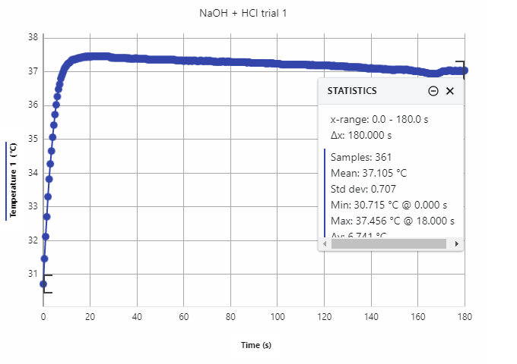
This graph shows the change in temperature for the reaction between NaOH and HCl for Trial #1 for approximately 180 seconds.

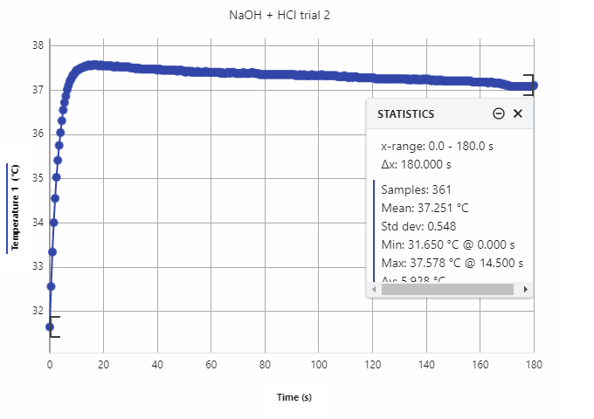
This graph shows the change in temperature for the reaction between NaOH and HCl for Trial #2 for approximately 180 seconds.
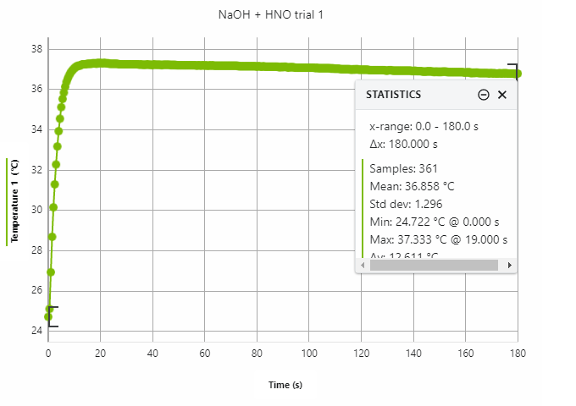

This graph shows the change in temperature for the reaction between NaOH and HNO₃ for Trial #1 for approximately 180 seconds.

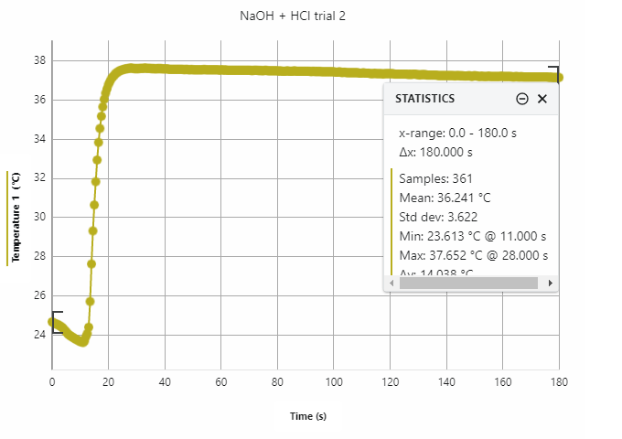
This graph shows the change in temperature for the reaction between NaOH and HNO₃ for Trial #2 for approximately 180 seconds.
Calculations:
Reaction between NaOH and HCl:
Trial#1:
$∆T = T_{f} - T_{i}$ = 37.456°C – 24.55°C = 12.906°C
$$Q_{react}= {-Q}_{solut}$$

$Q_{solut}$ = 3.70 $\frac{J}{g°C}$ ∗ 𝑡𝑜𝑡𝑎𝑙 𝑚𝑎𝑠𝑠 𝑜𝑓 𝑠𝑜𝑙𝑢𝑡𝑖𝑜𝑛 ∗∆𝑇 = 3.70 $\frac{J}{g°C}$ ∗ 104.5𝑔 ∗ 12.906°C = 4.990 kJ

𝐻𝐶𝑙(𝑎𝑞) + 𝑁𝑎𝑂𝐻(𝑎𝑞) → 𝑁𝑎𝐶𝑙(𝑎𝑞) + 𝐻2𝑂(𝑙)
.
For NaOH: 50.0𝑚𝐿 ∗ $\frac{1 L}{1000mL} * \frac{2.079 mol NaOH}{1 L} *\frac{1 mol H_{2}O}{1 mol NaOH}$ = 0.104 𝑚𝑜𝑙 $H_{2}O$
For HCl: 50.0𝑚𝐿 ∗ $\frac{1 L}{1000mL} * \frac{1.913 mol HCl}{1 L} *\frac{1 mol H_{2}O}{1 mol HCl}$ = 0.0957𝑚𝑜𝑙 $H_{2}O$
The limiting reactant is HCl
$∆H_{neut}$ = $\frac{Qreact}{\# moles of H_{2}O produced }= \frac{-4.990kJ}{0.0957 mol H_{2}O}= -52.14 \frac{kJ}{mol H_{2}O}$

Trial#2:
$∆T = T_{f} - T_{i}$ = 37.578°C – 24.6°C = 12.978°C
$Q_{react}= {-Q}_{solut}$

$Q_{solut}$ = 3.70 $\frac{J}{g°C}$ ∗ 𝑡𝑜𝑡𝑎𝑙 𝑚𝑎𝑠𝑠 𝑜𝑓 𝑠𝑜𝑙𝑢𝑡𝑖𝑜𝑛 ∗∆𝑇 = 3.70 $\frac{J}{g°C}$ ∗ 102.606𝑔 ∗ 12.978°C = 4.927 kJ

𝐻𝐶𝑙(𝑎𝑞) + 𝑁𝑎𝑂𝐻(𝑎𝑞) → 𝑁𝑎𝐶𝑙(𝑎𝑞) + 𝐻2𝑂(𝑙)
.
For NaOH: 50.0𝑚𝐿 ∗ $\frac{1 L}{1000mL} * \frac{2.079 mol NaOH}{1 L} *\frac{1 mol H_{2}O}{1 mol NaOH}$ = 0.104 𝑚𝑜𝑙 $H_{2}O$
For HCl: 50.0𝑚𝐿 ∗ $\frac{1 L}{1000mL} * \frac{1.913 mol HCl}{1 L} *\frac{1 mol H_{2}O}{1 mol HCl}$ = 0.0957𝑚𝑜𝑙 $H_{2}O$
The limiting reactant is HCl.
$∆H_{neut}$ = $\frac{Qreact}{\# moles of H_{2}O produced }= \frac{-4.927kJ}{0.0957 mol H_{2}O}= -51.48 \frac{kJ}{mol H_{2}O}$
Average enthalpy of neutralization:

$Avg ∆H_{neut }= \frac{∆H_{neut1 }+ ∆H_{neut2}}{2}= \frac{-52.14 \frac{kJ}{mol} + -51.48\frac{kJ}{mol}}{2}=-51.81 \frac{kJ}{mol H_{2}O}$

Percent error between trials:

$\% error= \frac{\left|{∆H}_{neut1}- {∆H}_{neut2}\right|}{Avg ∆H_{neut}} *100\%$ $= \frac{\left|-52.14 \frac{kJ}{mol H_{2}O}- -51.48\frac{kJ}{mol H_{2}O} \right|}{-51.81\frac{kJ}{mol H_{2}O}} *100\%=1.274\%$

Reaction between NaOH and HNO₃:
Trial#1:
$∆T = T_{f} - T_{i}$ = 37.333°C – 24.95°C = 12.383°C
$Q_{react}= {-Q}_{solut}$

$Q_{solut}$ = 3.70 $\frac{J}{g°C}$ ∗ 𝑡𝑜𝑡𝑎𝑙 𝑚𝑎𝑠𝑠 𝑜𝑓 𝑠𝑜𝑙𝑢𝑡𝑖𝑜𝑛 ∗$∆$𝑇 = 3.70 $\frac{J}{g°C}$ ∗ 104.857𝑔 ∗ 12.383°C = 4.804 kJ

𝐻𝑁𝑂 (𝑎𝑞) + 𝑁𝑎𝑂𝐻(𝑎𝑞) → 𝑁𝑎𝑁𝑂 (𝑎𝑞) + 𝐻2𝑂(𝑙)
For NaOH: 50.0𝑚𝐿 ∗ $\frac{1 L}{1000mL} * \frac{2.079 mol NaOH}{1 L} *\frac{1 mol H_{2}O}{1 mol NaOH}$ = 0.104 𝑚𝑜𝑙 $H_{2}O$

For ${HNO}_{3}$: 50.0𝑚𝐿 ∗ $\frac{1 L}{1000mL} * \frac{1.851 mol {HNO}_{3}}{1 L} *\frac{1 mol H_{2}O}{1 mol HCl}$ = 0.0926 𝑚𝑜𝑙 $H_{2}O$

The limiting reactant is HCl.

$∆H_{neut}$ = $\frac{Qreact}{\# moles of H_{2}O produced }= \frac{-4.804kJ}{0.0926 mol H_{2}O}= -51.88 \frac{kJ}{mol H_{2}O}$

Trial#2:
$∆T = T_{f} - T_{i}$ = 37.652°C – 25.25°C = 12.402°C
$Q_{react}= {-Q}_{solut}$

$Q_{solut}$ = 3.70 $\frac{J}{g°C}$ ∗ 𝑡𝑜𝑡𝑎𝑙 𝑚𝑎𝑠𝑠 𝑜𝑓 𝑠𝑜𝑙𝑢𝑡𝑖𝑜𝑛 ∗∆𝑇 = 3.70 $\frac{J}{g°C}$ ∗ 105.453𝑔 ∗ 12.402°C = 4.839kJ

𝐻𝑁𝑂3 (𝑎𝑞) + 𝑁𝑎𝑂𝐻(𝑎𝑞) → 𝑁𝑎𝑁𝑂 (𝑎𝑞) + 𝐻2𝑂(𝑙)
For NaOH: 50.0𝑚𝐿 ∗ $\frac{1 L}{1000mL} * \frac{2.079 mol NaOH}{1 L} *\frac{1 mol H_{2}O}{1 mol NaOH}$ = 0.104 𝑚𝑜𝑙 $H_{2}O$
For ${HNO}_{3}$: 50.0𝑚𝐿 ∗ $\frac{1 L}{1000mL} * \frac{1.851 mol {HNO}_{3}}{1 L} *\frac{1 mol H_{2}O}{1 mol {HNO}_{3}}$ = 0.0926 𝑚𝑜𝑙 $H_{2}O$
$∆H_{neut}$ = $\frac{Qreact}{\# moles of H_{2}O produced }= \frac{-4.839kJ}{0.0926 mol H_{2}O}= -52.26\frac{kJ}{mol H_{2}O}$

Average enthalpy of neutralization:

$Avg ∆H_{neut }= \frac{∆H_{neut1 }+ ∆H_{neut2}}{2}= \frac{-51.88 \frac{kJ}{mol} + -52.26\frac{kJ}{mol}}{2}=-52.07 \frac{kJ}{mol H_{2}O}$

Percent error between trials:
$\% error= \frac{\left|{∆H}_{neut1}- {∆H}_{neut2}\right|}{Avg ∆H_{neut}} *100\%$ $= \frac{\left|-51.88 \frac{kJ}{mol H_{2}O}- -52.26\frac{kJ}{mol H_{2}O} \right|}{-52.07\frac{kJ}{mol H_{2}O}} *100\%=0.7298\%$

Heat of Neutralization using enthalpies of formation and net ionic equations:
NaOH-HCl reaction: 𝐻𝐶𝑙(𝑎𝑞) + 𝑁𝑎𝑂𝐻(𝑎𝑞) → 𝑁𝑎𝐶𝑙(𝑎𝑞) + 𝐻2𝑂(𝑙)
Total Ionic Equation (TIE): $H^{+}\left(aq\right)+{Cl}^{-}\left(aq\right)+{Na}^{+}\left(aq\right)+{OH}^{-}\left(aq\right)→ {Cl}^{-}\left(aq\right)+{Na}^{+}\left(aq\right)+H_{2}O(l)$
Net Ionic Equation (NIE): $H^{+}\left(aq\right)$ + ${OH}^{-}\left(aq\right) → H_{2}O(l)$

NaOH-HNO₃ reaction: $HNO3(aq) + NaOH(aq) → NaNO3(aq) + H2O(l)$
TIE: $H^{+}\left(aq\right)+{NO}_{3}^{-}\left(aq\right)+{Na}^{+}\left(aq\right)+{OH}^{-}\left(aq\right)→ {NO}_{3}^{-}\left(aq\right)+{Na}^{+}\left(aq\right)+H_{2}O\left(l\right)$
NIE: $H^{+}(aq) + OH^{-} (aq) → H2O(l)$

Formation of water: 𝐻⁺(𝑎𝑞) + OH⁻(𝑎𝑞) → 𝐻₂𝑂(𝑙)
∆𝐻 = ∆𝐻°𝑓(𝐻₂𝑂(𝑙)) − [∆𝐻°𝑓(𝐻⁺(𝑎𝑞)) + ∆𝐻°𝑓(𝑂𝐻⁻(𝑎𝑞))] =
-258.8$\frac{kJ}{mol}- \left[0\frac{kJ}{mol}+\left(-230.0\frac{kJ}{mol}\right)\right]= -55.8\frac{kJ}{mol}$

Percent error for experimental average (NaOH-HCl reaction): % 𝑒𝑟𝑟𝑜𝑟 =
$\frac{\left|experimental value-true value\right|}{true value}\left|\frac{-51.81 \frac{kJ}{mol H_{2}O}-\left(-55.8\frac{kJ}{mol}\right)}{-55.8\frac{kJ}{mol}}\right|*100\%$= 7.15%

Percent error for experimental average (NaOH-HNO₃ reaction): % 𝑒𝑟𝑟𝑜𝑟 =
$\frac{\left|experimental value-true value\right|}{true value}\left|\frac{-52.26 \frac{kJ}{mol H_{2}O}-\left(-55.8\frac{kJ}{mol}\right)}{-55.8\frac{kJ}{mol}}\right|*100\%$= 6.34%

Results:
Results Table to Determine Heat of Neutralization for the HCl(aq)-NaOH(aq) Reaction

 | Trial #1 |  | Trial #2
Maximum Temperature  (y-intercept) from the plot | 37.456°C |  | 37.578°C
Change in Temperature (T) | 12.906°C |  | 12.978°C
q_{solution} (in kJ) | 4.990kJ |  | 4.927kJ
q_{reaction} (in kJ) | -4.99kJ |  | -4.927kJ
# of moles of H₂O produced | 0.0957 |  | 0.0957
∆H_{neut} (in kJ/mol H₂O) | -52.14 |  | -51.48
Average ∆H_{neut} (in kJ/mol H₂O) |  |  | -51.81
Percent Error |  | 1.274 | %
This table presents the results obtained for the reaction between HCl and NaOH for the two trials carried out. It includes the maximum temperature, the change in temperature, the heat of solution, the heat of reaction, the number of moles of water produced, the heat of neutralization, the average heat of neutralization and the percent error between the experimental value and the true value for the heat of neutralization.

Results Table to Determine Heat of Neutralization for the HNO₃(aq)-NaOH(aq) Reaction

 | Trial #1 |  | Trial #2
Maximum Temperature  (y-intercept) from the plot | 37.333°C |  | 35.25°C
Change in Temperature (∆T) | 12.383°C |  | 12.5°C
q_{solution} (in kJ) | 4.804 |  | 4.843
q_{reaction} (in kJ) | -4.804 |  | -4.843
# of moles of H₂O produced | 0.0926 |  | 0.09
∆H_{neut} (in kJ/mol H₂O) | -51.88 |  | -52.25
Average ∆H_{neut} (in kJ/mol H₂O) | - | 552.07
Percent Error |  | 40.7298%
This table presents the results obtained for the reaction between HNO₃ and NaOH for the two trials carried out. It includes the maximum temperature, the change in temperature, the heat of solution, the heat of reaction, the number of moles of water produced, the heat of neutralization, the average heat of neutralization and the percent error between the experimental value and the true value for the heat of neutralization.

Discussion:
In this experiment, the heats of neutralization for the reactions NaOH-HCl and NaOH-HNO3 were determined through two trials for each reaction. The goal was to achieve a percentage difference of less than 5% between the experimentally determined heat of neutralization and the true value.

For the first part of the experiment, the calculated heats of neutralization for the two trials were -52.14kJ/mol and -51.48kJ/mol respectively, with a percent difference of 1.27%. The average heat of neutralization of -51.81kJ/mol was obtained, resulting in a percent error of 7.15% compared to the true value obtained using heats of formation. For the second part of the experiment, the calculated heats of neutralization for the two trials were -51.88kJ/mol and -52.26kJ/mol respectively, with a percent difference of 0.73%. The average heat of neutralization of 52.07xkJ/mol was obtained, resulting in a percent error of 6.34% compared to the true value obtained using heats of formation (-55.8kJ/mol).

The observation that the initial temperatures of the solutions were lower than the final temperatures indicated that the acid-base neutralization reactions were exothermic. This also confirmed that the calculated heat of neutralization should be negative due to the exchange of heat between the solutions and calorimeter.

Interestingly, the experimentally determined heats of neutralization for the two reactions were not the same, but when determined using the net ionic equations and heats of formation, they were identical. This discrepancy is because heat is a state function and only depends on the initial and final states of the system. Since both reactions involved the same starting acid and base and resulted in the same end products (water and salt), the heats of neutralization should be the same. This concept would also apply if the base were replaced with barium hydroxide.
2𝐻𝐶𝑙(𝑎𝑞) + 𝐵𝑎(𝑂𝐻)₂ (𝑎𝑞) → 𝐵𝑎𝐶𝑙₂(𝑎𝑞) + 2𝐻2𝑂(𝑙)
Total Ionic Equation (TIE): $H^{+}\left(aq\right)+{Cl}^{-}\left(aq\right)+{Ba}^{+}\left(aq\right)+{OH}^{-}\left(aq\right)→ {Cl}^{-}\left(aq\right)+{Na}^{+}\left(aq\right)+H_{2}O(l)$
Net Ionic Equation (NIE): 2𝐻⁺ (𝑎𝑞) + 2𝑂𝐻⁻ (𝑎𝑞) → 2𝐻2𝑂(𝑙)
𝐻⁺ (𝑎𝑞) + 𝑂𝐻⁻ (𝑎𝑞) → 𝐻2𝑂(𝑙)
In this case Ba2+ would have been a spectator ion and again the reactions would have had the same beginning and ending which is reflected by the equal values of heat of neutralization. Also on both cases, with sodium hydroxide or with barium hydroxide, there is an equivalence between the number of moles of reactants and products, which is also reflected in the values of the heats of neutralization.

As part of the experimental process, different circumstances were considered, like change in concentrations or volumes. Regarding changes in concentrations, as the mathematical relationships show below, if we doubled the concentration of the acid and the base, it would have also doubled the moles present on the reaction for both the acid and the base. Consequently, this would have doubled the heat of the reaction and the change in temperature. Given this, the heat of neutralization stays the same since both the heat of the reaction and the moles were doubled.
$∆T = T_{f} - T_{i}$
$Q_{react}= {-Q}_{solut}$
𝐽
𝑞_{solute} = 3.70 ∗ 𝑡𝑜𝑡𝑎𝑙 𝑚𝑎𝑠𝑠 𝑜𝑓 𝑠𝑜𝑙𝑢𝑡𝑖𝑜𝑛 ∗∆𝑇
𝑔°C
𝑣𝑜𝑙𝑢𝑚𝑒 ∗ 𝑐𝑜𝑛𝑐𝑒𝑛𝑡𝑟𝑎𝑡𝑖𝑜𝑛 = 𝑚𝑜𝑙𝑒𝑠
𝑞_{react}
∆𝐻 =
# 𝑚𝑜𝑙𝑒𝑠 𝑜𝑓 𝐻 𝑂 𝑝𝑟𝑜𝑑𝑢𝑐𝑒𝑑
When it comes to changes in volumes, if we cut the volume of the acid and base in half while keeping the concentrations the same, the moles present in the reaction for both the acid and base would also be halved, as the mathematical relationships indicate. This would result in a halving of both the heat of the reaction and the temperature change. However, despite these changes, the heat of neutralization remains the same, as both the heat of the reaction and the moles were similarly reduced.
$$∆T = T_{f} - T_{i}$$
$Q_{react}= {-Q}_{solut}$
𝐽
𝑞_{solute} = 3.70 ∗ 𝑡𝑜𝑡𝑎𝑙 𝑚𝑎𝑠𝑠 𝑜𝑓 𝑠𝑜𝑙𝑢𝑡𝑖𝑜𝑛 ∗∆𝑇
𝑔°C
𝑣𝑜𝑙𝑢𝑚𝑒 ∗ 𝑐𝑜𝑛𝑐𝑒𝑛𝑡𝑟𝑎𝑡𝑖𝑜𝑛 = 𝑚𝑜𝑙𝑒𝑠
𝑞_{react}
∆𝐻_{neut} =
# 𝑚𝑜𝑙𝑒𝑠 𝑜𝑓 𝐻 𝑂 𝑝𝑟𝑜𝑑𝑢𝑐𝑒𝑑

Conclusion:
In this lab experiment, the goal was to determine the heat of neutralization for the reactions between NaOH and HCl, and NaOH and HNO3. The experimental values for the heat of neutralization for NaOH and HCl were found to be around -51.81kJ/mol H2O, while the calculated value using heats of formation and the net ionic equation was -55.8kJ/mol. Similarly, for the reaction between NaOH and HNO3, the experimental value was around -52.26kJ/mol H2O, while the calculated value was 55.8kJ/mol. The experiment may have had some sources of human error, such as parallax errors or not starting the timer at the correct time. The percentage errors between the experimentally found heat of neutralization values and the values calculated using heats of formation and the net ionic equation were both higher than the required 5% threshold, with percentage errors of 7.15% and 6.34% respectively

