Mark A. Heien
Lab partner: Amelia Bawani
Chem 163
Summer 2023
Professor Laurence Giordano

Lab Report: Qualitative Analysis of Known and Unknown Substances

Objective:
To identify the presence of specific ions, namely silver, ammonium, sodium, and potassium in both known and unknown samples using various qualitative tests.

Introduction:
Qualitative analysis helps determine the constituents of a sample without necessarily quantifying them. In this experiment, the identity of ions is determined through flame tests, chemical reactions, and observations with litmus paper.

Materials and Methods:

Hot plate
Nichrome wire
Test tubes and test tube rack
6 M solutions of HCl, HNO3, and NaOH
CaO and (NH4)2CO3
Litmus paper (both red and blue)
Centrifuge
Known samples (silver, ammonium, sodium, potassium)
Unknown sample
Procedure:

Flame Test:
Clean the nichrome or platinum wire by immersing it in 6 M HCl and subsequently placing it in the Bunsen burner flame until no color is detected.
Dip the wire into each sample and introduce it to the flame. Observe the resulting flame color.

Centrifuge Test with 6 M HCl and 6 M HNO3:
Place a small quantity of each sample in separate test tubes.
To one set of tubes, add 6 M HCl dropwise, observing for any reactions. Use the centrifuge if necessary and document the findings.
Perform the same for another set using 6 M HNO3.

Confirmation of Ammonium:
6 M NaOH Reaction and Litmus Paper Test:
Add several drops of 6 M NaOH to a set of samples.
Test the resulting solution with litmus paper and record any color changes.
Observations:

Flame Test:

Silver: No distinctive color.
Ammonium: Absence of flame color, but a distinct ammonia odor can be present.
Sodium: Produces a bright yellow flame.
Potassium: Lilac or pale violet flame.
Unknown sample: Bright yellow flame.
Centrifuge Test with 6 M HCl and 6 M HNO3:

Silver with HCl: Formation of white precipitate (AgCl).
Ammonium with HNO3: Release of gas (NH3).
Sodium: No observable change.
Potassium: No observable change.
Unknown sample with HCl: White precipitate formed.
Unknown sample with HNO3: No observable change.
Reaction with CaO and (NH4)2CO3:

Silver: No significant change.
Ammonium: No change observed with CaO.
Sodium: No change.
Potassium: No change.
Unknown sample: No observable reactions.
Reaction with 6 M NaOH and Litmus Paper:

Silver: No change.
Ammonium: Solution turns litmus paper blue.
Sodium: No observable change.
Potassium: No change.
Unknown sample: No change with litmus paper.
Results and Discussion:

By comparing the observations from known samples, a flow chart can be generated to identify ions in the unknown sample:
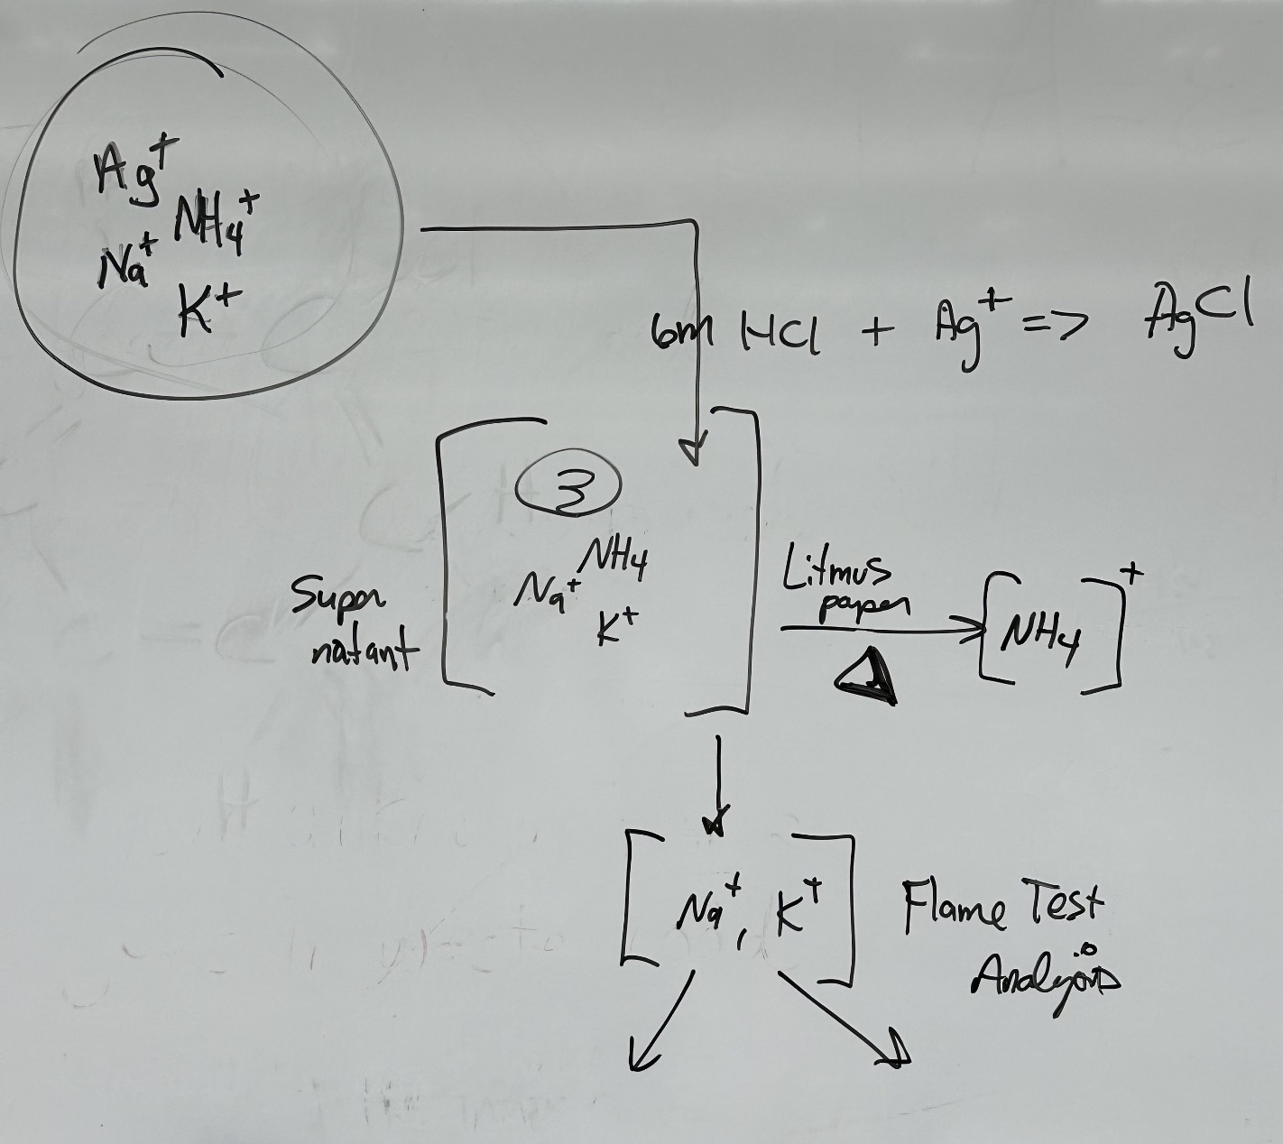
Conduct a flame test:

Yellow flame: Presence of Sodium.
Lilac flame: Presence of Potassium.
No distinct color, but detectable odor: Ammonium might be present.
No color: Proceed to other tests.
Introduce 6 M HCl:

White precipitate indicates the presence of Silver.
Add 6 M HNO3:

Evolution of gas points to Ammonium.
Test with 6 M NaOH and litmus paper:

A shift to blue on litmus paper: Ammonium presence.
From the observations, the unknown sample was found to contain both Silver (Ag) and Sodium (Na).

Conclusion:
Using the qualitative techniques, the presence of Silver and Sodium was successfully identified in the unknown sample.

Recommendations:
For greater accuracy, meticulous cleaning of equipment between tests is advised. Further tests could provide a more comprehensive insight into the composition of unknown samples.

