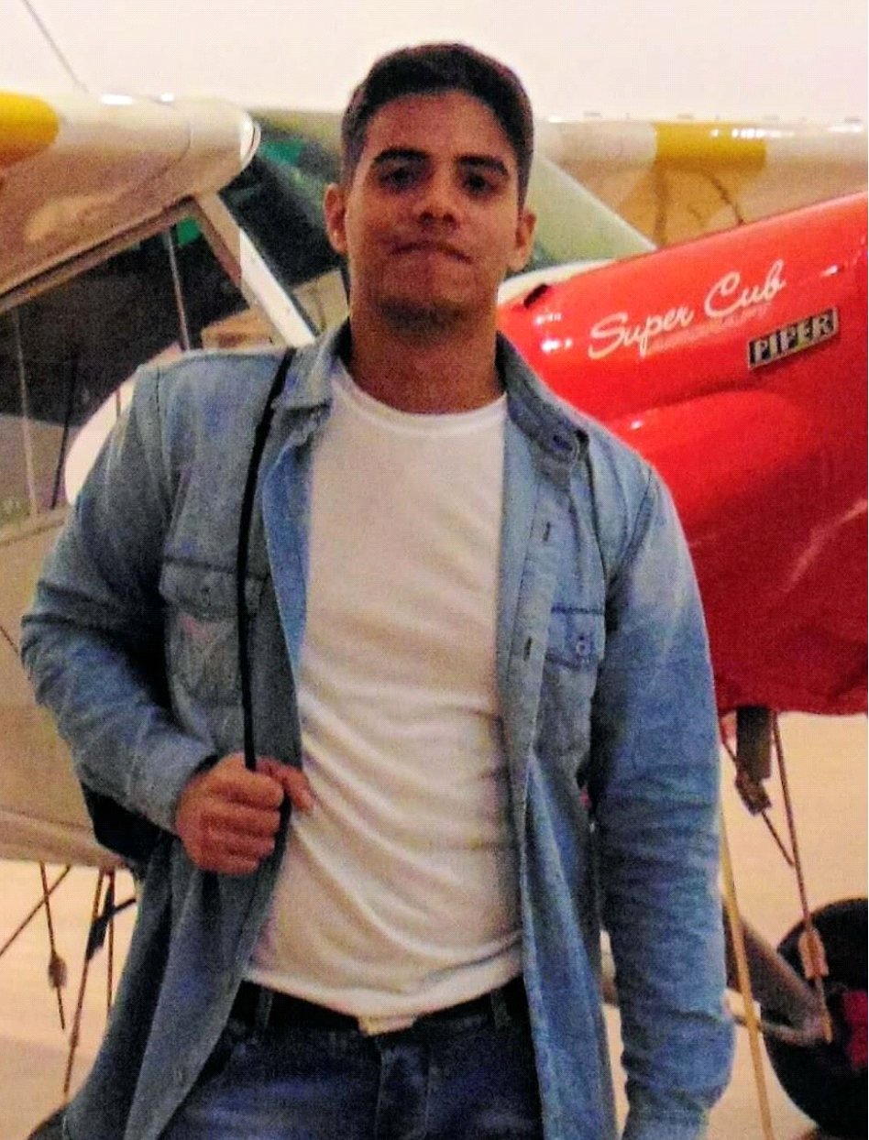

**FullName**: Edermar Dominguez **Edad:** 26

**Address:** Buenos Aires, Argentina **Email:** ederdoski19@gmail.com

**Phone:** +54 9 11 28956660 **Website:** http://ederdoski.com/

I'm a tech-loving mobile developer trying to unlock as many achievements as I can as long as I live. I consider myself a curious person in the technological field, with ease of adaptation to multidisciplinary work teams, since I entered the world of programming I am in constant research, I find the technologies that are born every day very interesting and I like to think that I am one of the people who make the world a better place.

**Software developer in the following Languages:**

Android, Java, Kotlin, HTML5, CSS3, NodeJS, Arduino, Python, C#,Unity.

**Experience**

**CIOM (Mar 2020 - Present)**

I am currently working on maintaining an app that performs product quality verification and certification services developed in kotlin, it had a native BD made in Room and I was in charge of migrating it to an ORM to improve the information treaty.

**Naranja X (Oct 2019 - Mar 2020)**

I worked as an Android developer in the prepaid card team, a module in charge of managing the balance of credit cards in a virtual wallet, we migrated the code written in Java to Kotlin and migrated from an MVC architecture to MVVM

**Toolbox (Nov 2018 - Nov 2019)**

I worked for several months maintaining and updating the video player app made in Android in the company, after that I led the development team to make an App compatible with Android TV written in Kotlin that would play videos with different types of licenses among them DRM, DASH, HLS and SMOOTHSTREAMING.

**Code Or Chop (Nov 2016 - JUN 2018)**

- Develop electronic prototypes "shields" capable of connecting with a "Rapsberry" motherboard to handle different home automation sensors that controlled the operation of objects in a model house.

- I worked on an application for pet tracking where I had to communicate with devices through BLE, I wrote a library capable of carrying out communication without problems, it is publicly available on Android Arsenal and on my GitHub

**Adrena Studies (JUN 2016 - MAY 2018)**

**VIDEOGAME DESIGNER**

-Development of prototypes of Android video games for mobile phones