Molbank 2010, M660
OPEN ACCESS
molbank
ISSN 1422-8599
www.mdpi.com/journal/molbank
Supporting Information

Luminescent Aza-27-crown-9 Amino Acid

Andreas Späth and Burkhard König *

Institute of Organic Chemistry, University of Regensburg, D-93040 Regensburg, Germany

* Author to whom correspondence should be addressed; Fax: Int. +49-943-941-1717;
E-Mail: Burkhard.Koenig@chemie.uni-regensburg.de

Content
Page
1.) Syntheses – General methods S-2

2.) Characterisation of the precursors S-3

3.) ¹H – and ¹³C-NMR spectra of new compounds S-4

4.) Absorption- and emission spectrum of compound 6 S-7

5.) Energy minimization calculations with Spartan V.6.01 S-7

1.) General methods

Analytical characterization of the synthesized compounds was done by common methods. Melting points were determined on Büchi SMP or a Lambda Photometrics OptiMelt MPA 100 and are uncorrected. IR Spectra were recorded with a Bio-Rad FT-IR Excalibur FTS 3000. UV spectra were recorded on a Cary 50 BIO spectrometer with temperature control at 25°C. Electro spray mass spectra were performed on a Finnigan MAT TSQ 7000 ESI-spectrometer. Other Mass Spectra were recorded on Varian CH-5 (EI), Finnigan MAT 95 (CI; FAB and FD), Xenon serves as the ionization gas for FAB.
NMR spectra were recorded on Bruker Avance 600 (¹H: 600.1 MHz, ¹³C: 150.1 MHz, T = 300 K), Bruker Avance 400 (¹H: 400.1 MHz, ¹³C: 100.6 MHz, T = 300 K) or Bruker Avance 300 (¹H: 300.1 MHz, ¹³C: 75.5 MHz, T = 300 K) relative to external standards. NMR spectra were recorded in CDCl₃ at 300 MHz (¹H) or 75 MHz (¹³C) unless stated otherwise. Characterization of the signals: s = singlet, d = doublet, t = triplet, q = quartet, m = multiplet, bs = broad singlet, dd = double doublet, dt = double triplet, ddd = double double doublet. Integration is determined as the relative number of atoms, the coupling constants are given in Hertz [Hz]. The multiplicity of the carbon atoms is given as (+] = CH₃ or CH, (-] = CH₂ and (C_{quat}) for quaternary carbon atoms. Structural assignments are based on DEPT and COSY experiments where applicable. Error of reported values: chemical shift: 0.01 ppm for ¹H-NMR, 0.1 ppm for ¹³C-NMR and 0.1 Hz for coupling constants. The solvent used is reported for each spectrum.
Analytical TLC plates (silica gel 60 F₂₅₄) and silica gel 60 (70 - 230 or 230 - 400 mesh) were used for chromatographic separations. Visualization of the spots was by UV light and/or staining with phosphomolybdate or ninhydrin, both in ethanol. DMF, CH₃CN, CHCl₃, THF, and Et₂O were dried by standard procedures and stored over molecular sieves. PE means petrol ether with a boiling range of 70 - 90 ºC. All other solvents and chemicals were of reagent grade and used without further purification.
All test substances were of pro analysi grade, checked by NMR or HPLC and used as purchased without further purification.
Solvents for fluorescence measurements were from special spectroscopic purity purchased from Acros or Baker or Uvasol from Merck. Millipore water (18 MΩ, Milli Q_{Plus}) was used.
2.) Characterisation of the precursors

4,5-Bis-(2-{2-[2-(2-hydroxy-ethoxy)-ethoxy]-ethoxy}-ethoxy)-phthalic acid dimethyl ester (3)
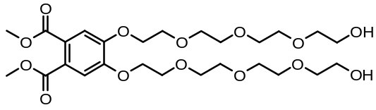
MF: C₂₄H₄₂O₁₄ – FW: 578.62 g/mol; - IR (neat): ν [cm⁻¹] = 3420 (bs), 2924 (s), 2876 (s), 1719 (s), 1598 (m), 1522 (m), 1434 (m), 1350 (m), 1293 (s), 1198 (s), 1124 (s), 1068 (m), 976 (w), 946 (w), 888 (w), 782 (w); - MS (ESI-MS, CH₂Cl₂/MeOH + 10 mmol NH₄OAc): e/z (%) = 596.4 (100, MNH₄⁺), 579.3 (8, MH⁺); - HRMS (PI-LSIMS FAB, MeOH/Glycerine): calc. for C₂₆H₄₂O₁₄⁺ [MH⁺]: 579.2653, found: 579.2661; - ¹H-NMR (300 MHz, CDCl₃): δ [ppm] = 3.06 (bs, 2 H), 3.50 (t, 4 H, J = 4.95 Hz), 3.56 – 3.70 (m, 20 H), 3.78 – 3.86 (m, 4 H), 3.80 (s, 6 H), 4.15 (t, 4 H, J = 4.95 Hz), 7.15 (s, 2 H); -¹³C-NMR (75 MHz, CDCl₃): δ [ppm] = 52.5 (+, 2 C), 61.5 (-, 2 C), 68.9 (-, 2 C), 69.4 (-, 2 C), 70.3 (-, 2 C), 70.5 (-, 2 C), 70.8 (-, 2 C), 70.8 (-, 2 C), 72.5 (-, 2 C), 113.7 (+, 2 C), 125.3 (C_{quat}, 2 C), 150.4 (C_{quat}, 2 C), 167.7 (C_{quat}, 2 C).

4,5-Bis-(2-{2-[2-(2-(p-toluenylsulfonyl)-ethoxy)-ethoxy]-ethoxy}-ethoxy)-phthalic acid dimethyl ester (4)
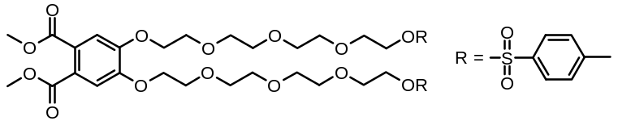
MF: C₄₀H₅₄O₁₈S₂ – FW: 886.99 g/mol; - IR (neat): ν [cm⁻¹] = 2946 (m), 2876 (m), 1721 (s), 1598 (m), 1519 (m), 1436 (m), 1352 (s), 1286 (s), 1175 (s), 1125 (s), 1098 (s), 1016 (m), 909 (m), 816 (m), 775 (m), 726 (s), 663 (m); - MS (+p ESI-MS, CH₂Cl₂/MeOH + 10 mmol NH₄OAc): e/z (%) = 904.4 (100, MNH₄⁺), 461.3 (2, (M+2NH₄⁺)²⁺), 452.8 (1, (M+H⁺+NH₄⁺)²⁺); (-p ESI-MS, CH₂Cl₂/MeOH + 10 mmol NH₄OAc): e/z (%) = 945.5 (100, M+OAc⁻);- ¹H-NMR (300 MHz, CDCl₃): δ [ppm] = 2.35 (s, 6 H), 3.50 (app. s, 8 H), 3.53 – 3.69 (m, 12 H), 3.71 – 3.87 (m, 4 H), 3.79 (s, 6 H), 4.06 (t, 4 H, J = 4.65 Hz), 4.13 (t, 4 H, J = 4.41 Hz), 7.15 (s, 2 H), 7.25 (d, 4 H, J = 7.95 Hz), 7.70 (d, 4 H, J = 7.95 Hz); - ¹³C-NMR (75 MHz, CDCl₃): δ [ppm] = 21.6 (+, 2C), 52.6 (+, 2 C), 68.6 (-, 2 C), 68.8 (-, 2 C), 69.3 (-, 2 C), 69.4 (-, 2 C), 70.5 (-, 2 C), 70.6 (-, 2 C), 70.7 (-, 2 C), 70.9 (-, 2 C), 113.8 (+, 2 C), 125.4 (C_{quat}, 2 C), 127.9 (+, 4 C), 129.9 (+, 4 C), 132.9 (C_{quat}, 2 C), 144.9 (C_{quat}, 2 C), 150.4 (C_{quat}, 2 C), 167.8 (C_{quat}, 2 C).

3.) ¹H – and ¹³C-NMR spectra of new compounds
NMR spectra were recorded in CDCl₃ on a Bruker Avance spectrometer 300 at 300 K. TMS was used as external standard.

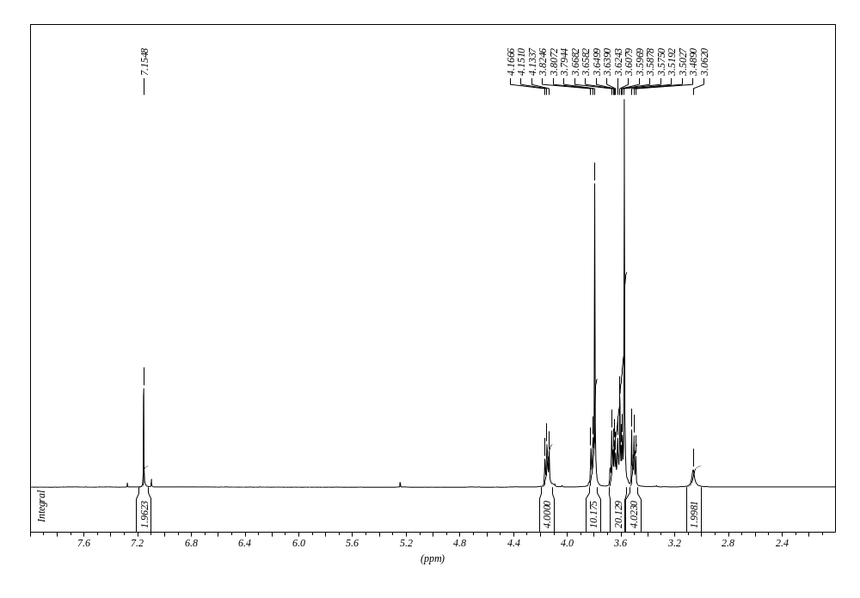
Figure S-1: ¹H-NMR spectrum of compound 3.

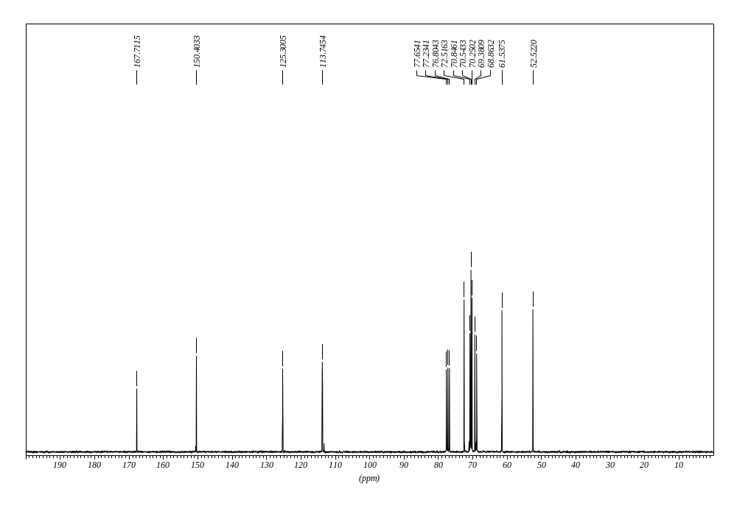

Figure S-2: ¹³C-NMR spectrum of compound 3.

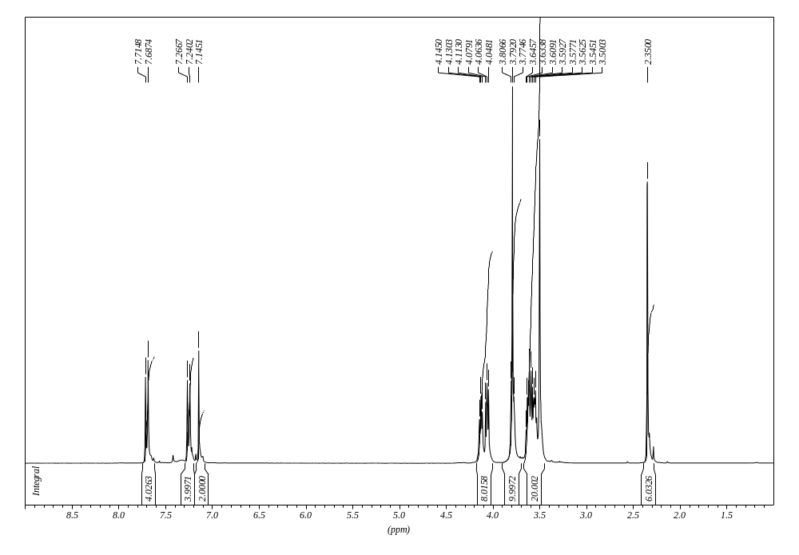
Figure S-3: ¹H-NMR spectrum of compound 4.

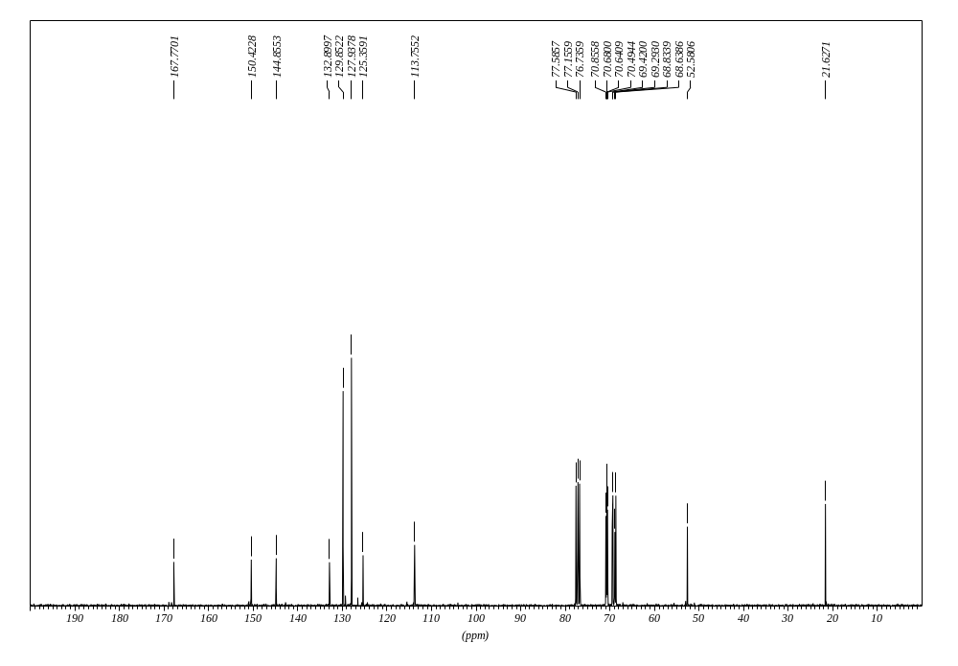
Figure S-4: ¹³C-NMR spectrum of compound 4.

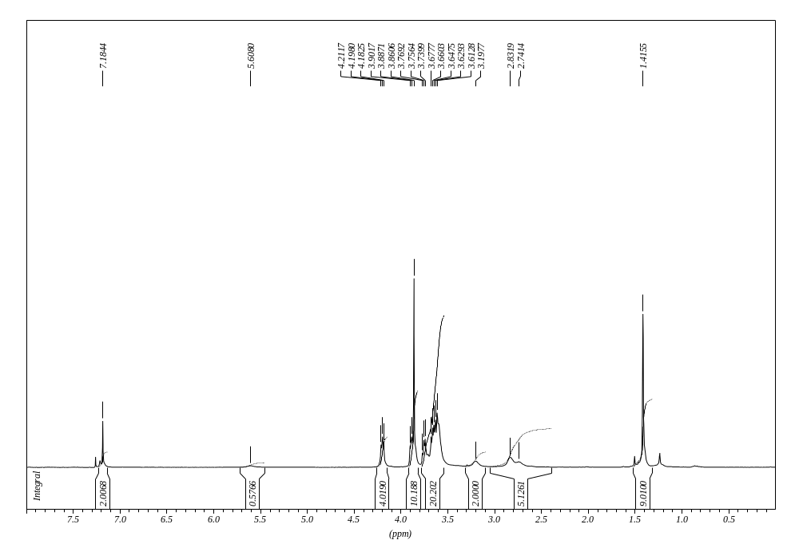
Figure S-5: ¹H-NMR spectrum of compound 6.

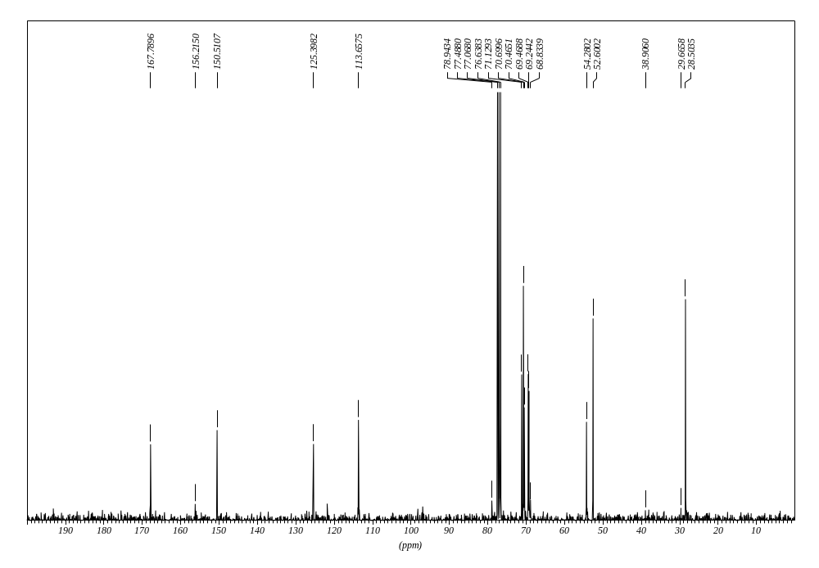
Figure S-6: ¹³C-NMR spectrum of compound 6.

4.) Absorption- and emission spectrum of compound 6

Compound 6 shows absorption maxima in methanol at 225 nm and 270 nm, and emits upon excitation at 390 nm (see figure S-7) with a quantum yield of about φ = 0.1. [1]

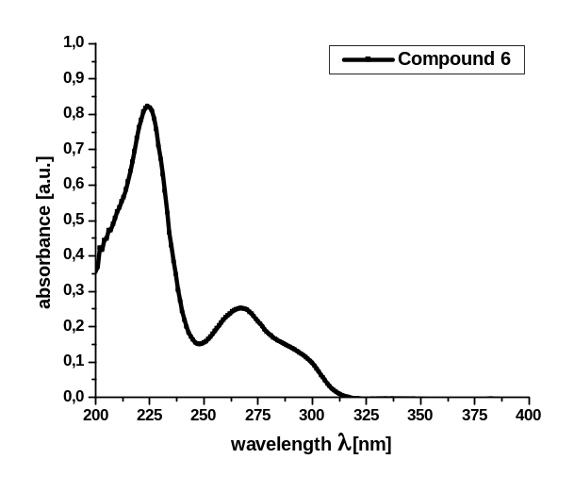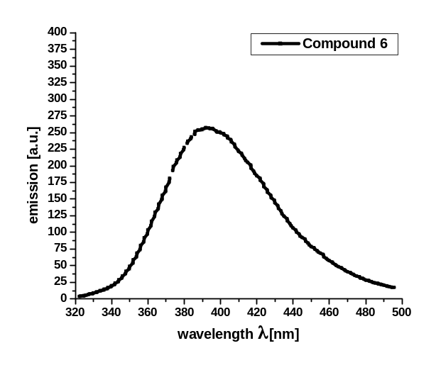
Figure S-7: Absorption and emission spectra of compound 6 (c = 2.8*10⁻⁵ mol/L) in methanol solution.

5.) Energy minimization calculations with Spartan V.6.01
Molecular models of the lowest energy conformers of both compounds were obtained by force field methods with the SPARTAN program package:

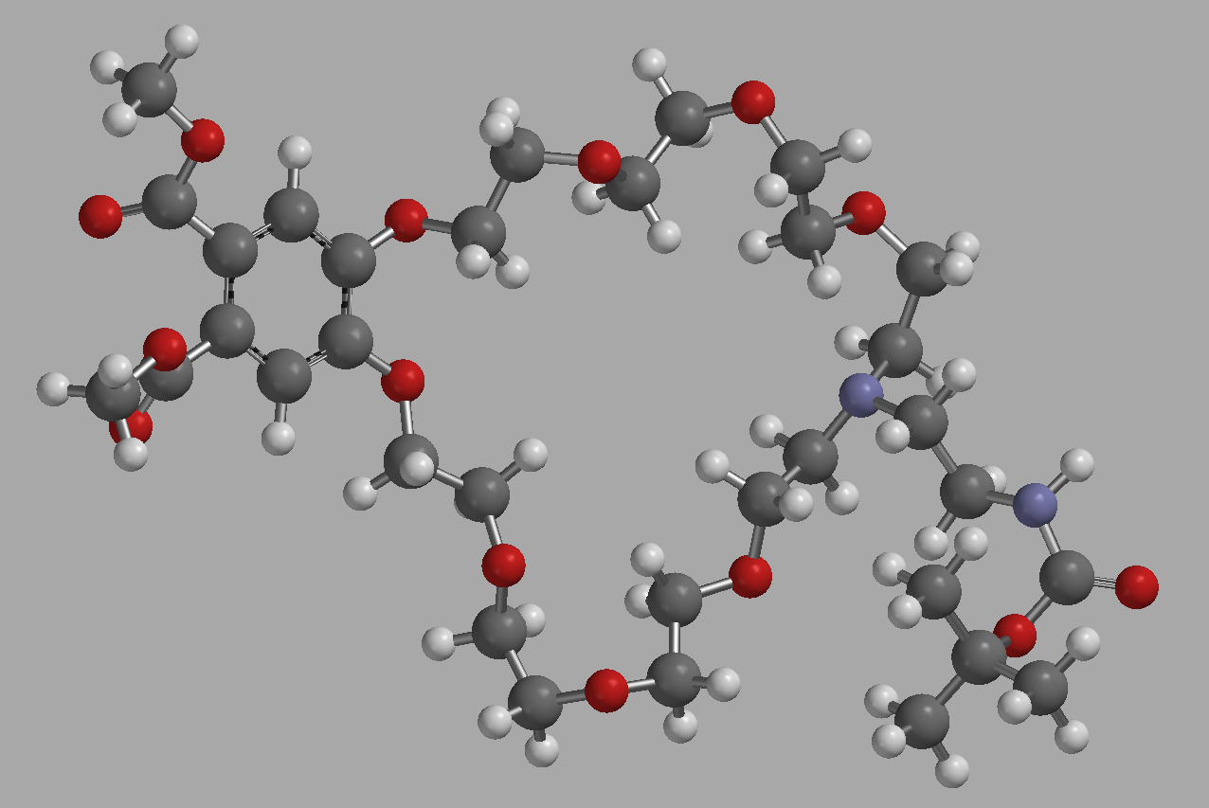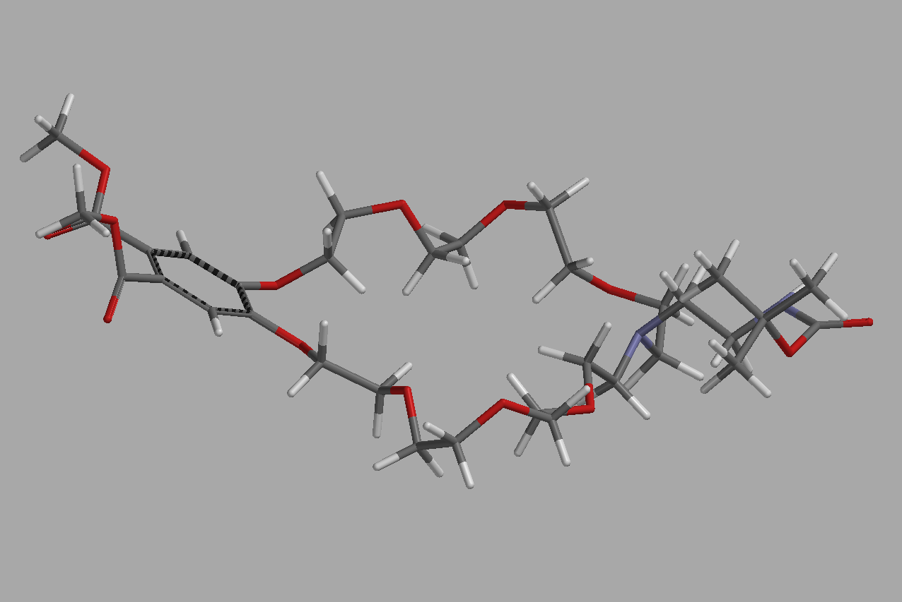

Figure S-8: Energy minimized structure of compound 6.

References and Notes

[1] All quantum yields were determined with quinine disulfate in 1 N H₂SO₄ as the reference compound (Φ = 0.546). The solution was degassed and measured in a closed, nitrogen flushed cuevette with septum.

© 2010 by the authors; licensee Molecular Diversity Preservation International, Basel, Switzerland. This article is an open-access article distributed under the terms and conditions of the Creative Commons Attribution license (http://creativecommons.org/licenses/by/3.0/).

